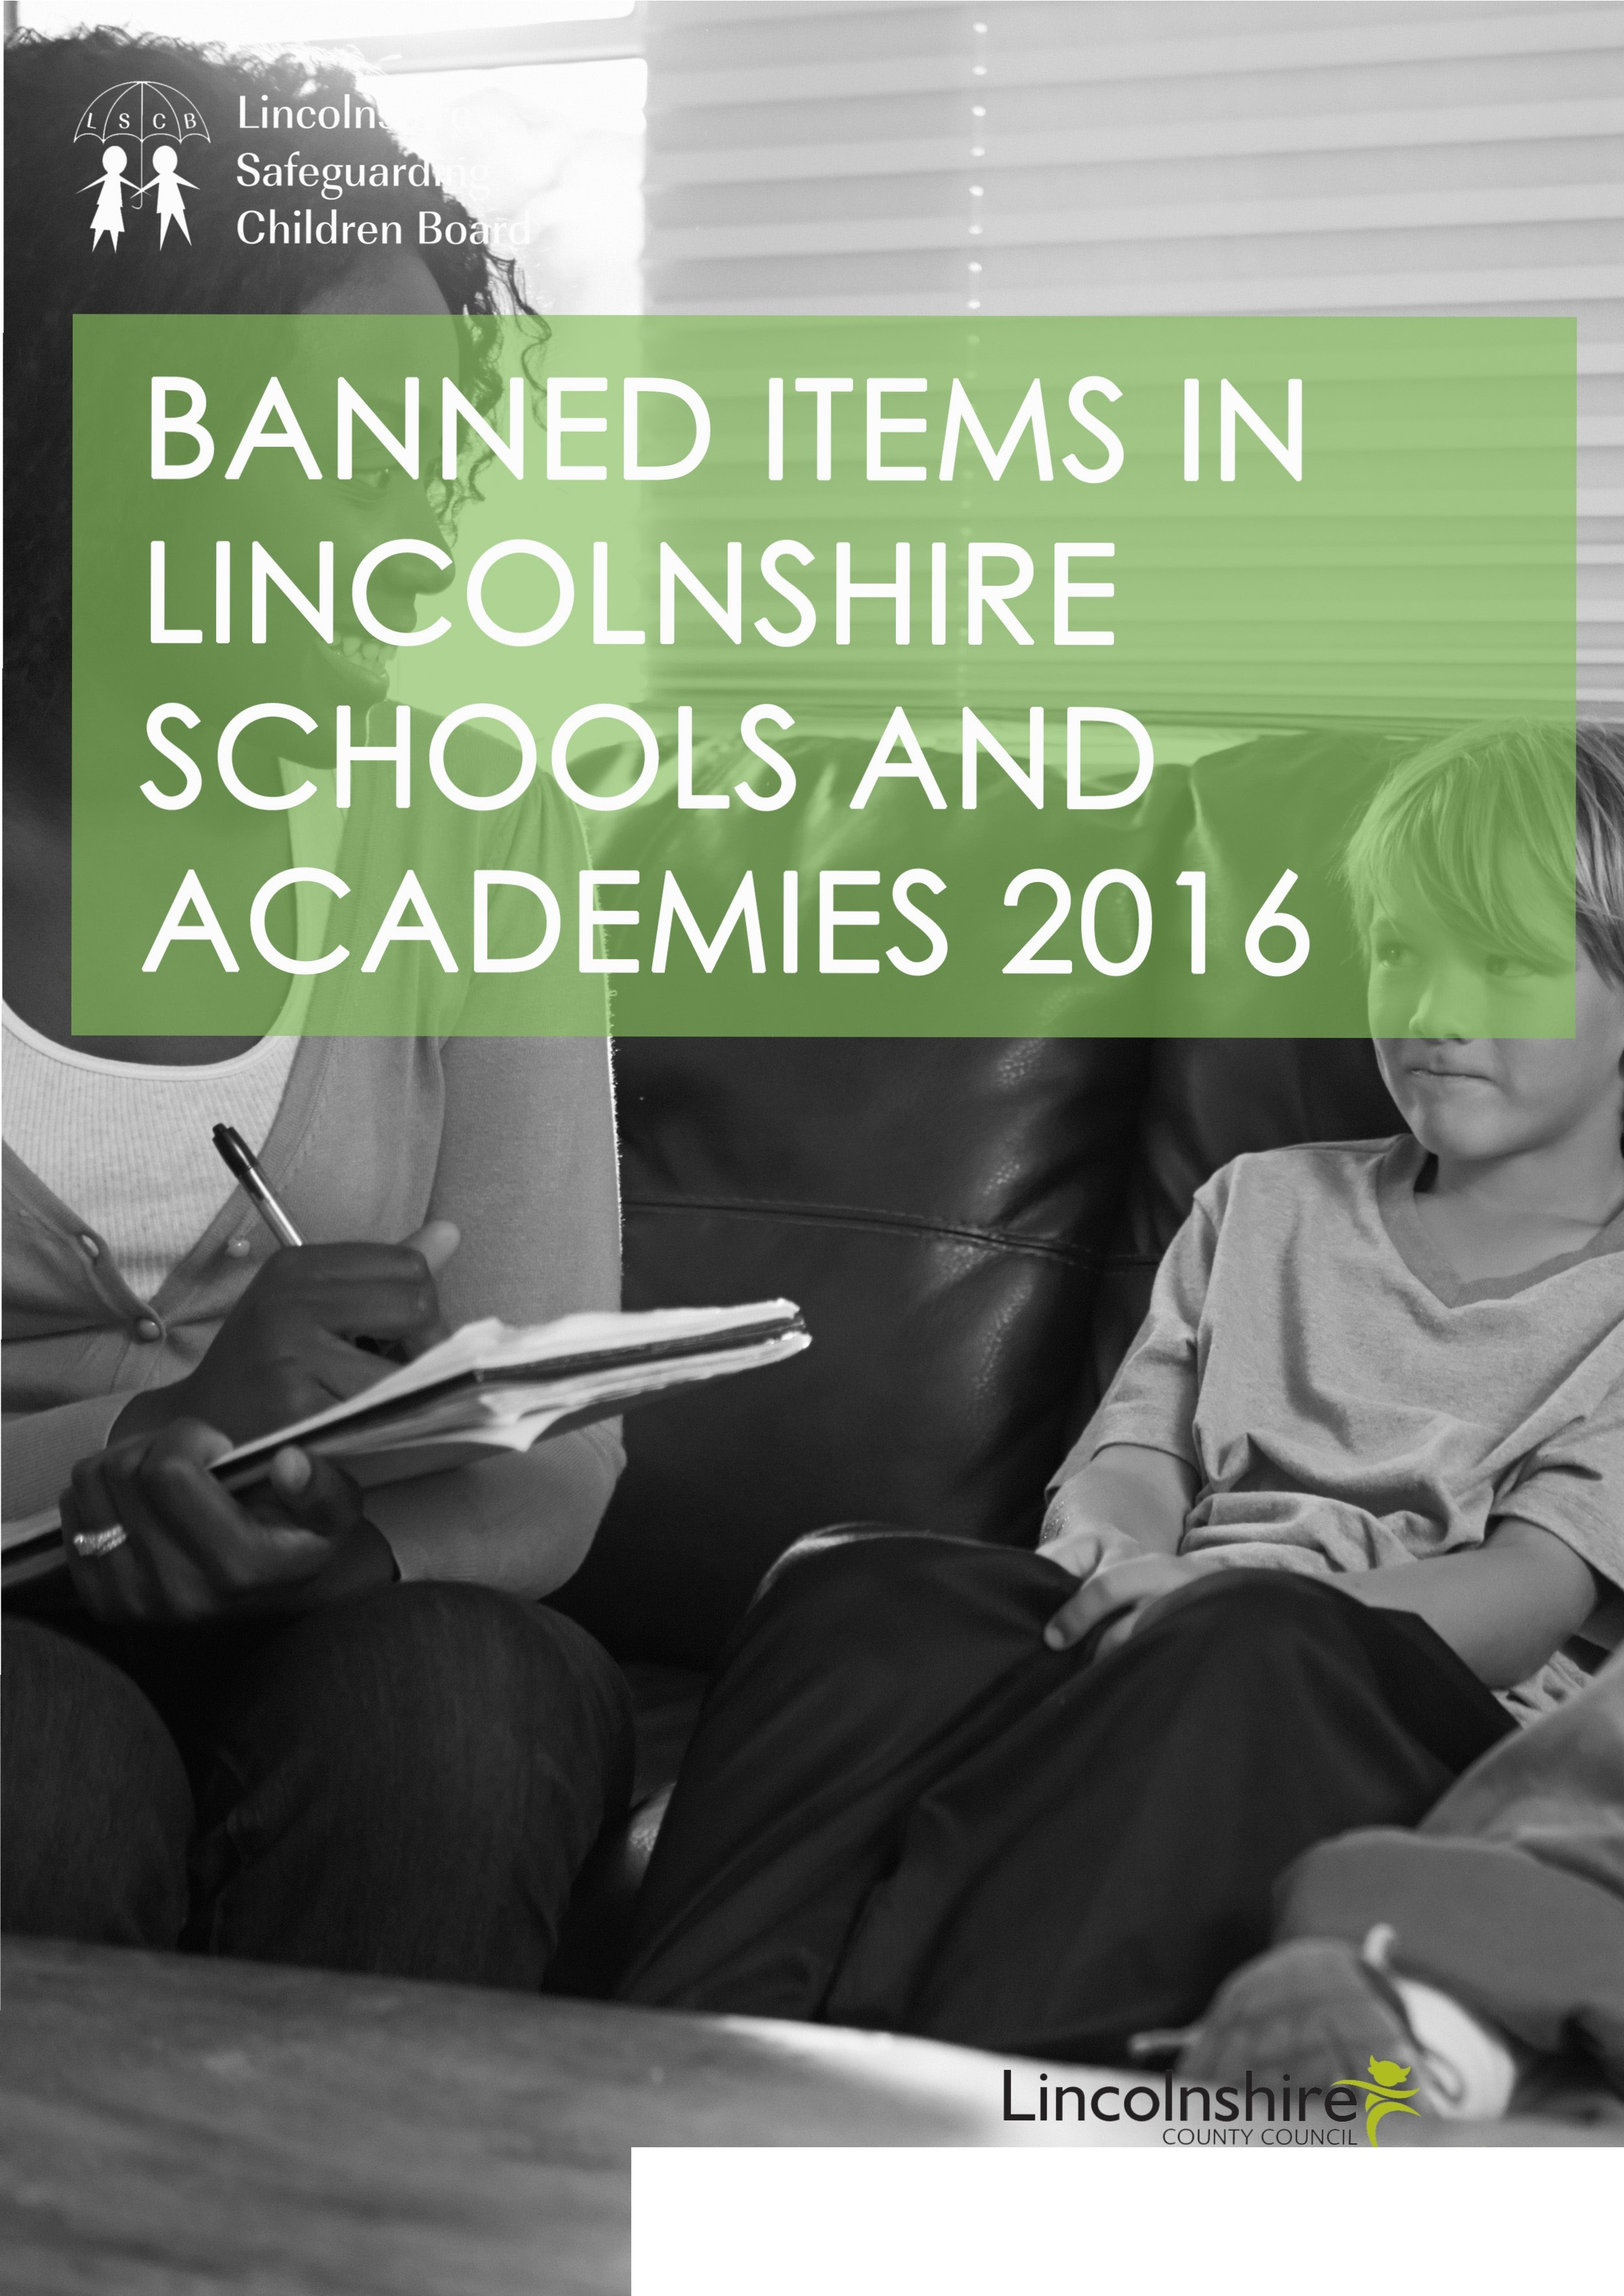

PJorK

Context

“The LSCB strongly holds the vi
each incident is unique and the necessitates an individual respo that a permanent exclusion sh not be the automatic response an incident involving prohibite inappropriate items.”

ew that refore nse and ould
to
d or

CONTEXT
LSCB values the commitment of Headteachers and Governors in their work to provide a high quality, safe, stimulating and successful learning environment for all the pupils in their care.

The LSCB has identified that there are differing responses between schools to incidents which involve the possession of prohibited or unauthorised items such as weapons.

Indeed, some schools operate a Zero Tolerance policy and others a more responsive policy with greater emphasis on safeguarding and restorative practice.

The LSCB seeks to address this anomaly and ensure that all Lincolnshire pupils experience a consistent and equitable response, regardless of their place of learning.

The LSCB strongly holds the view that each incident is unique and therefore necessitates an individual response and that a permanent exclusion should not be the automatic response to an incident involving prohibited or inappropriate items.

LSCB takes seriously the obligation paced on schools and academies under Health and Safety Legislation for them to be manged in a way which does not expose pupil or staff members to unnecessary risks.

Governing bodies of maintained schools have a duty under section 175 of the Education Act 2002 requiring them to make arrangements to ensure that their functions are carried out with a view to safeguarding and promoting
the welfare of children. The proprietors of Academies have a similar duty under paragraph 7 of Schedule 1 to the Education (Independent School Standards) (England)
Regulations 2010. They must ensure that arrangements are
made to safeguard and promote the welfare of pupils.

The LSCB has developed this model policy regarding such items to support school staff in managing an increasingly complex area of safeguarding concerns. The document is designed to be flexible in order that it can be further
developed by individual Governing Bodies/Trust to provide for primary and secondary settings and to reflect a school/ academy’s own ethos and values.

BANNED ITEMS
POLICY

(Alternatively this document could be incorporated into the schools own behaviour policy as an agreed appendix)

This is the approved Banned Items Policy for Bishop King C.E. Primary School

This policy has been drawn up in accordance with:
- DfE Guidance Screening, Searching and Confiscation (Feb, 2014)
- DfE Behaviour and Discipline in Schools (Jan, 2016)
- DfE Guidance on Exclusion from Maintained Schools, Academies and Pupil Referral Units. 2012

This is the approved policy of Bishop King C.E. Primary School/Academy which has been produced using the Lincolnshire Children’s Service Recommended Model.

Date of Approval by Governing Body Date of Review
This Policy should be read in conjunction with the
School’s published:
Drugs Policy Behaviour Policy Safeguarding Policy Uniform Policy
Health and Safety Policy
(add/remove others school policies which link with this document)

All stakeholders will recognise that there is a broad range of items which if, brought into a school setting or, in the possession of a young person, could compromise the health and safety of the individual pupil, other members of the school community, including students, staff or visitors to the school/ academy.

The Governing Body of Bishop King C.E. Primary School has a duty under section 175 of the Education Act 2002 requiring them to make arrangements to ensure that their functions are carried out with a view to safeguarding and promoting the welfare of children.

PROHIBITED ITEMS

The 2014 DfE Screening Searching and Confiscation Advice is the foundation for this policy and it identifies prohibited items as:

•
•
•
•
•
•
•
•
knives or weapons
alcohol illegal drugs stolen items
tobacco and cigarette papers fireworks
pornographic images
any article that the member of staff
reasonably suspects has been, or is likely to

The Governing Body consider that the following items are inappropriate and should not be brought into school:-
•
be, used to commit an offence, or to
cause personal injury to, or
damage to the property of, any person
(including the pupil).
Head Teachers and authorised staff can also search for any item banned by the school rules which has been identified in the rules as an item which may be searched for.
(DfE Screening Searching Confiscation Advice- Key points)

For the purpose of this policy - The definition of ‘Knife’ in this document includes any bladed article including- craft knife, Stanley knife, Swiss Army knife, fishing knife, razors, kitchen knives etc. or any bladed item.
•
•
•
•

•
•

•
•

•
•
•
•
•
•
•
•

•

•
Chains
Catapults Lighters, matches
Tools (scissors, screwdriver, hammer, nails etc)
Pepper sprays and gas canisters
Any item fashioned to cause injury i.e. a sharpened stick, shard of glass
Laser pens
Dangerous chemicals (acids, hair dyes, bleaches, nail varnish remover etc)
Aerosol (including deodorant and hair spray) E cigarettes
Stink bombs Solvents Chewing gum Energy drinks Super Glue
Needles (Syringes if required for medical grounds should be kept in accordance with the pupils own care plan and the schools own drugs/medical policy)
Offensive material- pornographic, racist, homophobic, extremist material (in any medium) Refer to school own social media policy)
Rope, cable ties

The term ‘weapon’ refers to any gun, including air rifles, BB gun, toy guns, pellet guns, crossbow, tasers, blow pipes, knuckledusters or any similar
item and includes any item made for the purpose of assault or defence.

The above is not an exhaustive list and could include other bladed items or weapons not specified
above. The policy is not constrained by the criminal definition of an offensive weapon but refers to any item which could cause harm, injury or distress to the holder or others, or which could be used to threaten, alarm, distress or intimidate others.
For details of the response to, and management of, any incident involving any type of Drug/ Alcohol/ tobacco/E-Cigarettes please refer to the schools own Drugs Policy - Title and Date

UNAUTHORISED ITEMS

In addition to the prohibited items identified above and detailed in the DfE Screening Searching and Confiscation Advice, there are a number of other items which could cause harm, distress or injury to pupils or persons.
Or ‘Adversely affect good order and
discipline of the school community’

(DfE Behaviour and Discipline in Schools (Jan 16)

This is not an exhaustive list and the Headteacher may consider other items as inappropriate if they believe that the possession of the item is to cause harm, distress or injury to another.

INCIDENTS OUTSIDE OF SCHOOL
LSCB and the Governing Body consider that the above items are inappropriate and possession of such items in school, on the journey to and from school, on a school trip or any extra curriculum activity- on or off the school premises- is unacceptable. The response to any pupil found with or believed to have possession of such items will be

managed in accordance with this policy.

PUBLICATION AND AWARENESS

This Policy will be actively promoted to parents, staff and students of Bishop King C.E. Primary School consider by the use of:
•
•
•
•
•
•
•

•
PHSE
School planners School Website Assemblies Notice boards
Individual pupil plans
Annual reminder to Parents of the policy in a newsletter home
Induction processes for new admissions and with particular regard to midyear admissions. (Schools/Academies should amend this list as they consider appropriate)
staff will thoroughly investigate the circumstances and if necessary the Head will exclude the pupil for a fixed term period whilst this process is underway.

When reviewing the appropriate response, the Headteacher will have regard to any likely
consequences following from any breach including, safeguarding the student involved, impact on students, members of staff and the wider school community. In their deliberations the head teacher will review:
Motivation and intention The specific item
Students awareness of the health and safety implications of the item in their possession The student’s own statement
Any threats or intimidation made referring to or
using the item
Any mitigating circumstance eg victim of bullying Frequency/repeated breaches Manipulation/duress of the student by others Vulnerability of the pupil
Any SEND the pupil may experience

The school maintains a robust and comprehensive risk management of all legitimate items held for the purpose of pupils education e.g. craft knives/scissors/kitchen equipment/science equipment/chemicals/tools etc as required for
the school’s own teaching facilities. This includes classroom arrangements for maintaining a safe learning environment and for monitoring and checking items.

All dangerous chemicals and equipment held in school will be stored in accordance with the COSSH guidelines including those for educational purpose and for the routine maintenance and cleaning of the school premises.

CONSEQUENCES

LSCB and Bishop King C.E. Primary School understand that students can make poor choices and that these choices may from time to time breach the above standards of expected behaviour, or a pupil may foolishly or unwittingly bring into school an inappropriate or prohibited item.

When considering the consequences of such an event, the Headteacher or designated member of

RESPONDING TO AN INCIDENT INVOLVING PROHIBITED OR UNAUTHORISED ITEMS

All screening, searching or confiscation will be carried out by designated staff representative of Bishop King C.E. Primary School and in
accordance with the DfE Screening Searching and Confiscations advice 2014.

The item will be confiscated and locked securely in the school office

A photograph/photocopy of the confiscated item including a scale to illustrate the size will be taken. Pupil will be removed to isolation and given the opportunity to make a statement concerning their reasons for having this item in school.

Parents will be contacted by telephone.

If necessary a fixed term will be considered to give opportunity for the incident to be investigated by the Head or a senior member of the school team

including taking witness statements from other
pupils and staff members.

The Headteacher will consider whether appropriate to inform the Police- for all incidents which involve the possession of a weapon the police will be informed.

In the event that the item has been used to intimidate, threaten or harm others, the police will be informed.

SAFEGUARDING RESPONSE TO INCIDENT INVOLVING BANNED ITEMS.

The Headteacher will always consider their safeguarding responsibilities arising from the discovery of a banned item and will make referrals as appropriate.

If the incident is in relation to drugs, the Headteacher will refer to the school/academy’s drugs policy.

If the item confiscated constitutes a safeguarding concern, e.g possession of pornographic material this must be reported in accordance with the school/academy’s own safeguarding arrangements.

If the item confiscated constitutes racist or extremist material, schools will make a referral/ reporting to appropriate agencies and establish internal interventions and support to address these concerns.

If the item confiscated was held for the purpose of self-harm, the school/academy will make referrals to appropriate support agencies and consider making a safeguarding referral.

If the item confiscated was for the purpose of bravado or perceived self-protection, school will make referrals to appropriate support agencies and establish internal school interventions and support.

Bishop King C.E. Primary School will always consider a multiagency approach to addressing wider needs including completing an Early Help Assessment with the family.
School will, where appropriate, make referrals to appropriate external support agencies.

CONSEQUENCES

Following investigation the Headteacher will consider an appropriate response which could include one or a combination of:
•
•
•
•
•
•
•
•
•
•
•
•
•
•
•
•
•
Letter home
Family/school meeting School based sanctions
A period of internal isolation Amended timetable
Restrictions on movement around school site Detentions
Loss of privileges
Short Fixed Term exclusion Changing classes or teaching groups Restorative conversation
Formal restorative conference Pastoral Support Plan Behaviour contract
Referral to external support Managed Move
Risk Assessment

Arrangements to minimise further breaches and to support the student’s continuation in the school/ academy.

(Schools/Academies should amend this list as they consider appropriate)

PERMANENT EXCLUSION

DfE Guidance on Exclusion from Maintained Schools, Academies and Pupil Referral Units 2012 states that: ‘Permanent exclusion should only be used as a last resort, in response to a serious breach, or persistent breaches, of the school’s behaviour policy; and where allowing the pupil to remain in school would seriously harm the education or welfare of the pupil or others in the school’.

Before any decision to permanently exclude a
student the Headteacher will:-

•

•

•

•
•

•

•
Thoroughly investigate the incident and take
witness statements etc
Refer to the school/academy behaviour
policy and others policies as necessary
Enable the student to make their own
statement regarding the incident
Consult with the LA pupil reintegration team Consider a referral for a restorative conversation or conference
Explore a Managed Move or Suspended Permanent Exclusion
Complete a risk assessment to ascertain the
impact of the pupil remaining in the school
For students with an Educational Health Care Plan/Statement of SEND or for LAC students the Headteacher will also contact the relevant team at Lincolnshire Children’s Services.

Any decision to fixed term or permanently exclude a student will follow the process and procedures as required in the Exclusion from maintained school, academies and pupil referral Units 2012.

