**Bishop King C.E. Primary School**Dream big. Love God. Live well.  
‘I can do all things through Him who strengthens me.’ Phillippians 4:13

**Our Intent, Implementation and Impact statement for computing**

**Computing intent statement:**

At Bishop King C.E Primary School, we provide children with opportunities to gain knowledge and to develop purposeful skills that will equip them for a safer, ever-changing digital world.

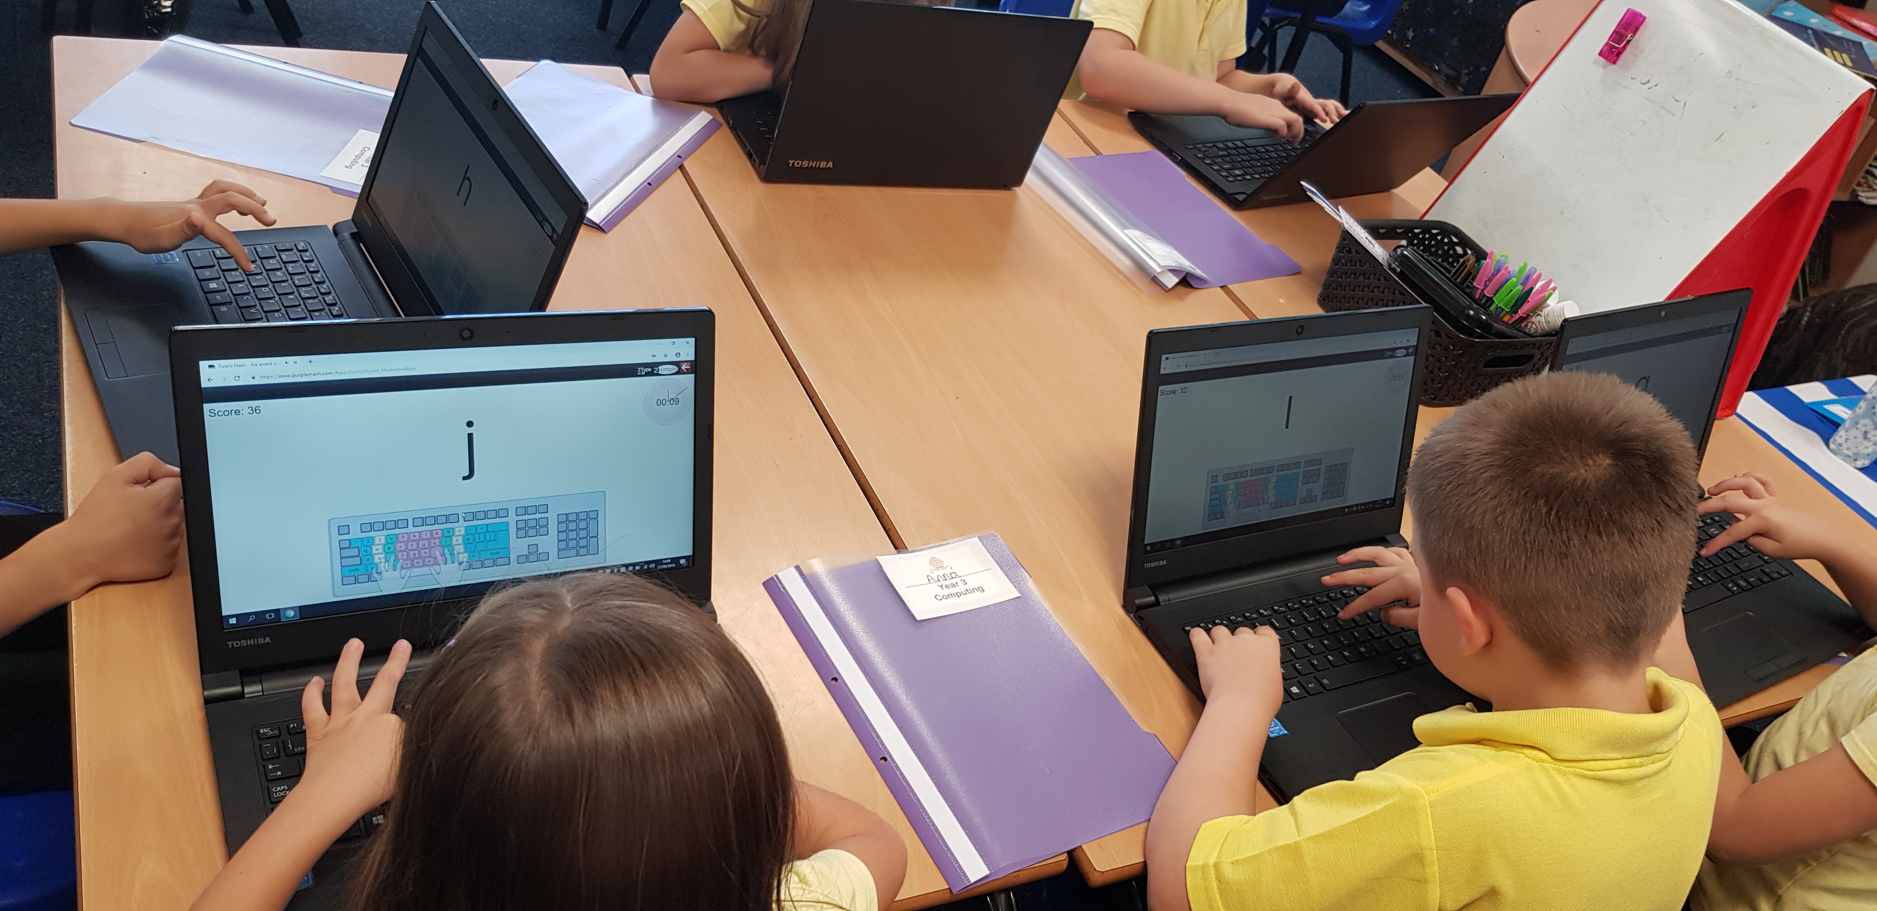

**Implementation statement:**

At Bishop King C.E Primary School, computing is taught in discreet computing lessons, using the ‘Purple Mash’ scheme. The scheme has been closely referenced against the 2014 National Curriculum attainment targets, in order to ensure progression and coverage. Having discrete lessons means that the children develop depth in their knowledge and skills over the duration of each computing topic. Where appropriate, cross-curricular links are made; this motivates pupils, supports them to make connections and encourages them to remember prior learning.

**Impact statement:**

The implementation of this curriculum ensures that, when children leave Bishop King C.E Primary school, they use their knowledge and skills to live safely in an ever-changing digital world.