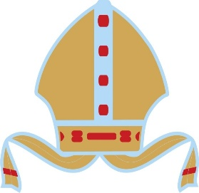

Dream big, love God and live well
'I can do all things through Him who strengthens me'
Philippians 4:13

Religion and Worldviews at Bishop King C of E Primary School:
intent, implementation and impact.
Intent
At Bishop King CE Primary School, we see the RE curriculum as a key tool in enabling our pupils to understand the religions within their community and the world they live in. We aim for pupils to learn about and have knowledge of a range of world views including Christianity.
Implementation
At Bishop King CE Primary School, the pupils experience a well-planned, spiral Religion and Worldviews curriculum, which supports our children in understanding the diverse community and world in which they live. Our Christian units of study are connected through the concepts of Creation, Incarnation and Salvation. All units of work are focused around a central question that pupils are challenged with finding the answer to and in doing so they understand the world in which they live. Our World Faith units are centred around pupils understanding other major religions such as Islam and Hinduism.

- Religion and Worldviews units begin with the introduction of key vocabulary and a fact file.
- A spiral curriculum with progressive skills, knowledge and vocabulary which is built upon through units of work and year groups.
- A sequence of work (sequential journey of learning) is planned using Understanding Christianity or the Lincolnshire Agreed Syllabus.
- Key questions are used to support all learners at an appropriate level.
- Enrichment activities are used to support the learning of key concepts eg visits to local churches, the mosque and Hindu workshops.
- Classroom environments support the learning journey, highlighting key knowledge and vocabulary. The previous terms vocabulary is also on display in the classroom.
- Assessments are used at the end of each unit to assess children’s learning and understanding of vocabulary.
Impact
Pupils will leave Bishop King CE Primary School, with knowledge of Christianity and other world faiths. They will be able to ask high level questions, challenge their own and others understanding of different religions and understand how religious diversity impacts on their community. They will also have an understanding of how religion interlinks with other areas of the curriculum and builds on this knowledge.

