Medium Term Curriculum Overview 2023/24 – Autumn Term Subject: PSHE Year: 2

'I can do all things through Him who strengthens me' Philippians. 4:13

 | Au1  Koinonia  Democracy  Healthy Lifestyle/ Health and Wellbeing | Au2  Generosity  Individual Liberty  Living in the Wider World - Respecting Environment/ Responsibility
Week 1  To always explore the British Value of the Term | To always explore the British Value of the Term  British Value  Democracy  - To understand the meaning of word Democracy  (Using our voice)  - To understand what Democracy looks like at Bishop King  - To understand what Democracy looks like in Great Britain (Government)  Please use pupil voice to create class rules/routines. | To always explore the British Value of the Term  British Value  Individual Liberty  - To understand the meaning of the words Individual Liberty  (Knowing we are free and have rights)  - To understand we are free to do what’s right, as long as it doesn’t hurt anyone else.  - To understand we must respect other people’s rights and choices.
Week 2 | ‘Exploring Feelings’  - To know understand and recognise different feelings  - To understand ‘Body Clues’ and the affect people’s bodies and how they behave.  - To understand strategies they can use to cope with their own feelings (self regulate)  - To know how to manage scenarios when things become difficult. | 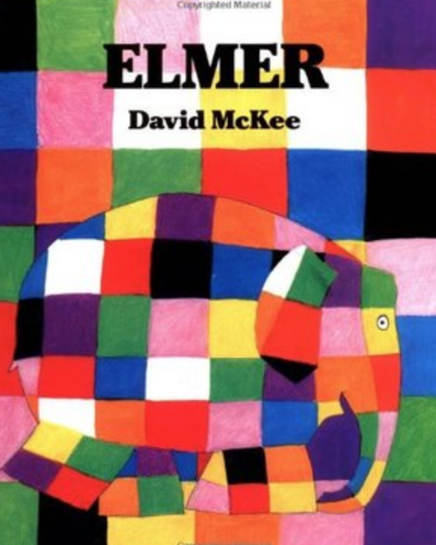  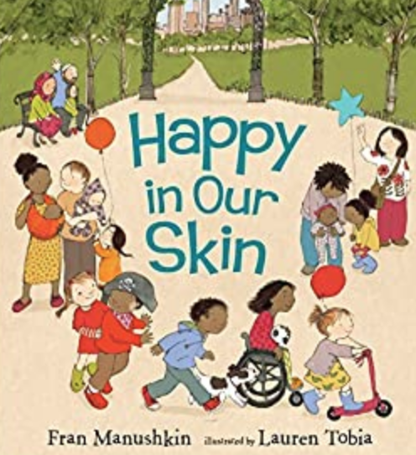  ‘We are all equal’  - To understand diversity within a community and learn how we respect people who are different to us.  - To know how to show tolerance, respect and generosity to people in different community groups to me.
Week 3 | ‘Keeping Healthy’ (Physically)  - To understand what it means to be physically healthy.  - To know what constitutes as a healthy diet.  - To understand the importance of maintaining good personal hygiene. | ‘Shared Responsibilities’  - To understand what are our own responsibilities and to know my shared and own responsibility in school, community and home.  - To understand our responsibility in caring for others and all living things
Week 4 | Mindfulness/Exploring Mental Health for Younger Children  - ‘To understand the importance of keeping our minds healthy as well as our physical health.  - To understand how to seek support for ‘big feelings’ and our own coping strategies for ‘small feelings.’  - To know we use mindfulness to reduce stress/worries or anxiety. | ‘Shared Responsibilities’  - To know and understand why look after our local environment, Bishop King.  - To know and understand why we keep safe in the local environment, Sincil Bank.  - To know how to and understand why we look after our wider world
Week 5 | ‘Keeping Safe -Exploring First Aid’  - To understand and know how to keep safe at home.  - To understand risk in simple everyday situations and what actions to take to minimise harm.  - To know how to contact people who help us in the community (999) | ‘Exploring Friendships’  - To know what makes a good friend  - To understand and know strategies to solve conflict between friends (Peer Pressure)  - To understand how our actions can make others feel (Empathy)
Week 6 | Our Class Family  - To know and understand who supports us in and out of school.  - To know who is in their ‘Support Network’  (Friends, Family and School Staff) | Can I recognise risky and negative relationships?  - How to recognise the feeling of comfortable and uncomfortable – what is acceptable and not acceptable  - To have the ability to say ‘no’  - To know a good friend is someone you can trust  When to say ‘no’/ ‘I’ll tell’ –  - To know that sometimes we have a responsibility to tell
Week 7 | ‘Ourselves Growing and Changing’  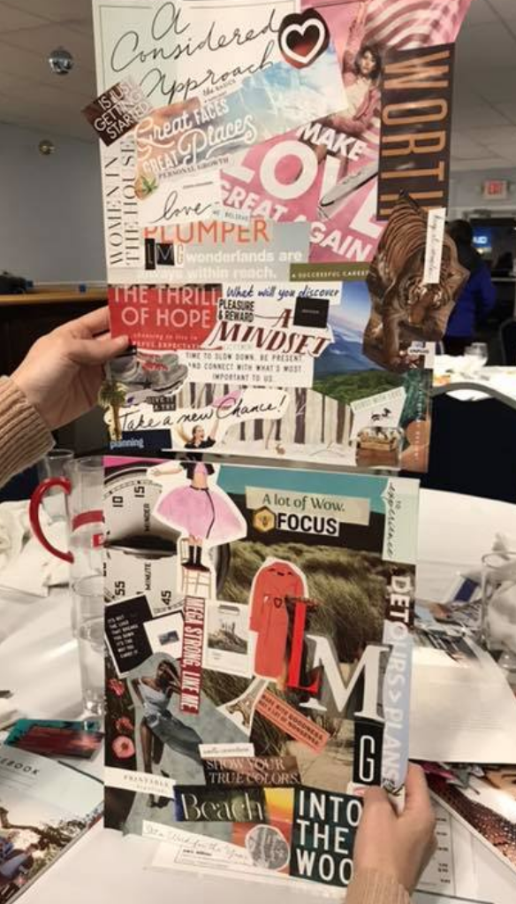  - To understand and know what makes them special and the ways in which we are all unique.  - To know what they am good at, what they like and dislike.  - To understand the importance of aspirations. (Dream Big) | ‘My Support Network – (Review)’  - To know which adults can help me?  - To know members of the community can help me?  - To know which friends can help me?  - To know could I help myself?

