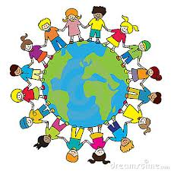
Global Learning Moderation
Spring 1 2020/21

Ongoing International projects

KA2 Poland
- Penpal system set up between children in BK, SPAG, MAPS and the three Polish schools. 15 children from each English school have written to the other children introducing themselves and telling them a bit about our school and Lincoln.
- We were very excited to receive replies to our letters.
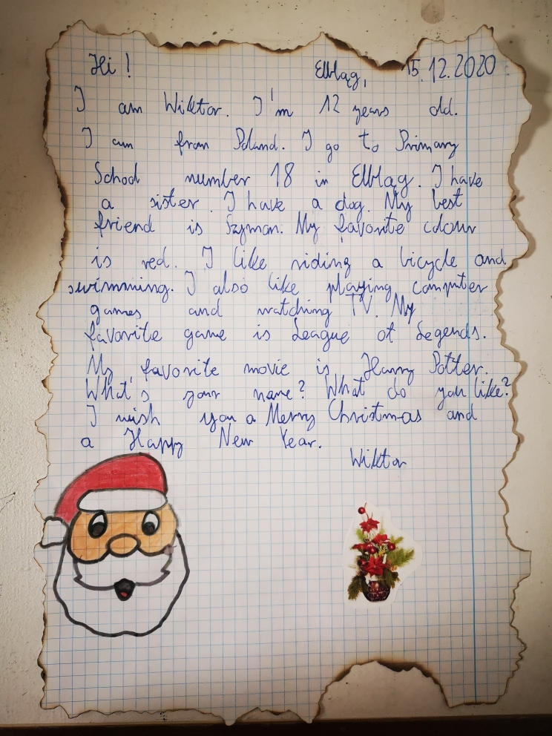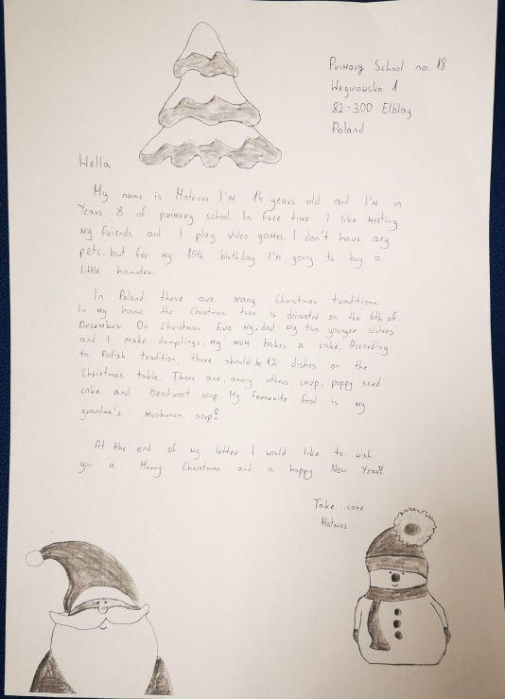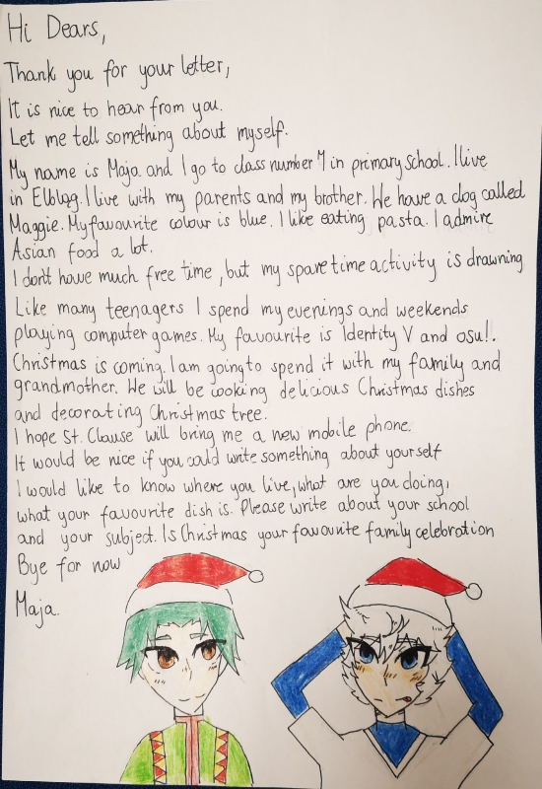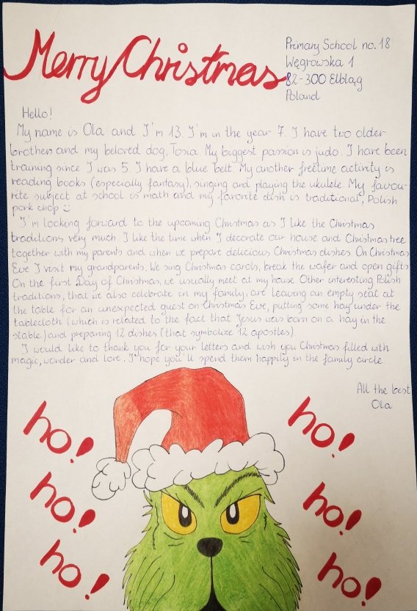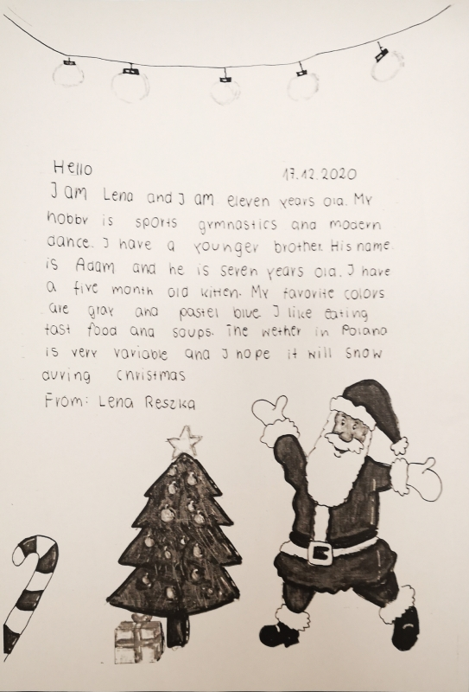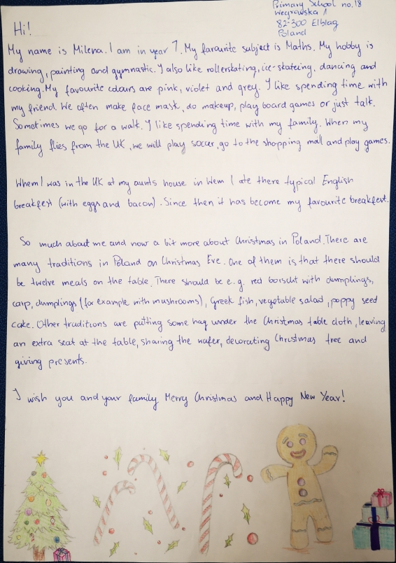

Connecting classrooms

We have received photographs from out partner school in response to the photographs we sent them.

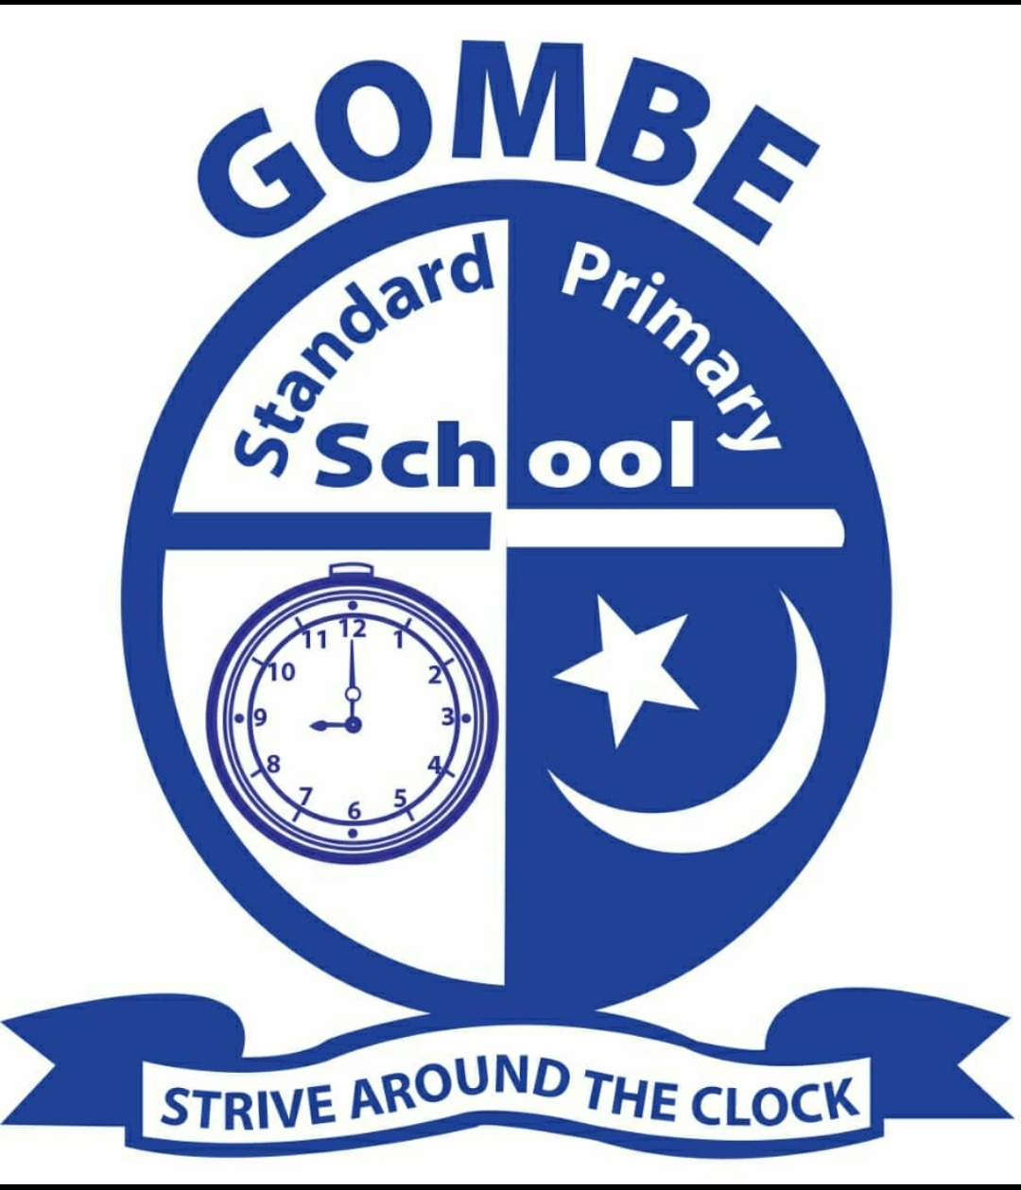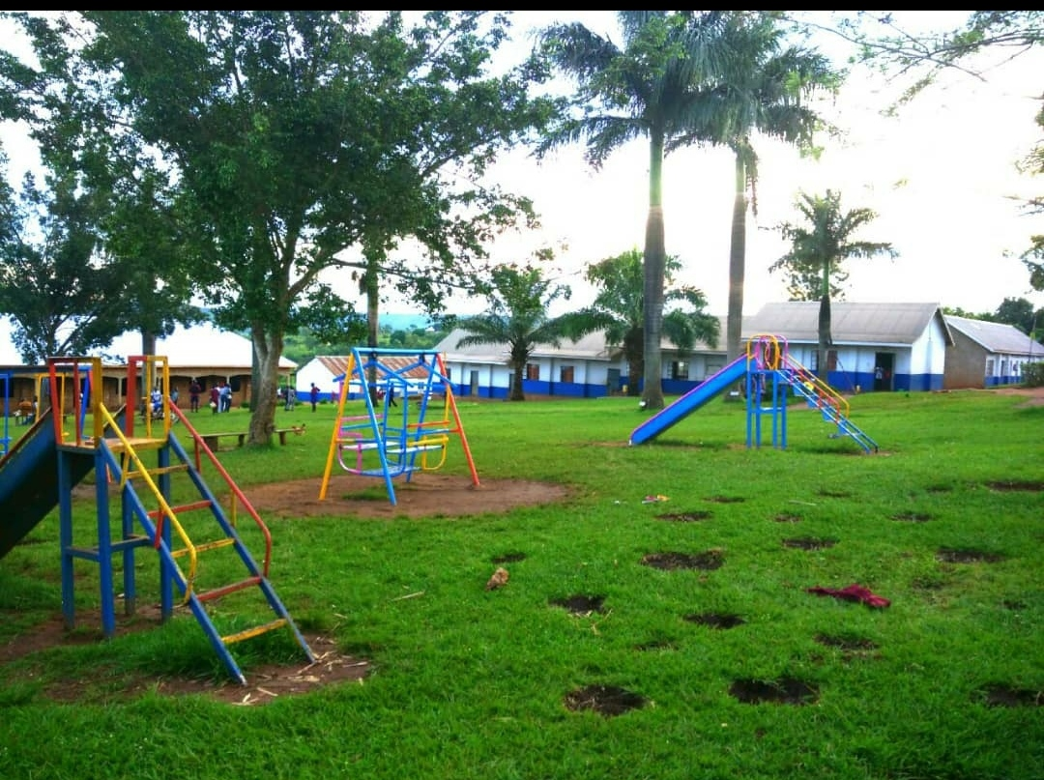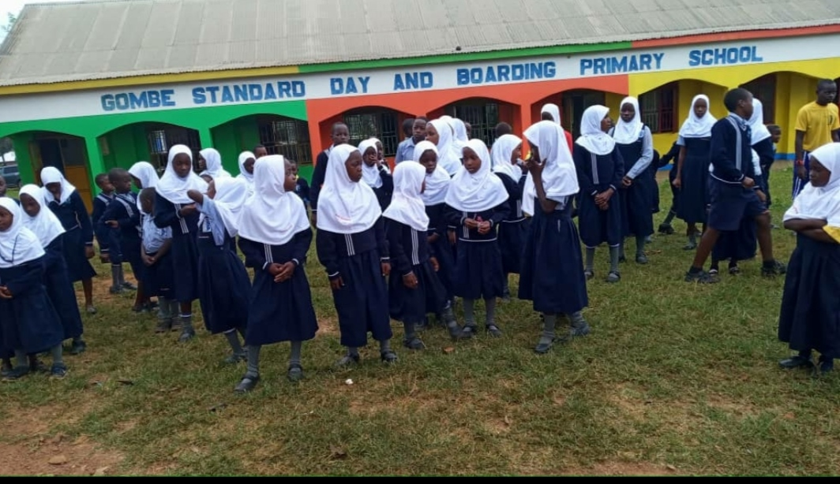
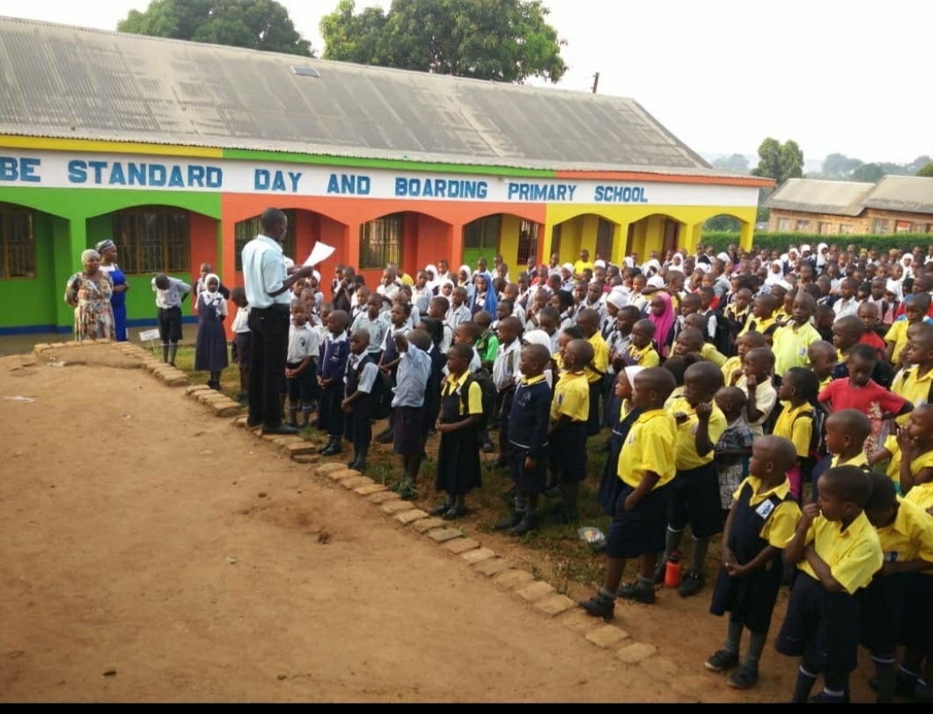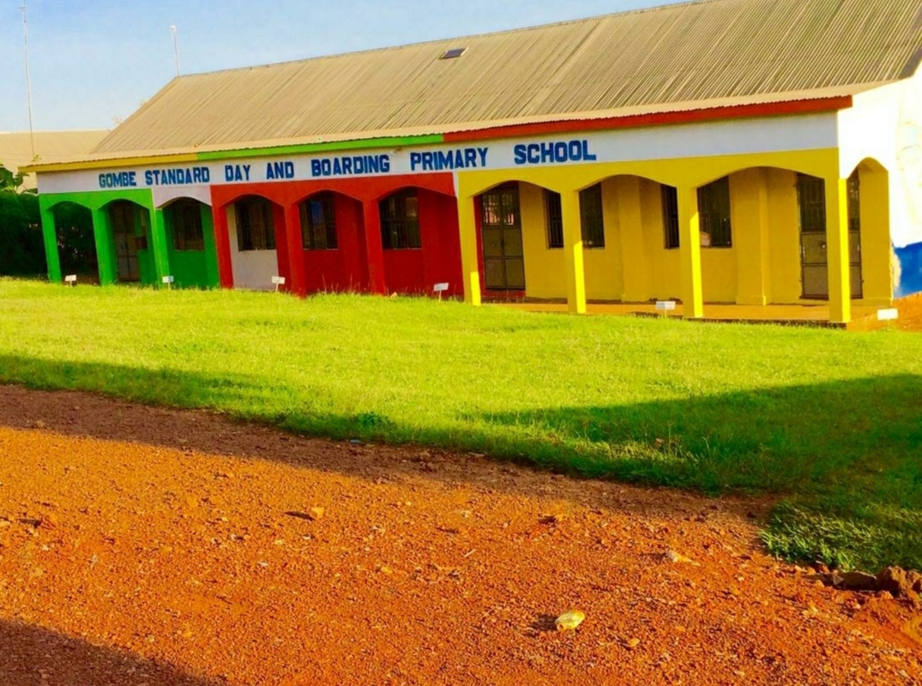

Children in Early Years, Year 5and Year 2 are completing work relating to our introductory projects.
What have you eaten today?
- Nursery responses
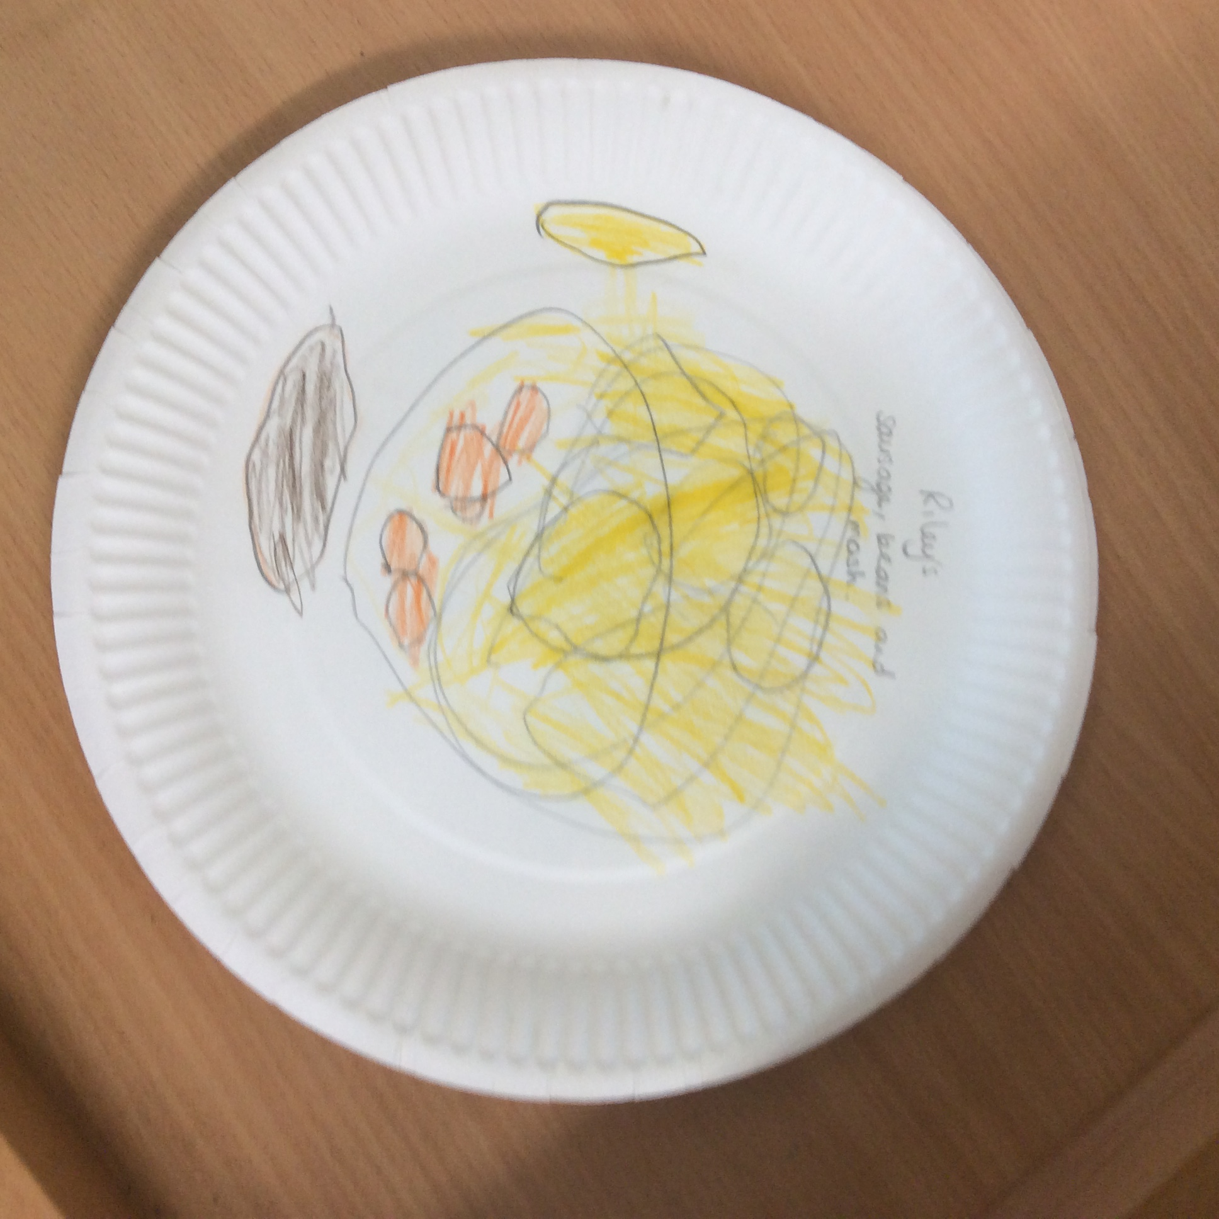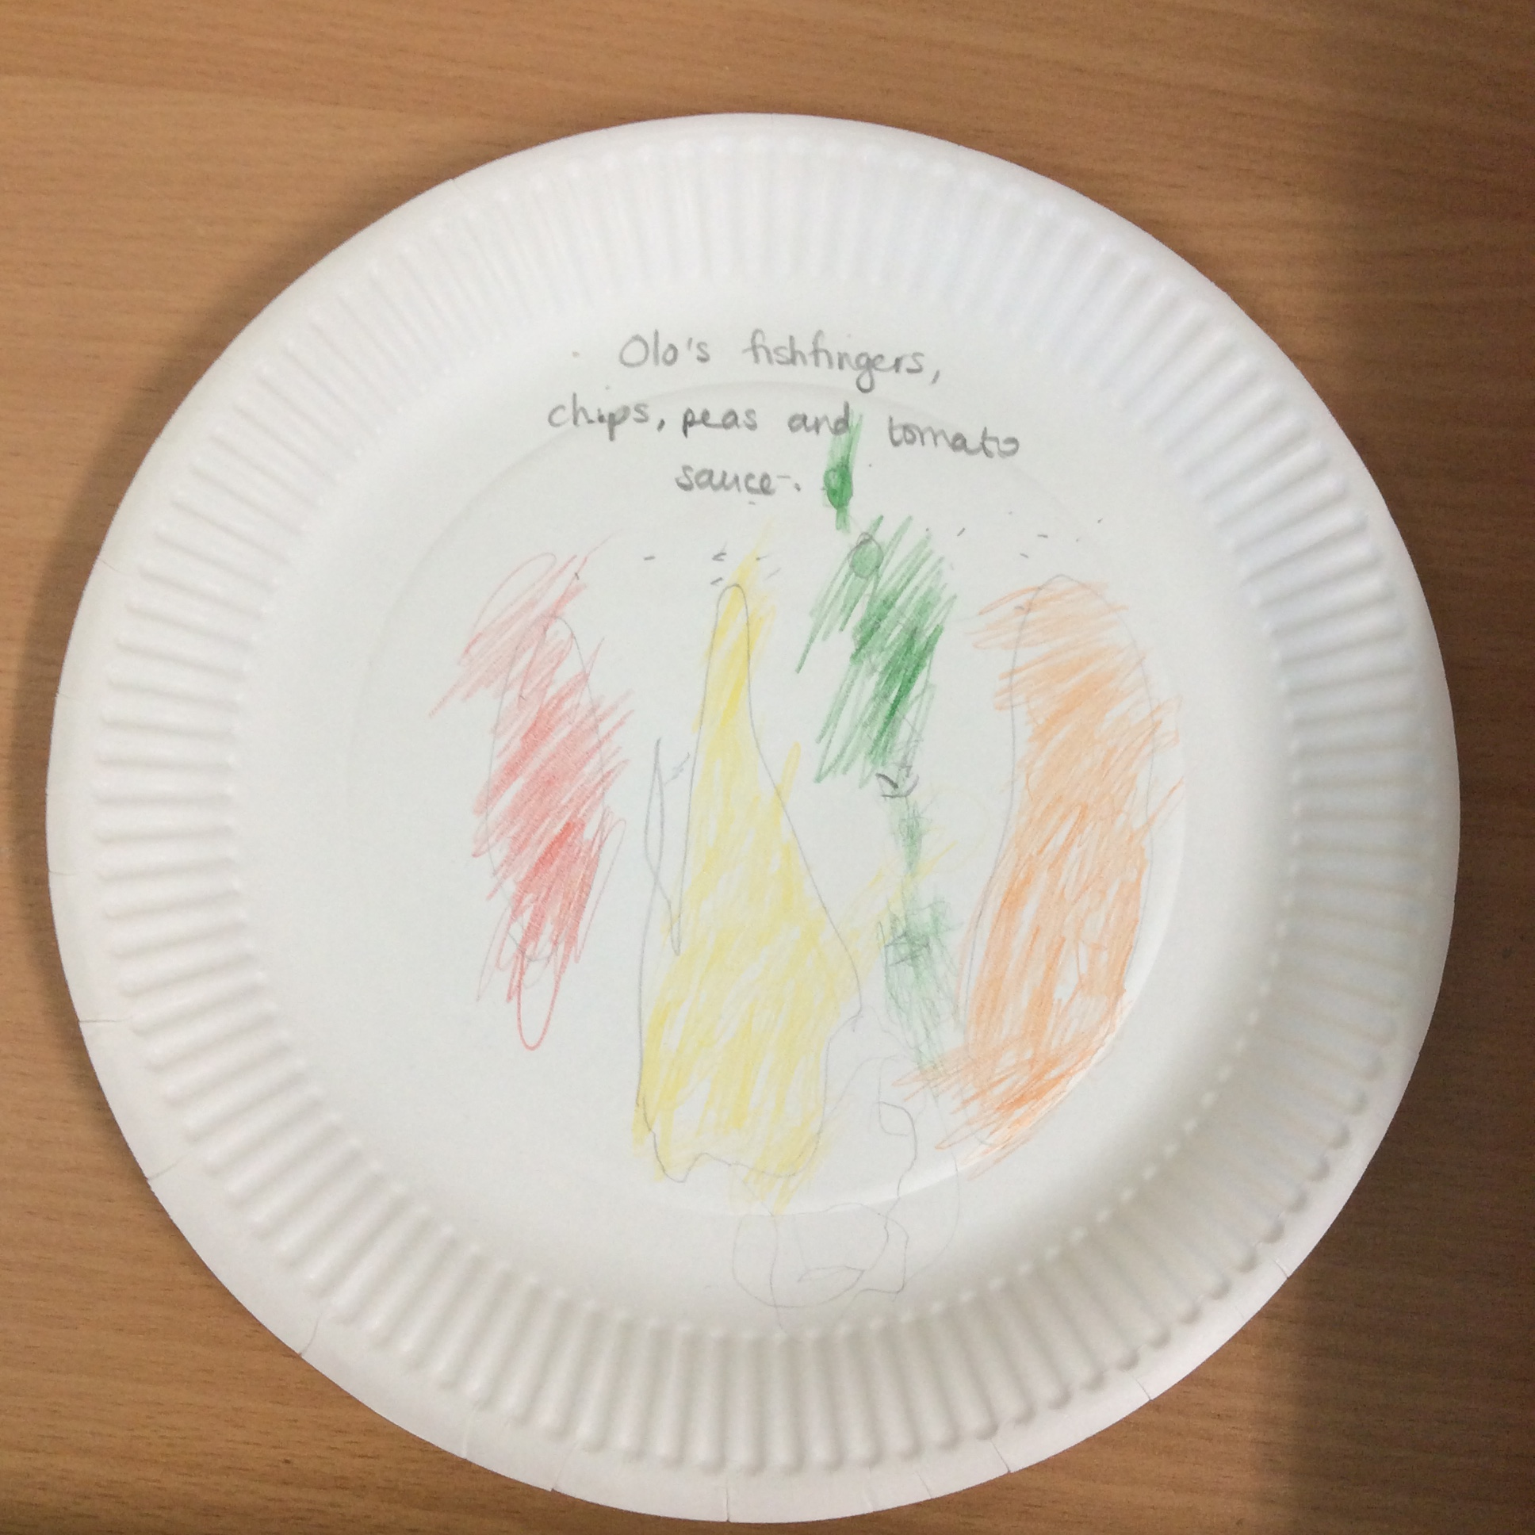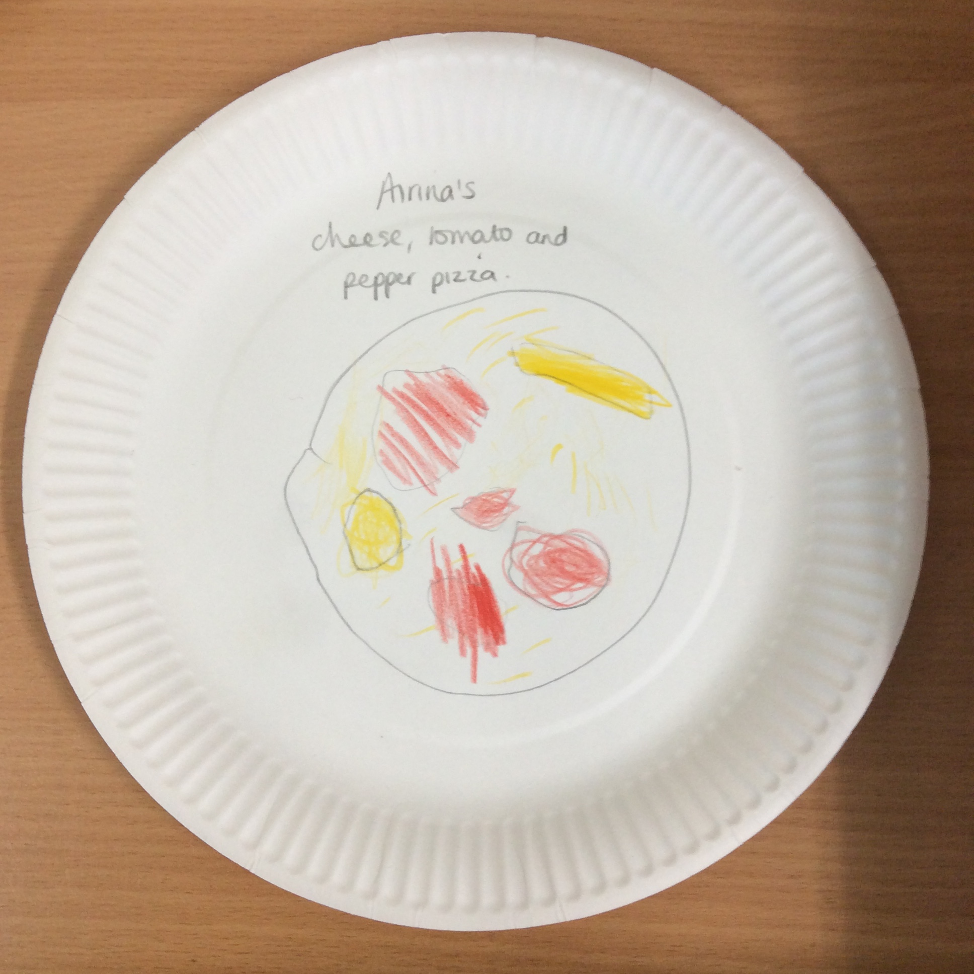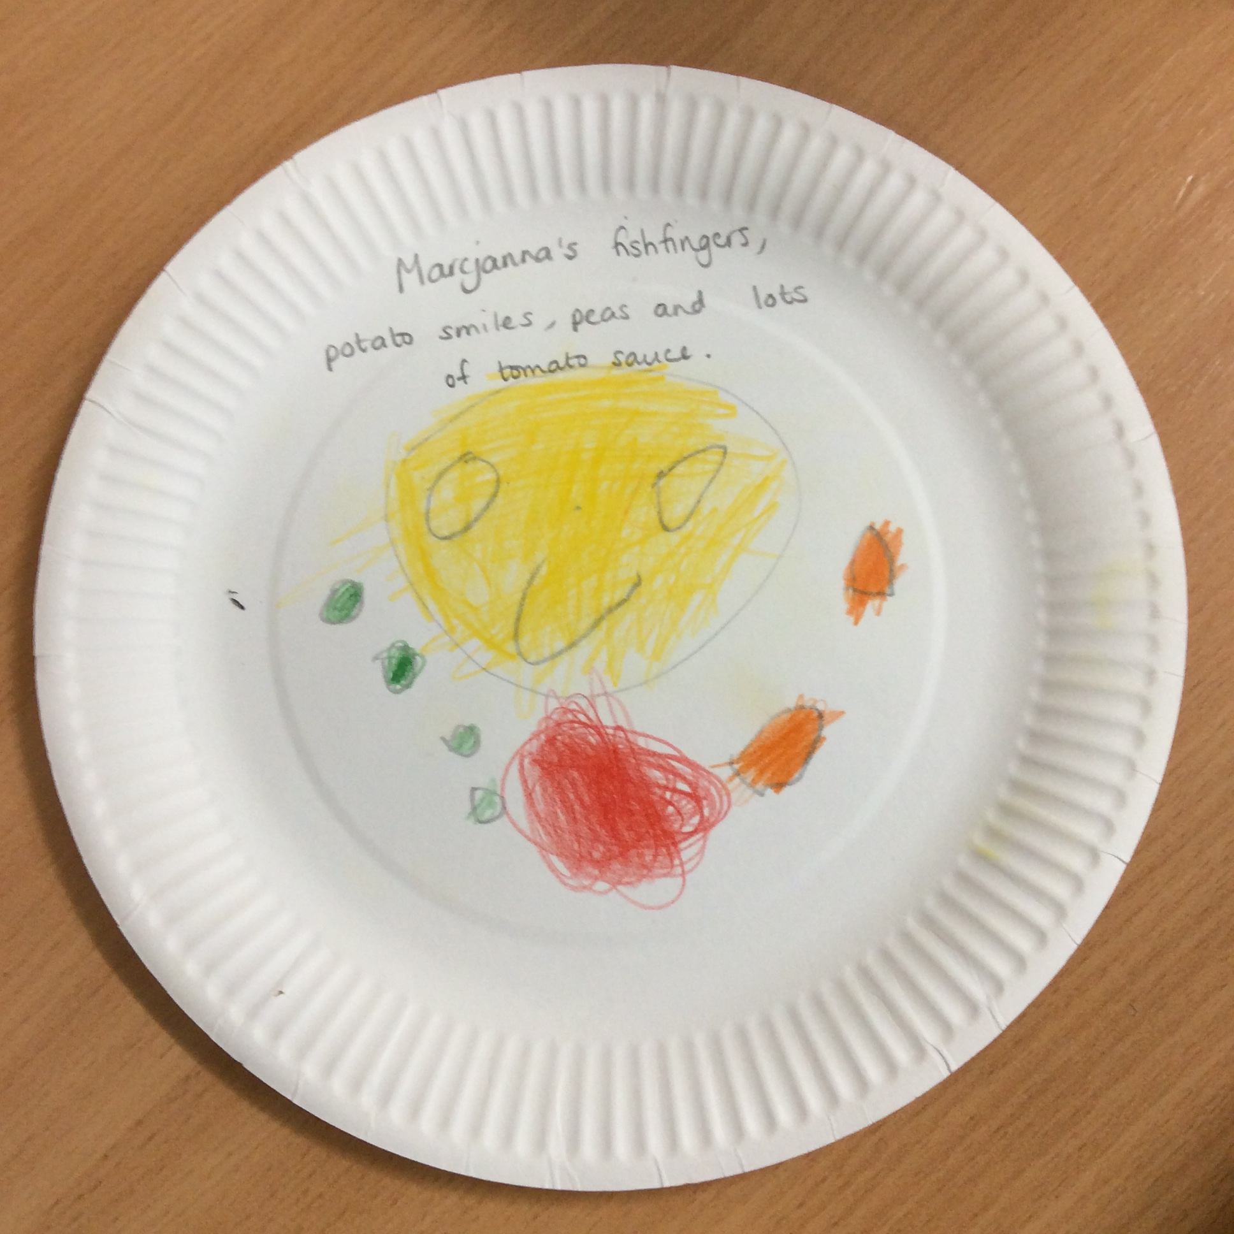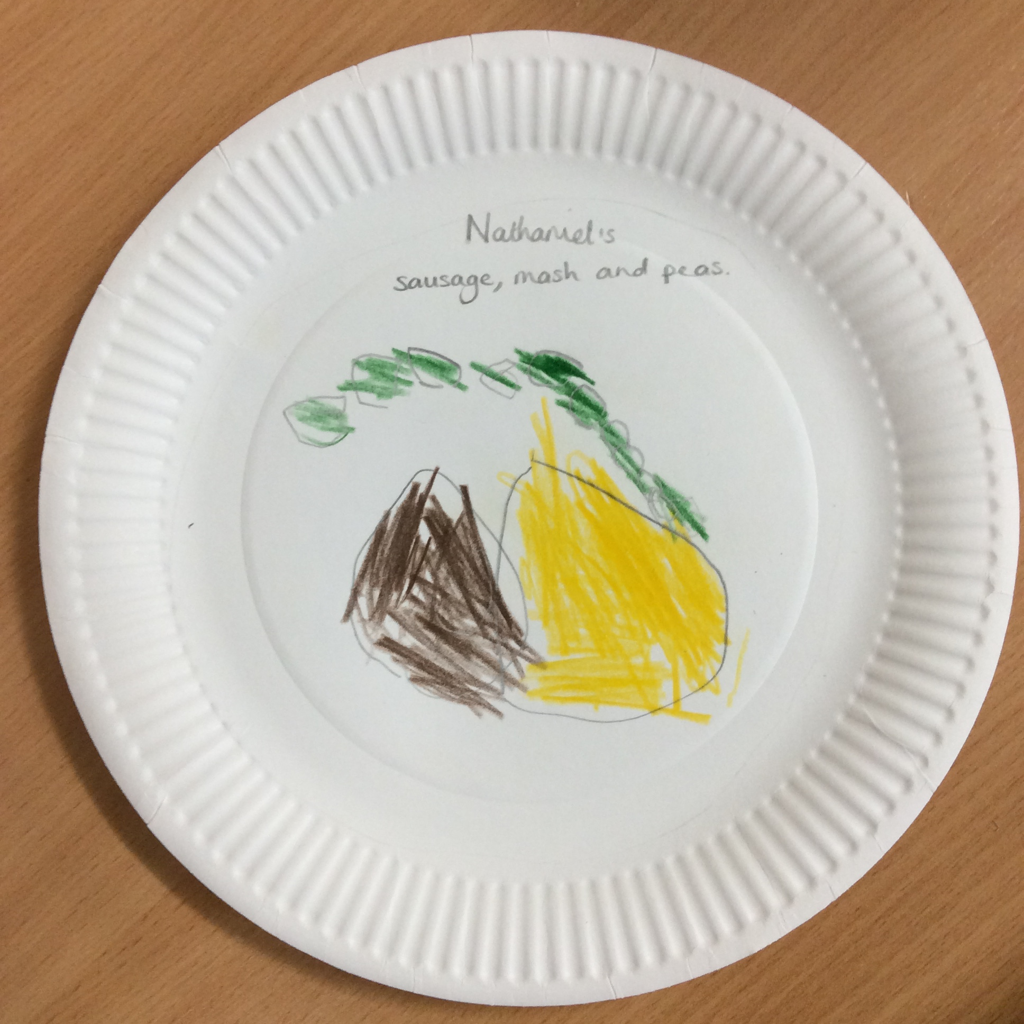

These will be sent to the partner school when the other year groups have completed the work.

KA1 Bulgaria and Romania
- Start date postponed until January 1st 2021.
- Funding has been granted.

Global Learning and our multicultural ethos within the curriculum

Climate awareness
Children in Year 6 wrote letters to some large UK companies in response to the ‘Picture News’ question….
‘Is it the responsibility of the young the protect the Environment?’
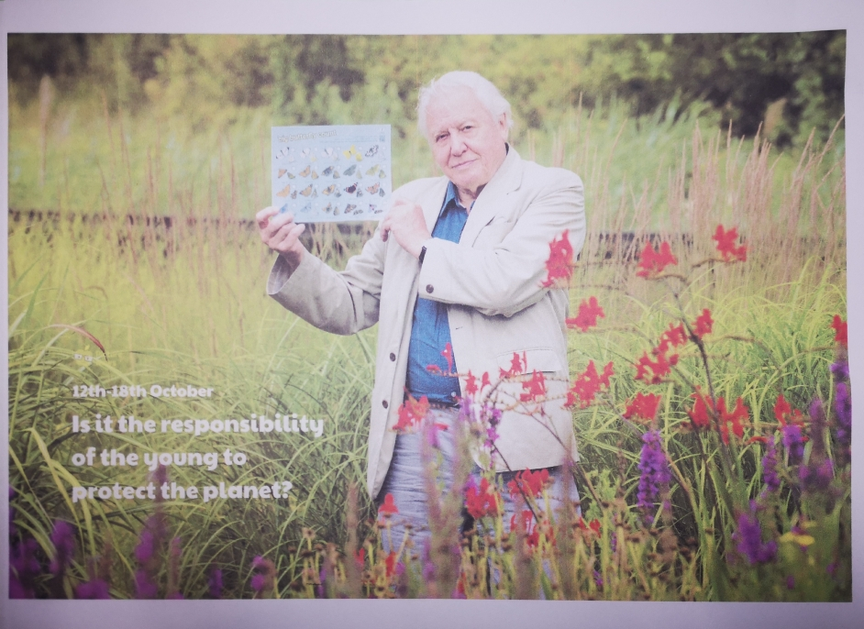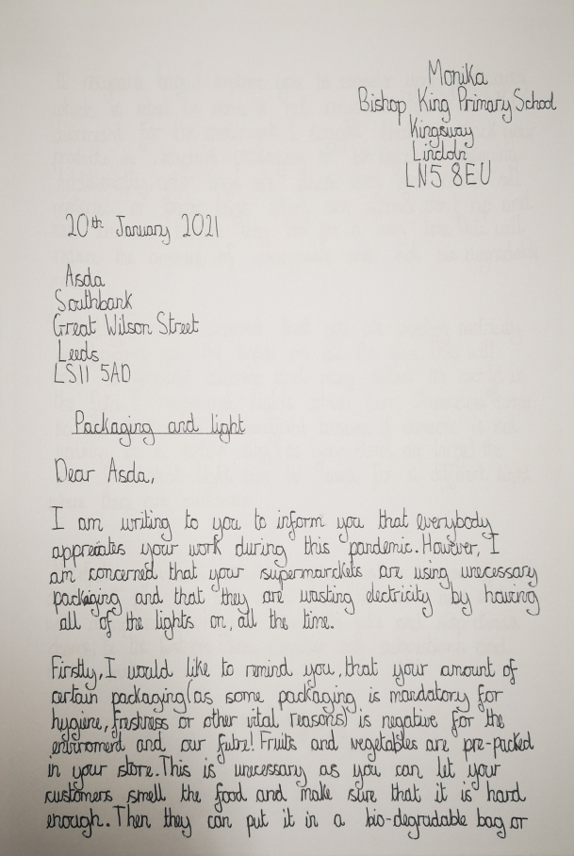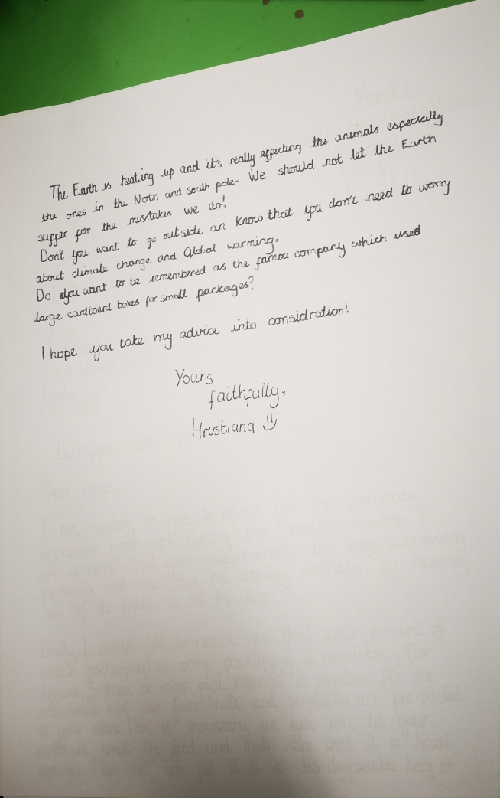
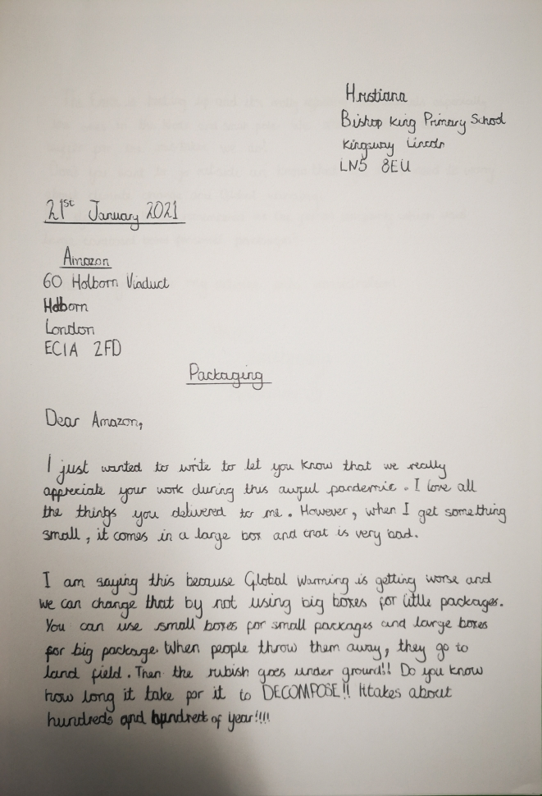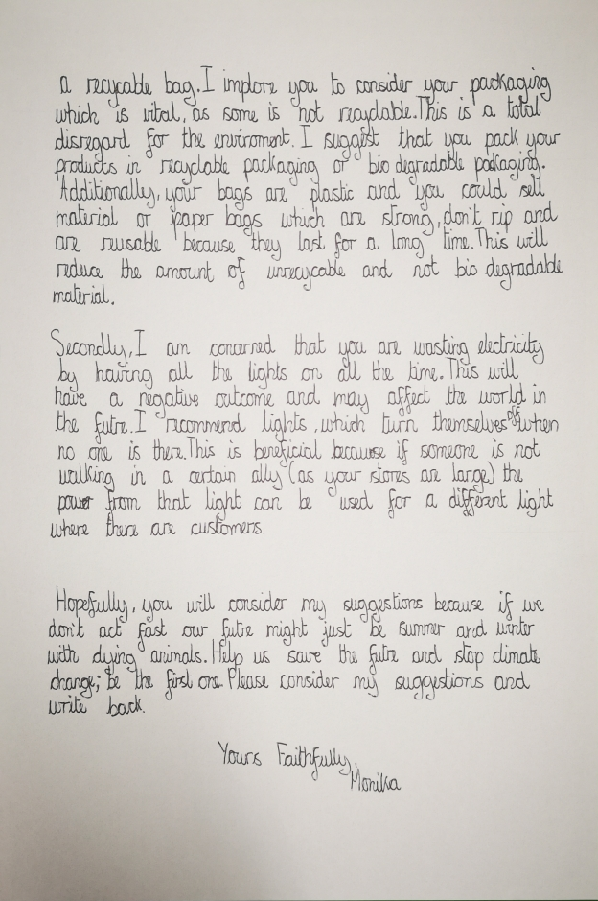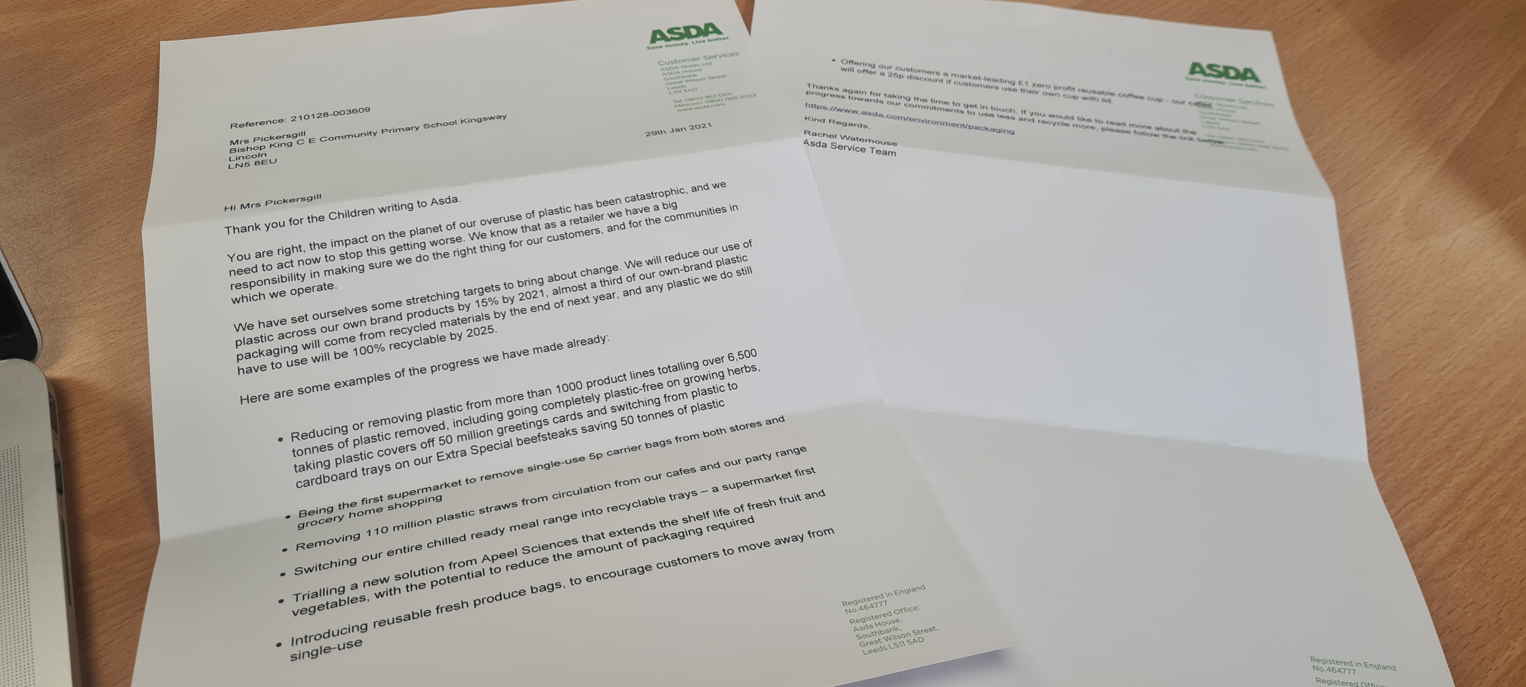

Actions towards action plan
- The above will impact on the children’s speaking and listening.
- Profile of Global learning through whole school projects eg. Erasmus KA1 and 2.
- Connecting and collaborating with local partners through KA2 project and Connecting Classrooms.

Next steps
To continue to lead the International projects.
To liase with MAPS and SPAG about project ideas.
To liase with partner school in Uganda to organise exchange of ideas and work.
To monitor how children are taught about current news through Picture News/ Newsround and First News.

