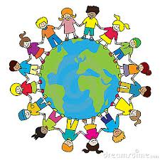
Global Learning Moderation
Spring 2 2020/21

Ongoing International projects

KA2 Poland
Monks Abbey have sent over an action plan for Summer term 1. This will be completed by children in Year 6. This involves, a film (virtual tour) of our school, a lesson taught in Polish and a collaborative retelling of a fairy tale.

We have received some pen pal responses to the letters that the Year 6 children who were going to travel to Poland sent last year. The children really enjoyed reading them and will create responses to them.

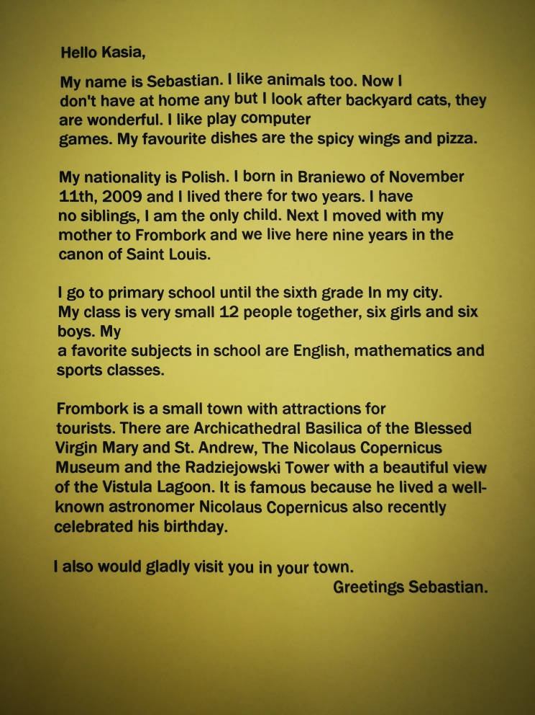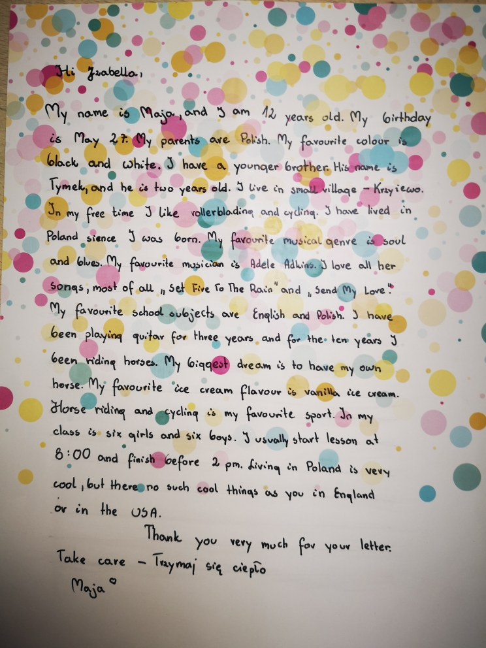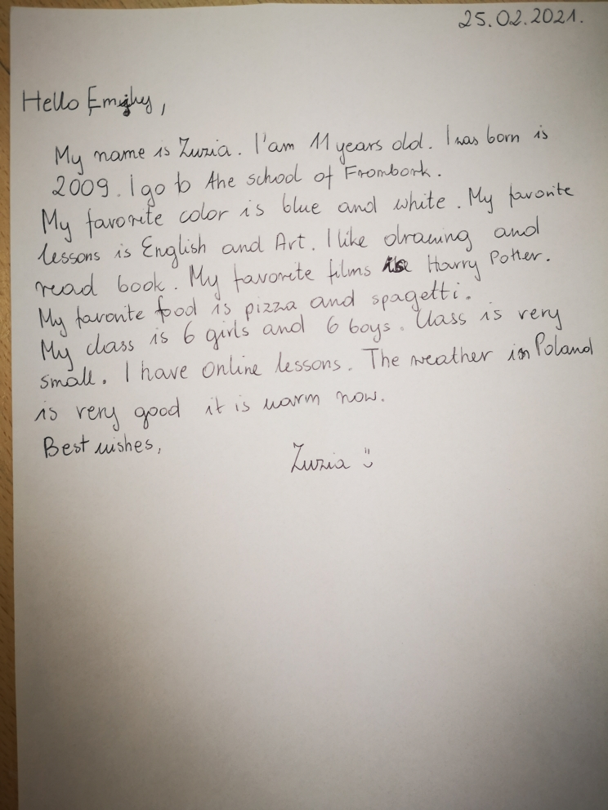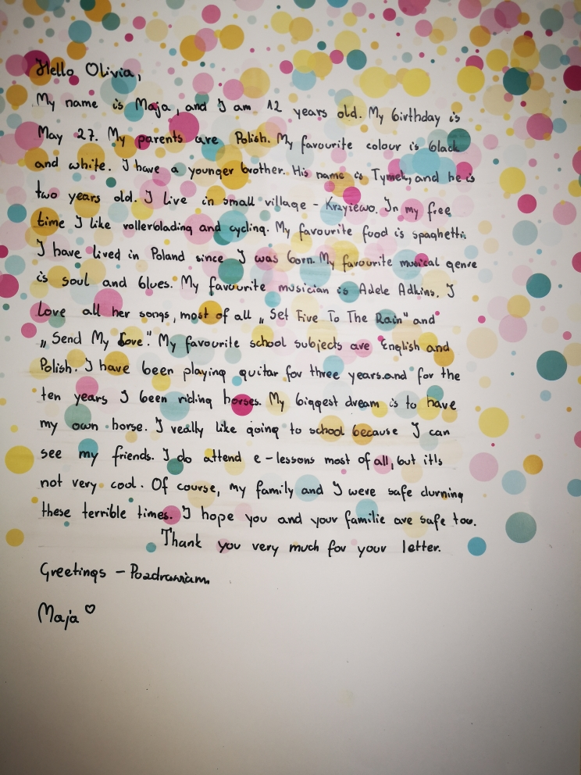

We have also made contact to ensure that the virtual mobilities amendments have been completed by MAPS.

Connecting classrooms
Work sent from Nursery, Year 2 and Year 6. See below.
What have you eaten today?
- Nursery responses
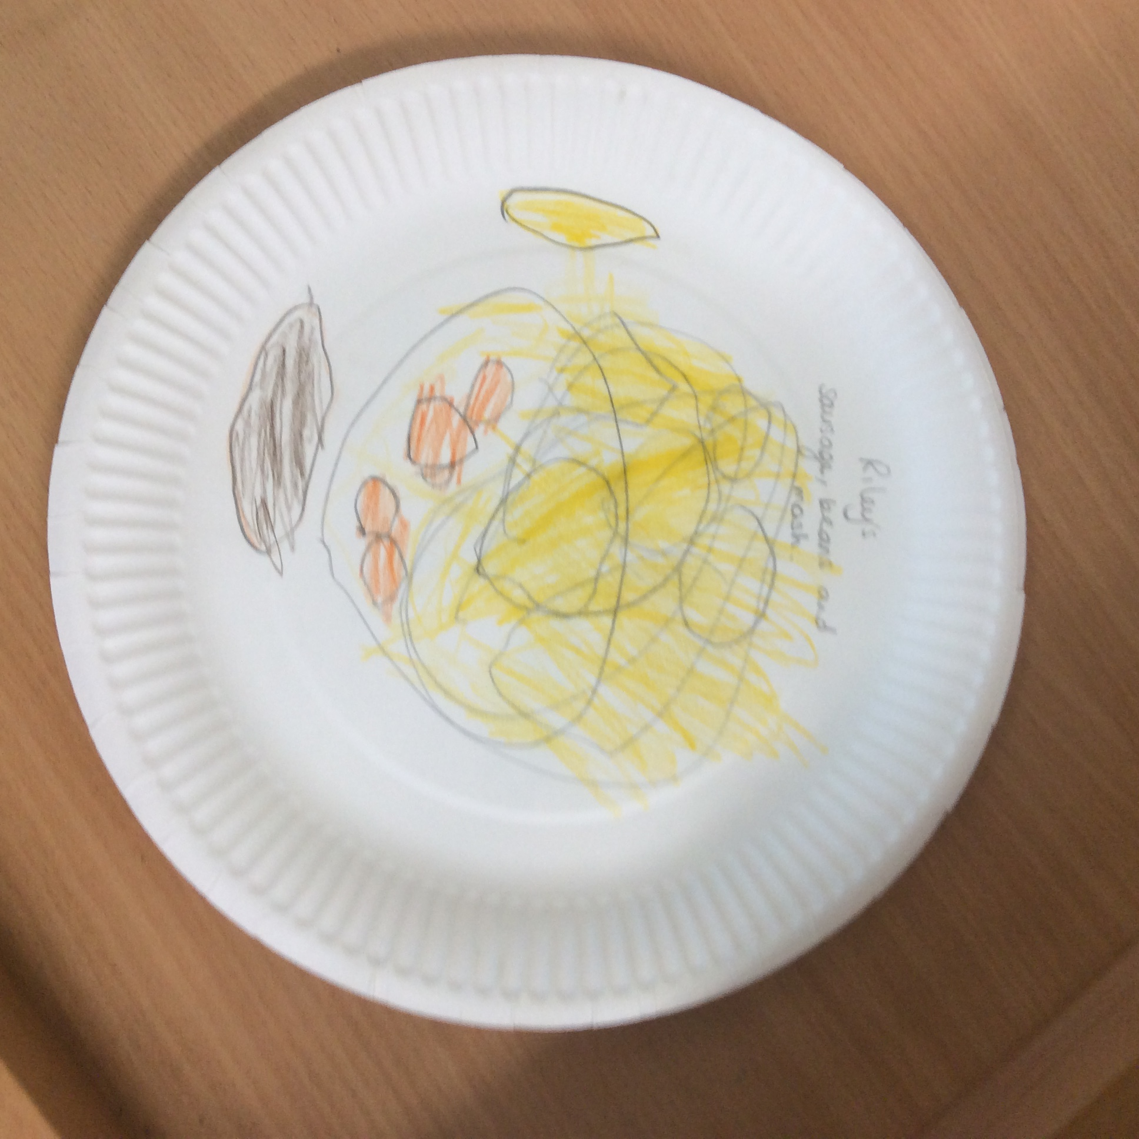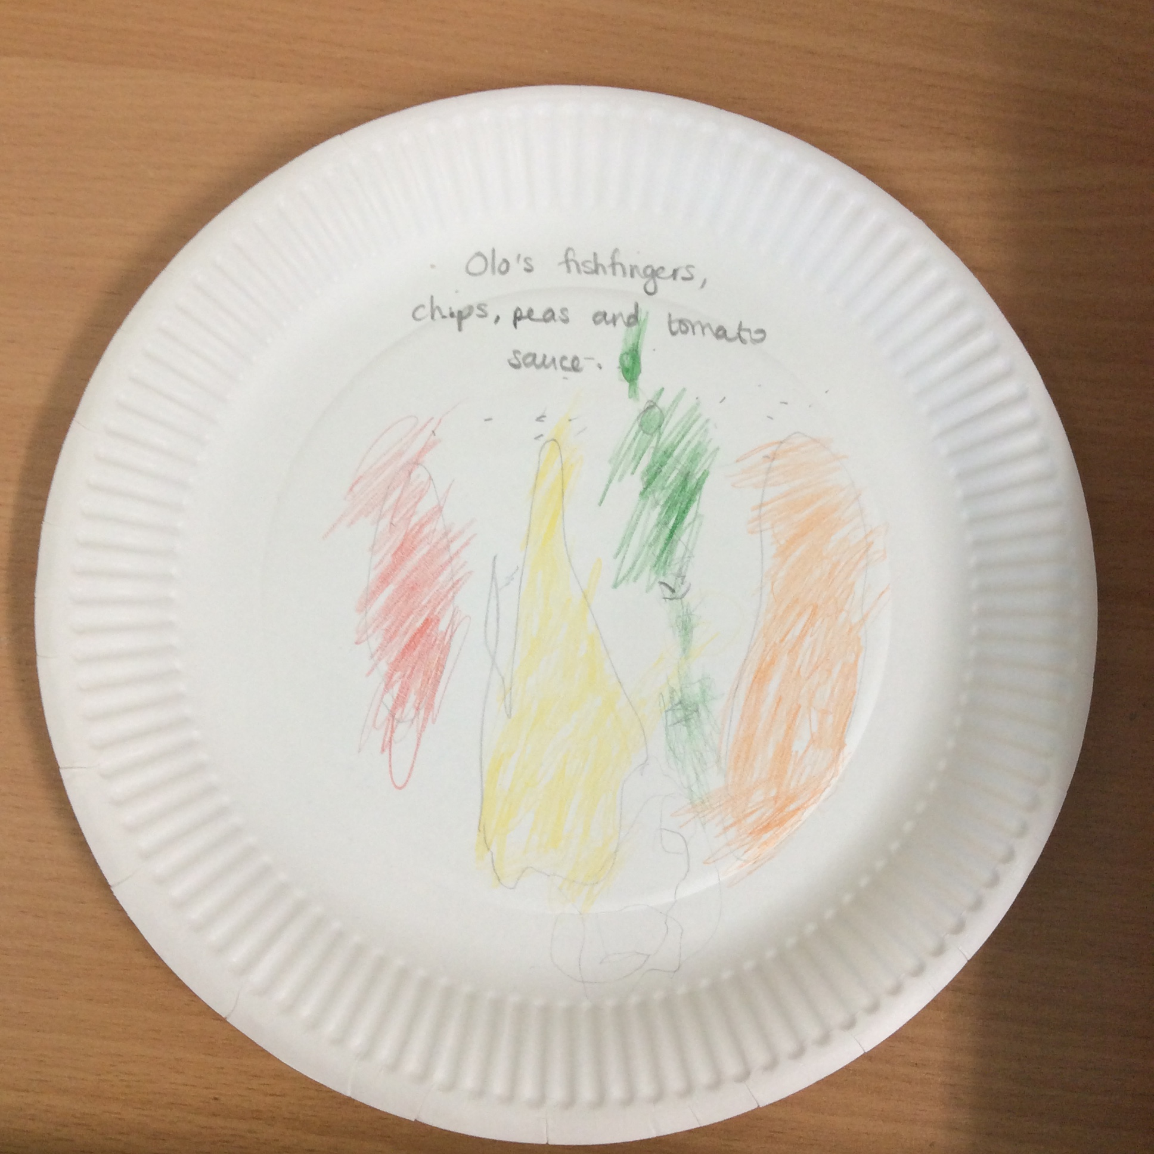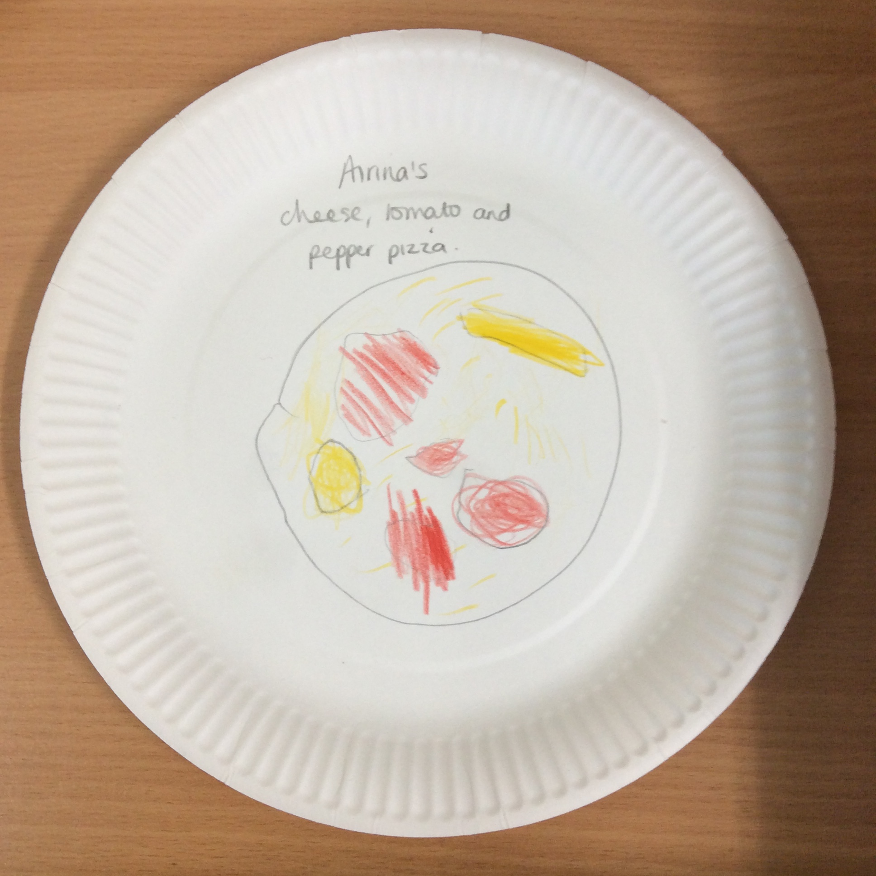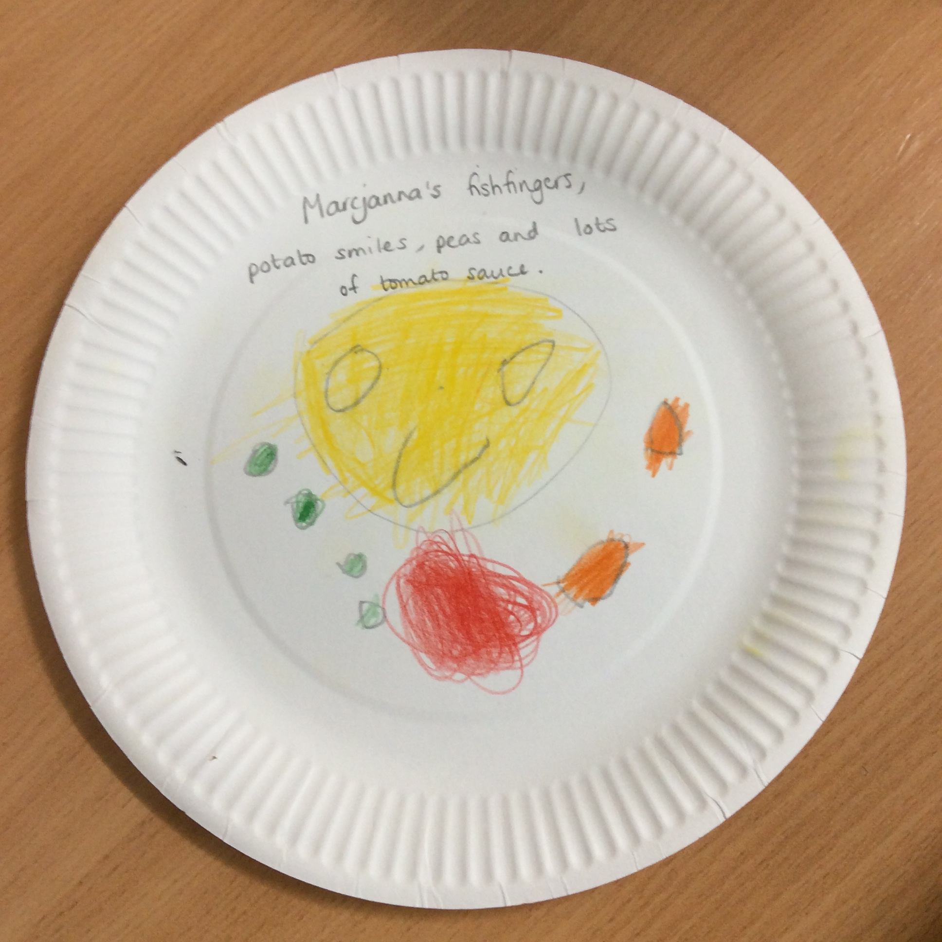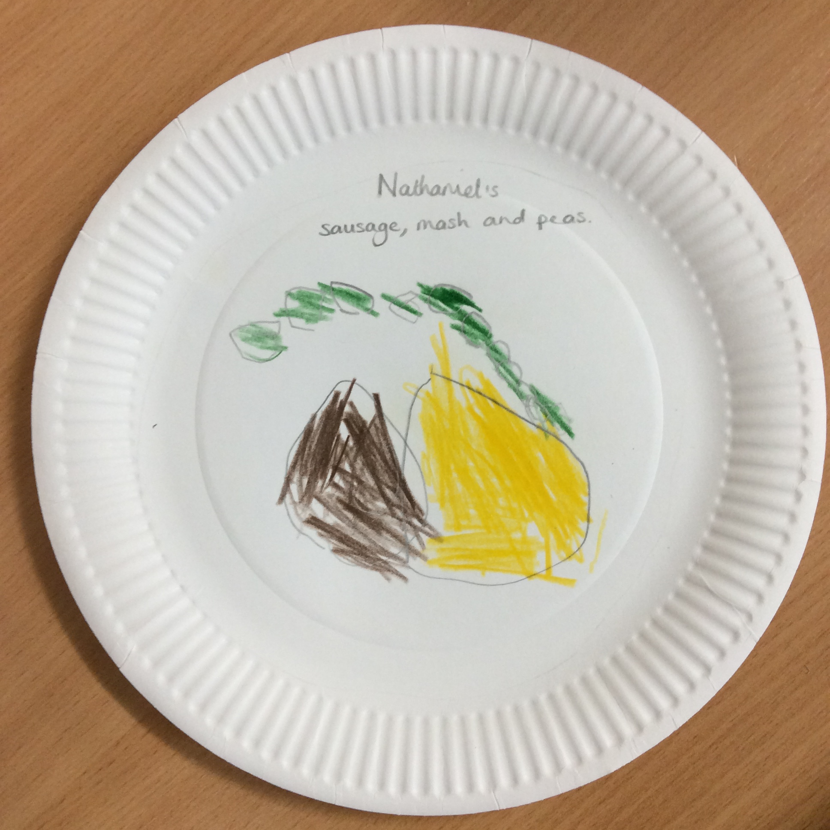

KA1 Bulgaria and Romania
- Start date postponed until January 1st 2021.
- Funding has been granted.

Erasmus Funding – handed over all the details of the funding of both Erasmus projects to Julie Stubbs.

Global Learning and our multicultural ethos within the curriculum

Chinese New Year in Early Years – dragon dances, Chinese writing, role play, repeated pattern dragons, eating pretend noodles with tweezers, listening to Chinese music, watching film clips of how children prepare for and celebrate Chinese New Year and creating money pockets.

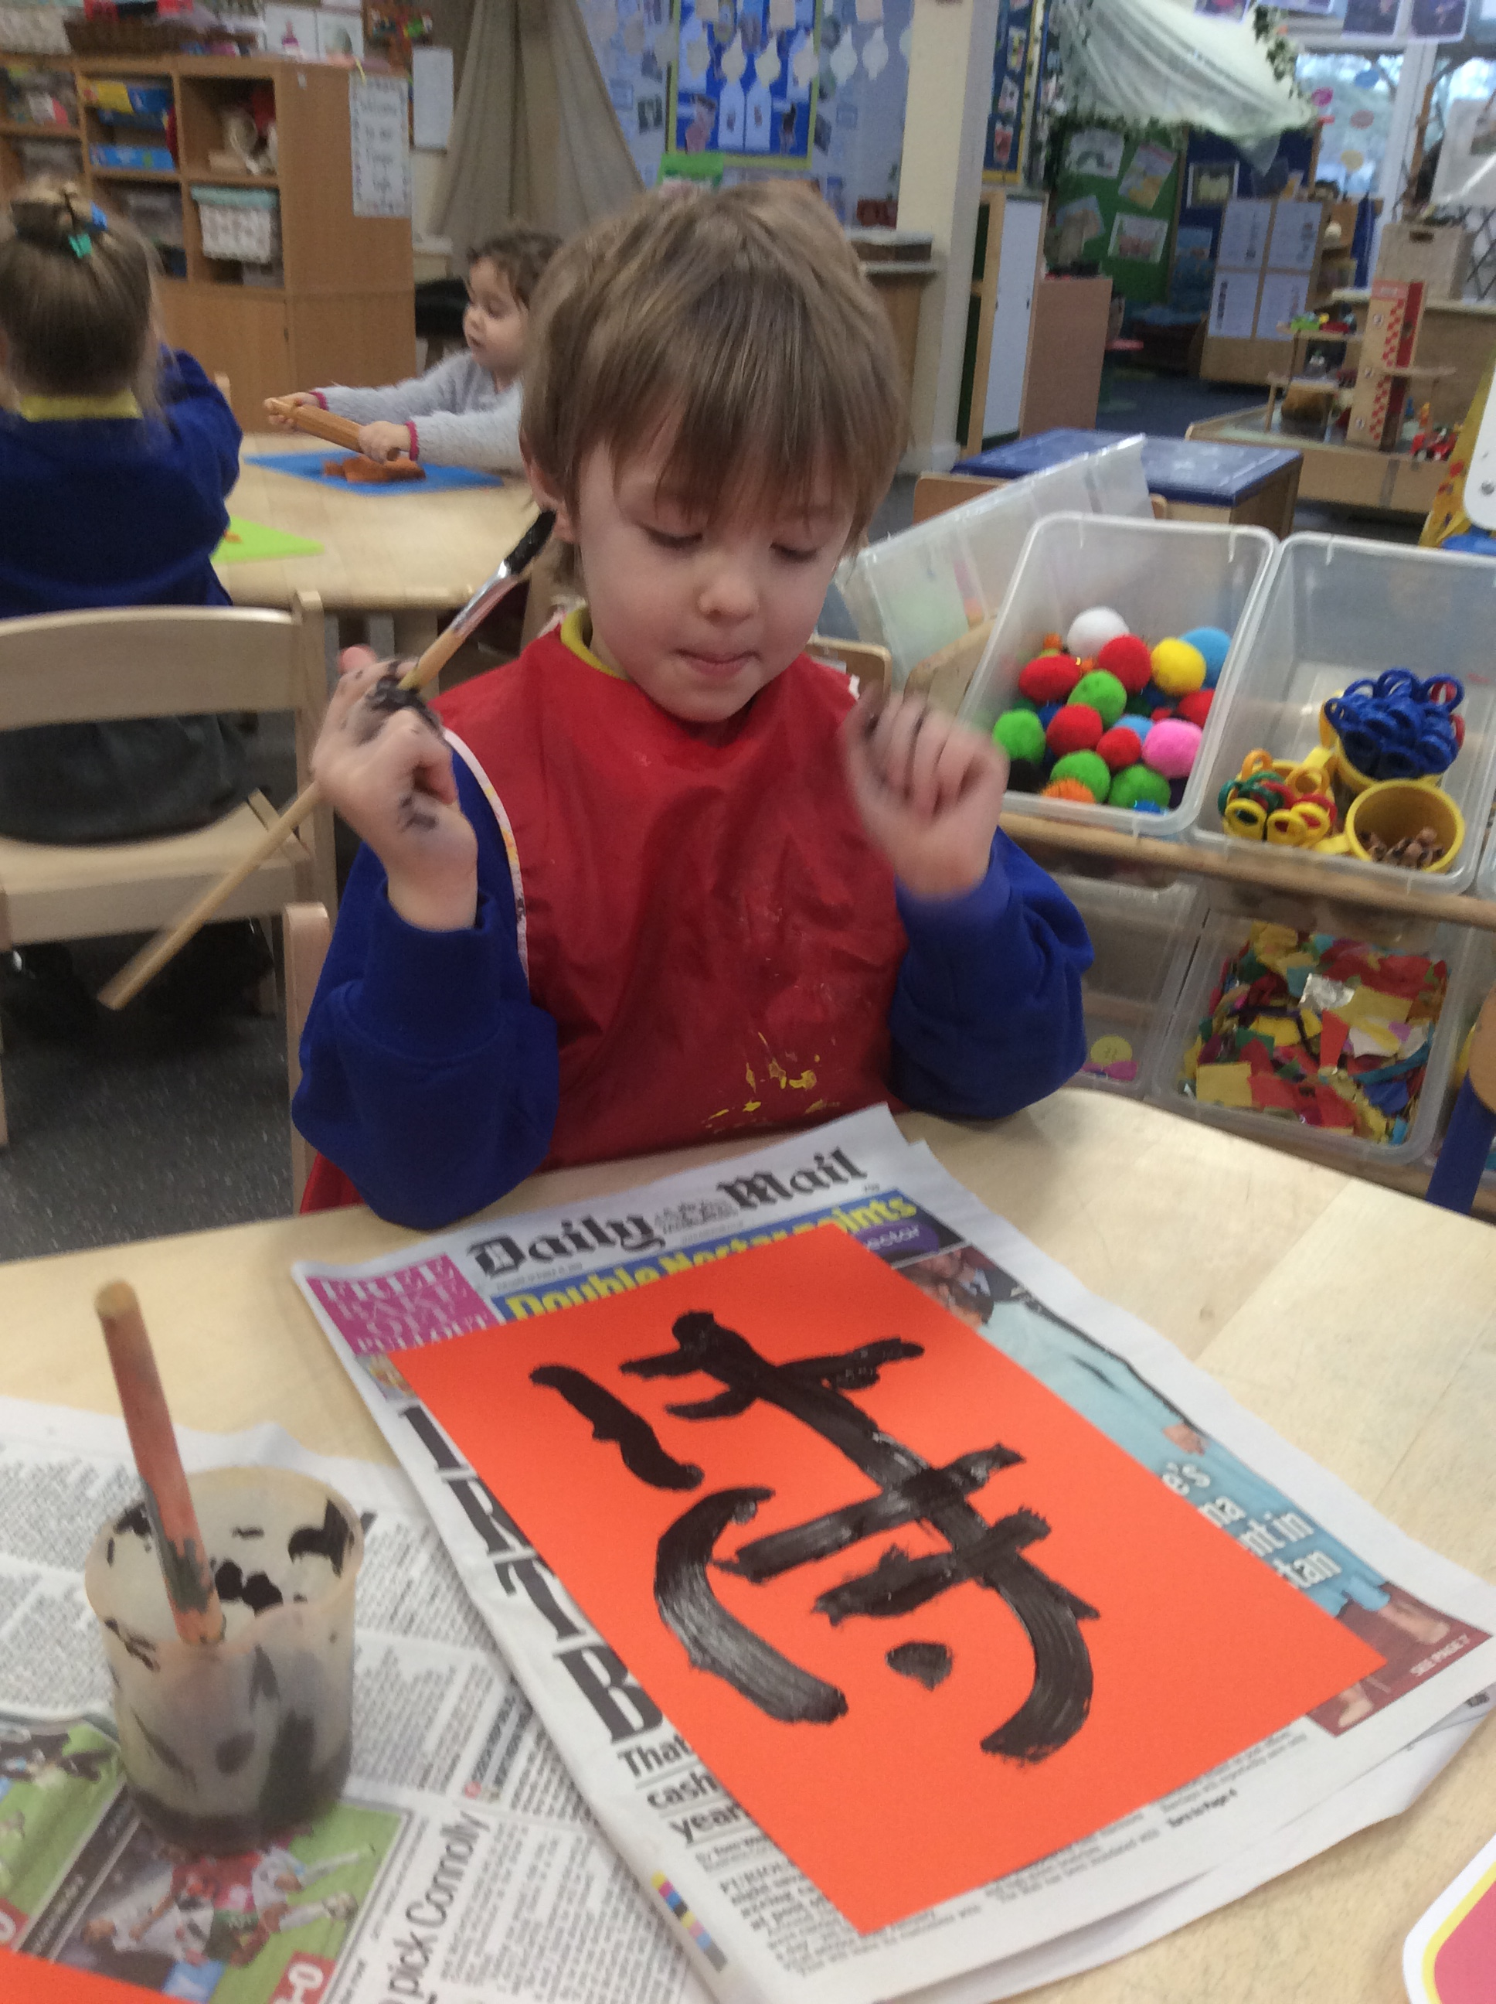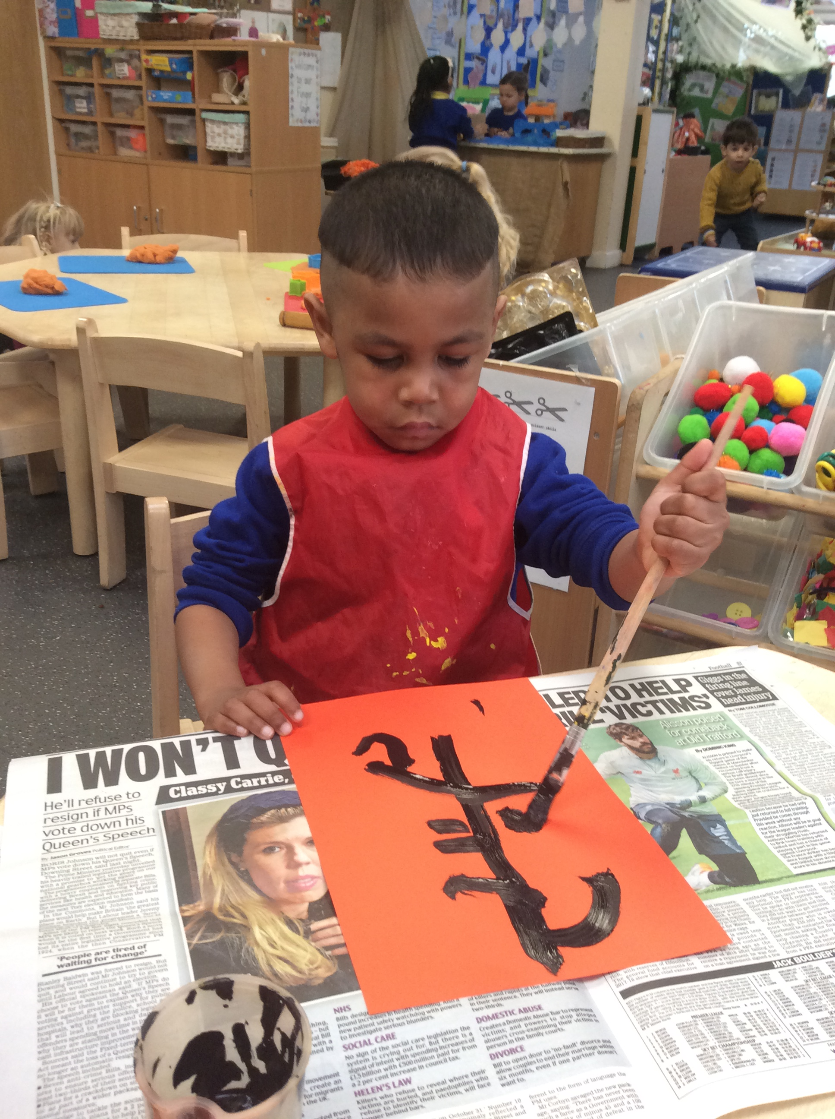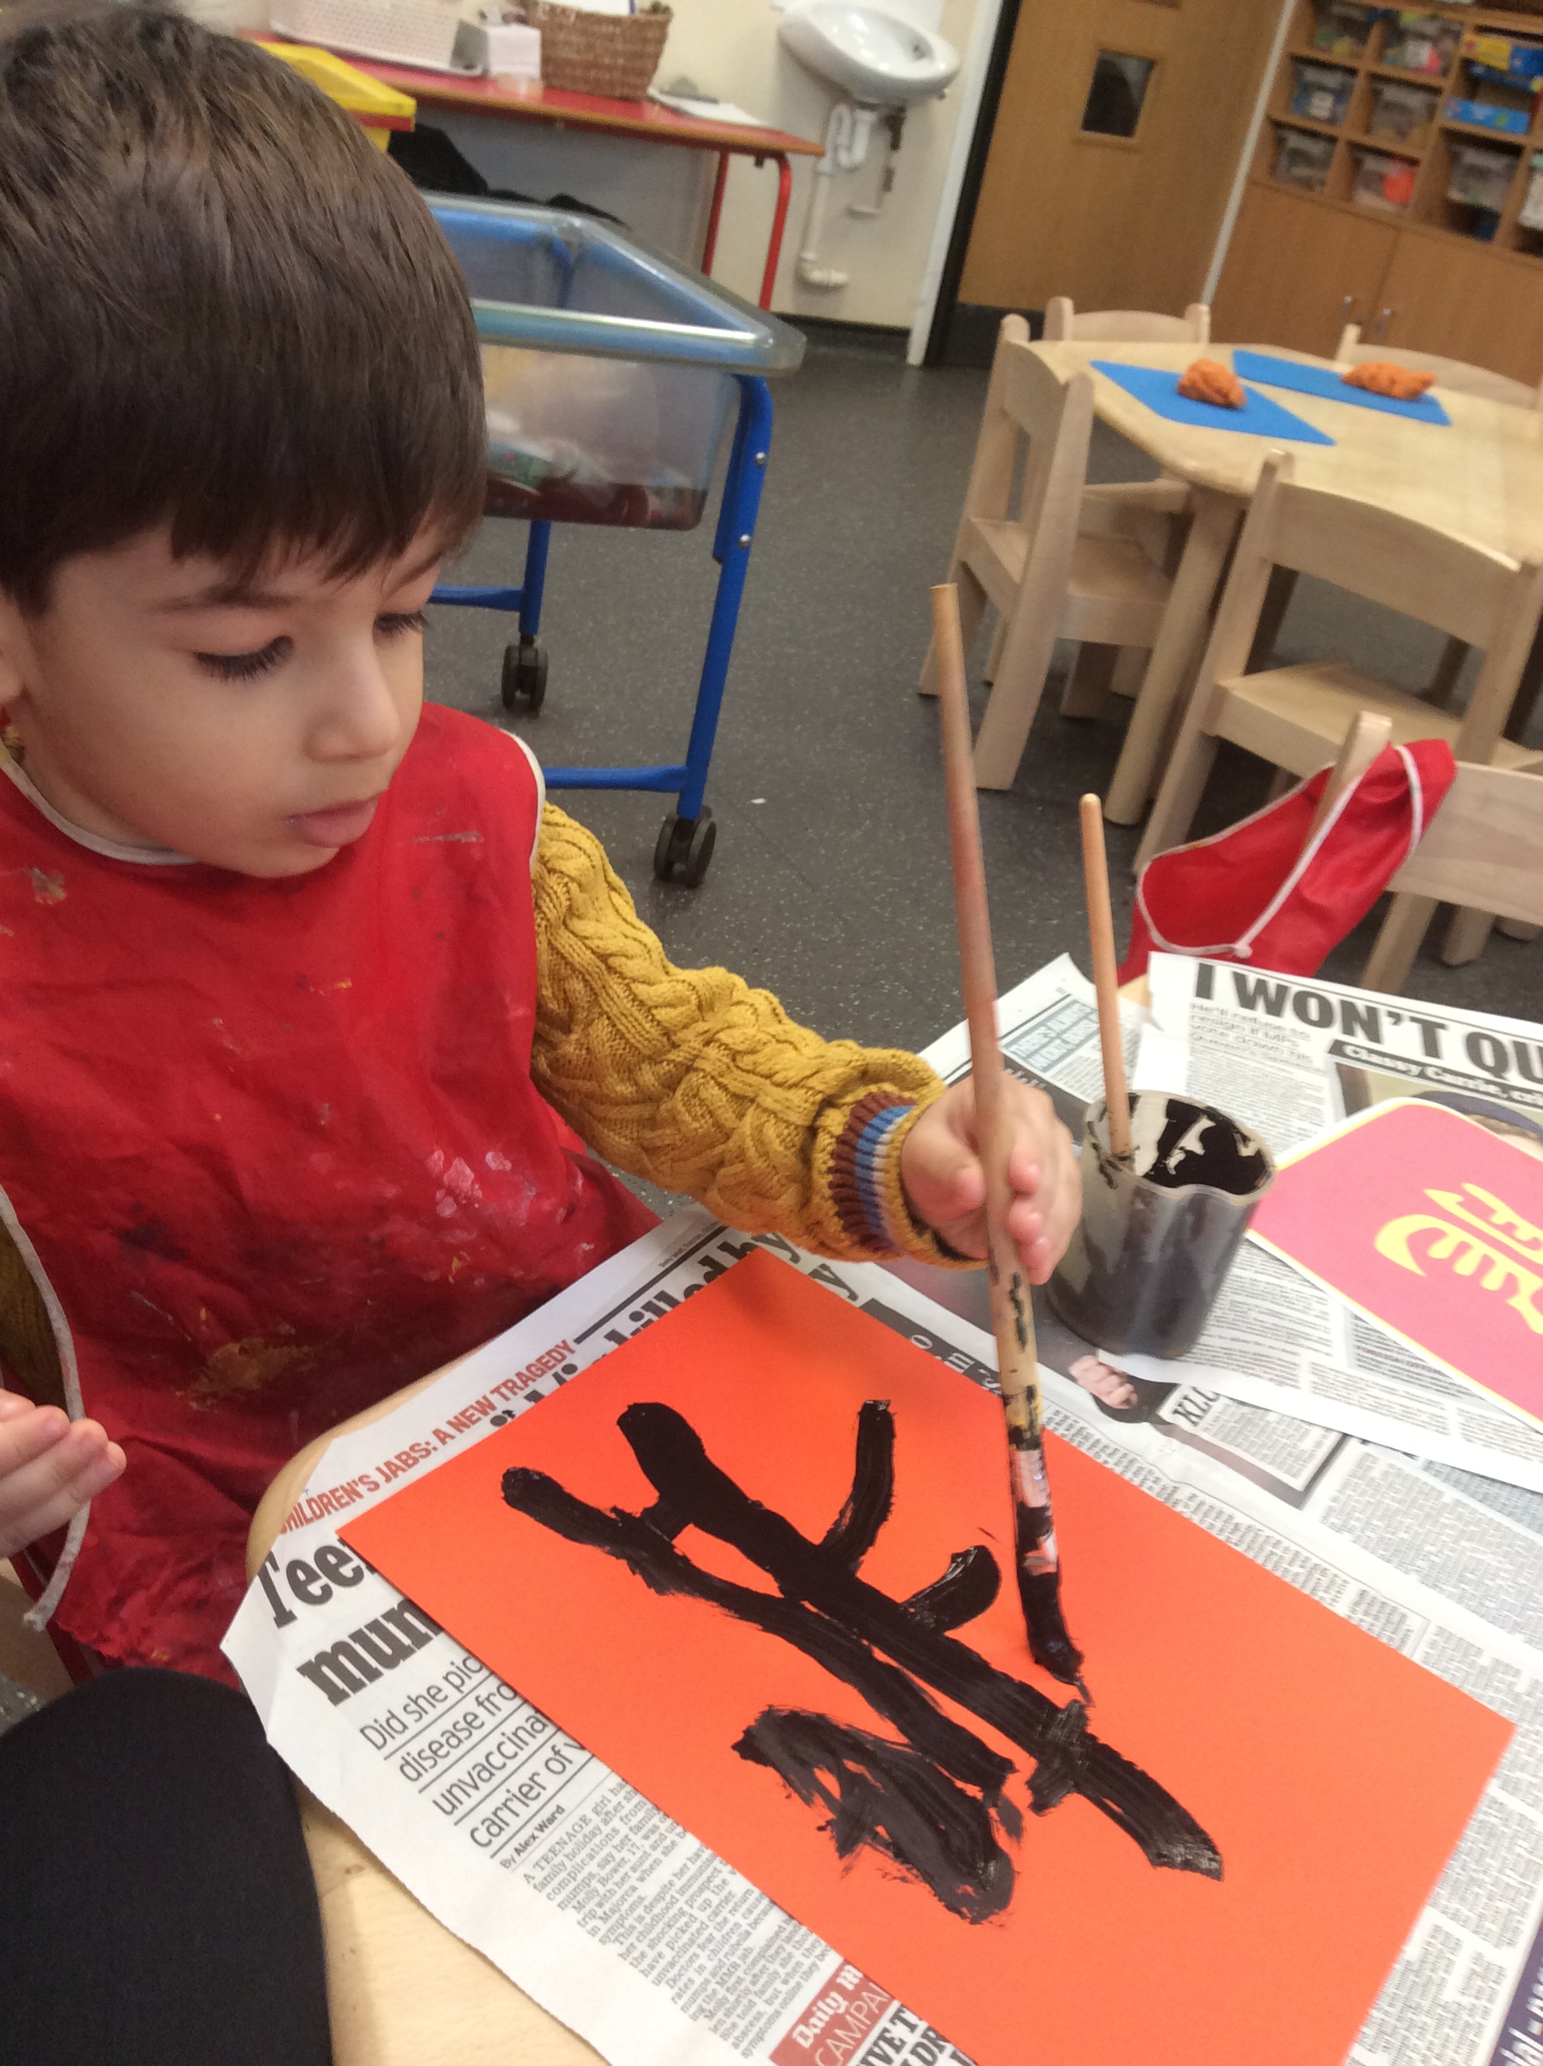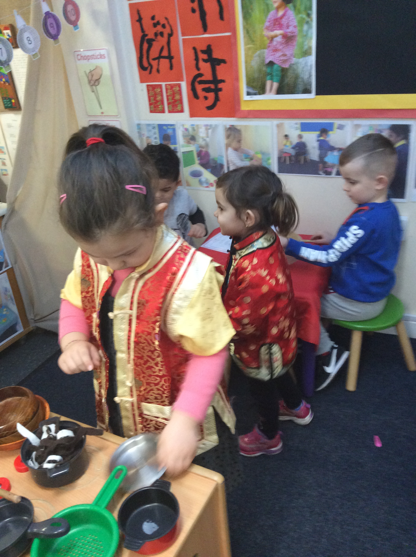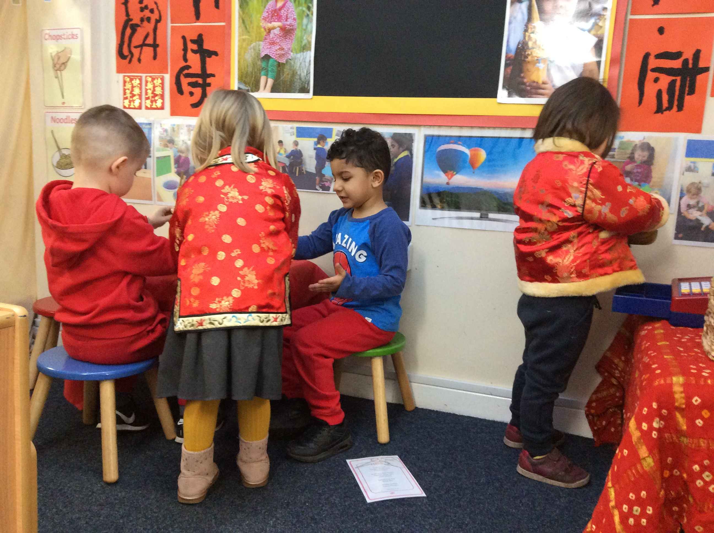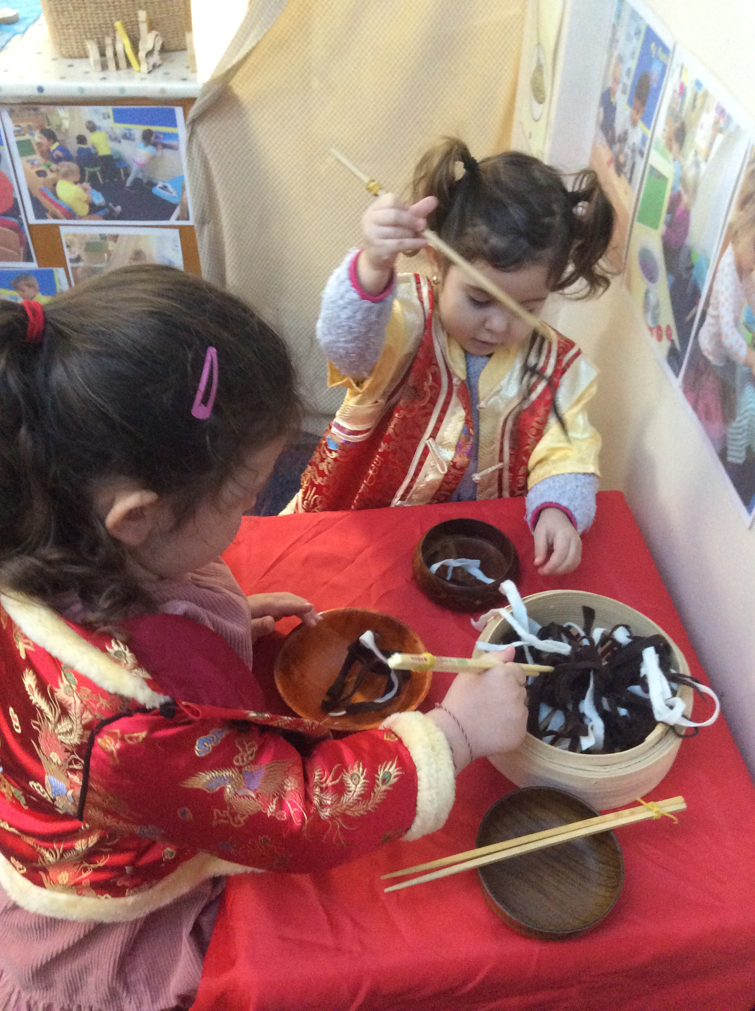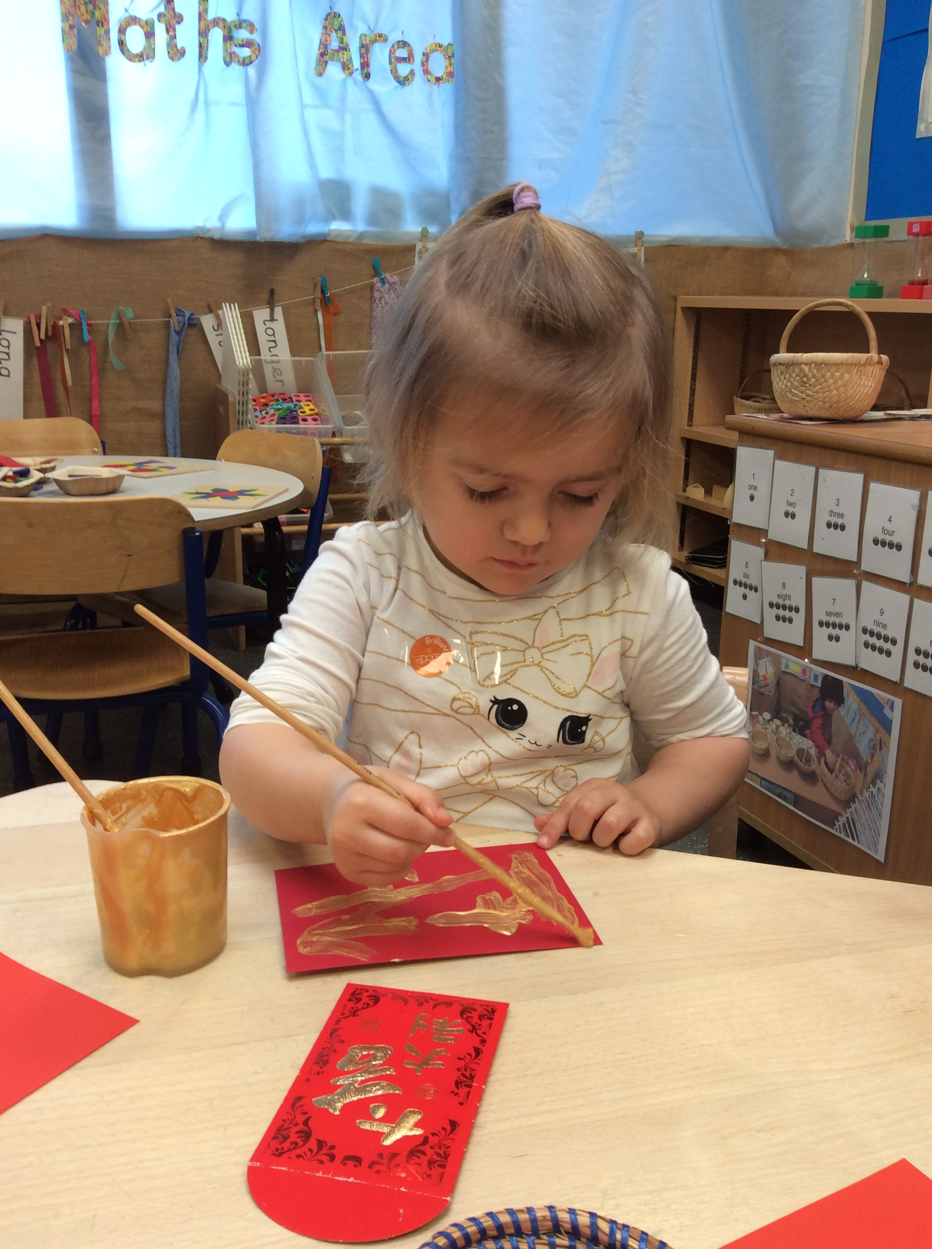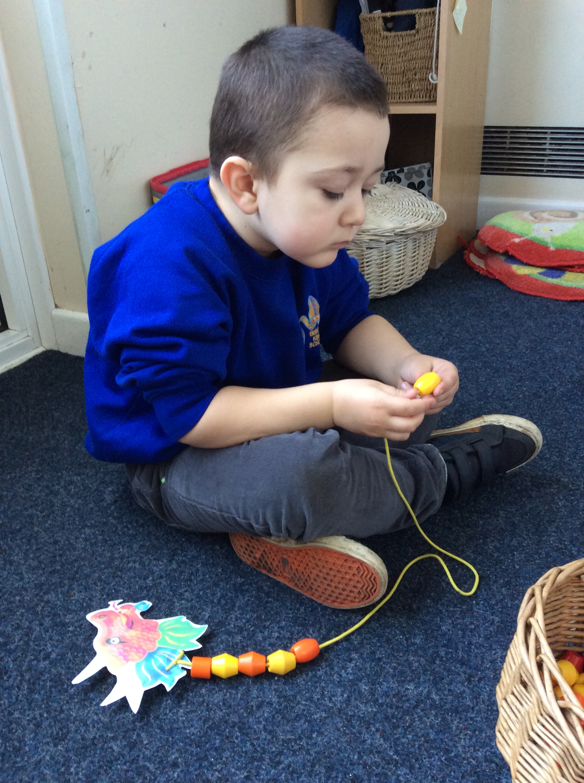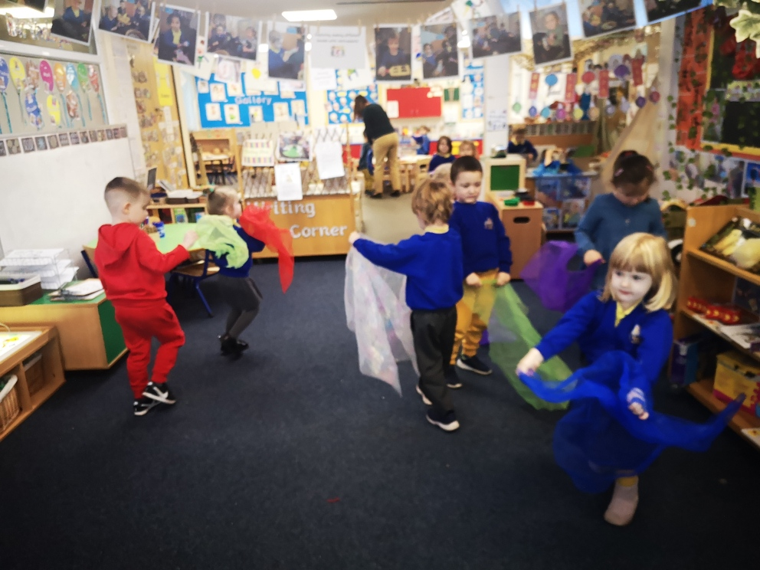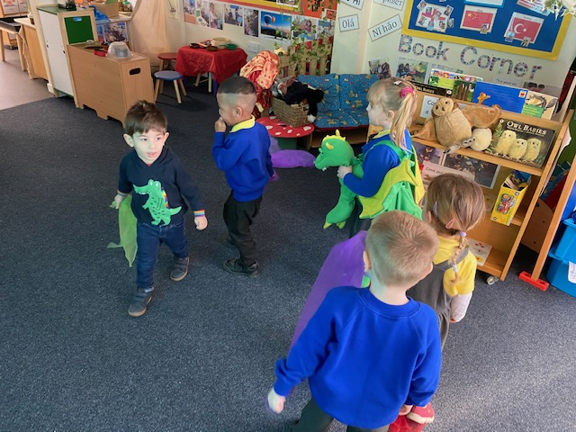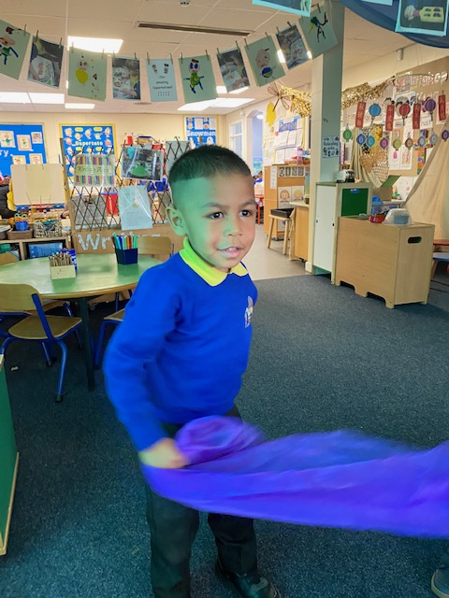

Year 1 have focused on the Polar/equator weather and saving the planet. The role play has been focusing on Polar regions, which the children can build and make themselves. They have also focused on some multicultural stories.
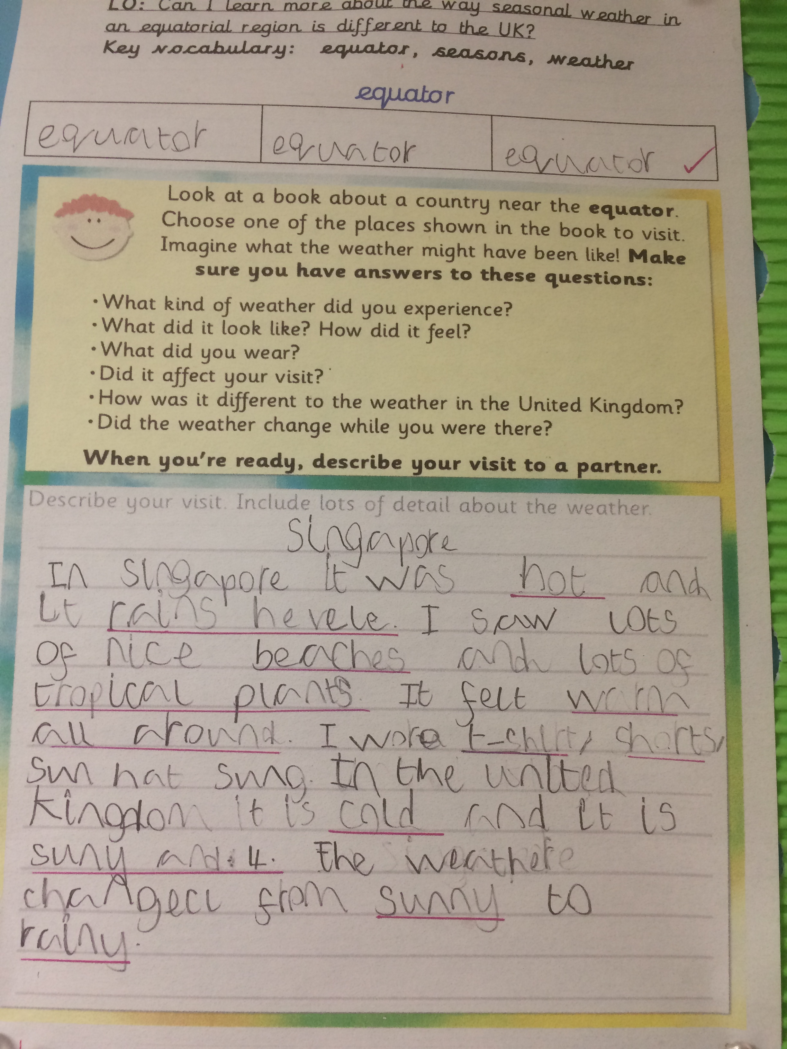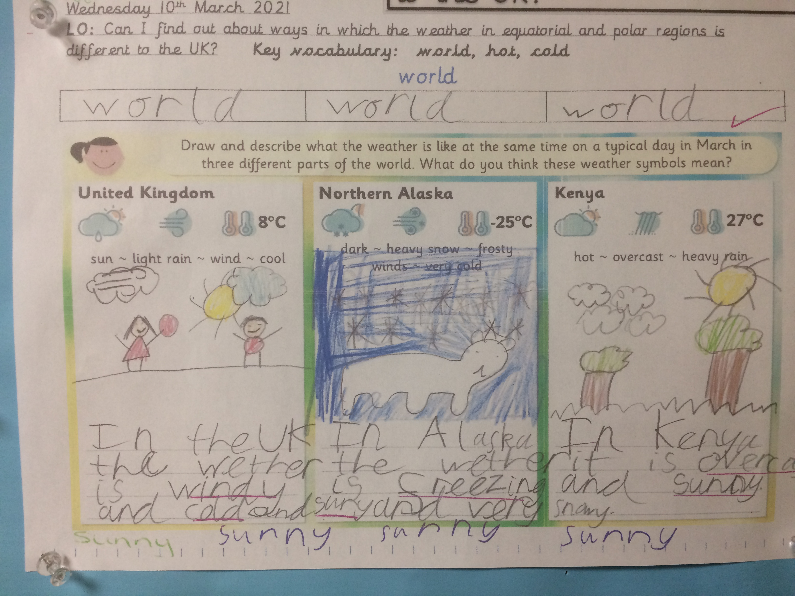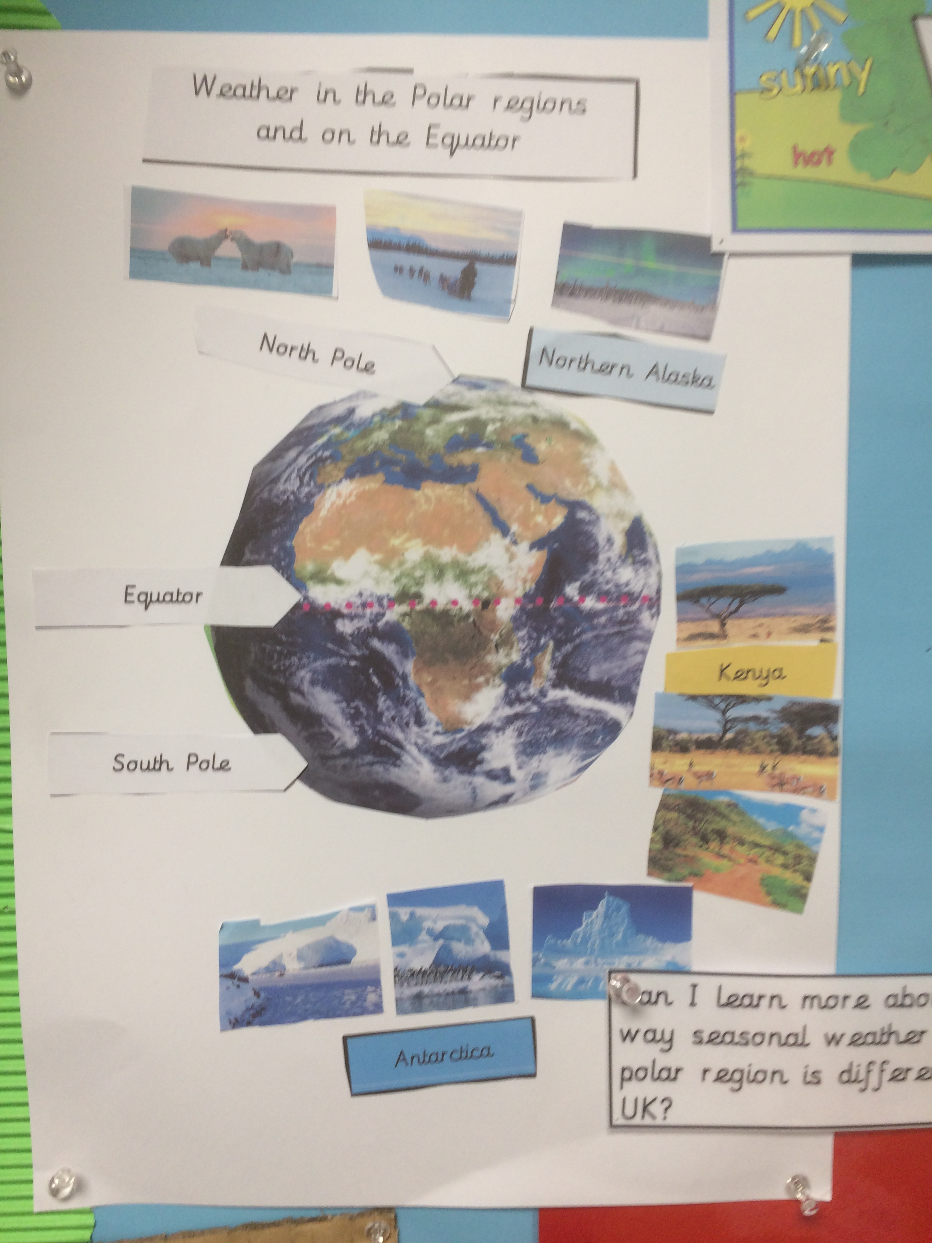

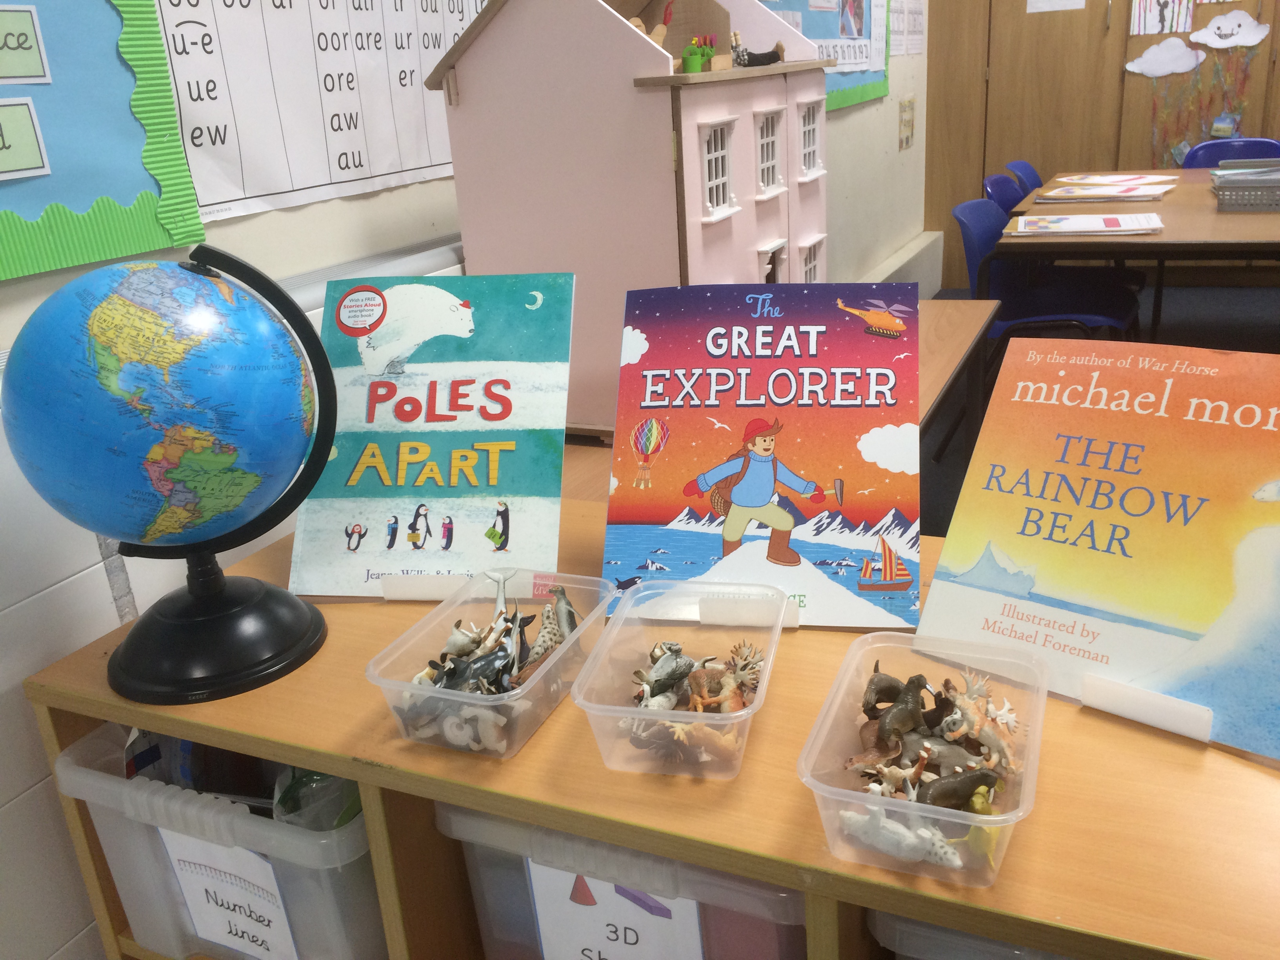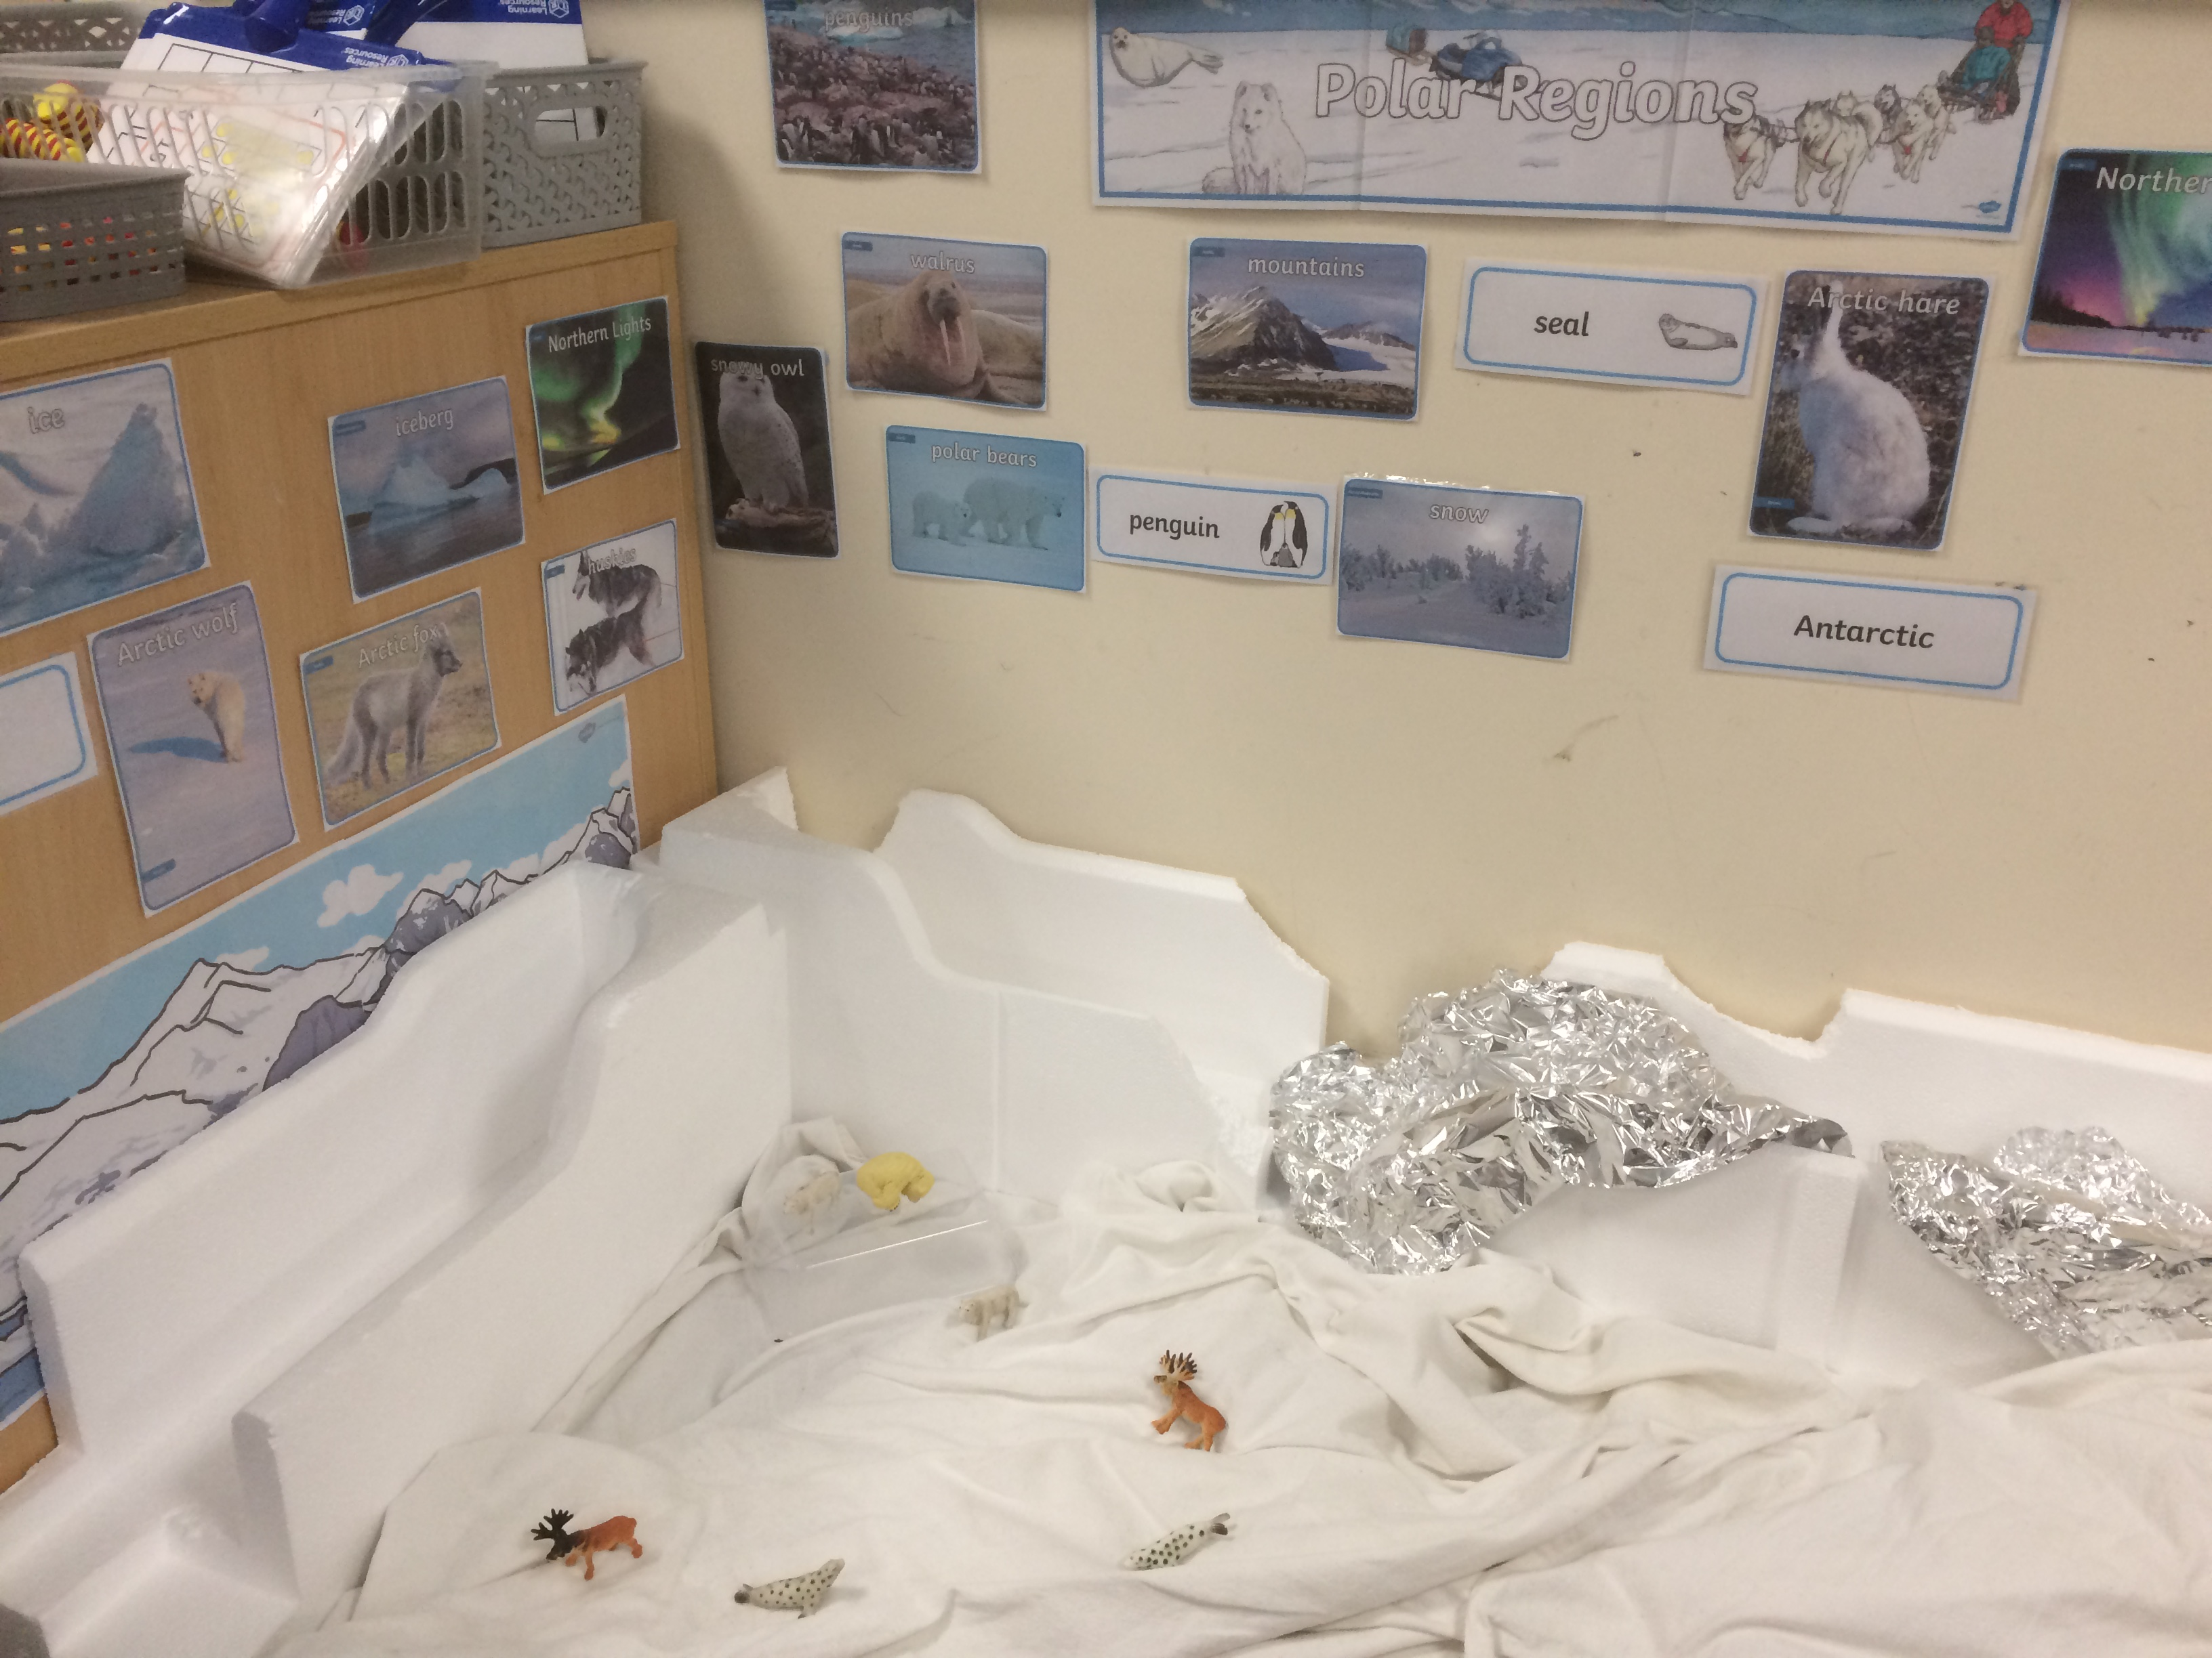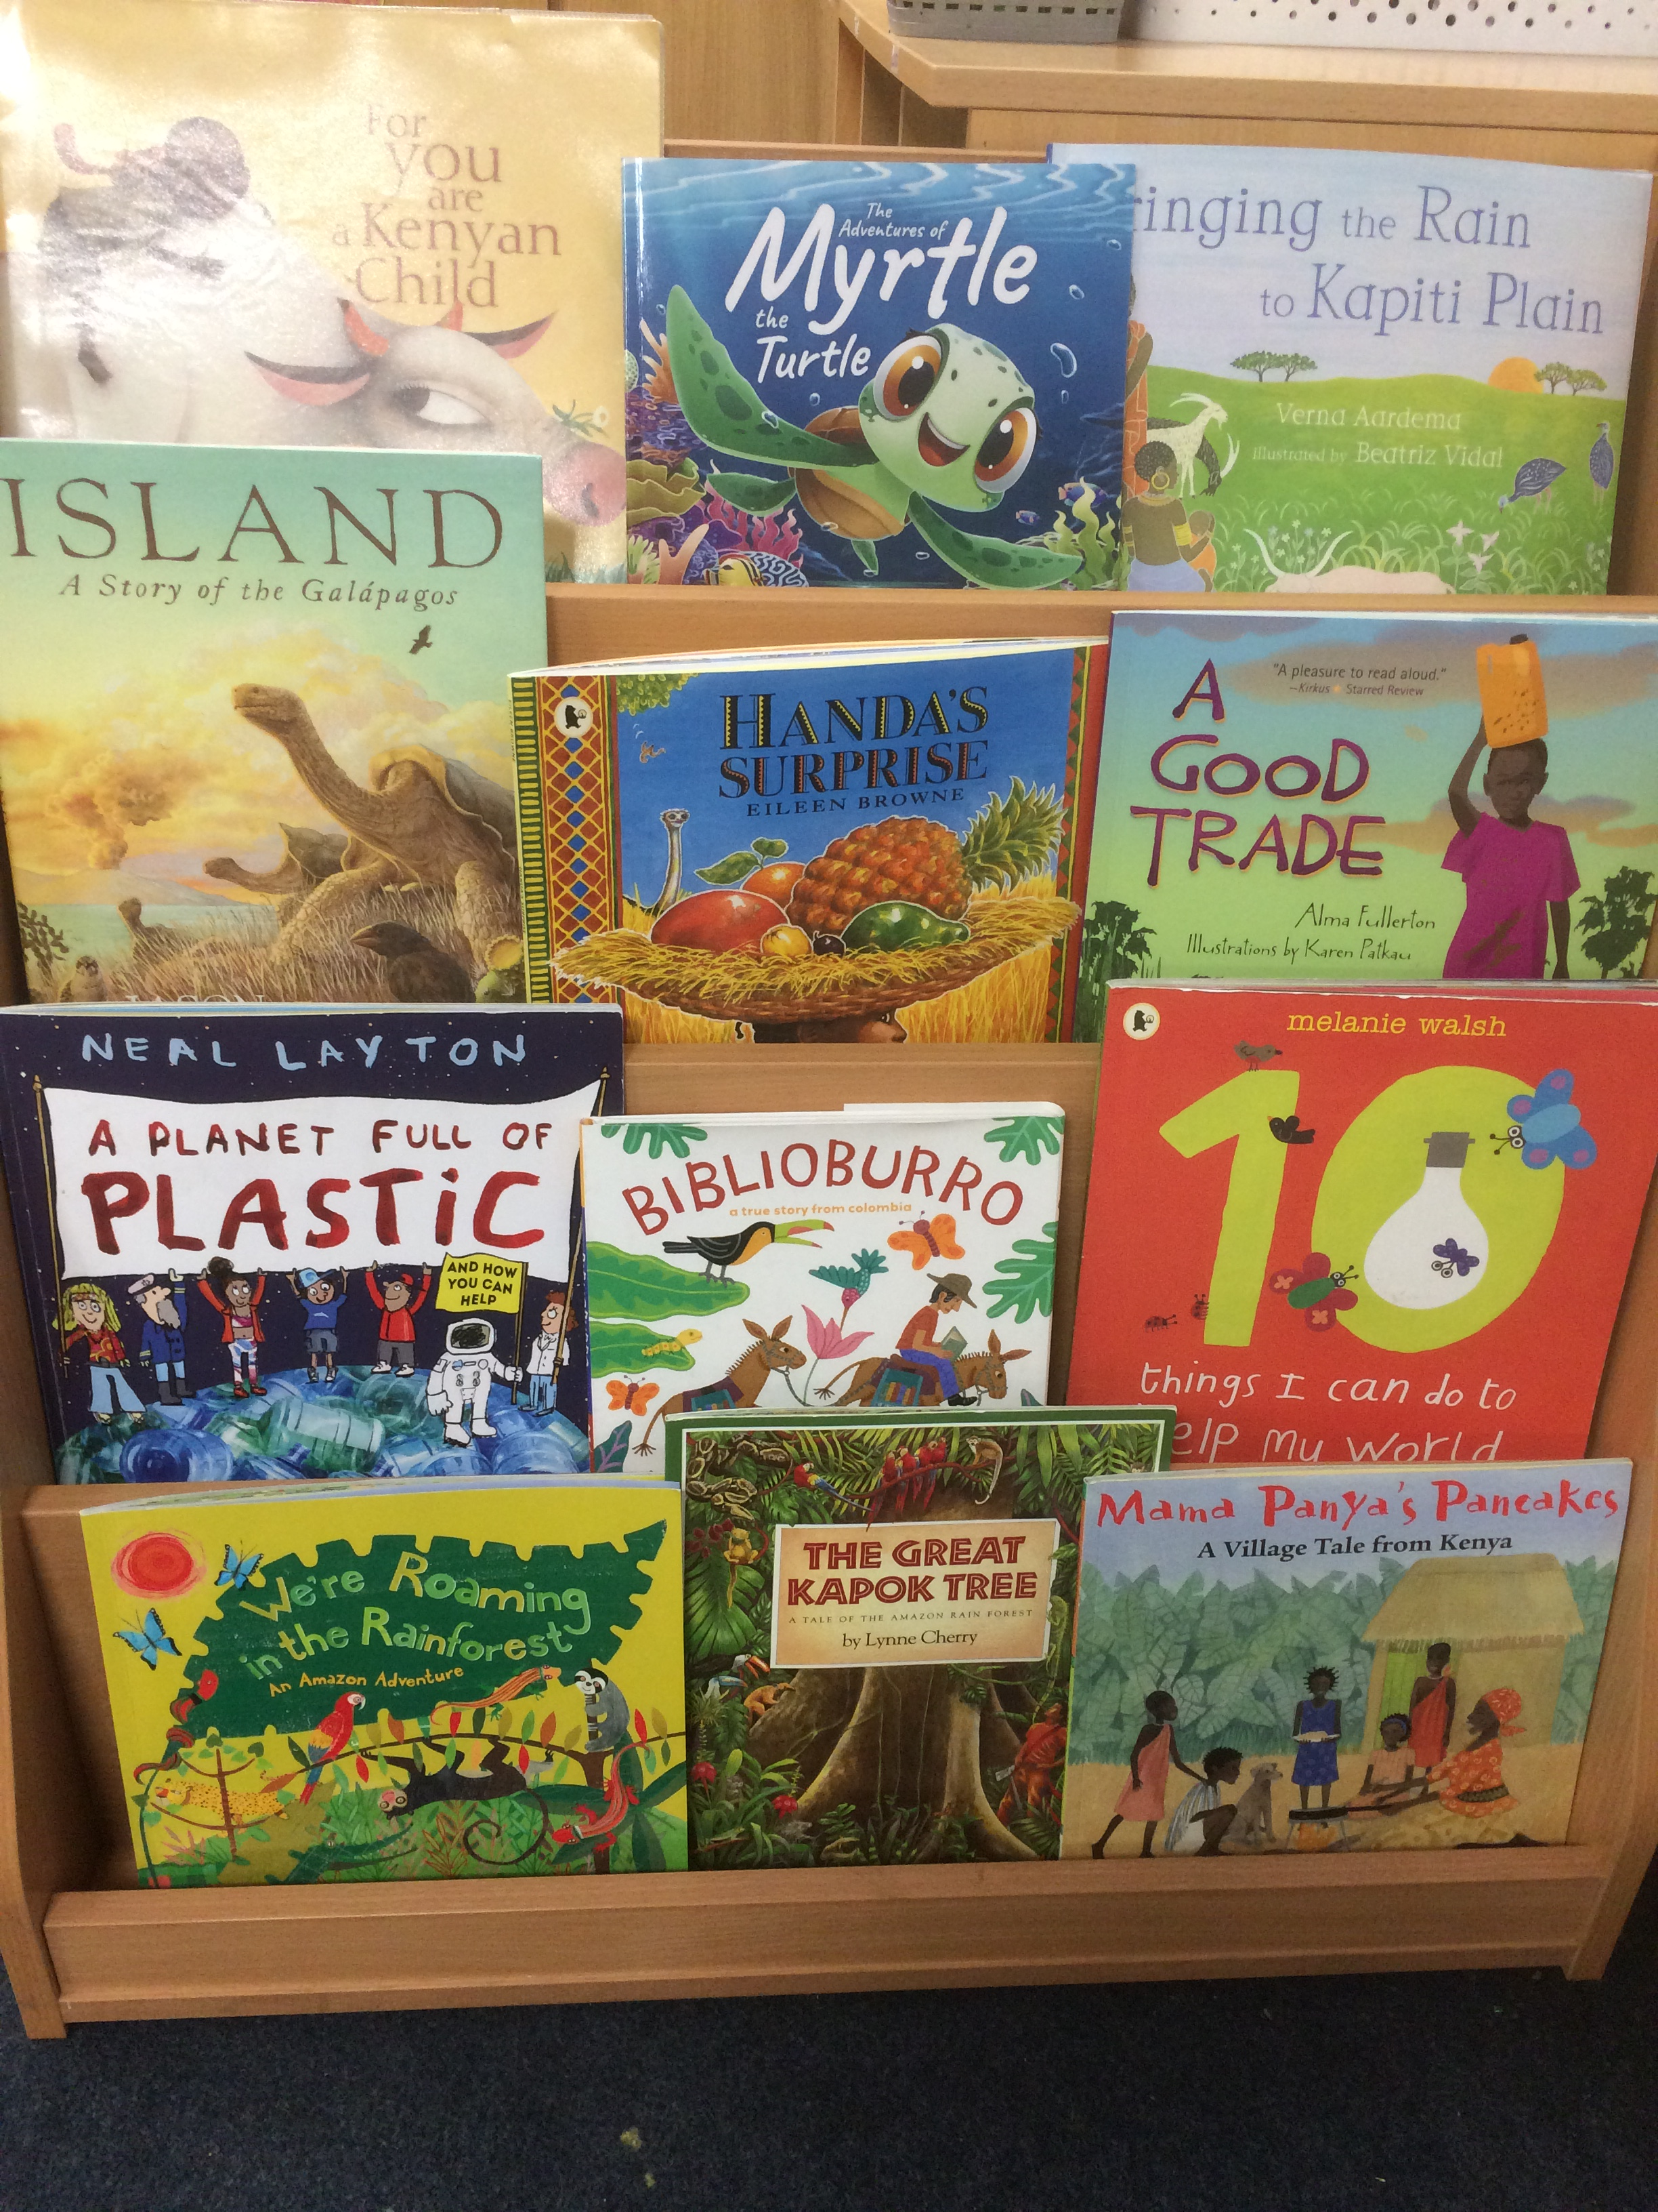
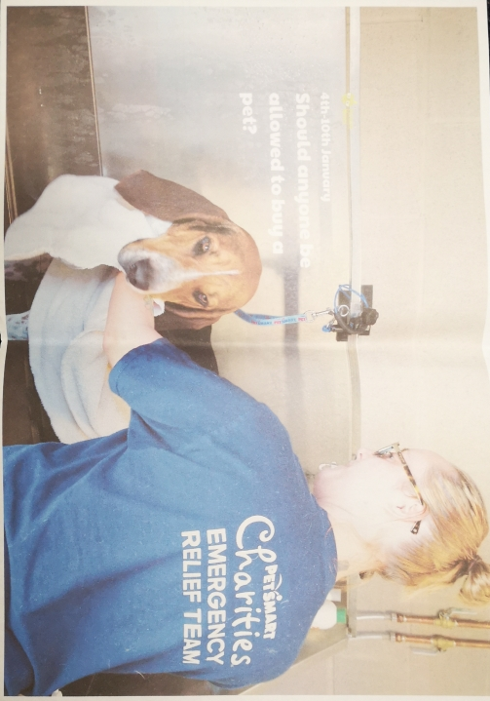
Year 2 have completed work based on one of the Picture News images.
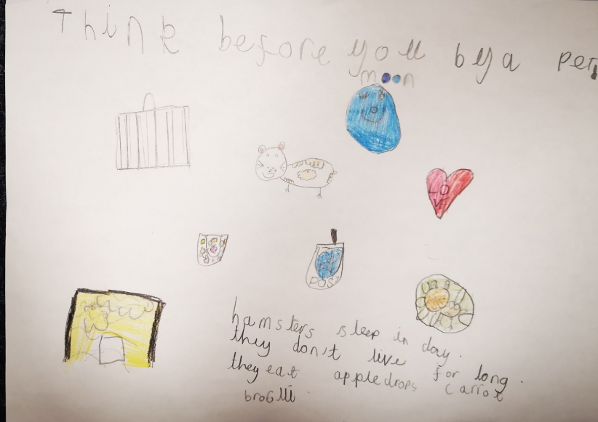
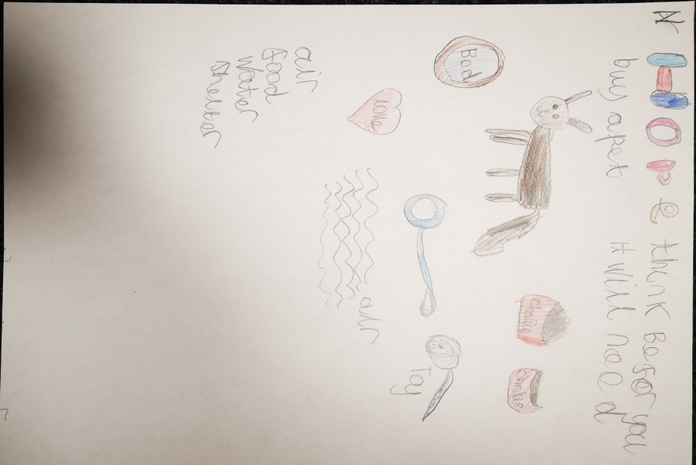
This related to their topic of pets. They make posters in response to the question and discussion.

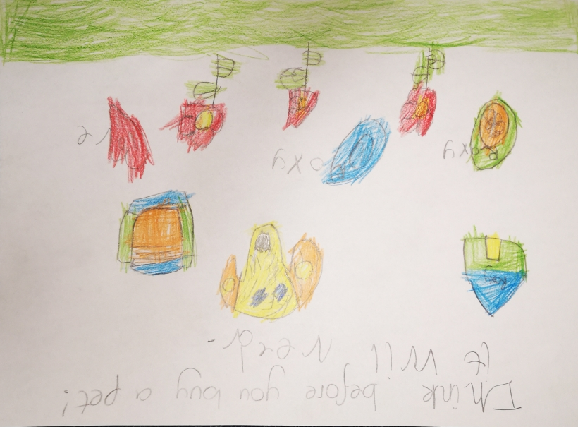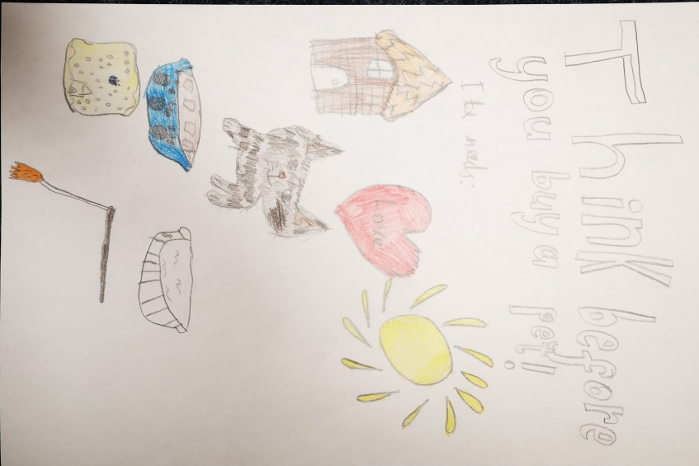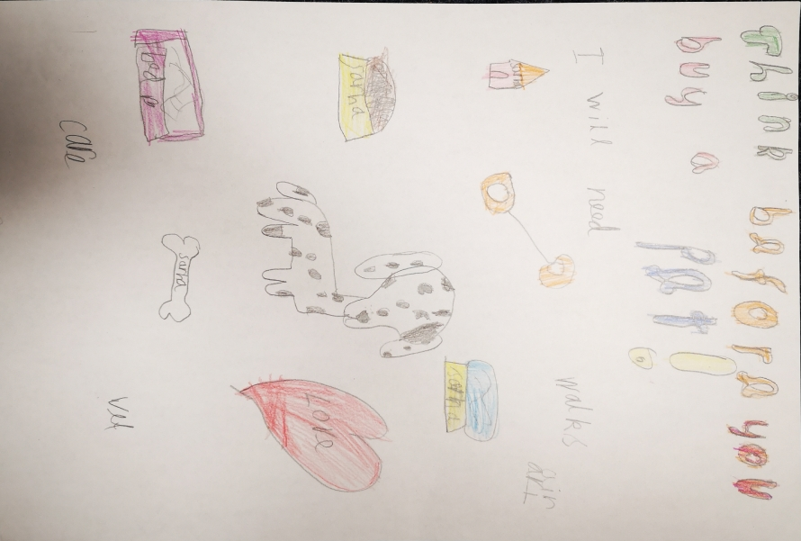

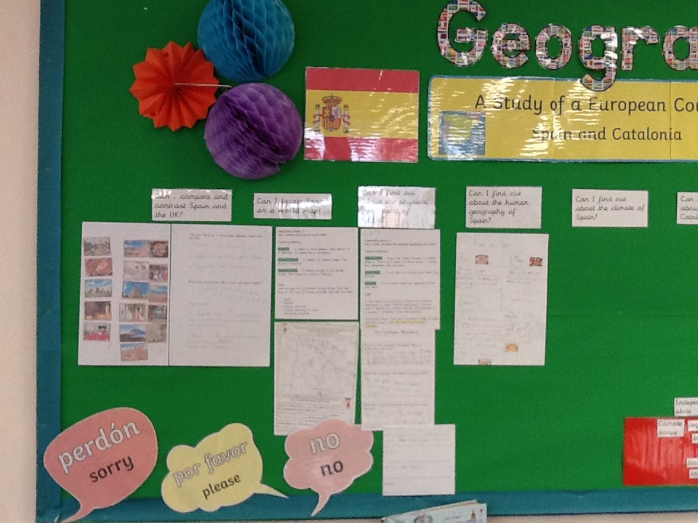
Year 3 have been learning about Spain as part of their Geography topic. They have compared Spain to England in terms of climate, houses, building and language spoken. They have found it on a world map and researched the human geography.

Year 4 have been learning about Brazil.

Year 5 have completed a local study of Lincoln.

Year 6 completed an activity designing ‘New Worlds’ taking the part of the world they like and putting them together. This focused on what is important to individual children and linked with our ‘rights, wants and needs’.

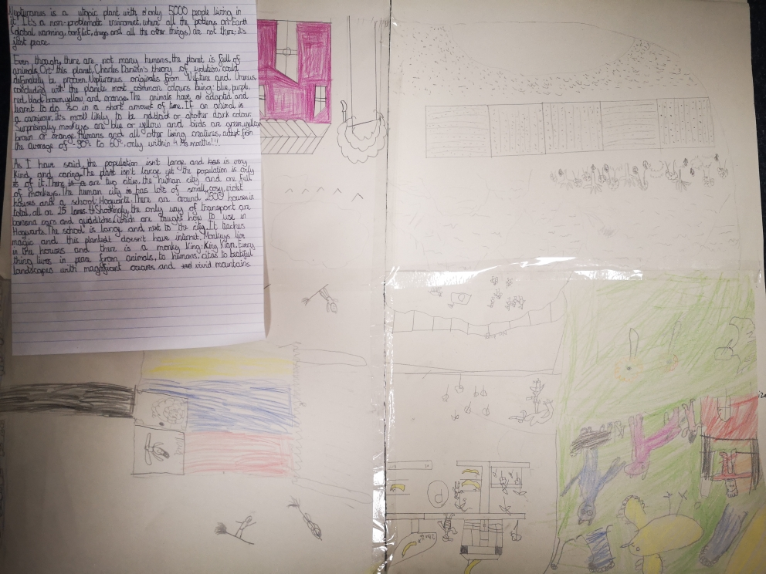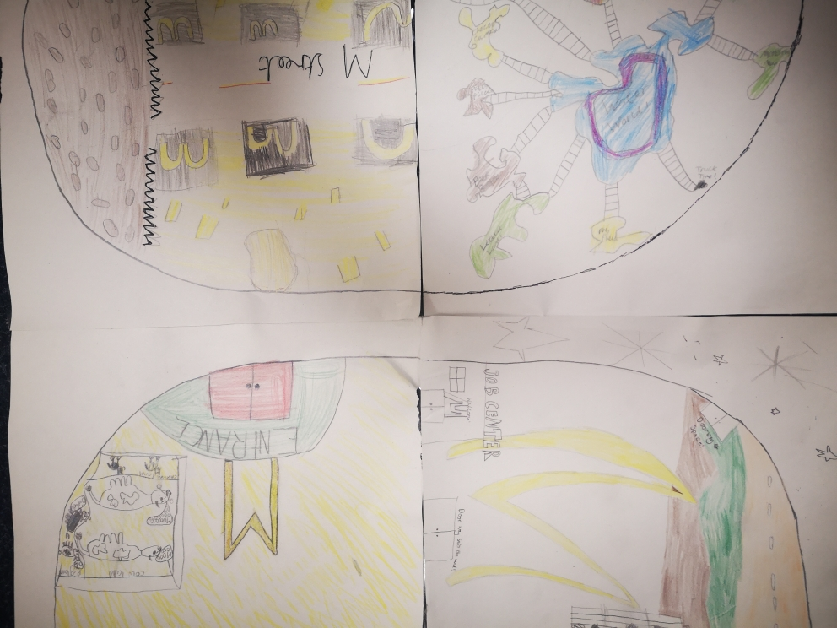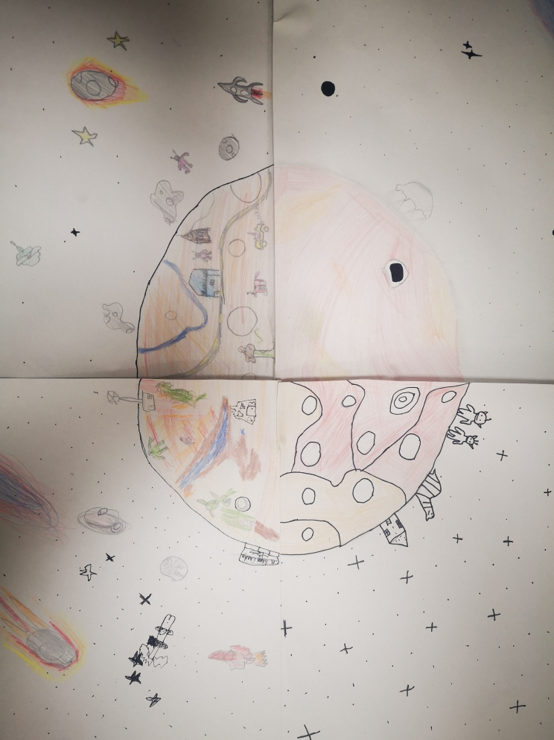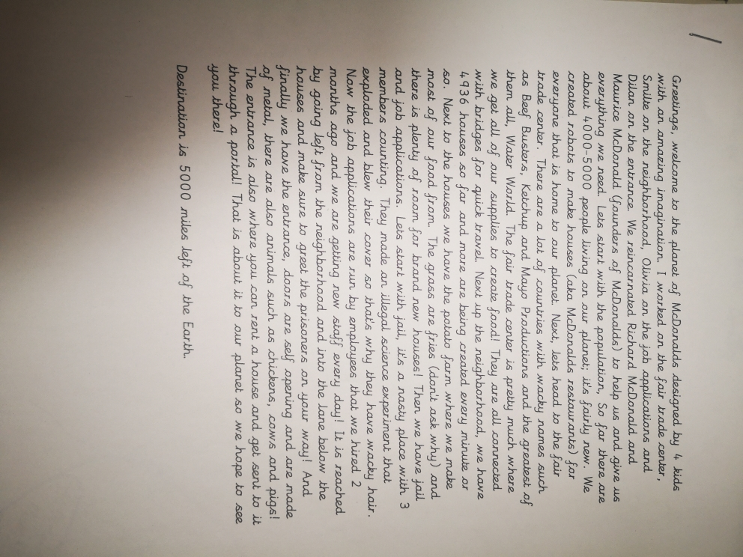

Year 6 have completed fact files about deforestation and a questionnaire which has been shared around school.

Feedback to staff delivered in training day from pupil voice interviews completed in December 2021
Strengths
- Children talked incredibly enthusiastically about all the multicultural books.
- They all looked forwards to being read too were and talked in detail about how it made them feel.
- Children could tell me about both the differences and similarities between themselves and characters.
- They confidently talked about feelings of the characters in the books and related to when they felt a similar way.
Children were really enthusiastic when the adult had made a personal link either with themselves, someone in the class or a family member.
Area of concern
- When asked what they found out about other countries they were unsure and sometimes said nothing. However, when talking about the stories and characters they said lots of things about where they lived eg. housing, climate, clothes and lifestyle illustrating that they had learnt about the countries.
- In Early Years and Key Stage 1 they could talk about the feeling of characters but found it tricky to link it to their own life experiences.
Actions
- Whole school - Staff to be specific and tell them what the book tells us about the country through discussion.
- EYFS and KS1 - Use story discussions to focus on this.
- Repeat pupil voice in Summer 2.

Summer monitoring focus - the use of Picture News / Newsround and First News to inform children knowledge of the wider world and current events/issues.

Actions towards action plan
- The above will impact on the children’s speaking and listening.
- Profile of Global learning through whole school projects eg. Erasmus KA1 and 2.
- Connecting and collaborating with local partners through KA2 project and Connecting Classrooms.

Next steps
To continue to lead the International projects.
To liase with MAPS and SPAG about project ideas.
To liase with partner school in Uganda to organise exchange of ideas and work.
To monitor how children are taught about current news through Picture News/ Newsround and First News.

