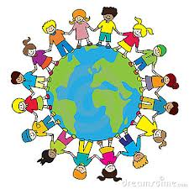
Global Learning Moderation
Summer 2 2020/21

Ongoing International projects

Erasmus KA2 – Culture, Curriculum and Communications
Virtual training for staff – SPAG and one of the partner schools in Poland delivered some training to all 6 partner schools on Monday 14th June.

One of the Polish schools delivered a fantastic powerpoint about returning to school after the National Lockdown. This was really interesting. Their focus was completely on the well-being of all pupils. There were no tests and won’t be for the rest of the year. Classes were more interactive, more outdoor learning/activities and big focus on all being together. They discussed how they had changed during Lockdown and how they felt about seeing their friends again. They had several large trips with children from different classes all going together. These involved a big bike ride, visits to trampoline parks, camp fire trips, theme parks, the cinema and sleepovers.
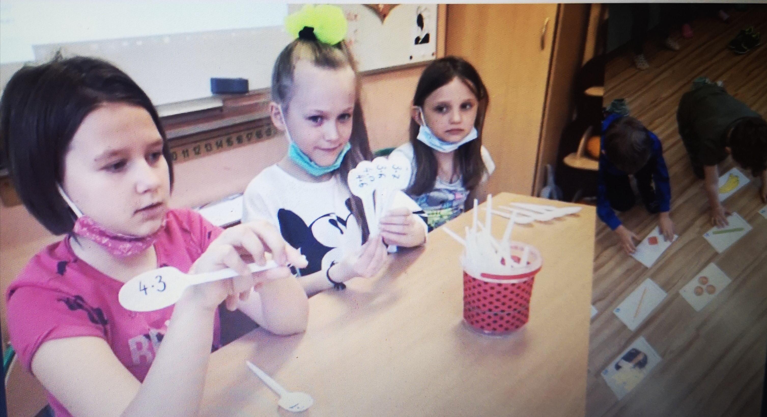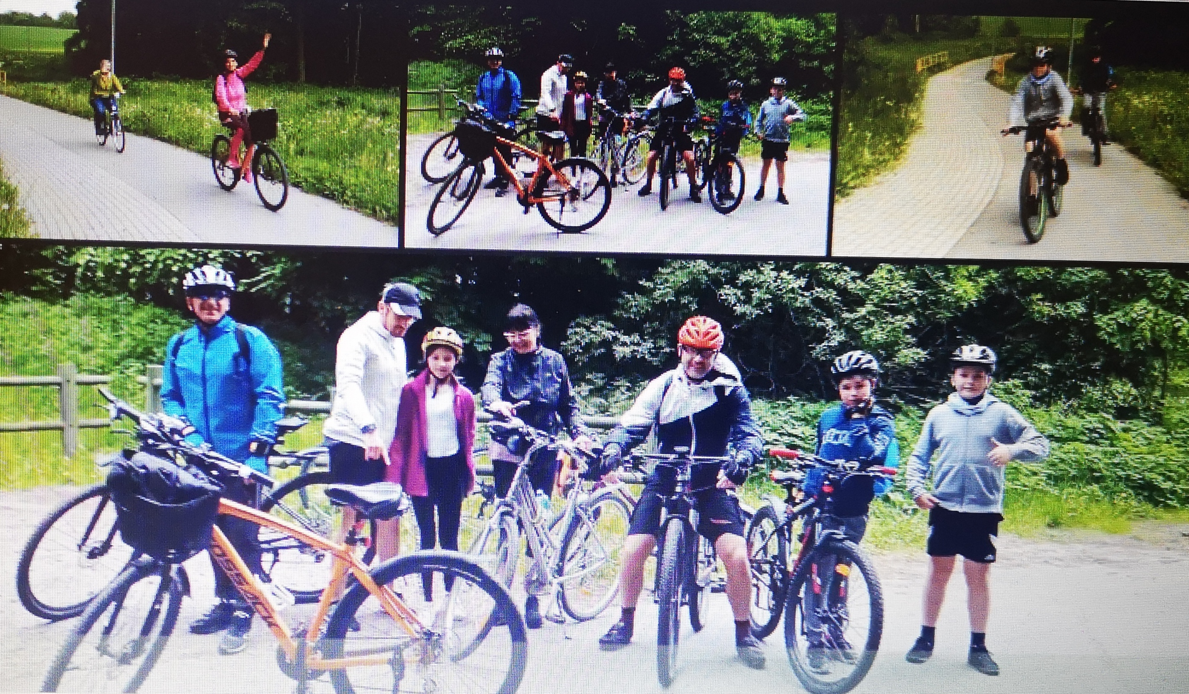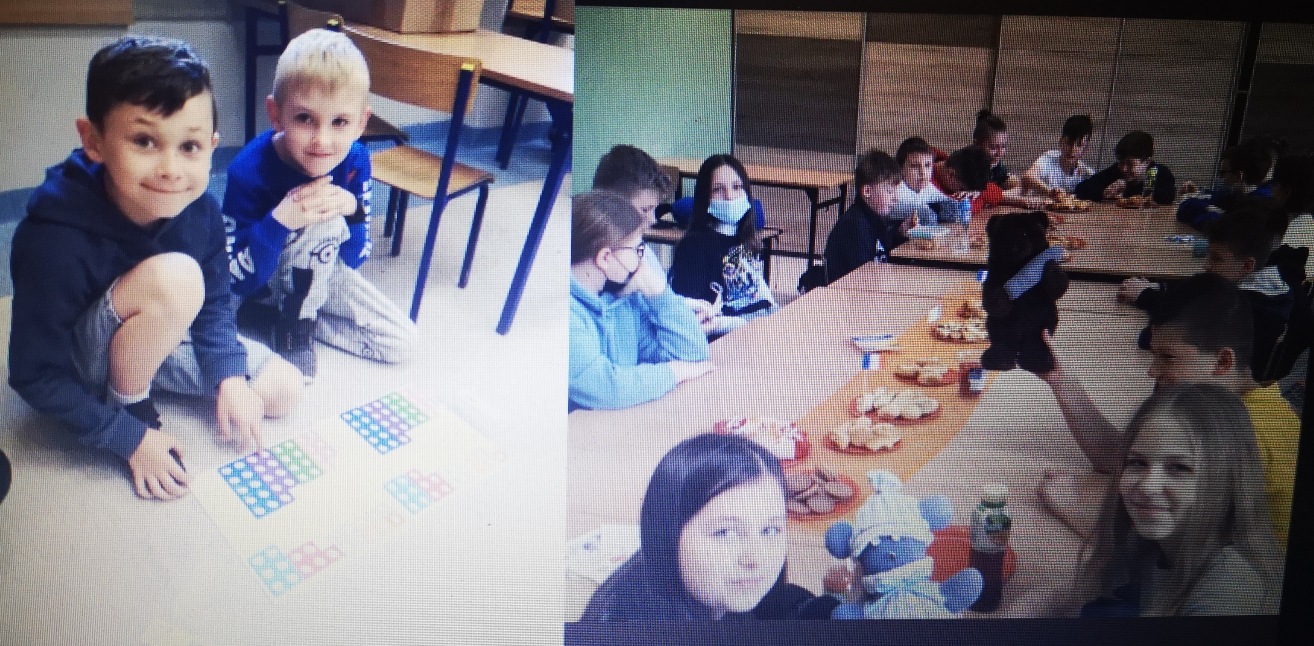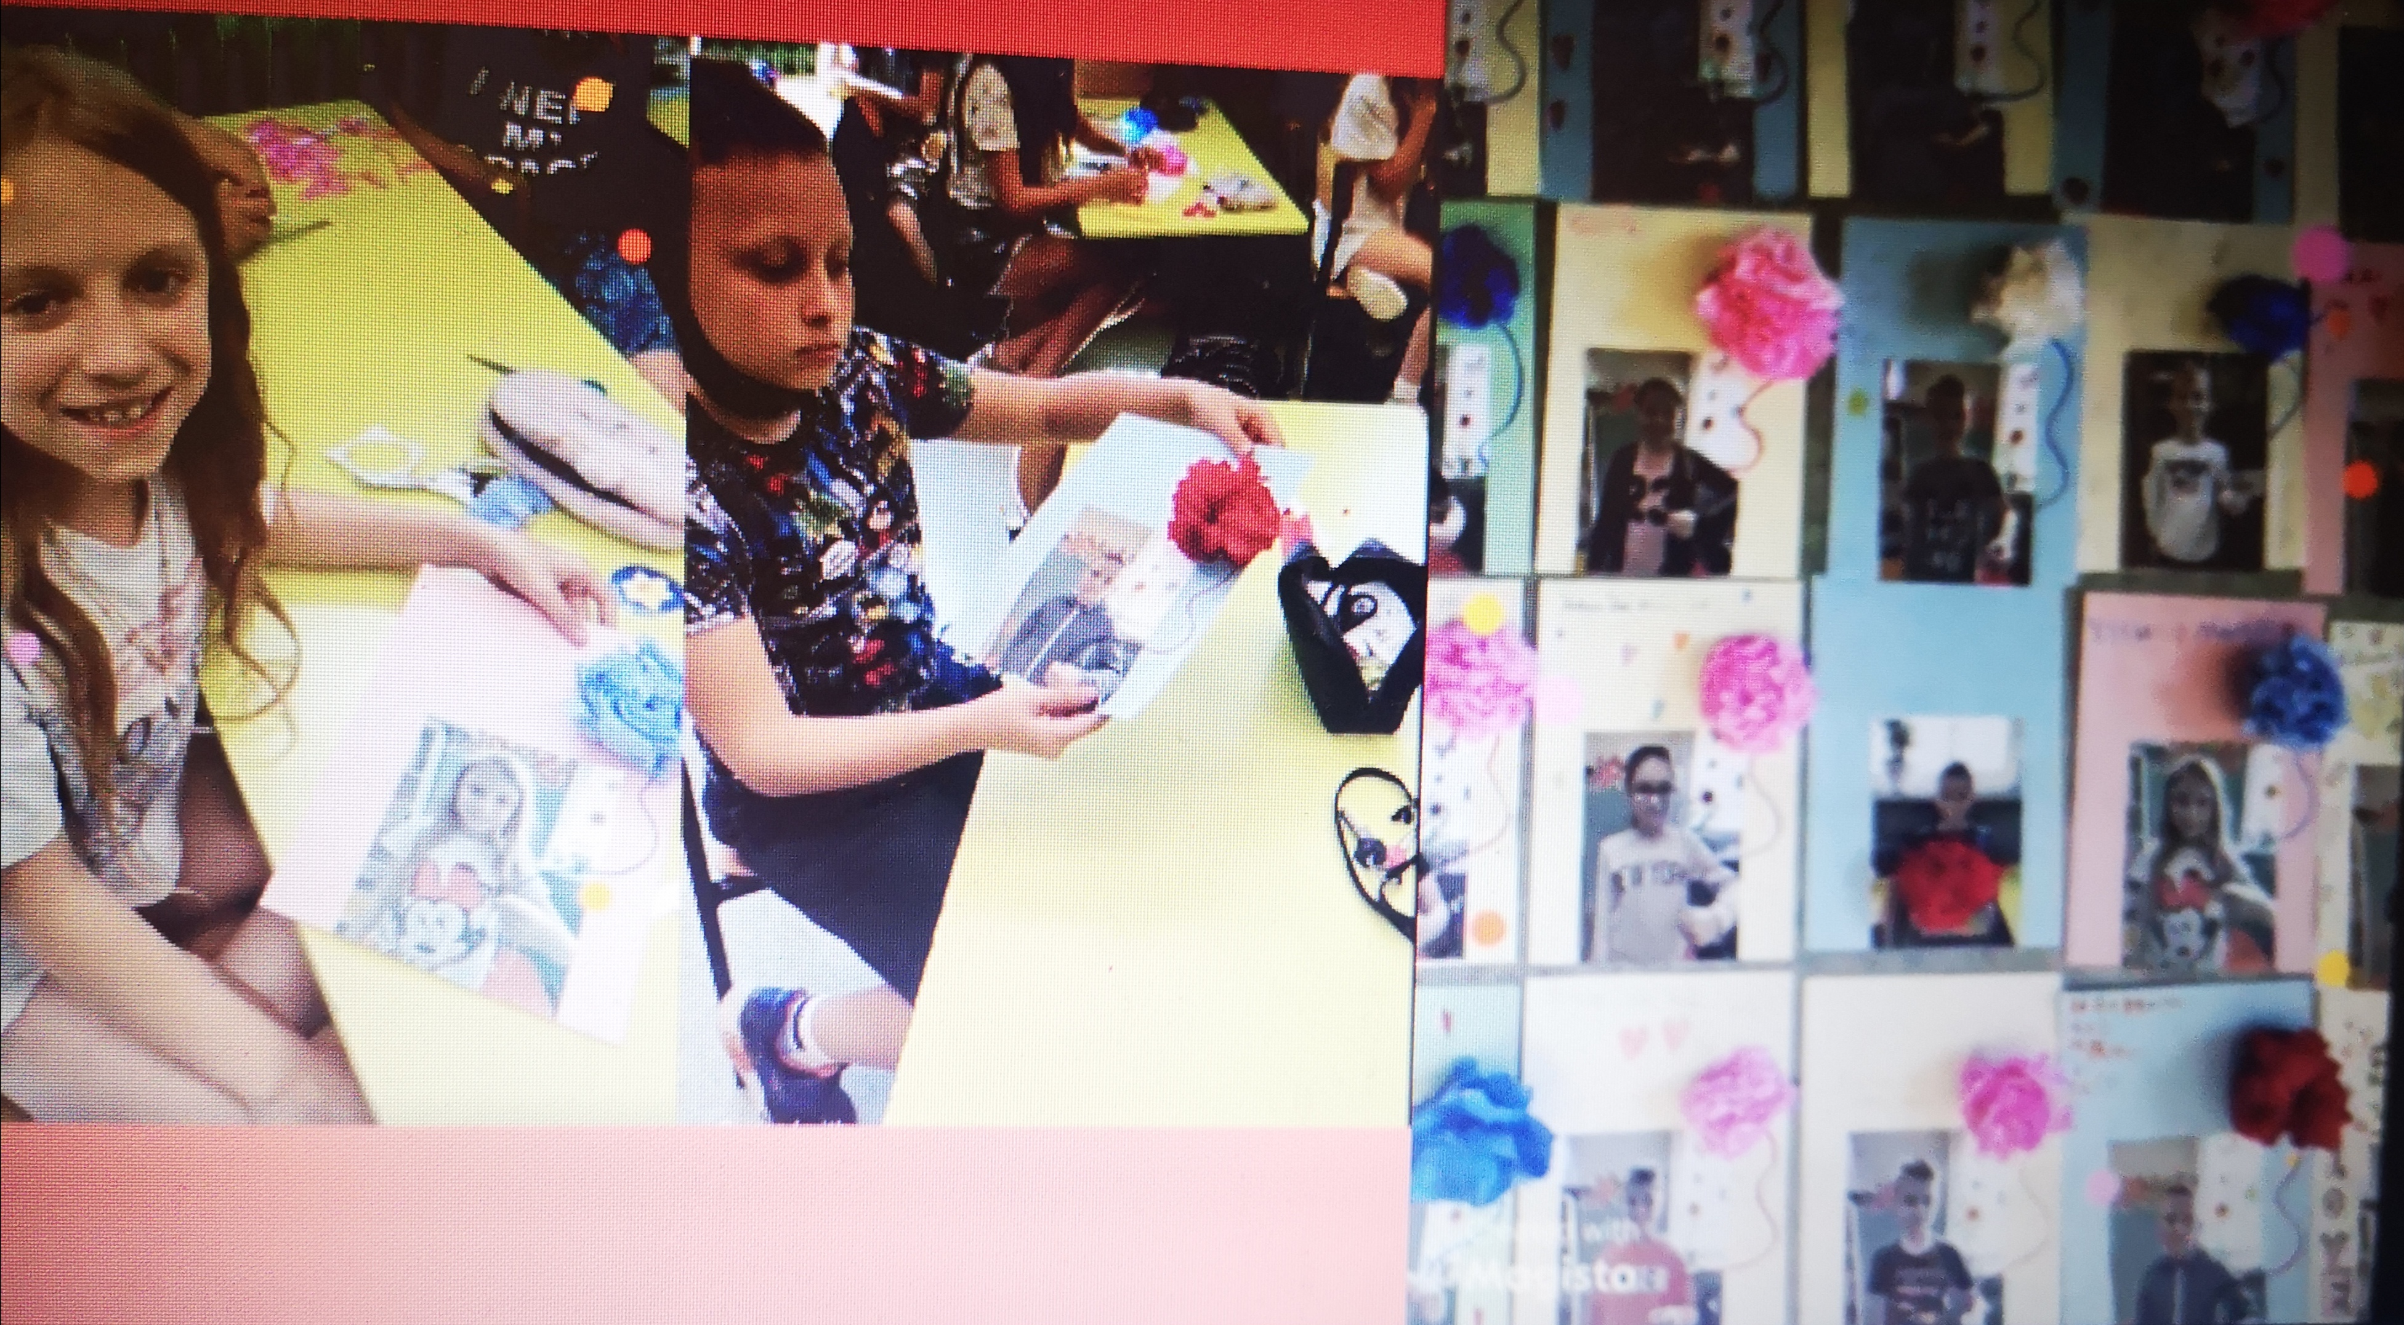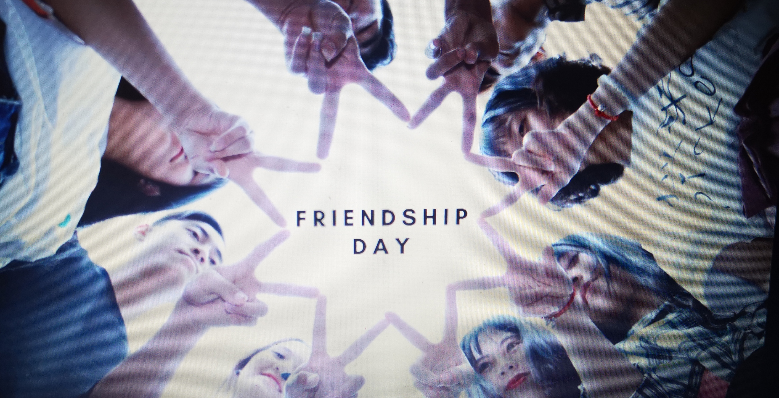

Connecting classrooms
The children in Uganda are still in Lockdown and therefore not at school. I have had lovely messages from the Headteacher thanking us for the work sent and wishing us well.
Staff Training
In order to ensure that our Intent statement reflected the whole school community. The staff completed an activity where they wrote about what skills, knowledge and values they thought a ‘Global Learner’ should have.

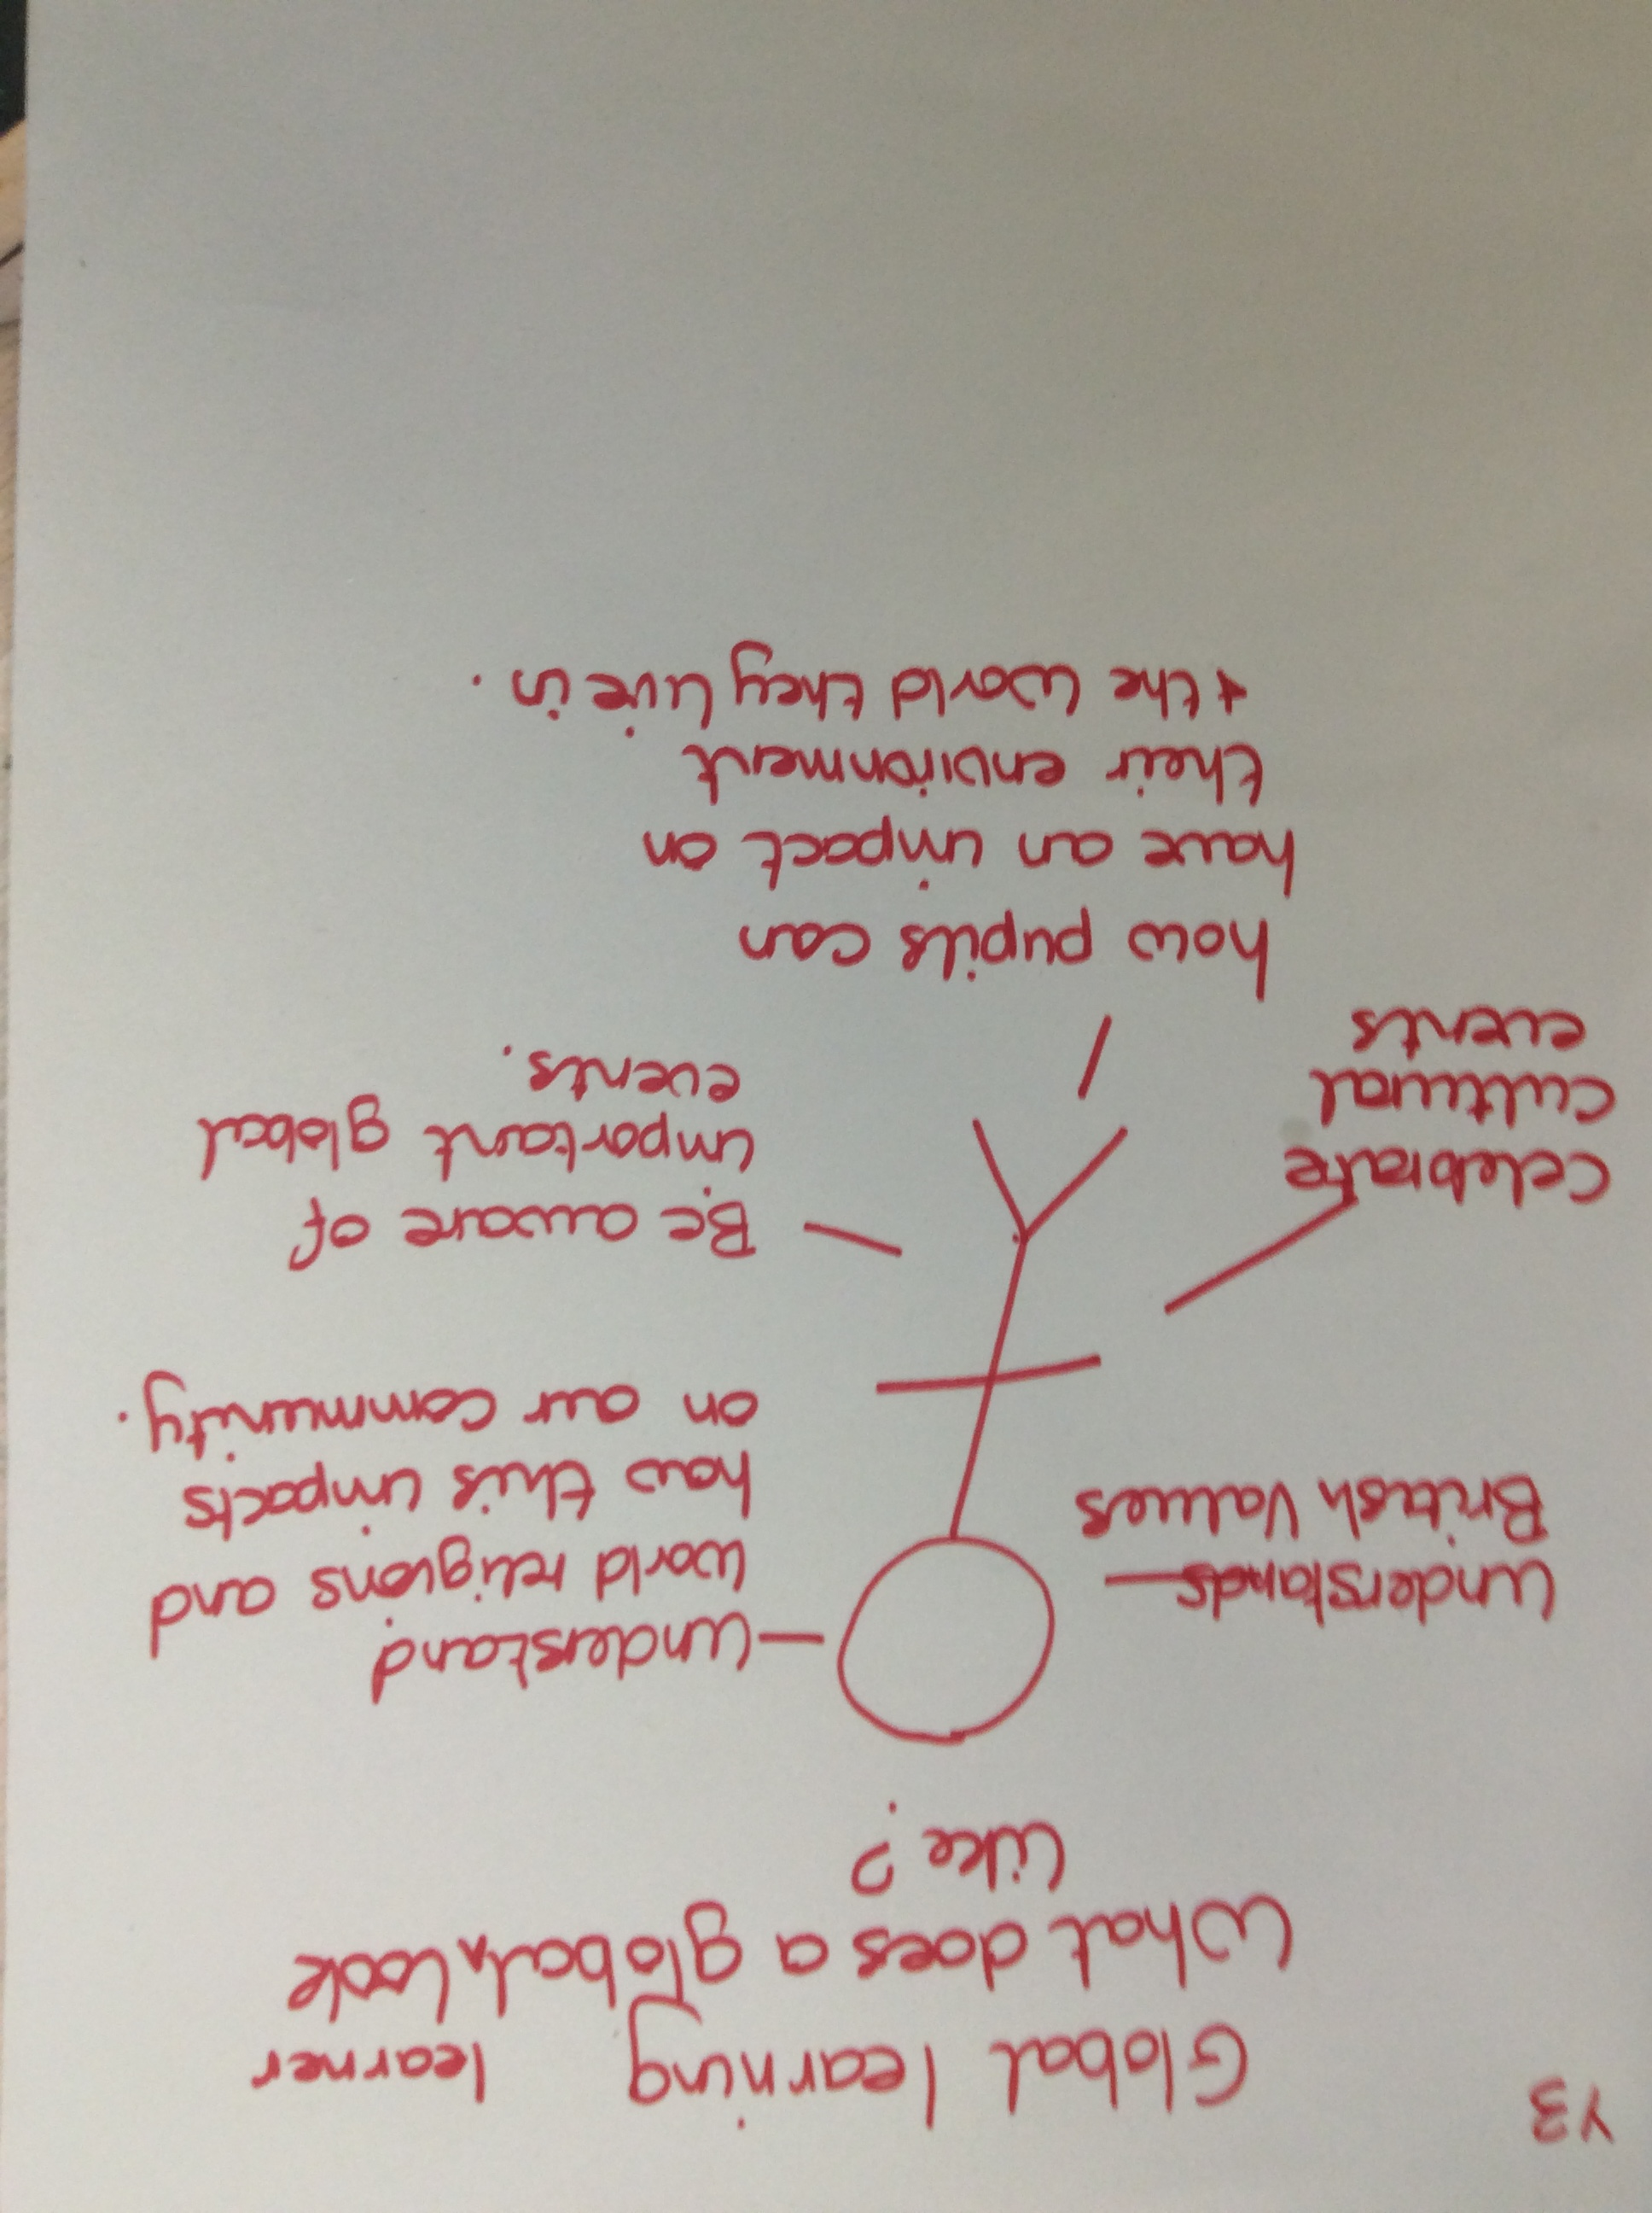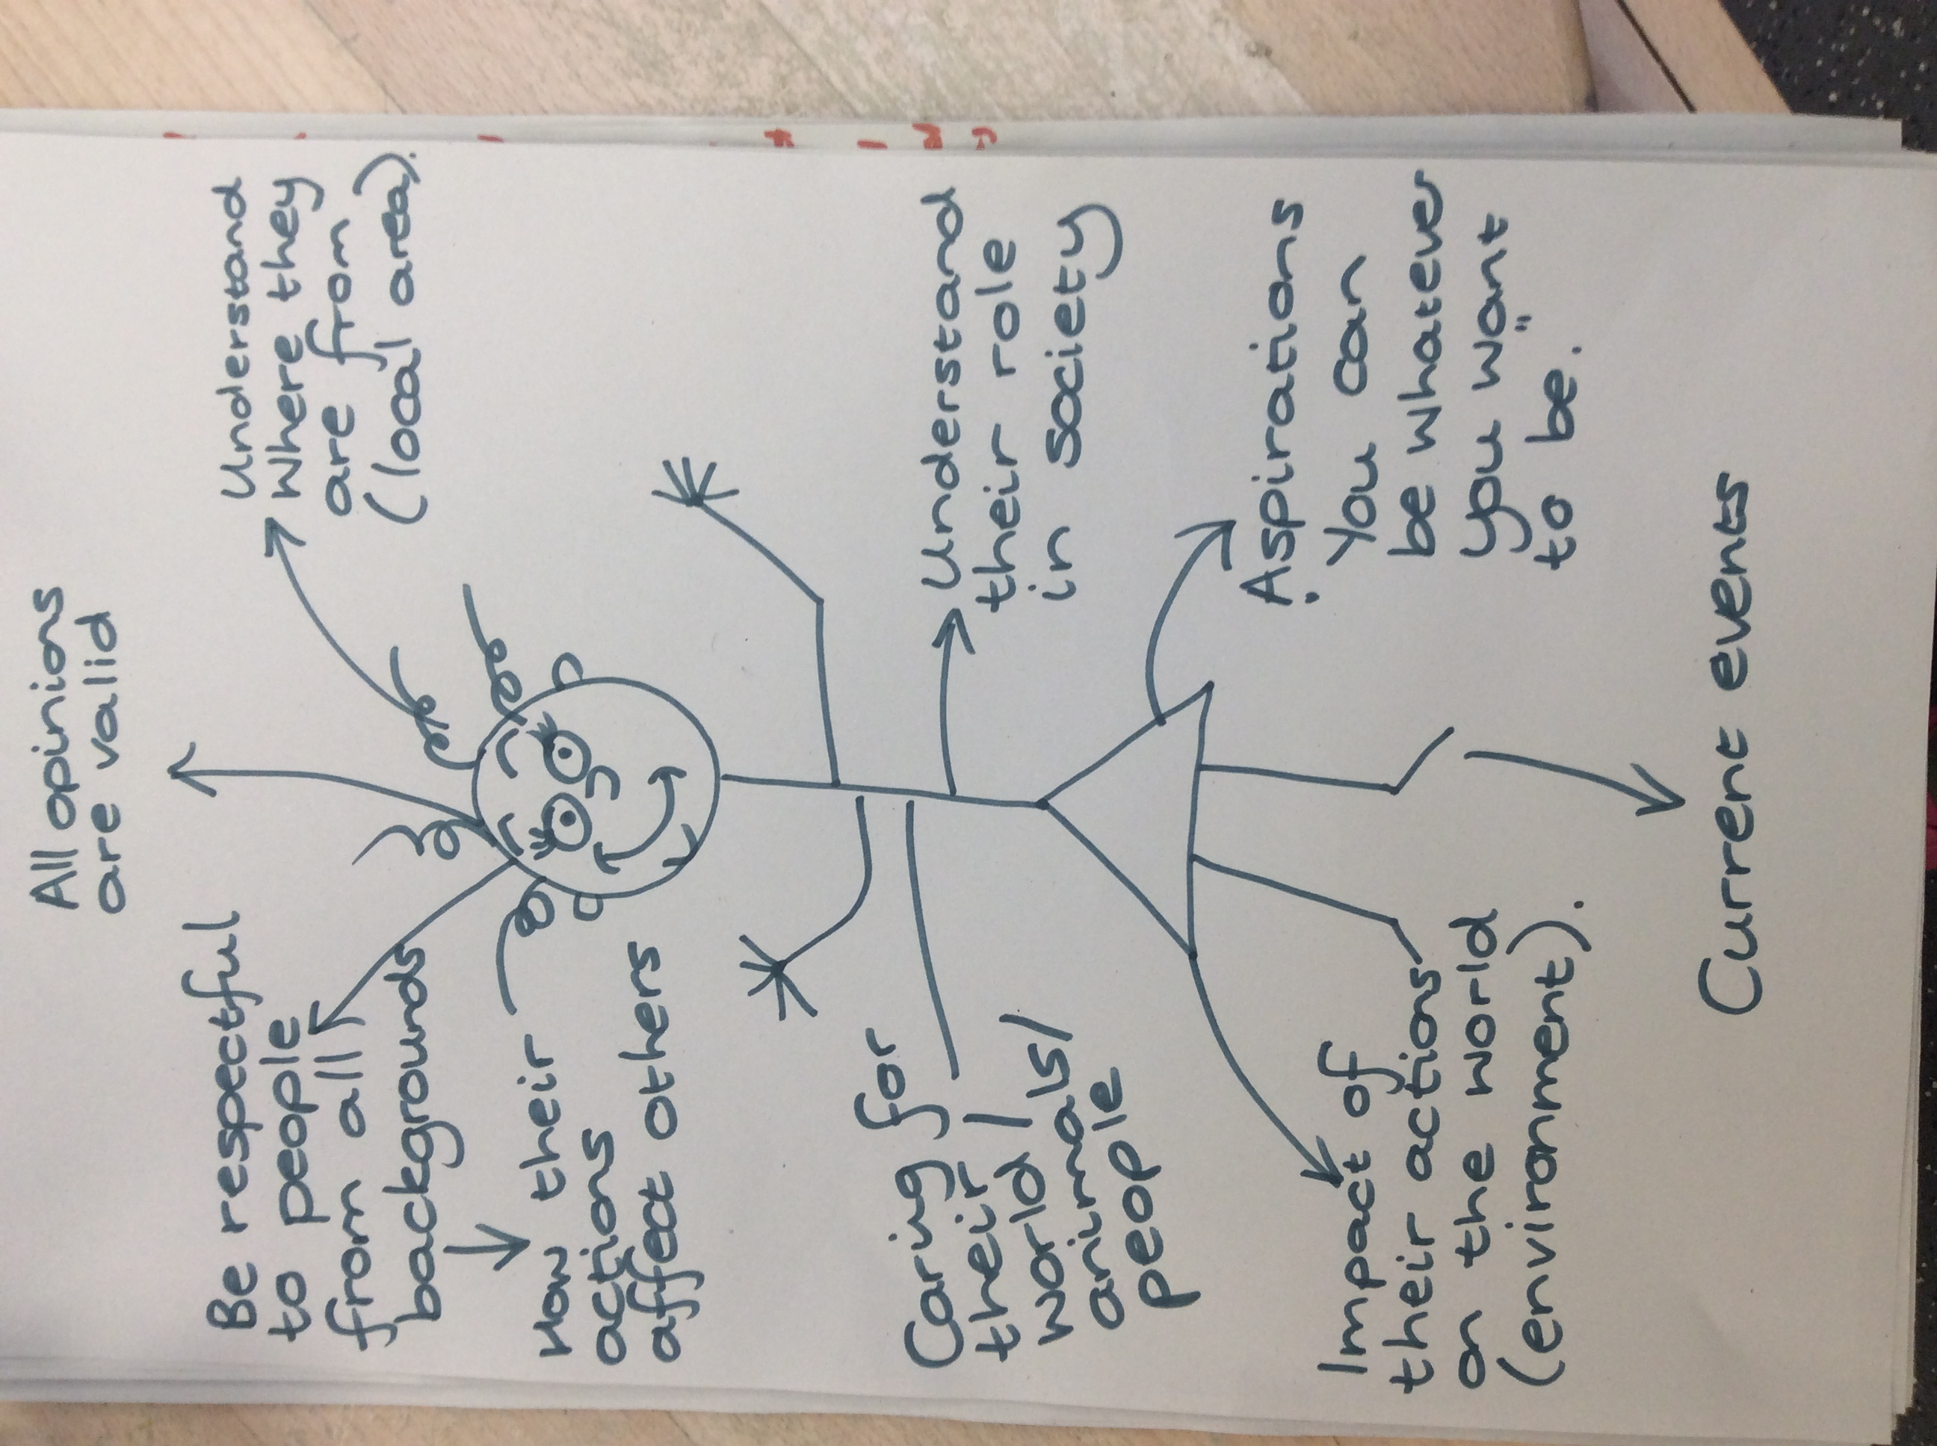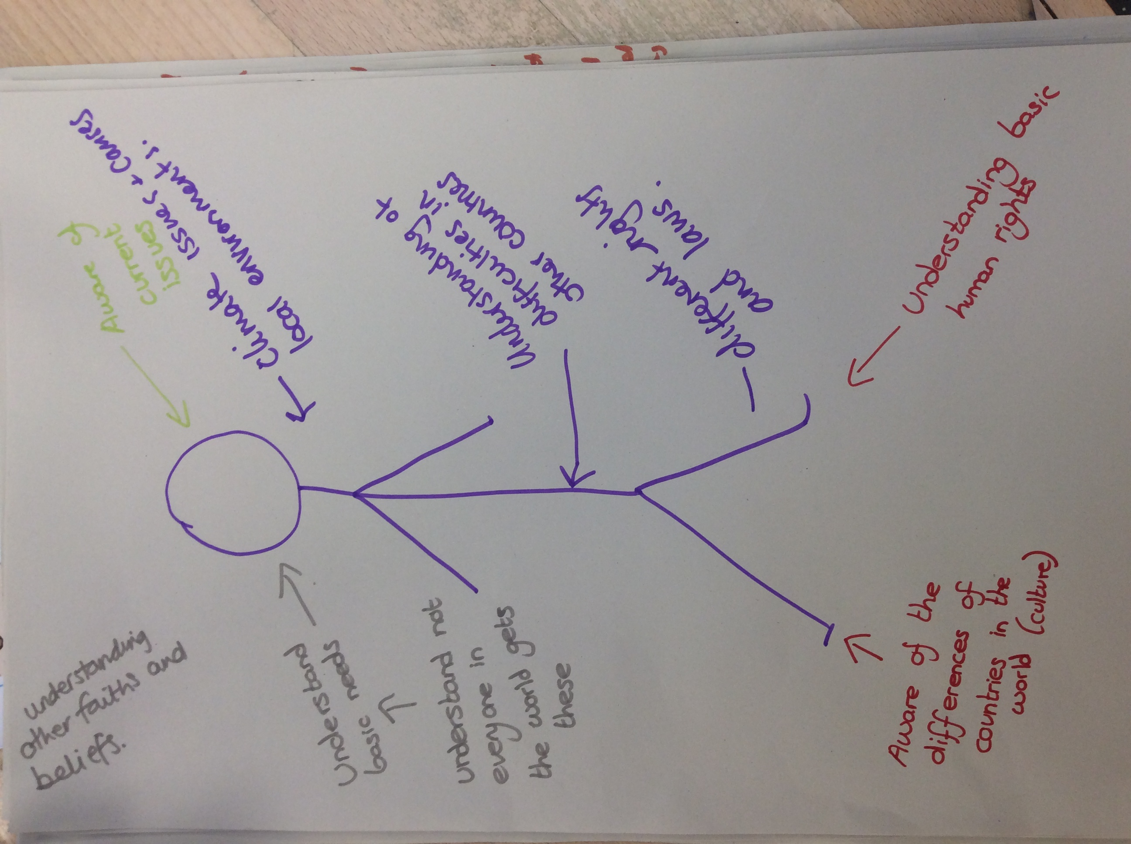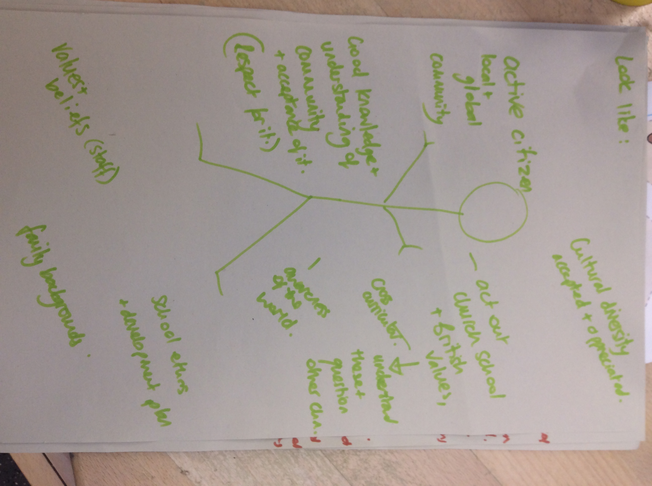

During staff training staff were reminded of the different strands of Global Learning in BK.
- Knowledge of the wider world
- Awareness of other cultures and their similarities and differences
- Knowledge of recent news events from around the world
They were all reminded of the list of website which contain a wide range of activities and resources eg. Global dimensions, Fairtrade, Risc, Global Learning and Global Goals.

The all, in year group teams, completed a Global themed activity on their table and shared it with the rest of the staff.
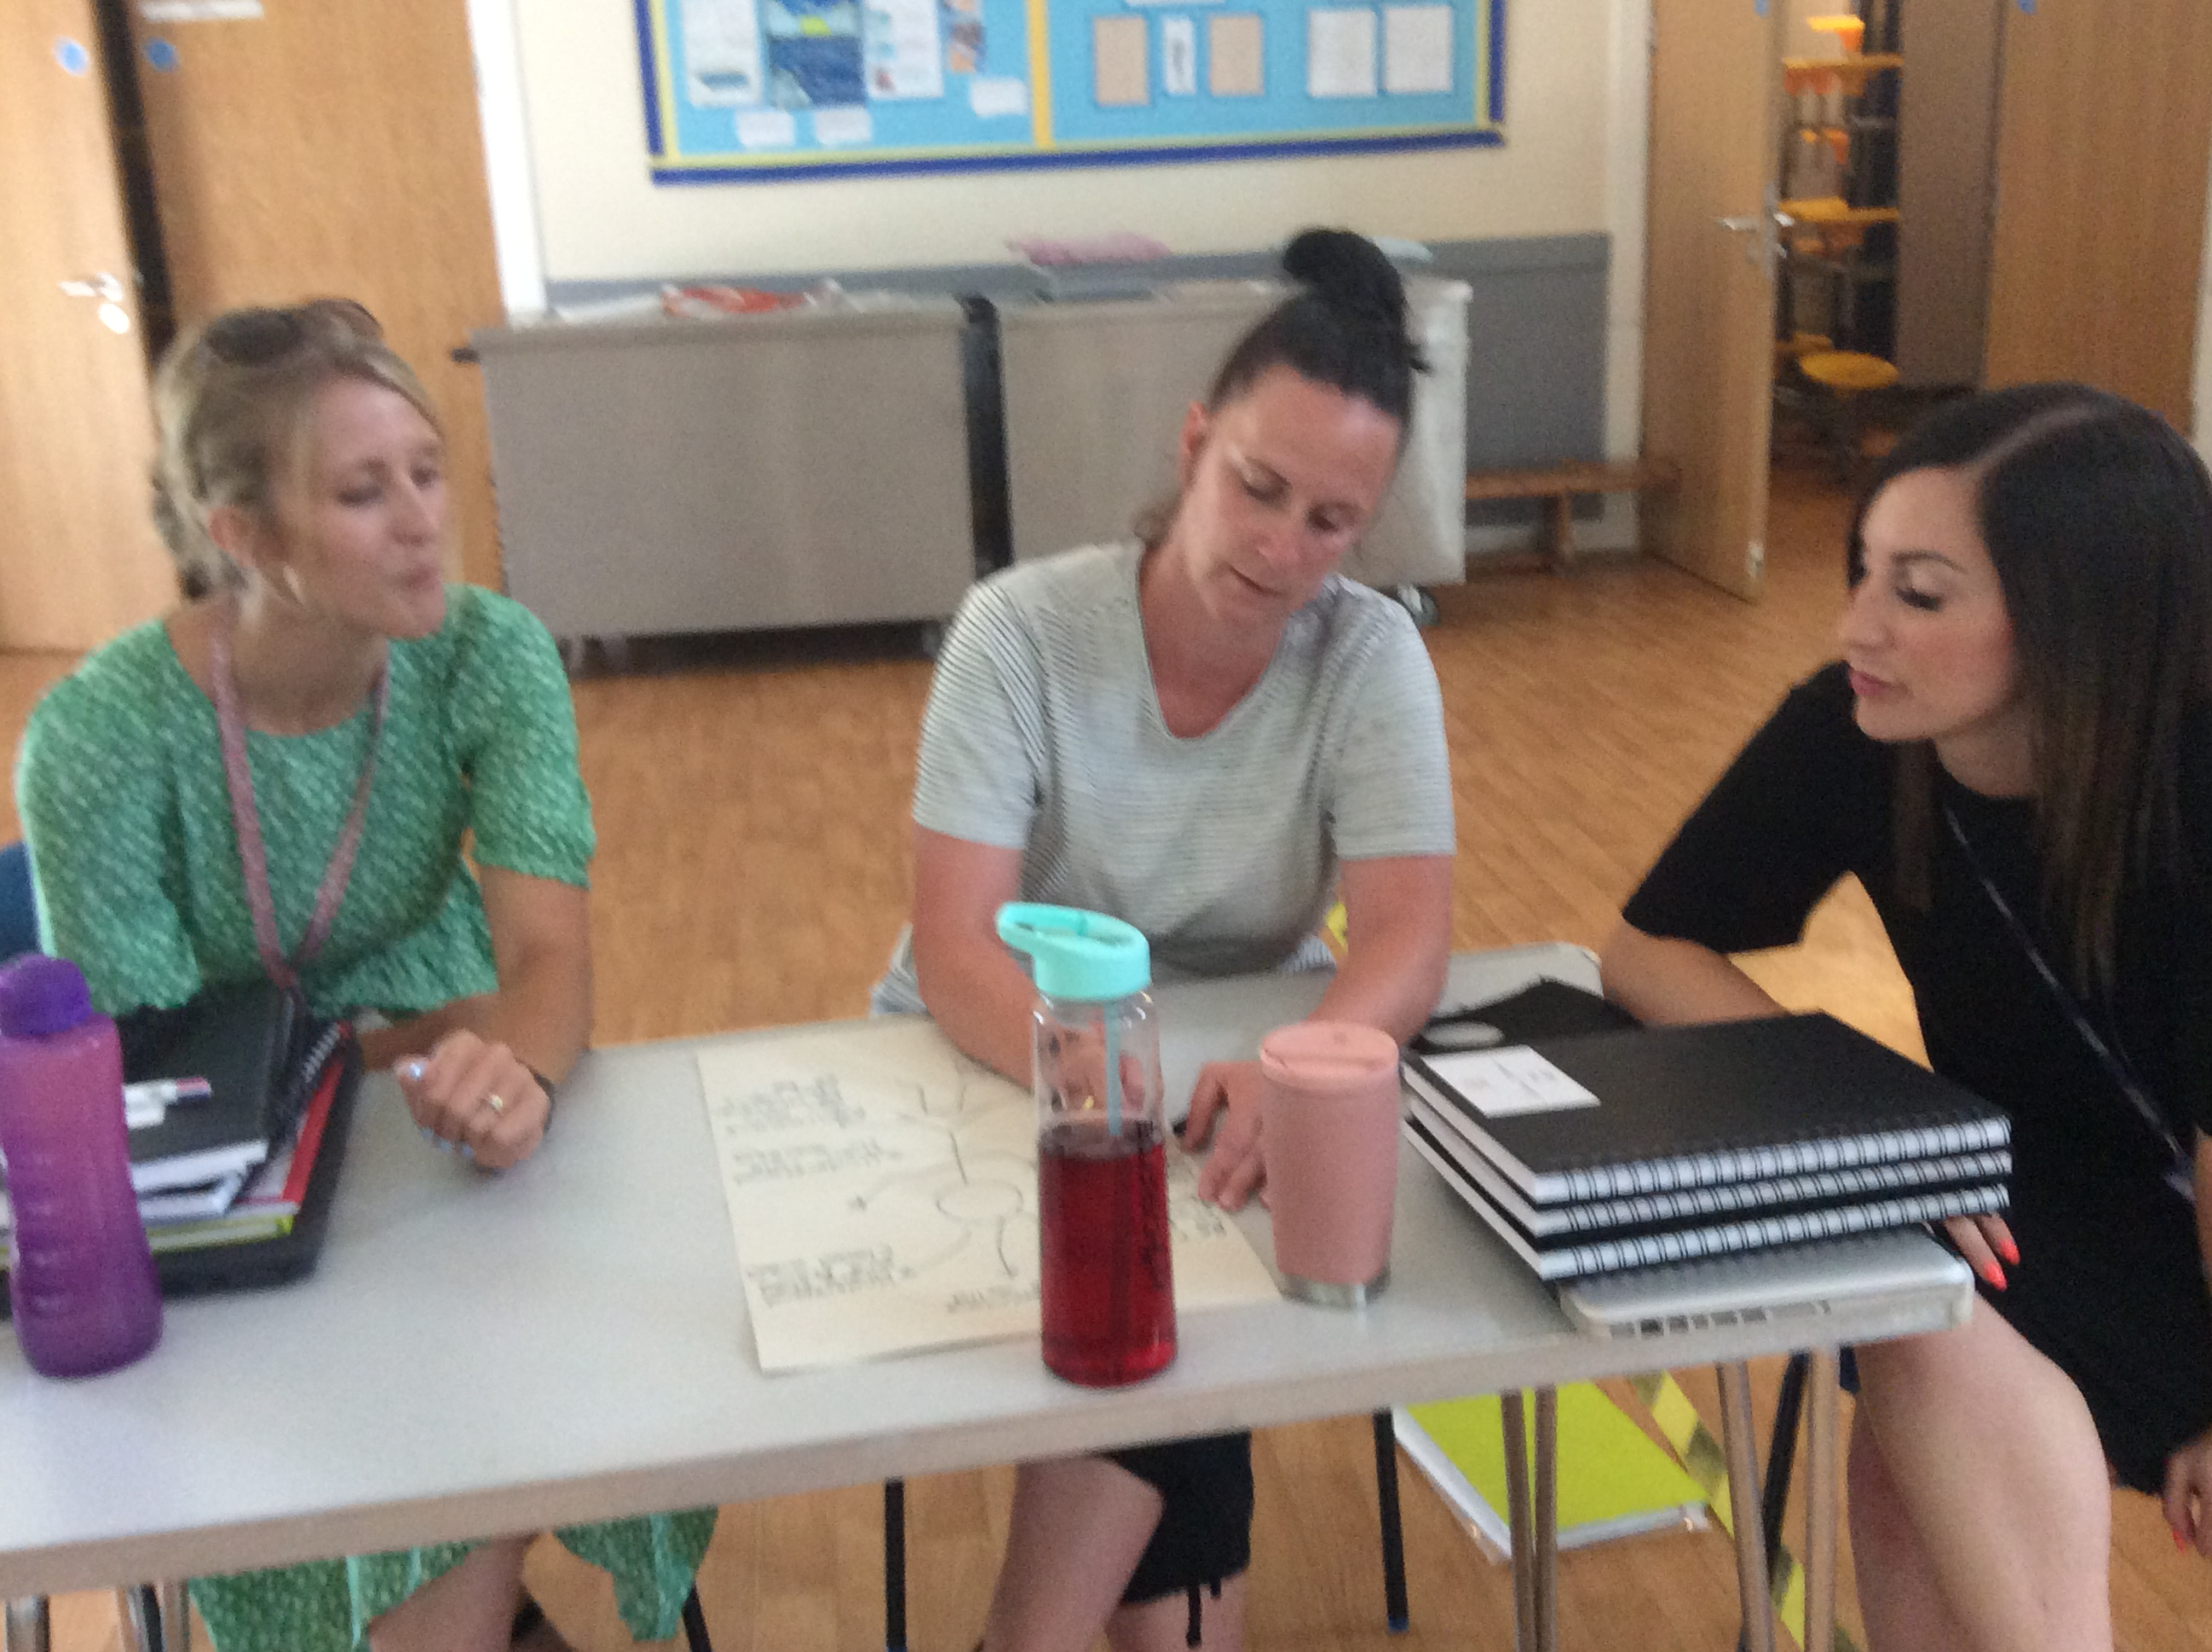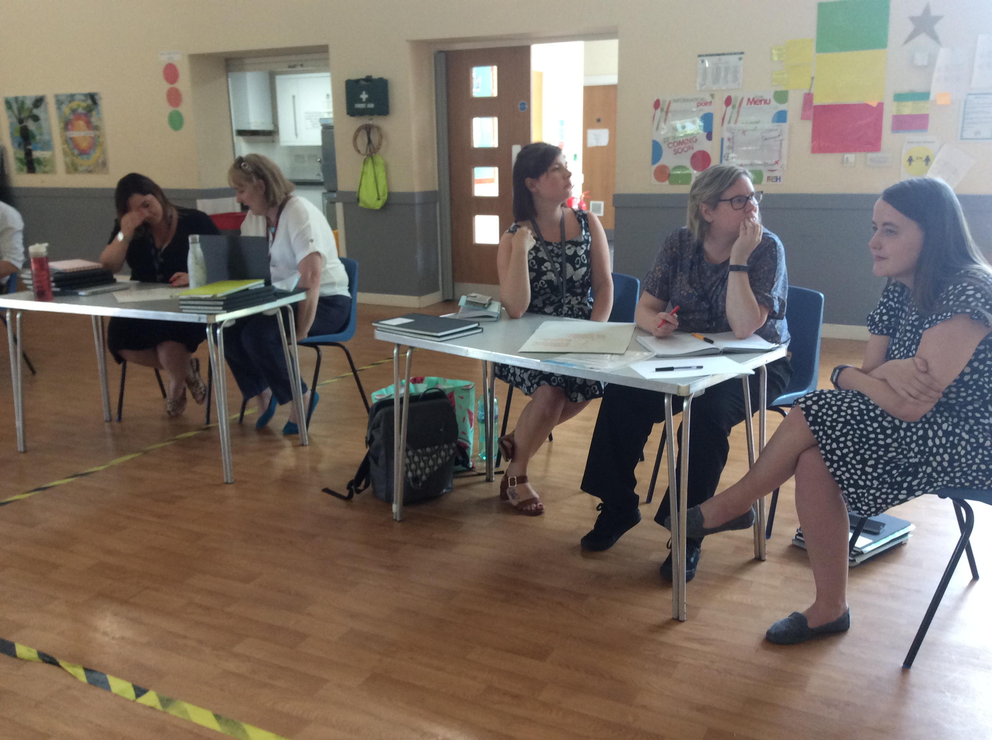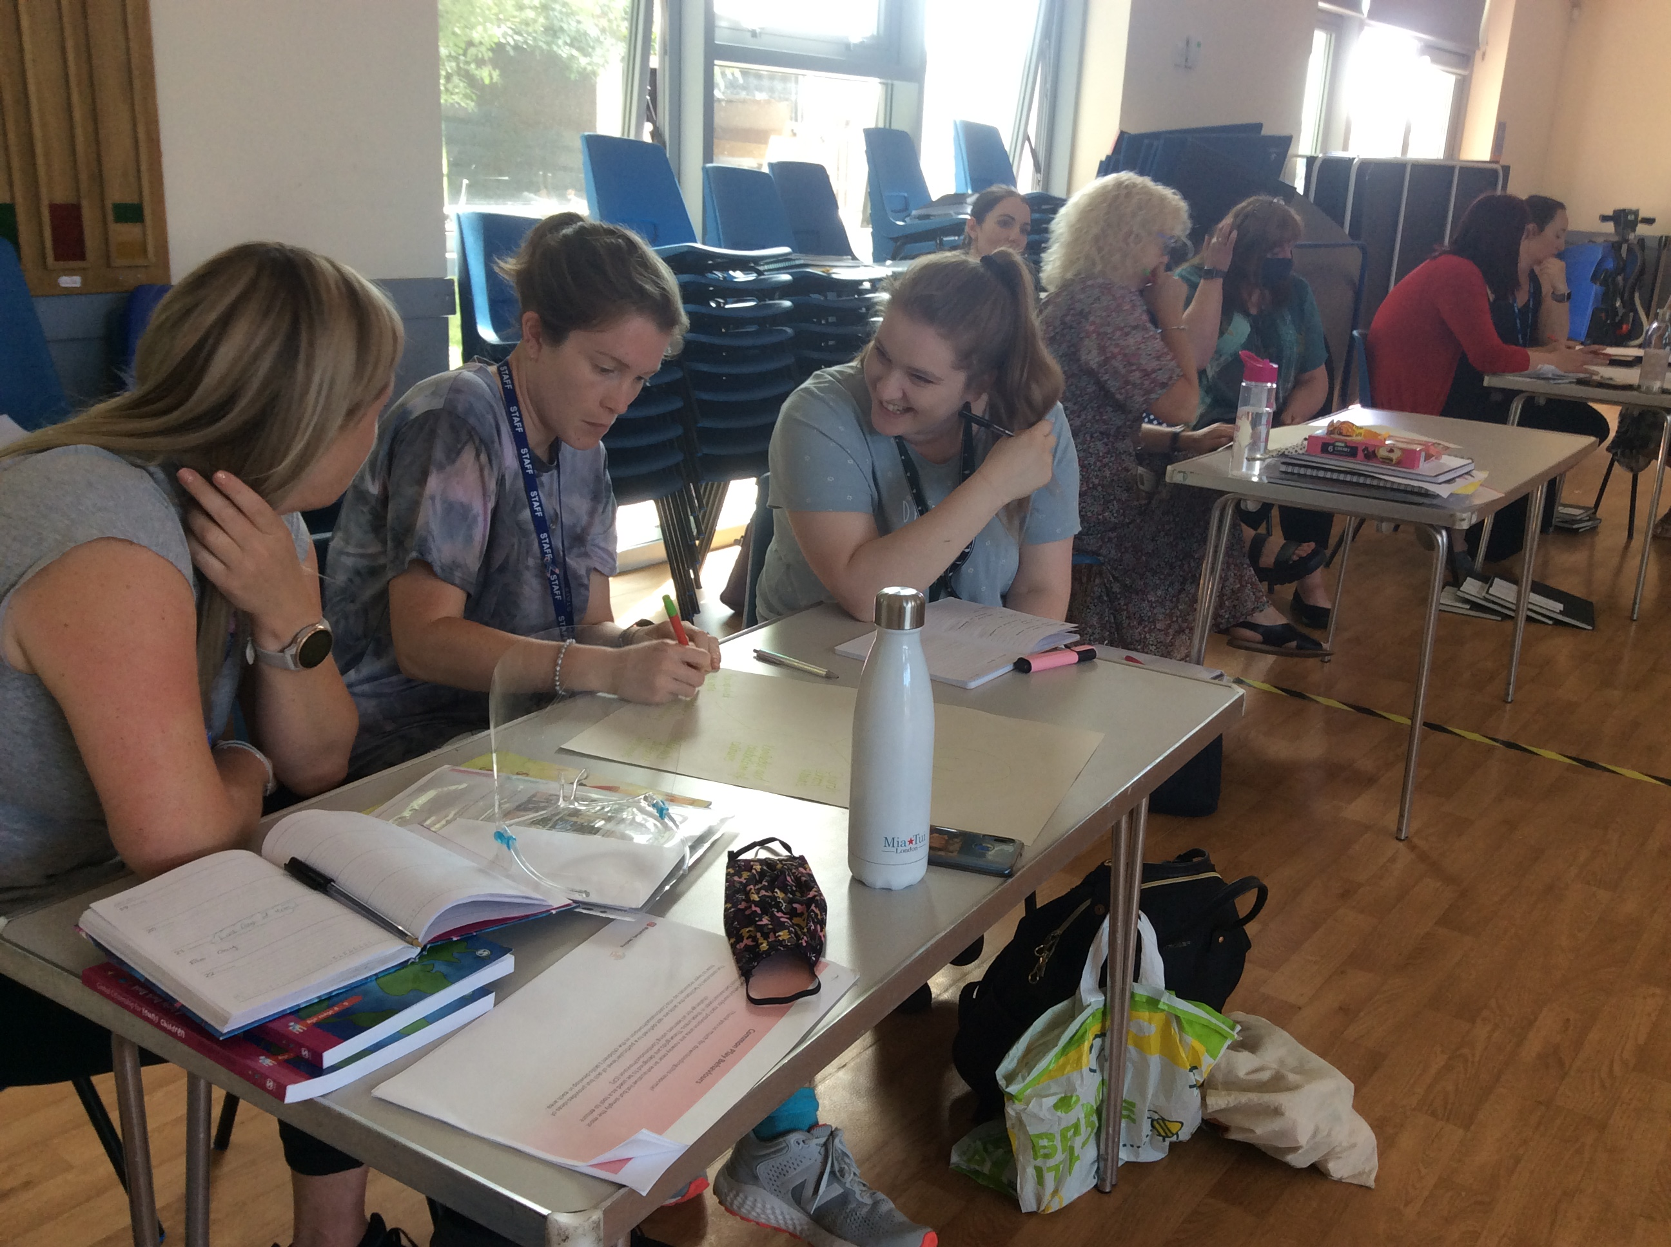

Year 1 have recorded their discussions after watching a range of ‘Newsround reports’ based on current news.
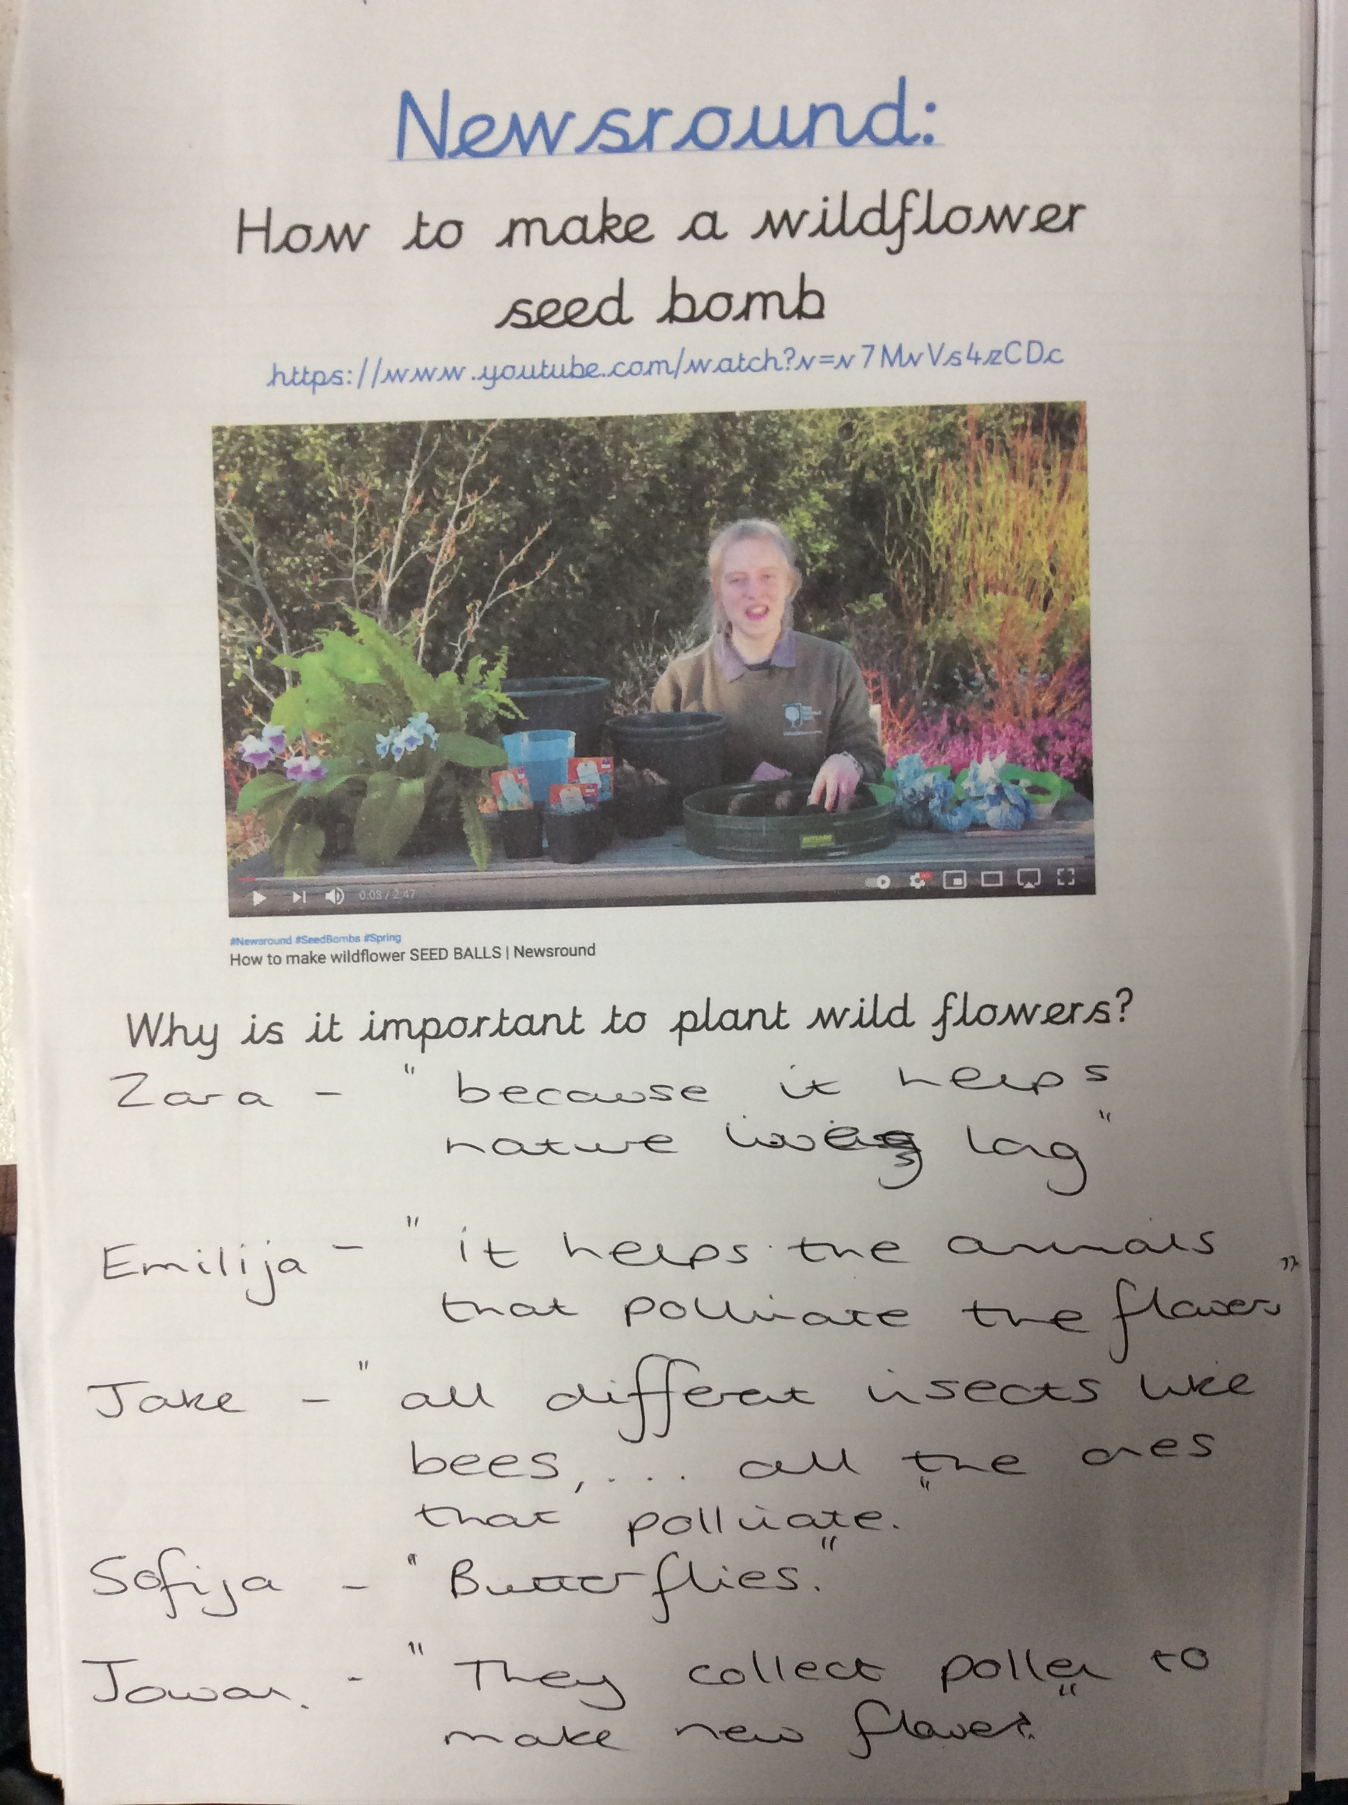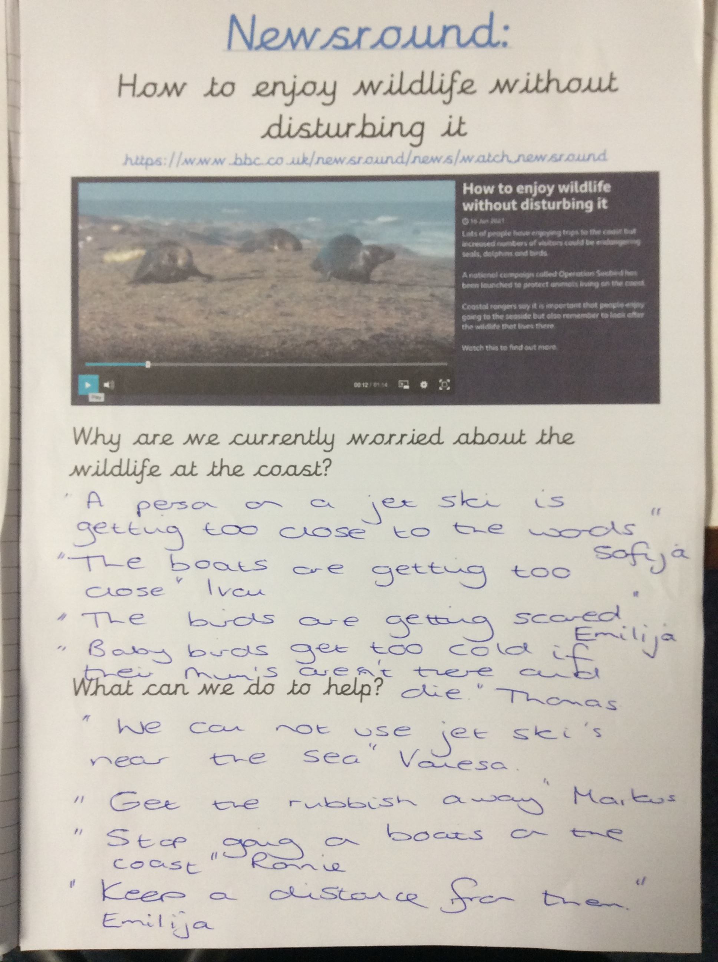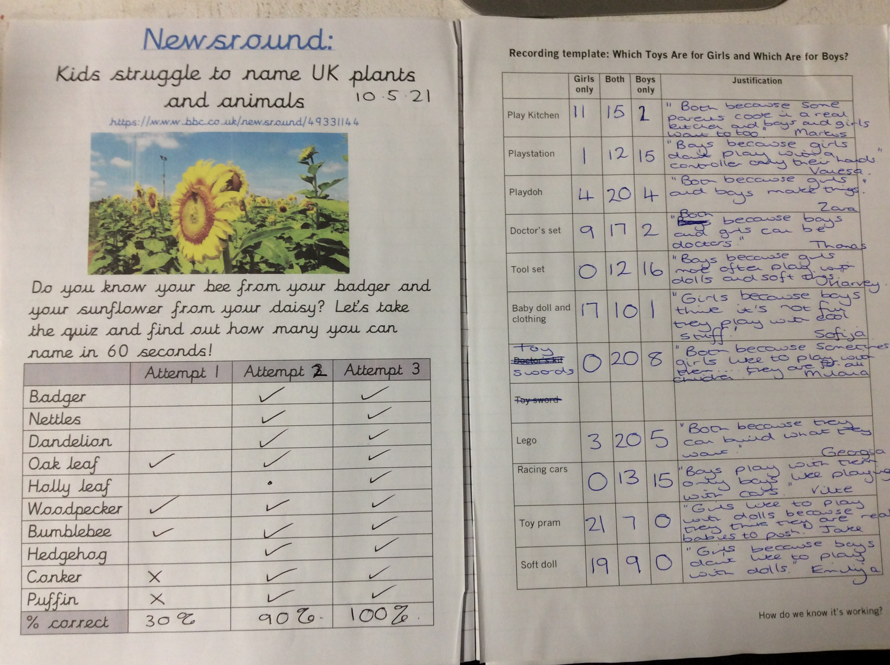

Year 2
Recorded discussions in their class book after watching Newsround several times this term. Discussions related to:
- Coronavirus – nobody wants another lockdown! How can we stop it happening?!
- Life on Mars
- Euro 2020 – Wales game
- Attracting wildlife to our outside areas
- Importance of Happy news

Year 3
In Year 3 they focus on a picture news question weekly and discuss in groups and as a whole. These are recorded and displayed in the classroom.
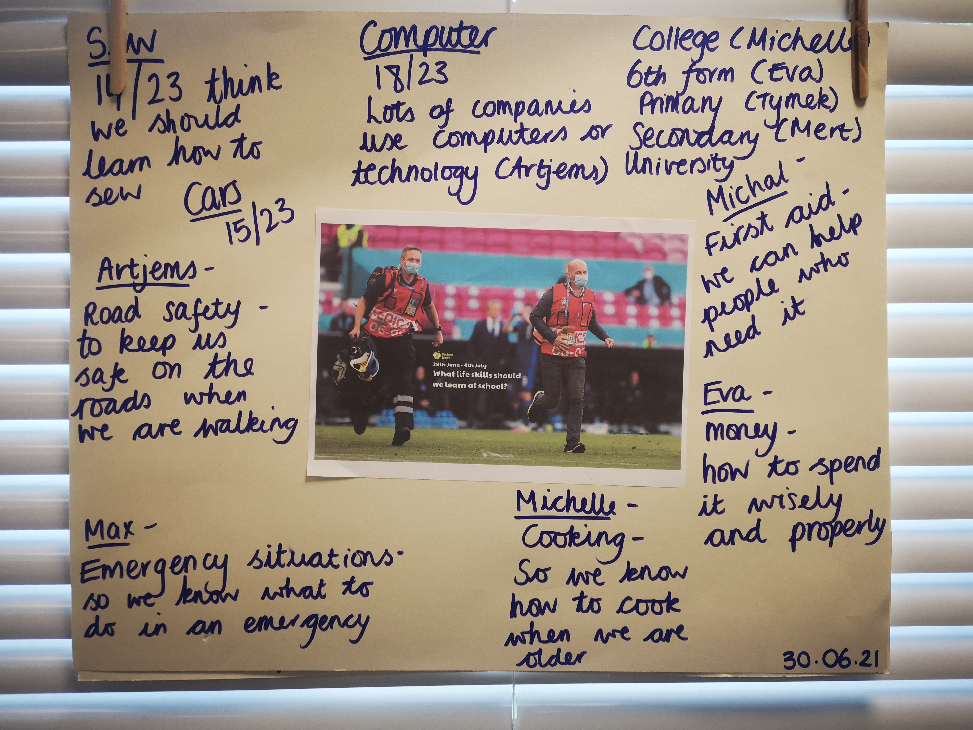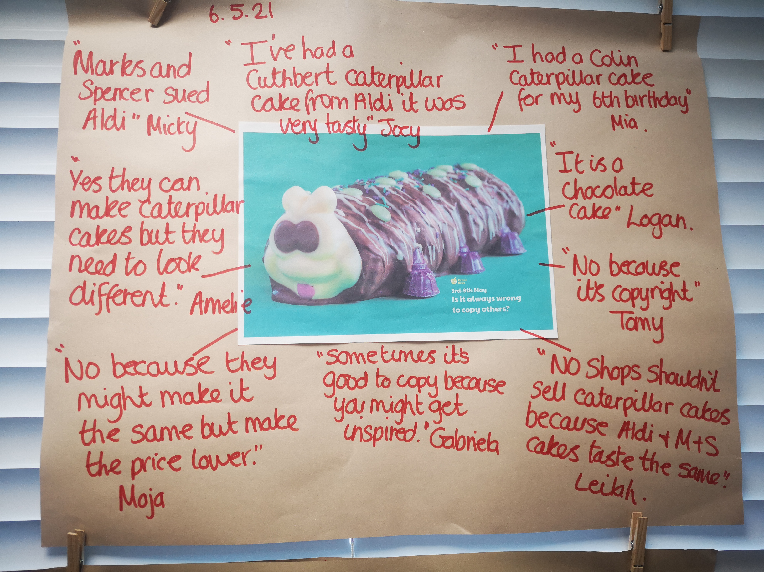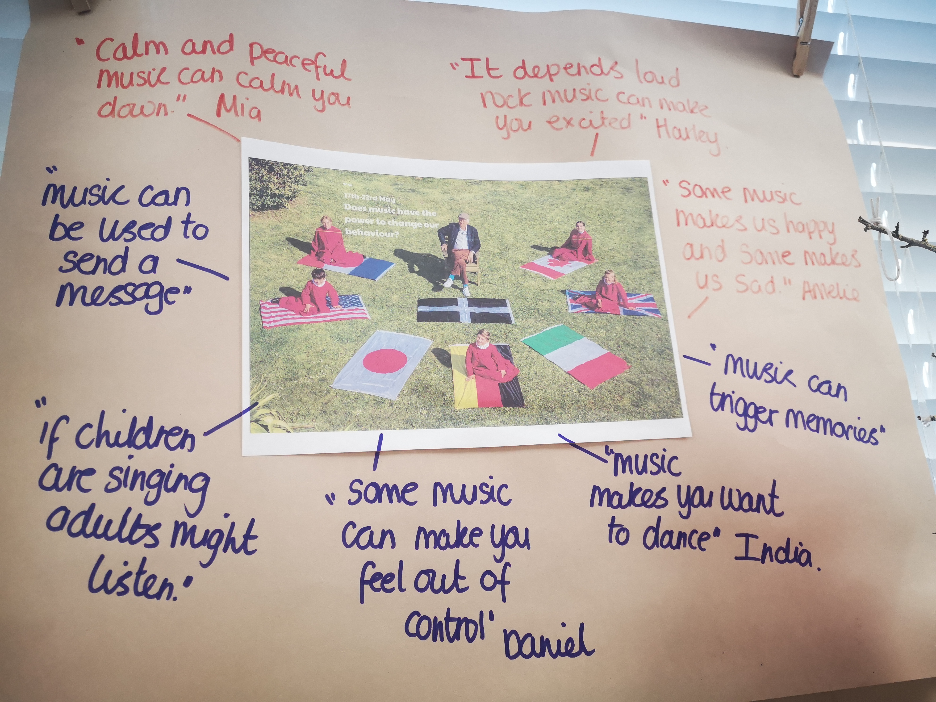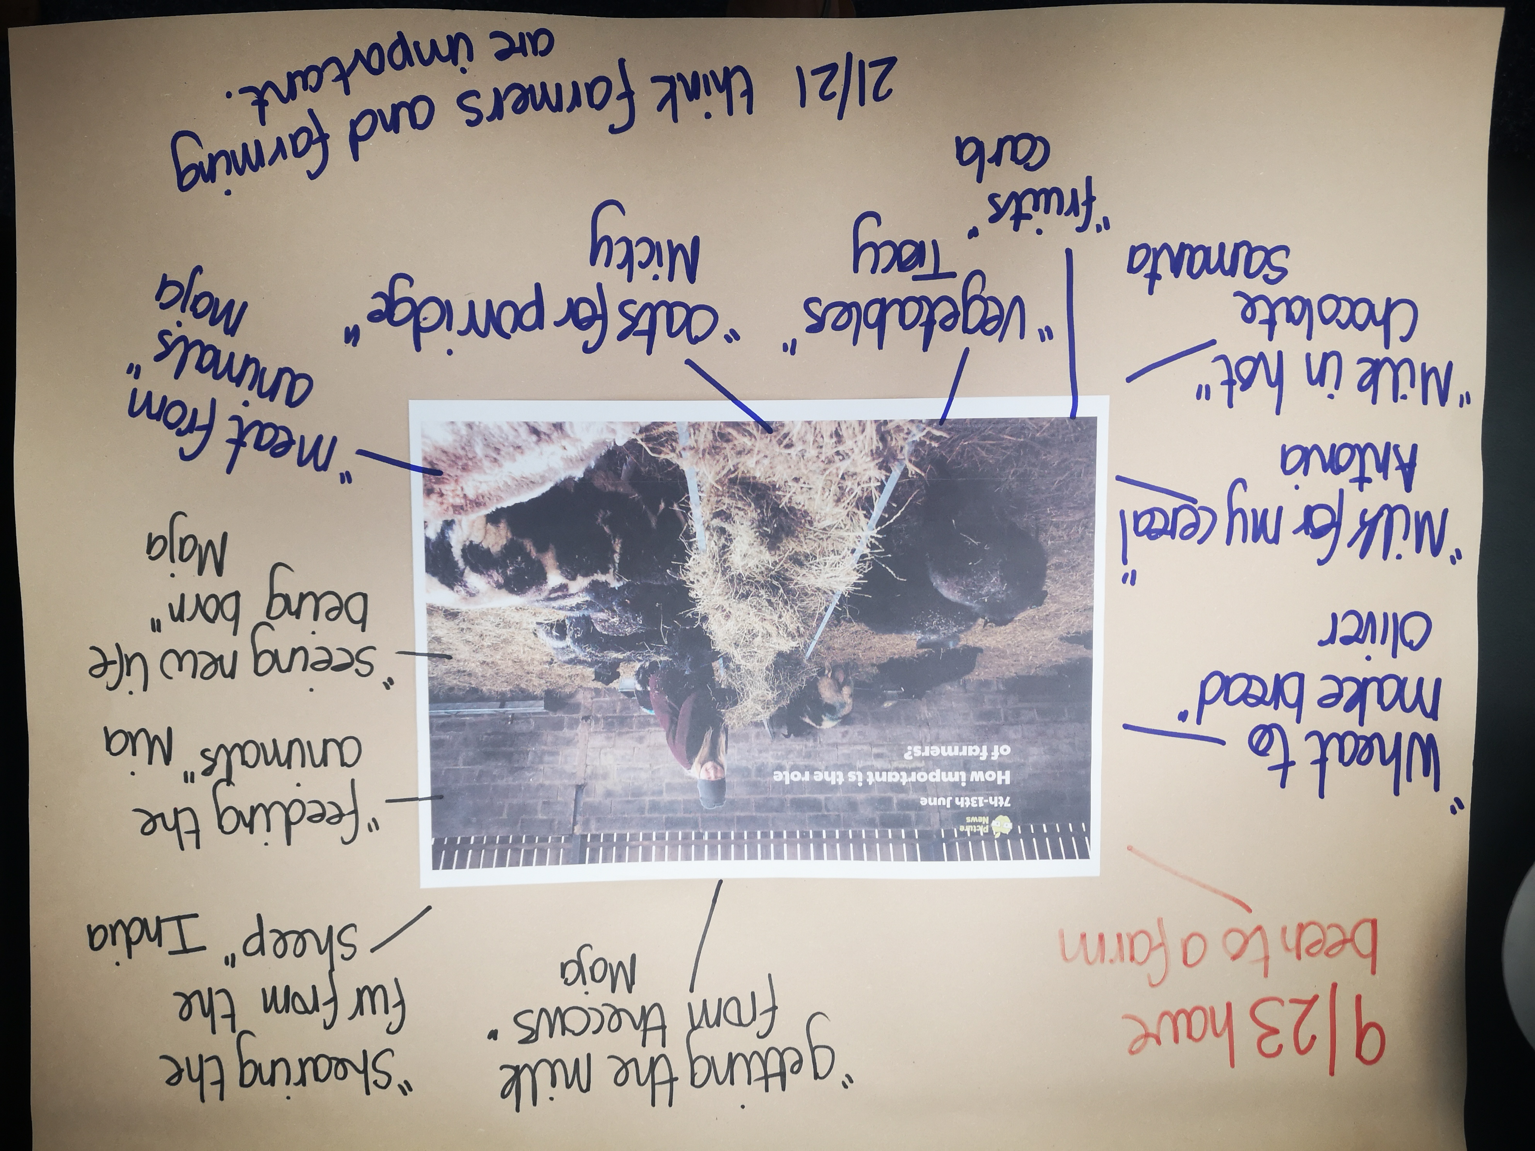

Year 6 produced some fantastic posters based on pollution after a discussion that
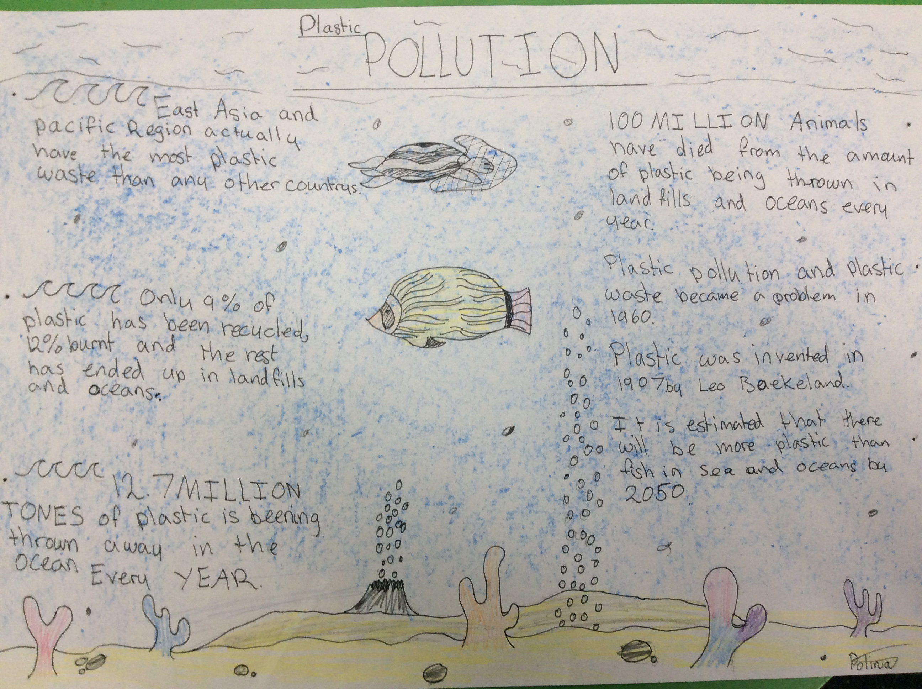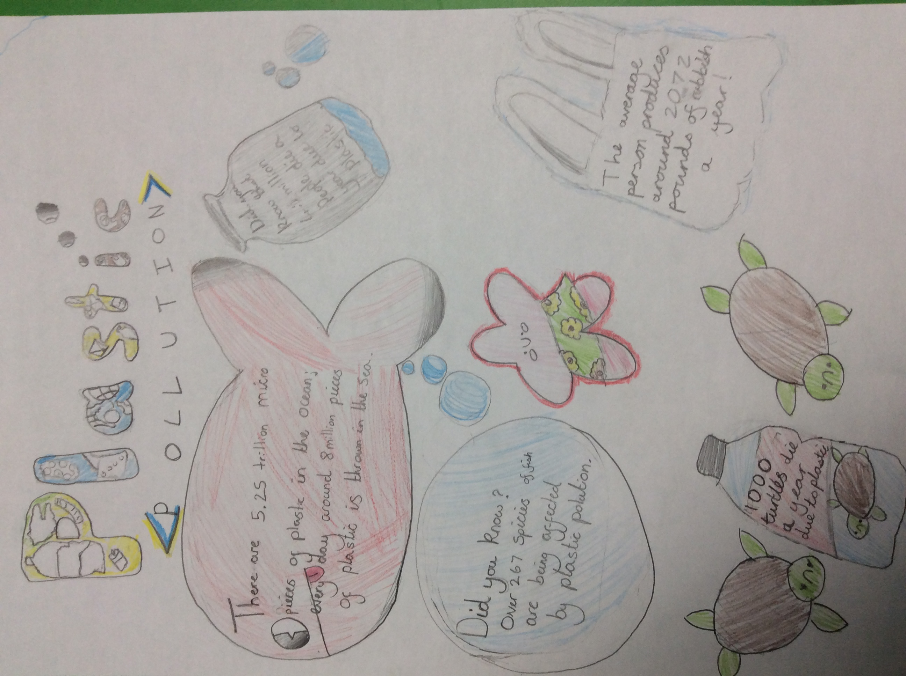
Autumn 1 2021 monitoring focus – the use of multicultural books to inform children of the differences and similarities between countries and the people who live in them.

Actions towards action plan
- The above will impact on the children’s speaking and listening.
- The above will impact on teacher confidence.
- Profile of Global learning through whole school projects eg. Erasmus KA1 and 2.
- Connecting and collaborating with local partners through KA2 project and Connecting Classrooms.

Next steps
To continue to lead the International projects.
To liase with MAPS and SPAG about project ideas.
To liase with partner school in Uganda to organise exchange of ideas and work.
To work with the staff member who is taking on leading the ISA next year to complete the application and action plan.
To monitor the use of multicultural books.

