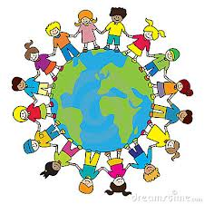
Global Learning Moderation
Autumn 2 2020/21

Ongoing International projects

KA2 Poland
- Penpal system set up between children in BK, SPAG, MAPS and the three Polish schools. 15 children from each English school have written to the other children introducing themselves and telling them a bit about our school and Lincoln.
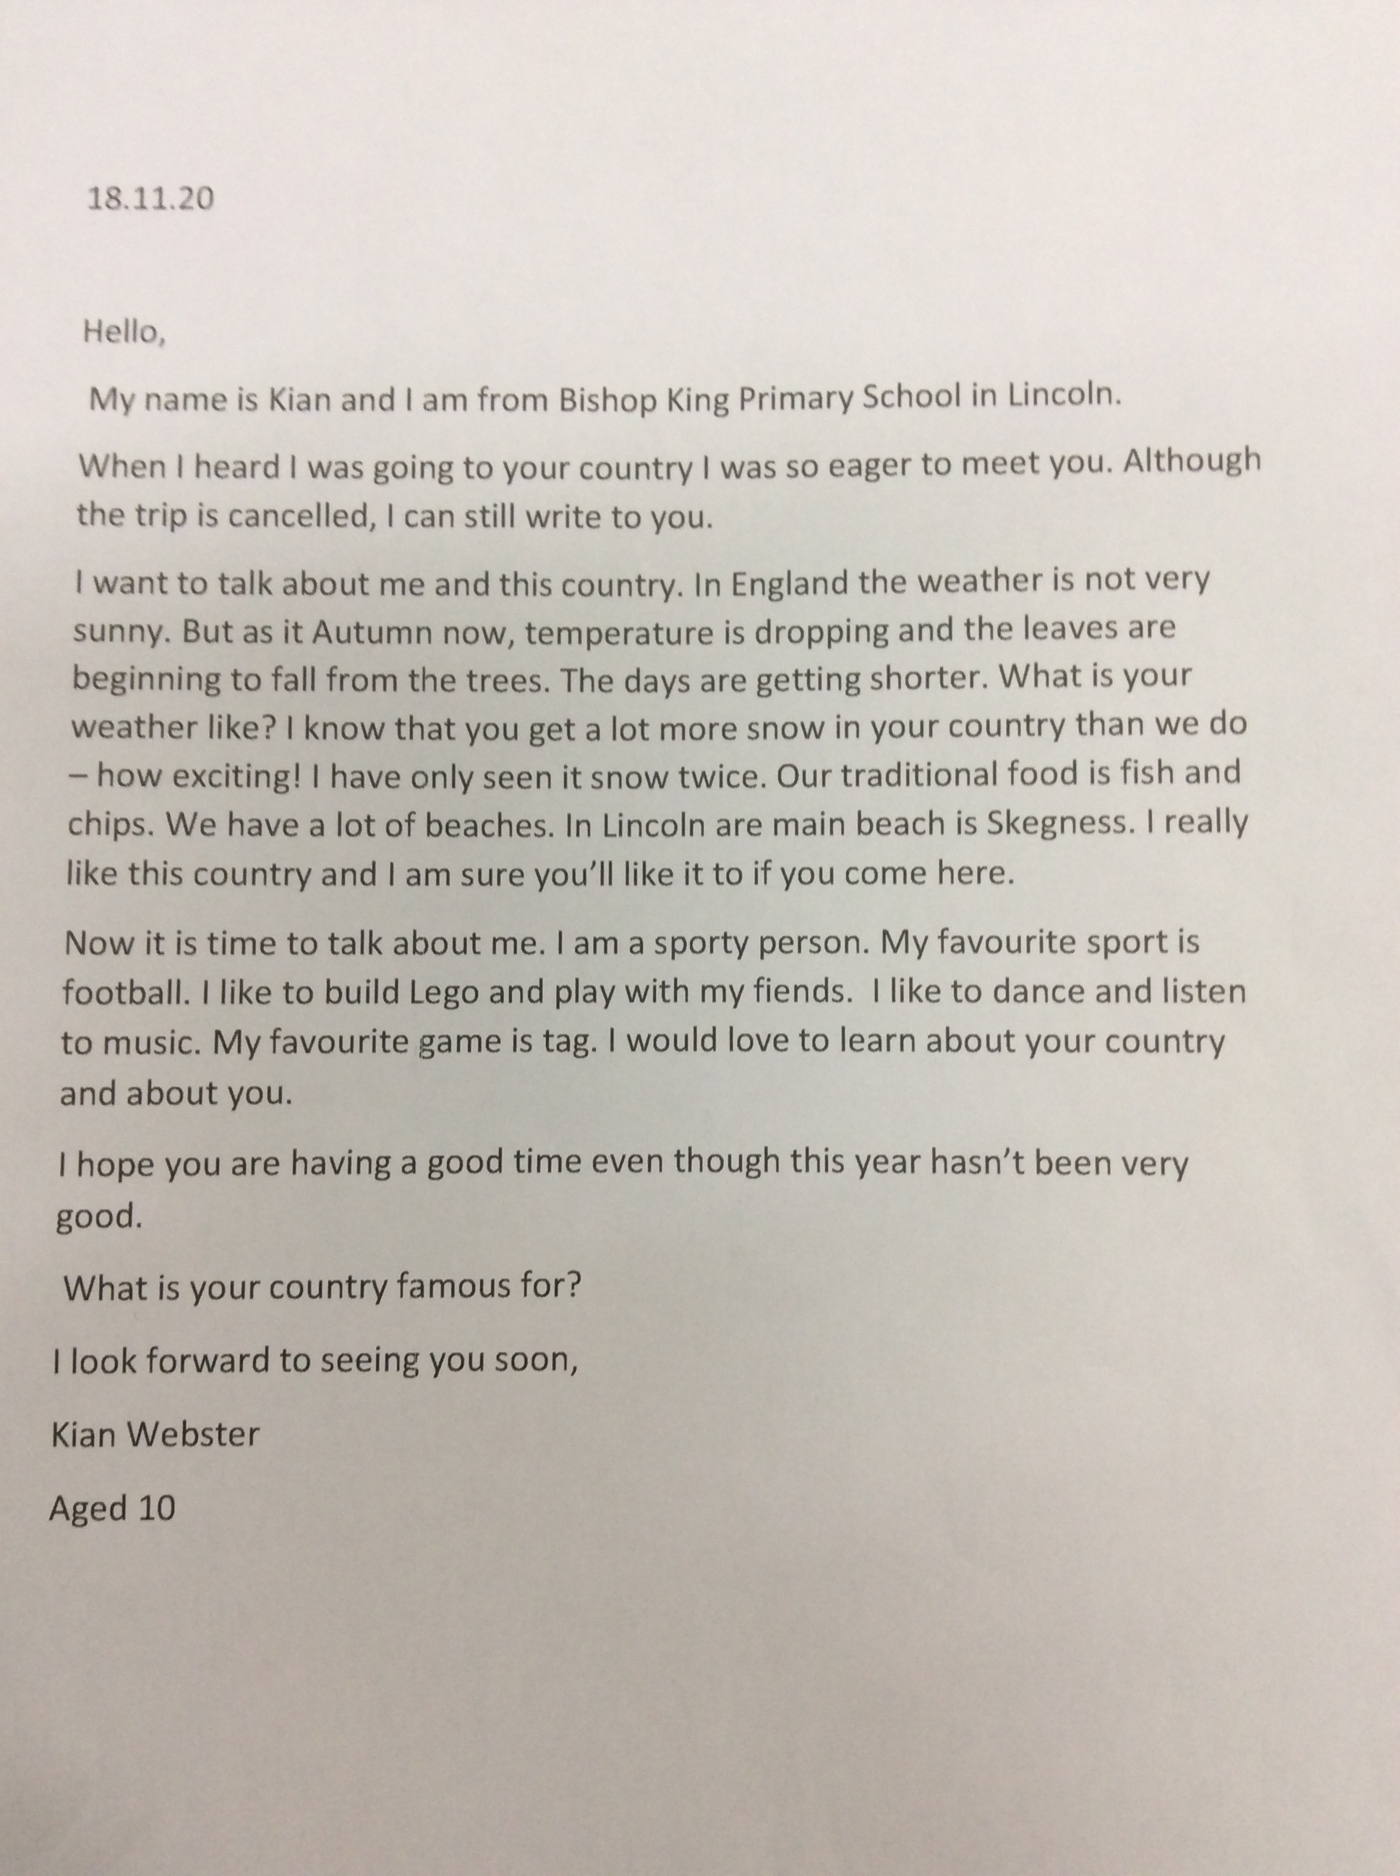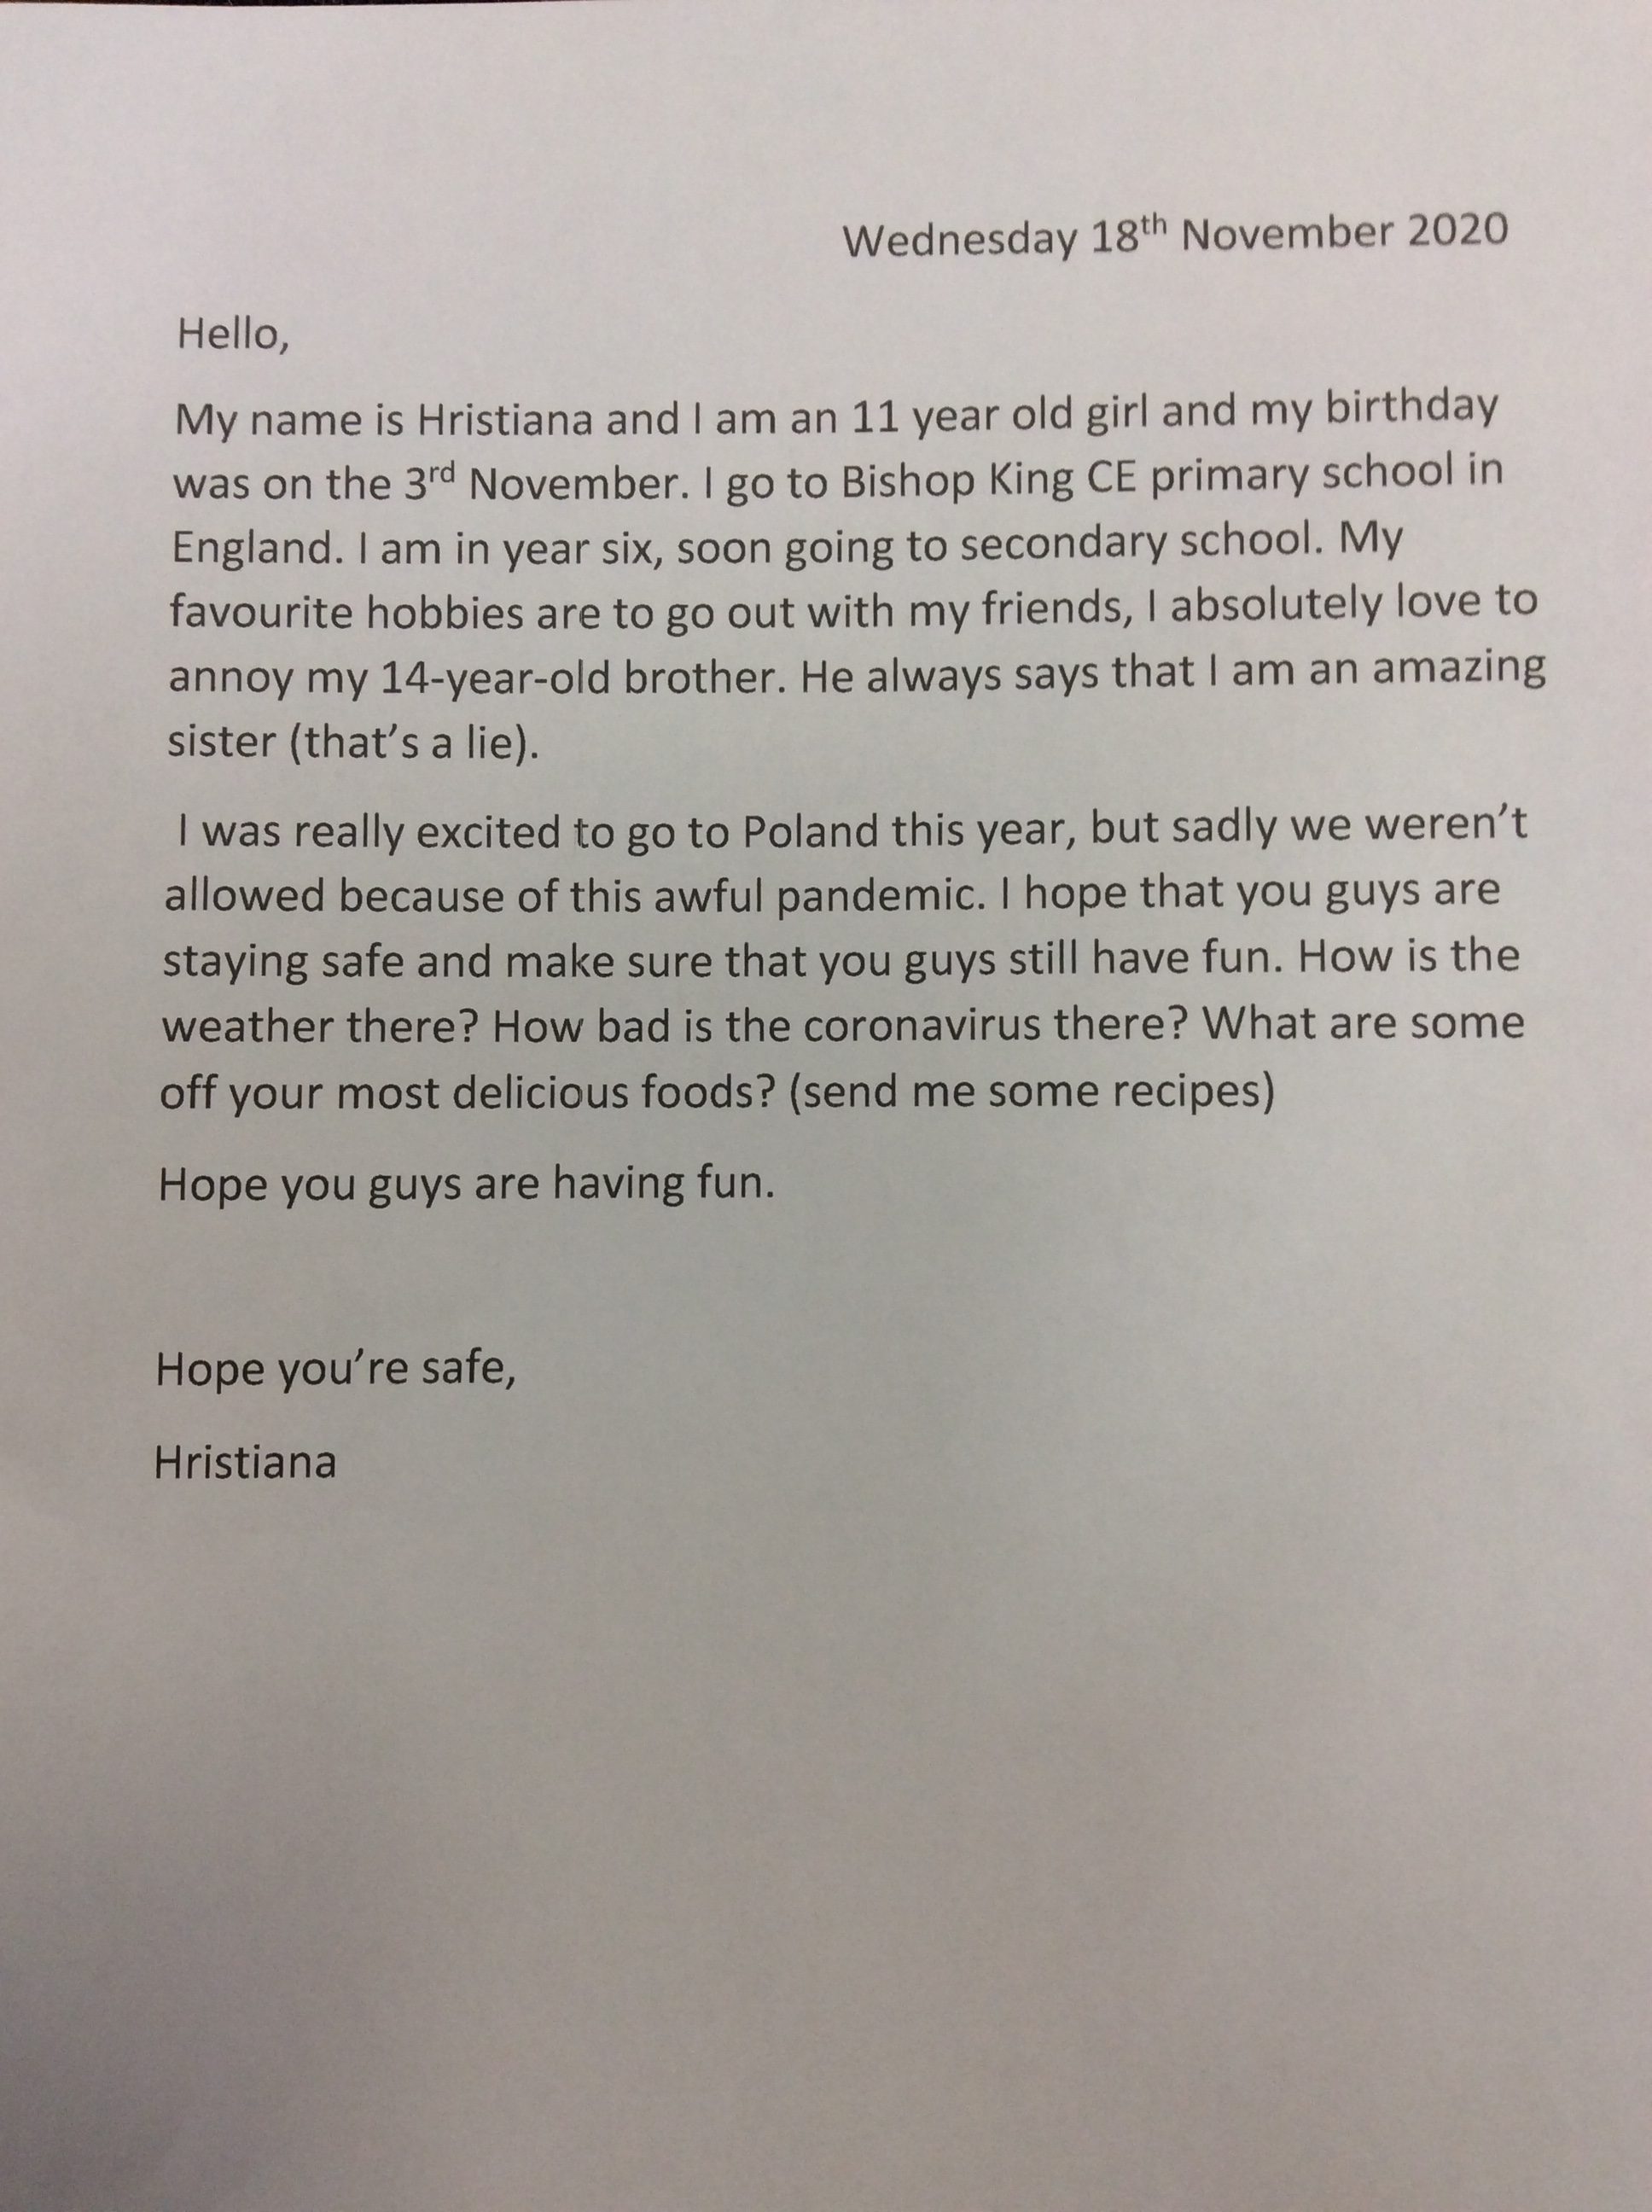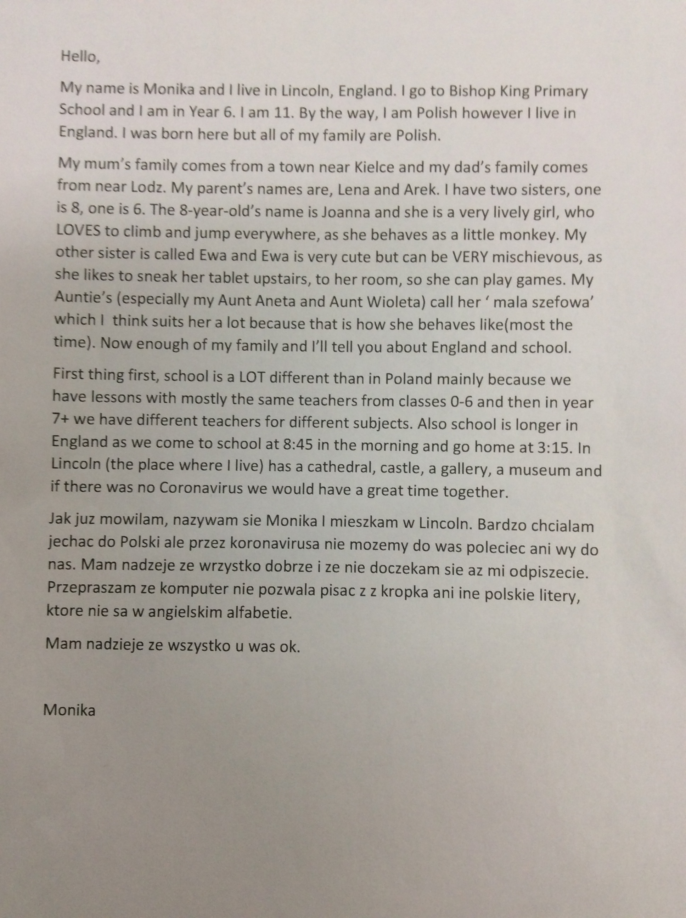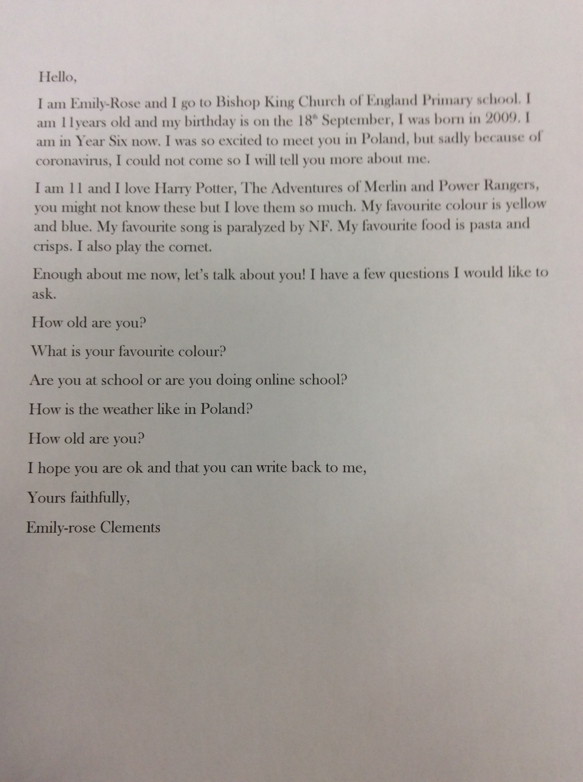
- The letters have been received by the Polish schools. They are all currently closed and completing online learning. They are intending to reply in the New Year.

KA1 Bulgaria and Romania
- Start date postponed until January 1st 2021.
- Funding has been granted.

KA1 – France
- Final evaluation report submitted and sent. Waiting for approval and final funding!

Connecting classrooms
- Partner school – Gombe Standard Primary School, Butambala,Uganda.
- Christmas cards have been sent as an way of making initial contact.

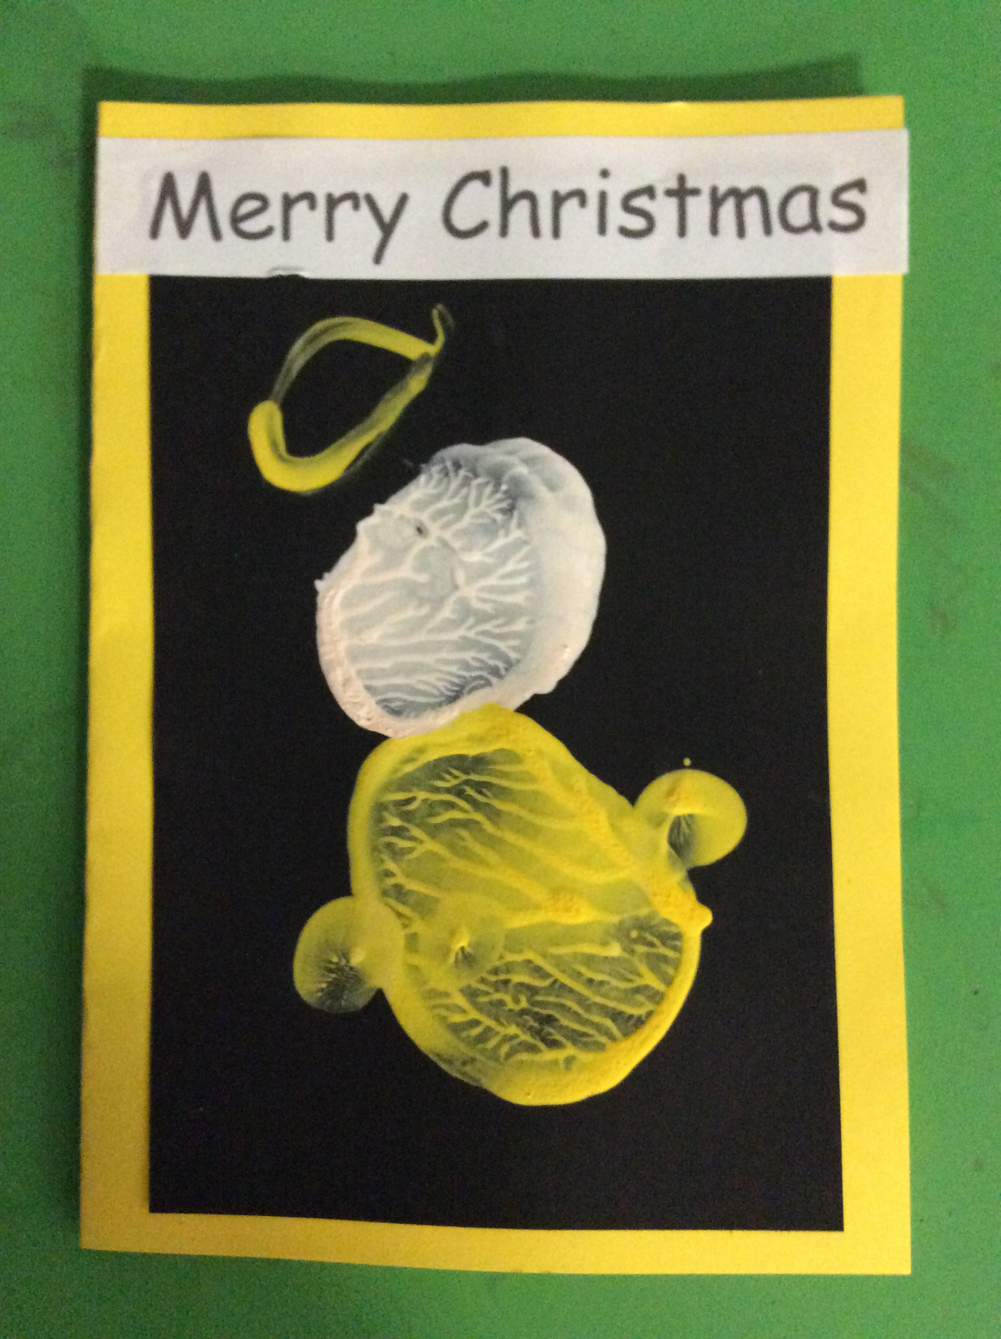
Maintaining contact with partner schools during difficult times
We have sent them all Christmas cards.

Global Learning and our multicultural ethos within the curriculum

World Hello Day 2020
World Hello Day has been a great success again this year with children learning about a wide range of countries, cultures and traditions. As usual all classes chose a country from which someone in their class originated. The countries chosen included Mexico, Poland, Spain, Italy and Vietnam.

Due to the current global situation all activities took place within the classrooms and have been shared virtually. Key Stage 2 classes have made some fantastic films to show what they learnt about their chosen country whilst Early Year and Key Stage one used Google classroom to say hello to each other in their countries language.

Nursery - England
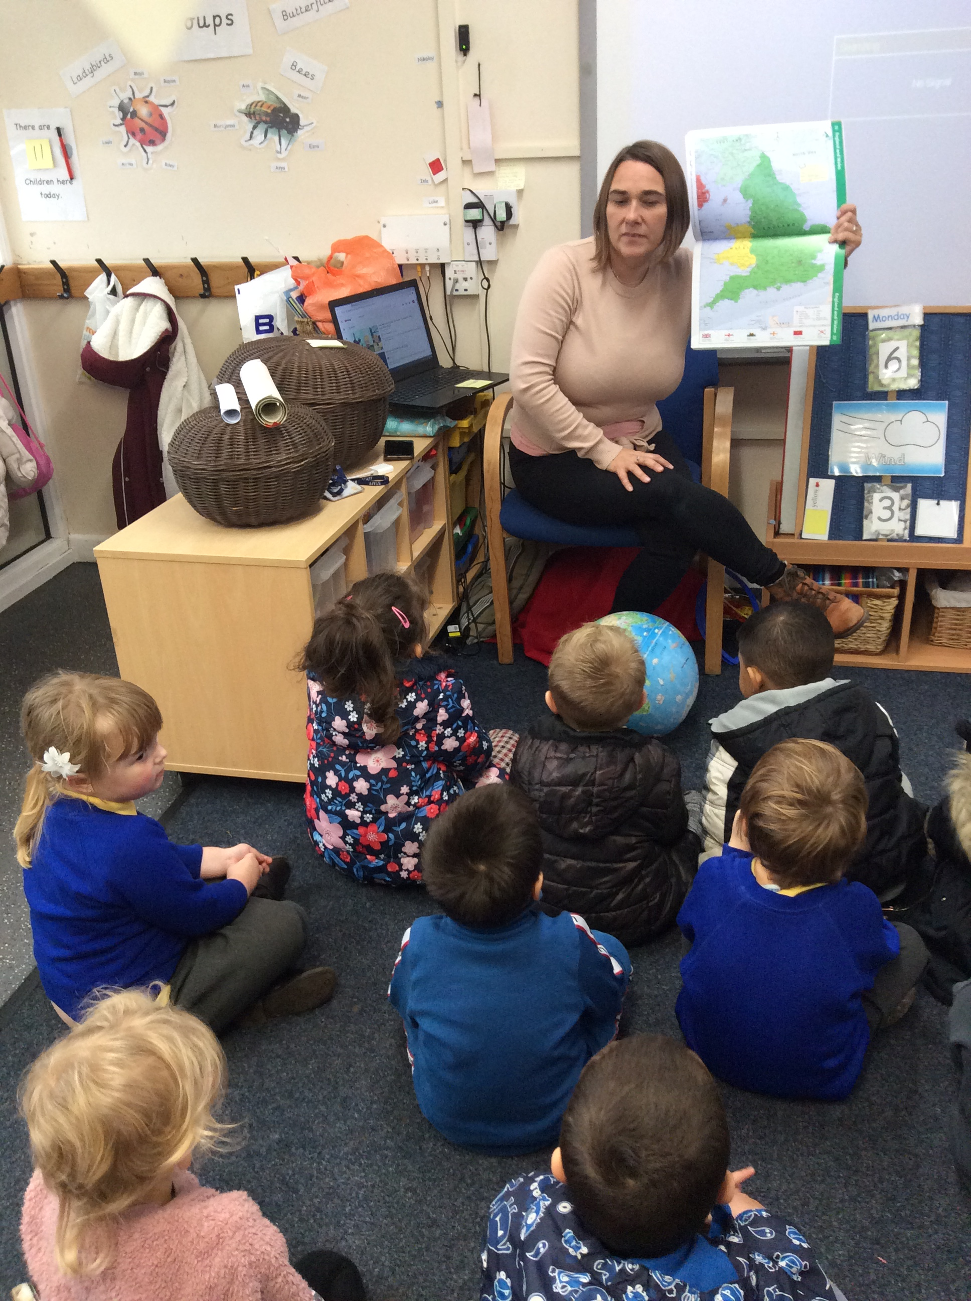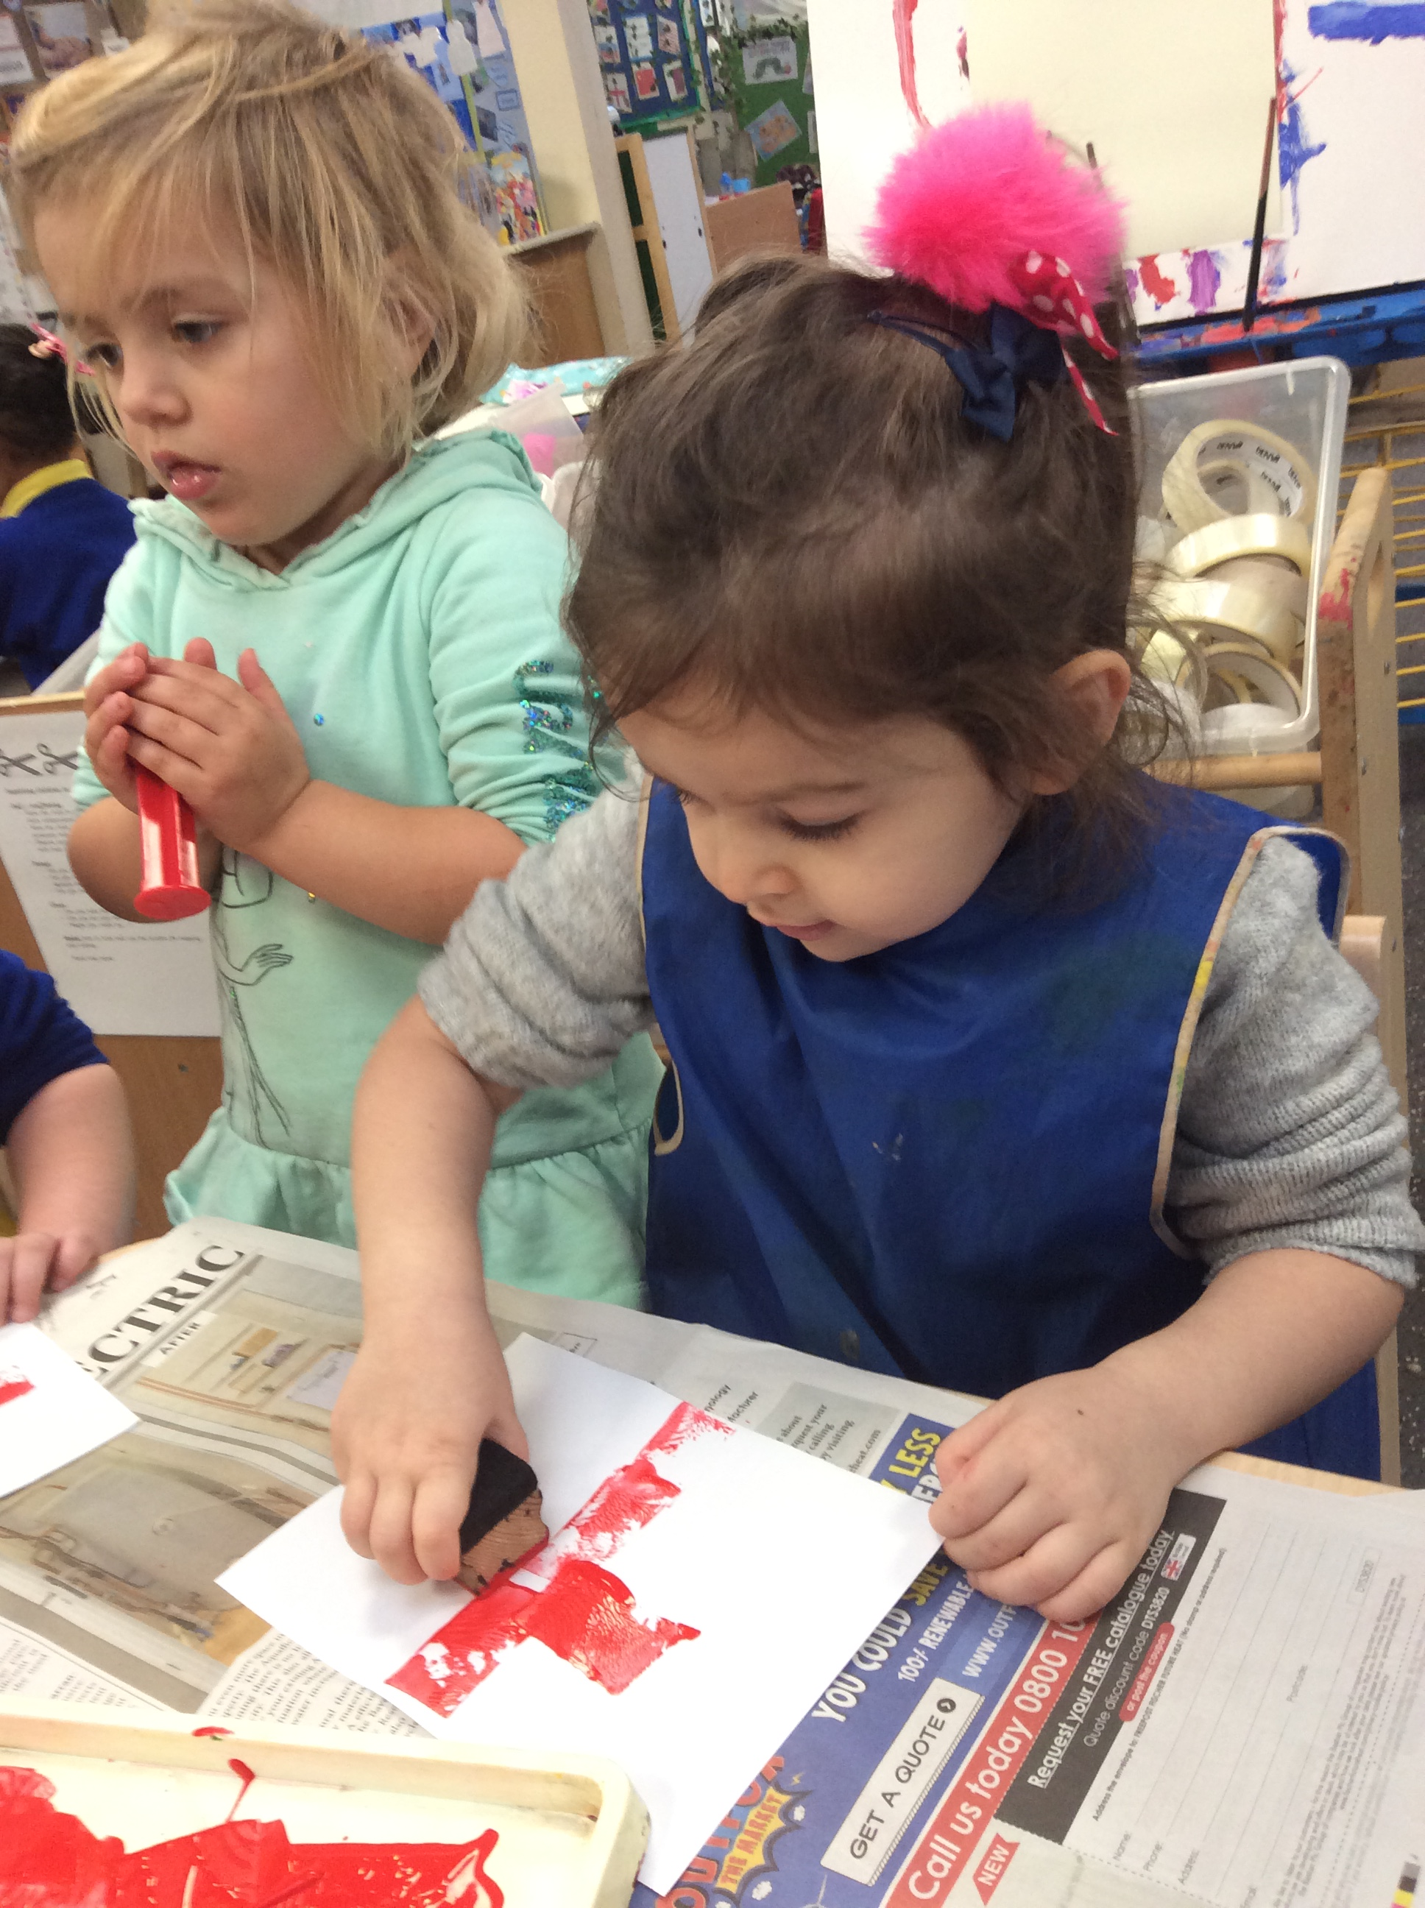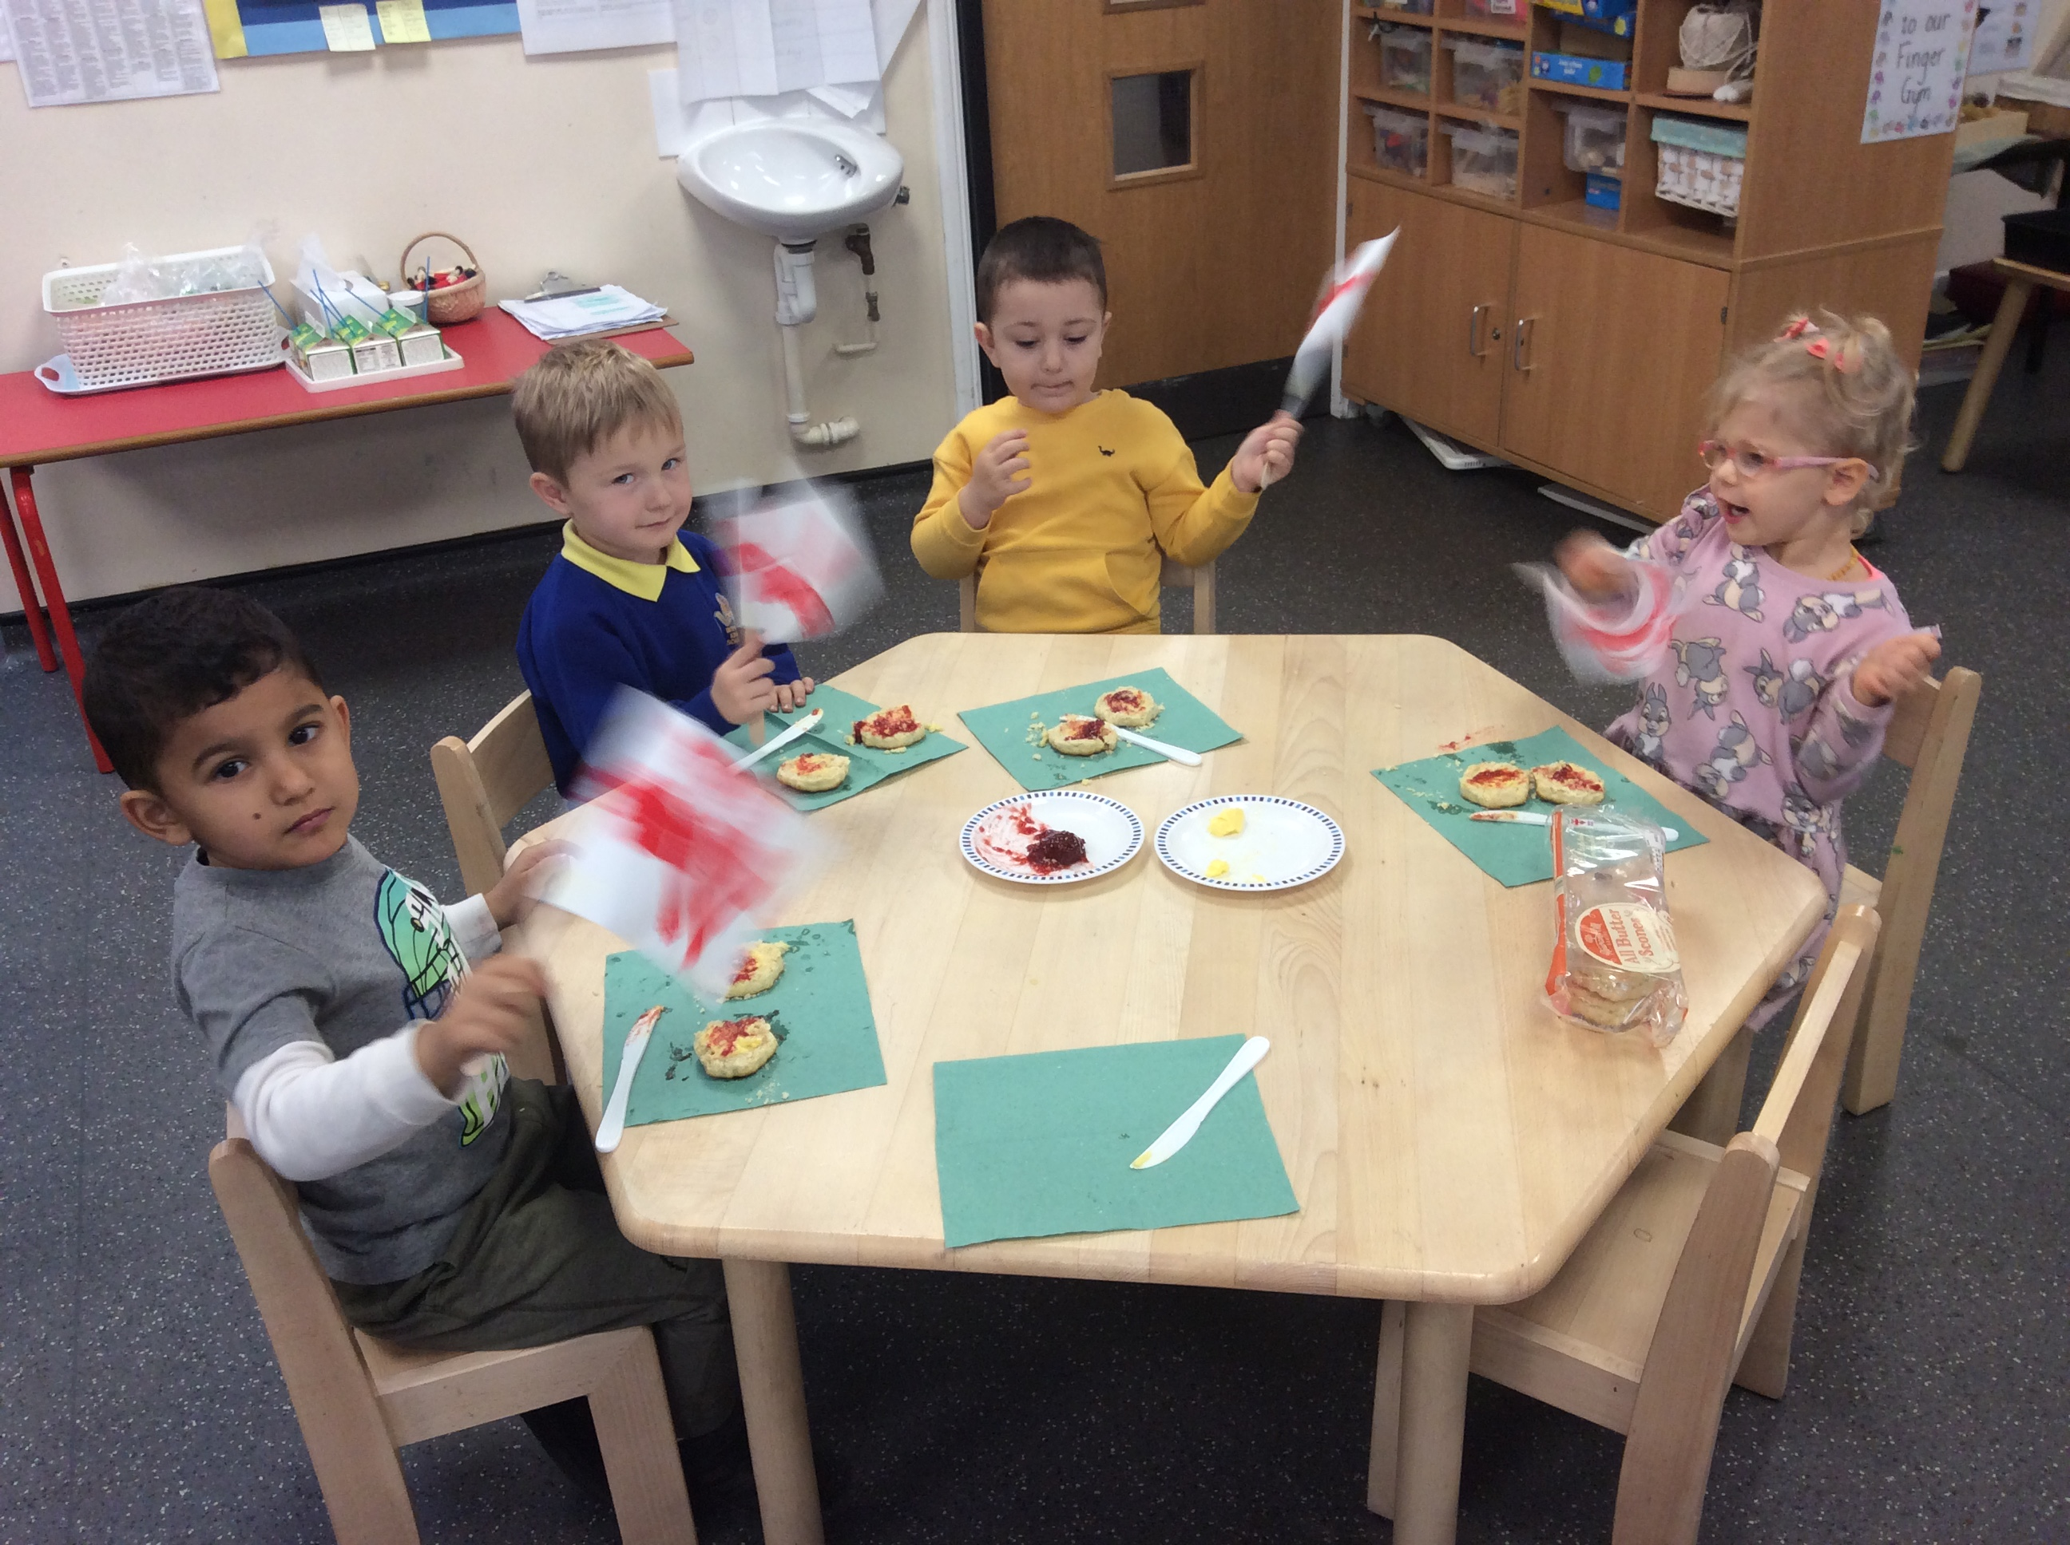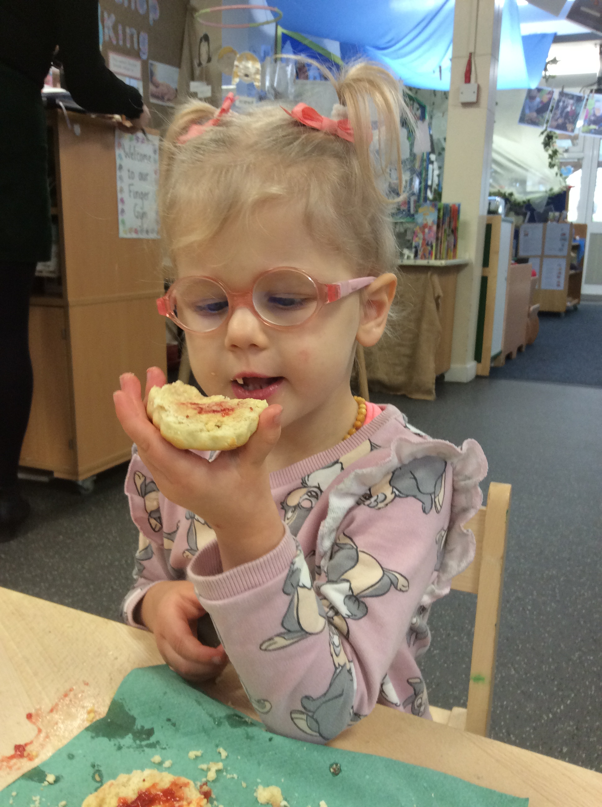
Reception – India
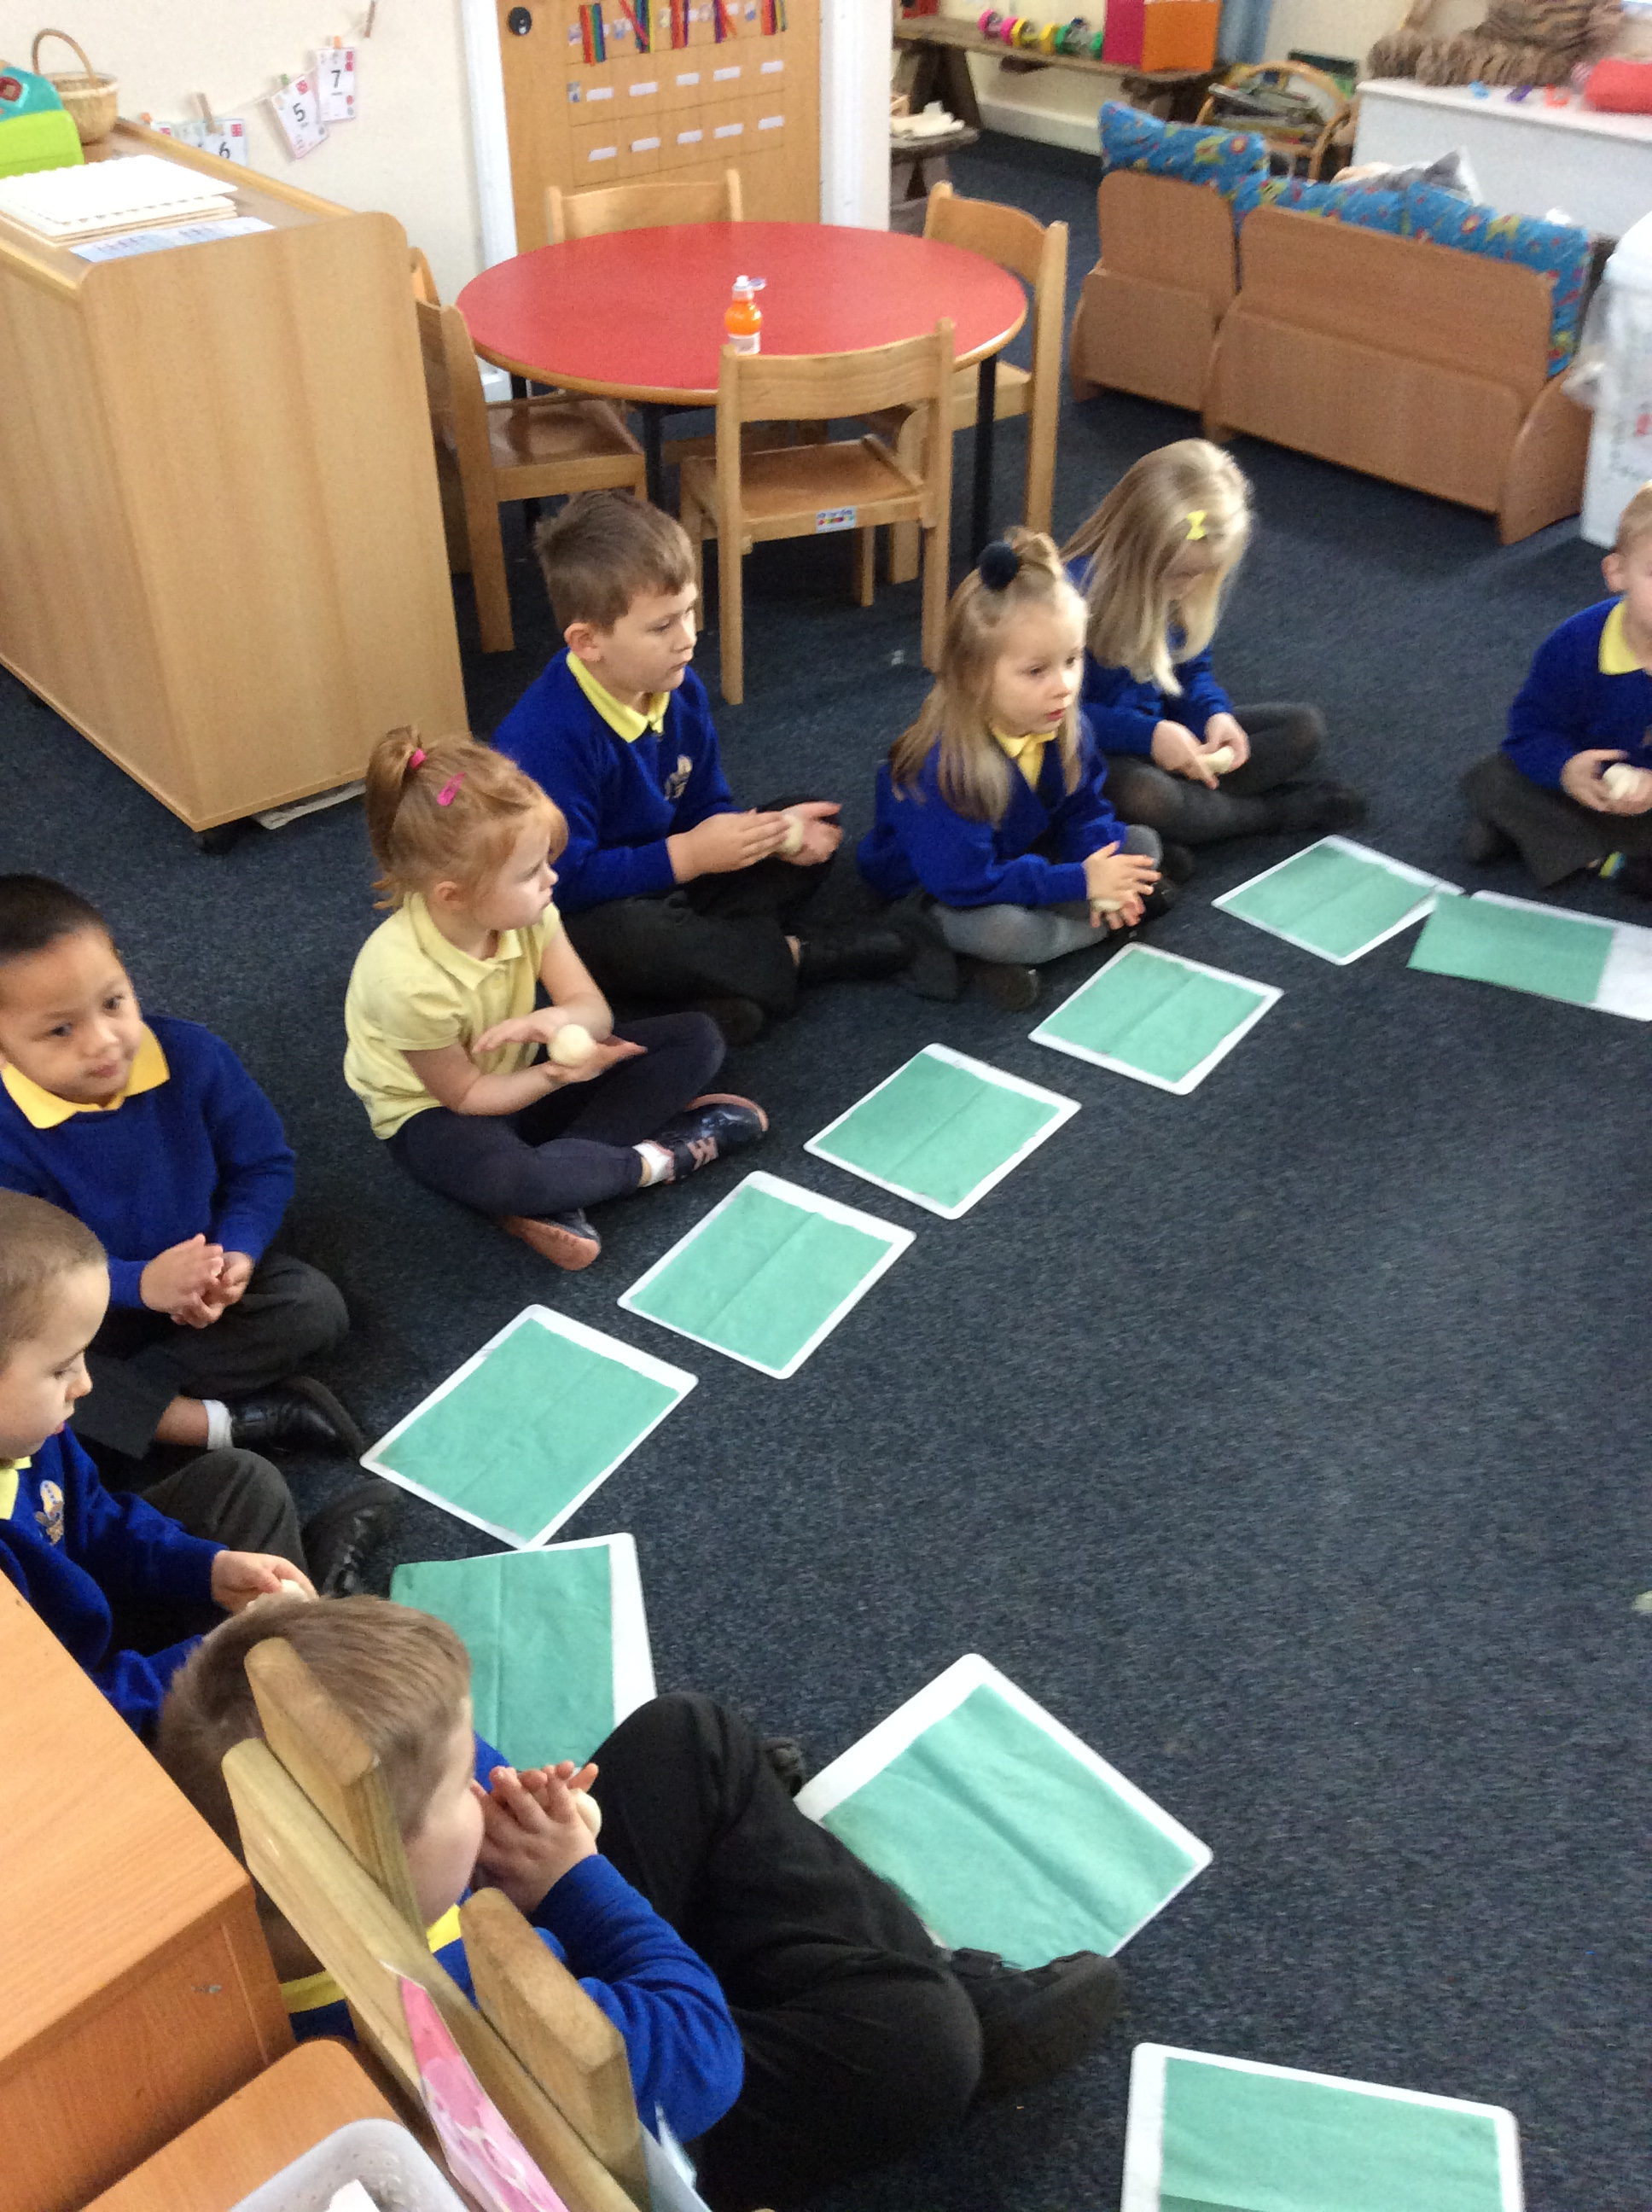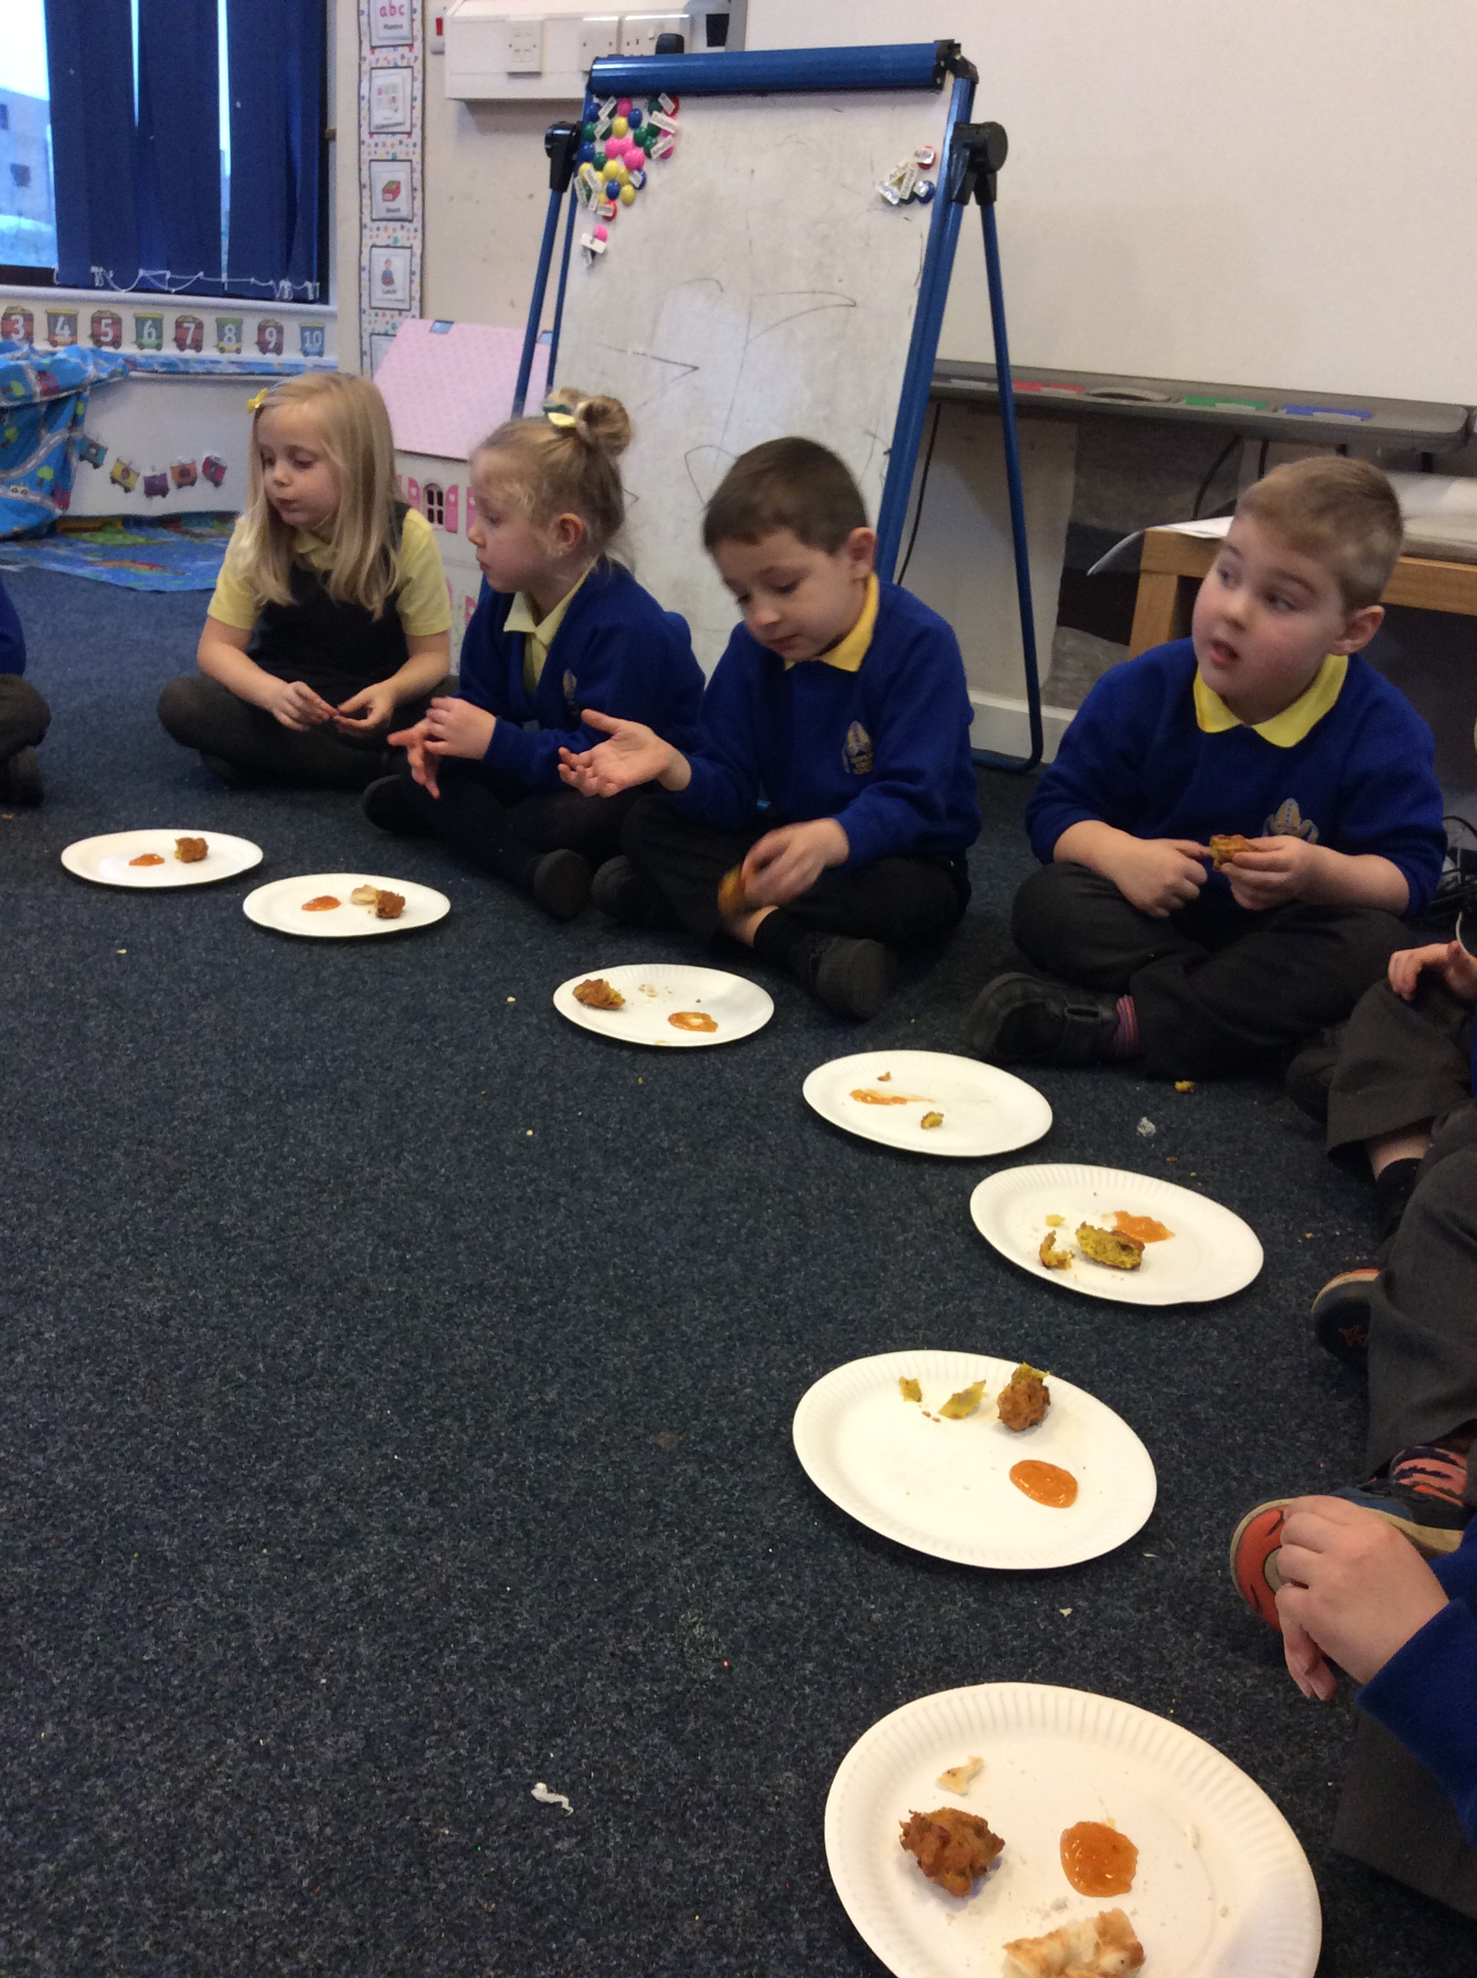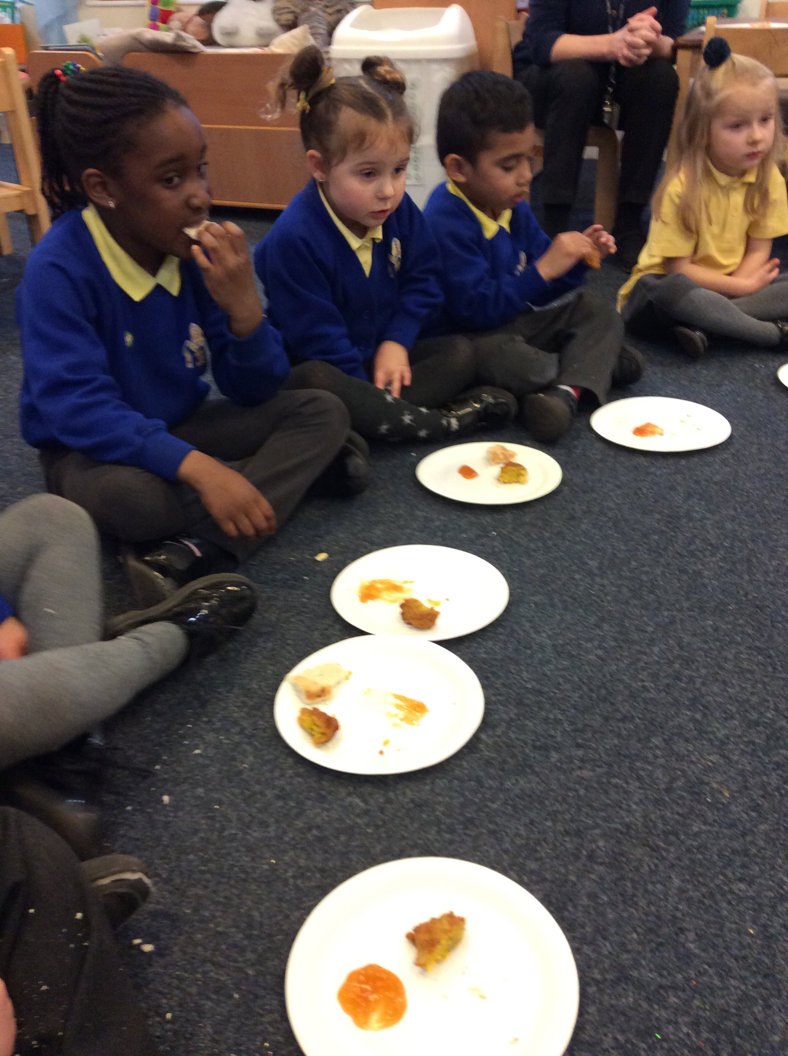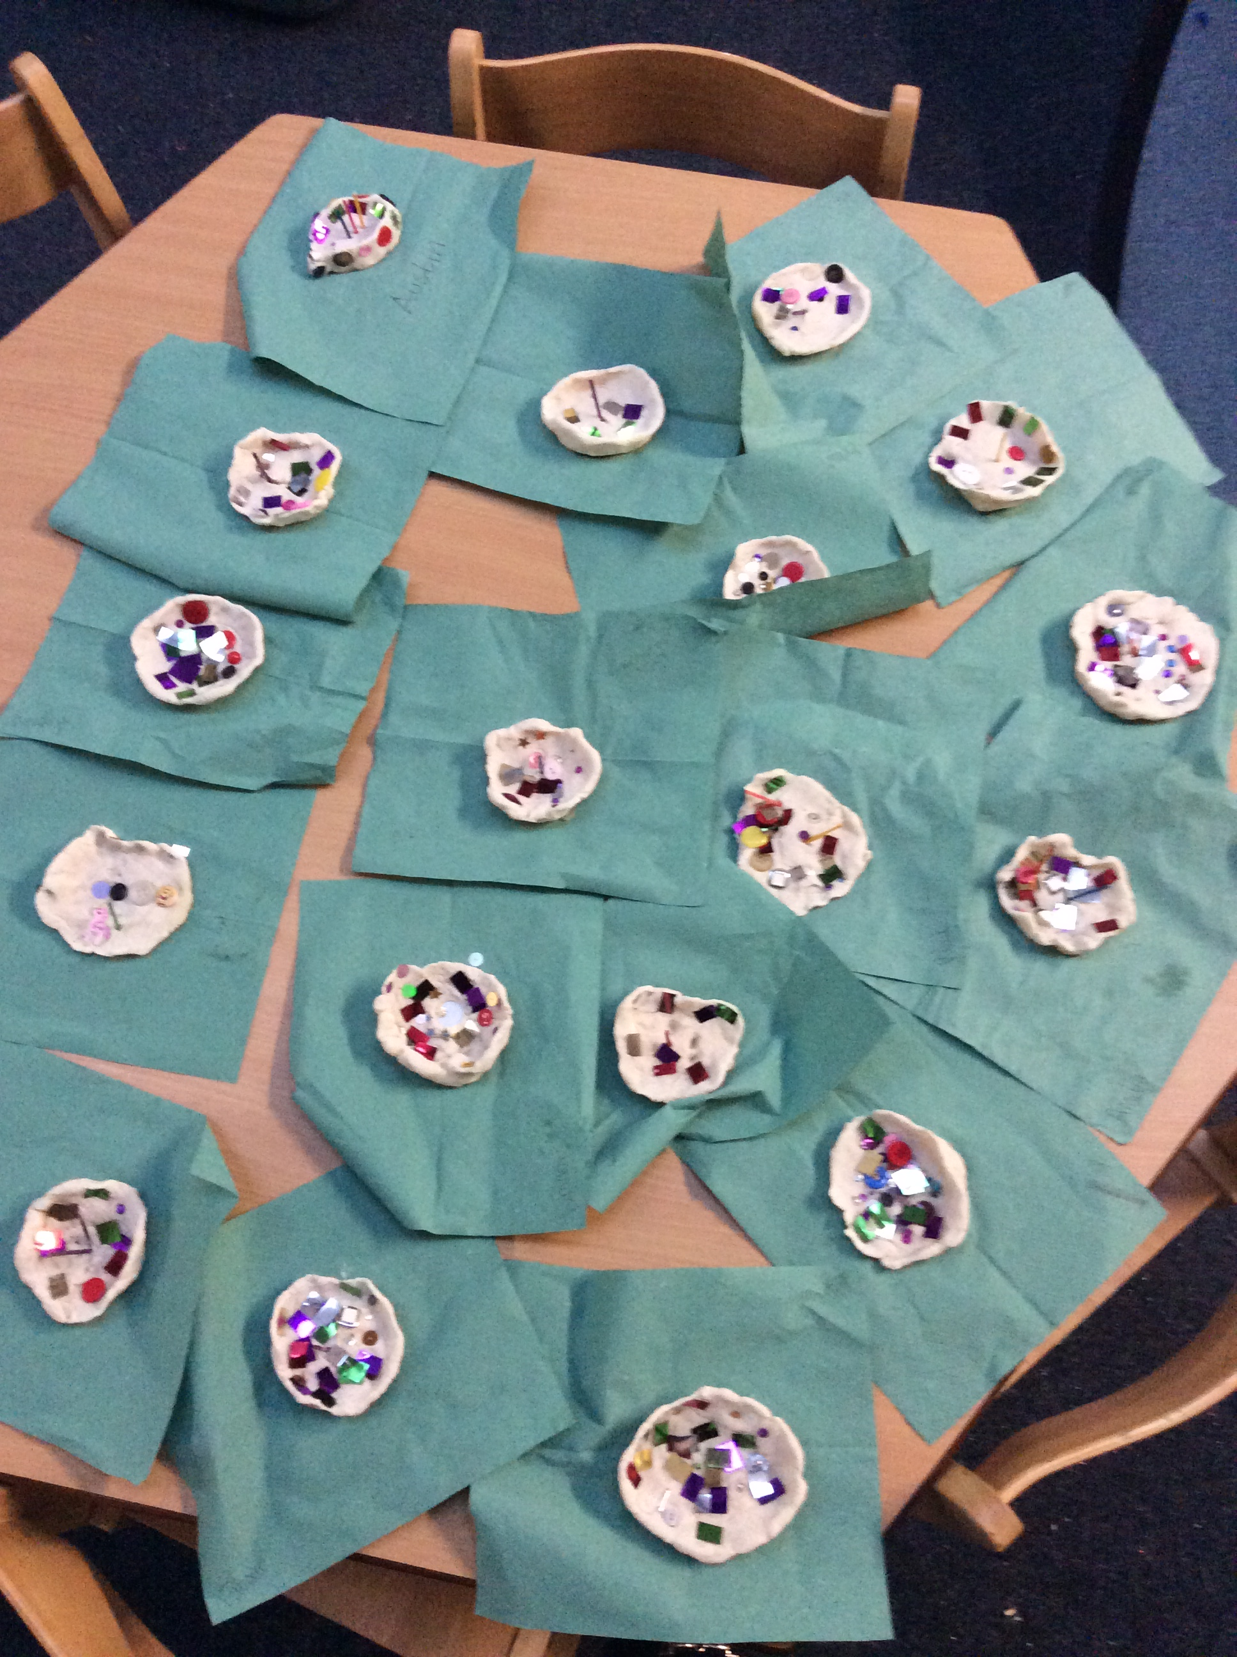
Year 1 – India
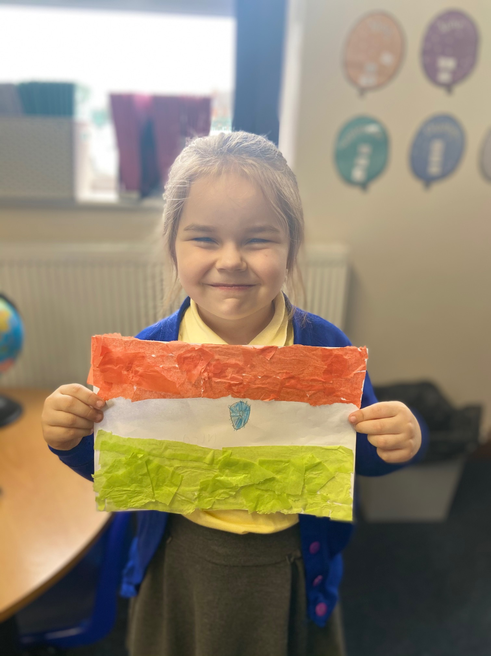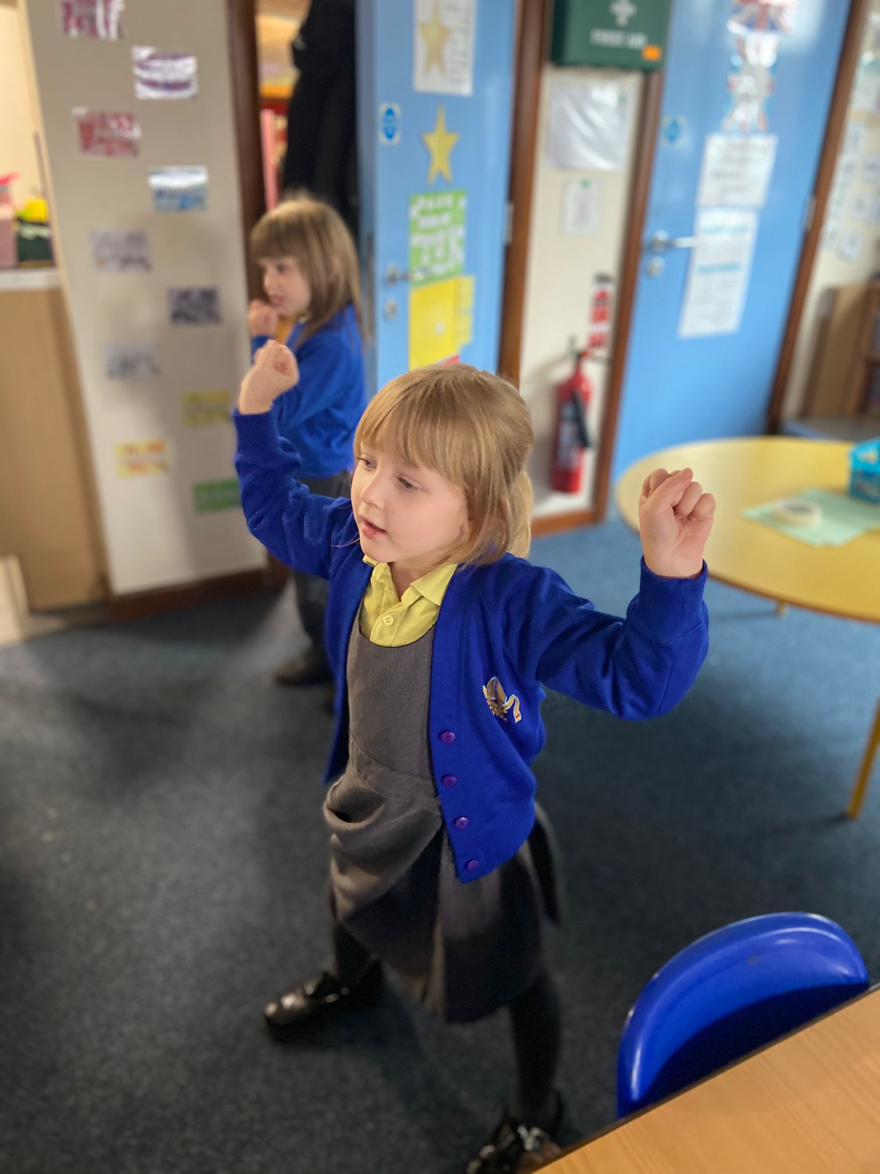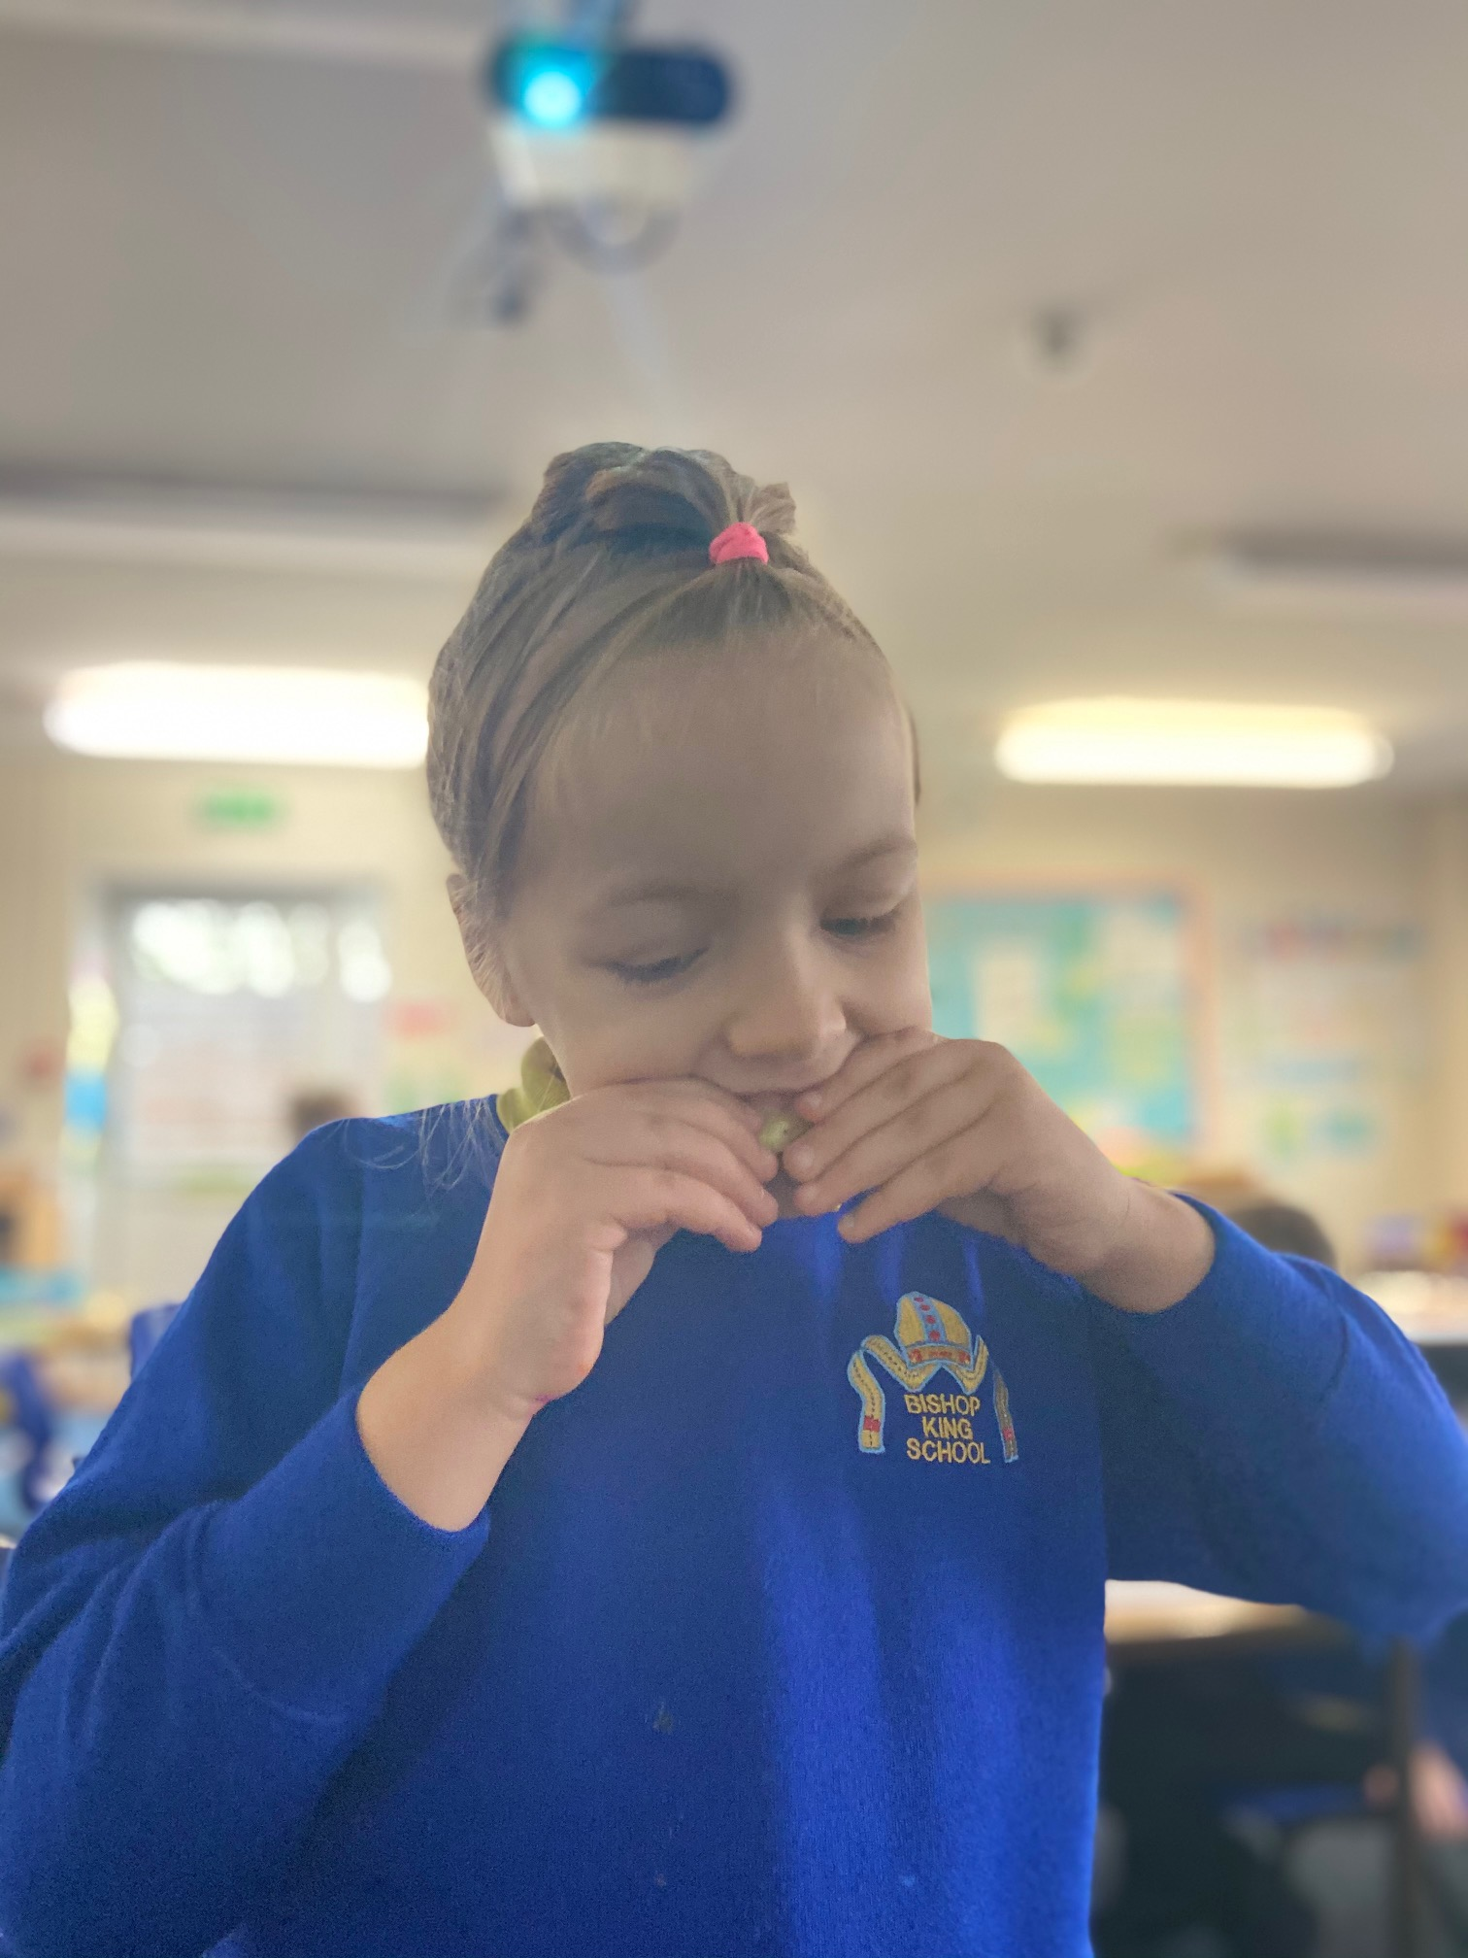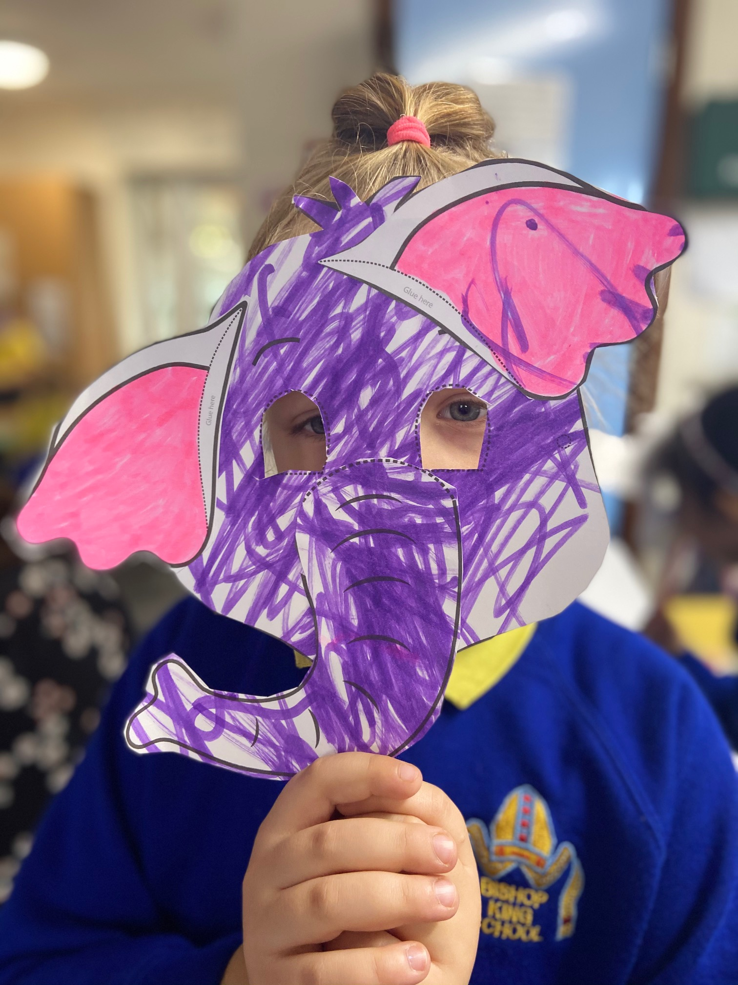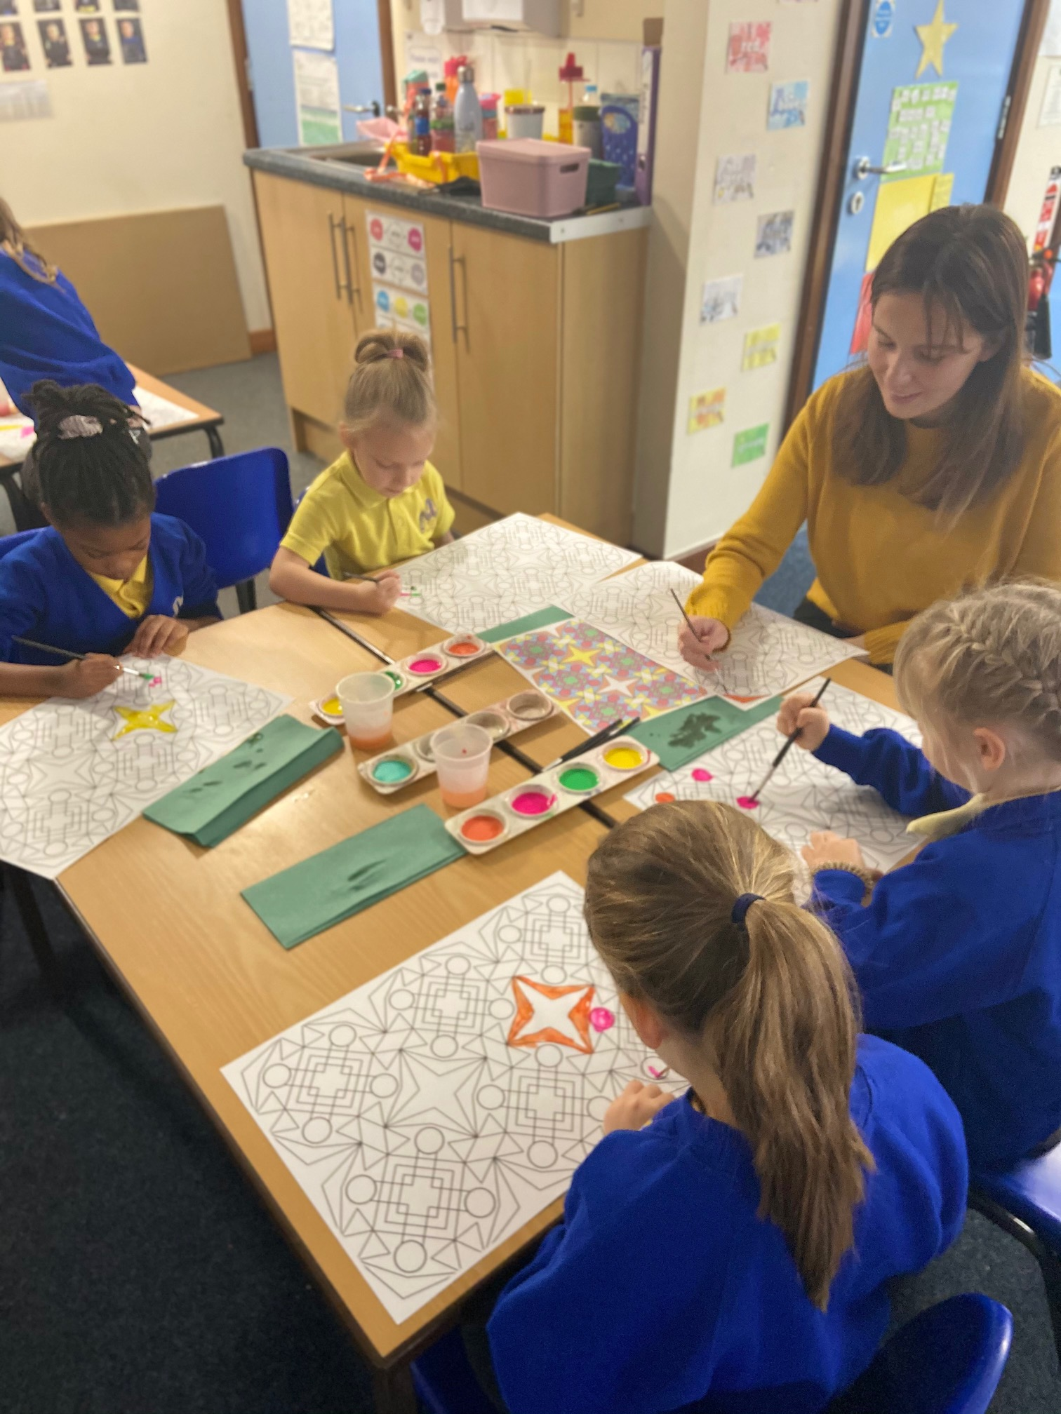

Year 1 – Mexico
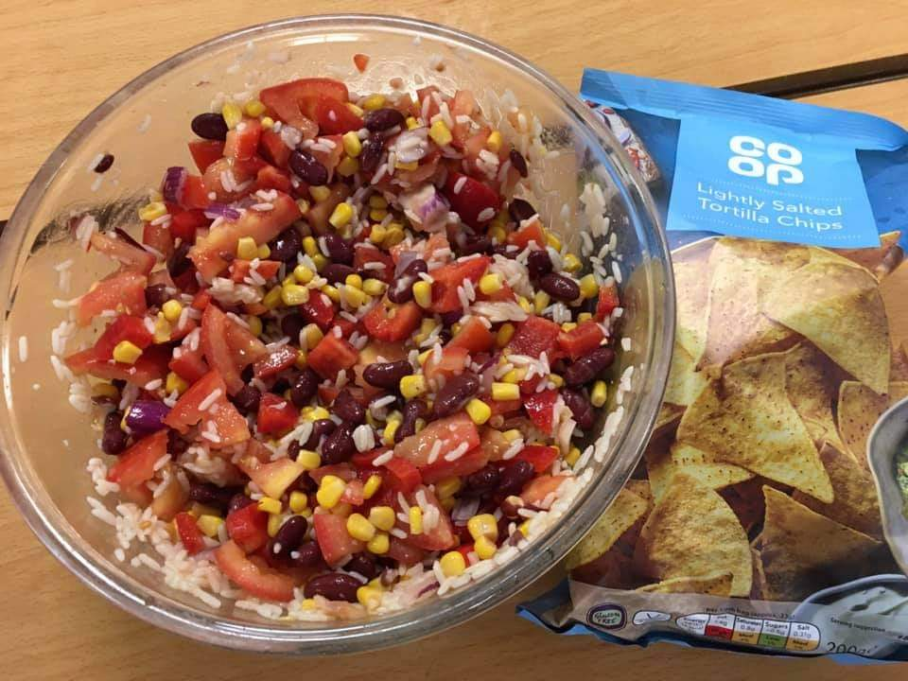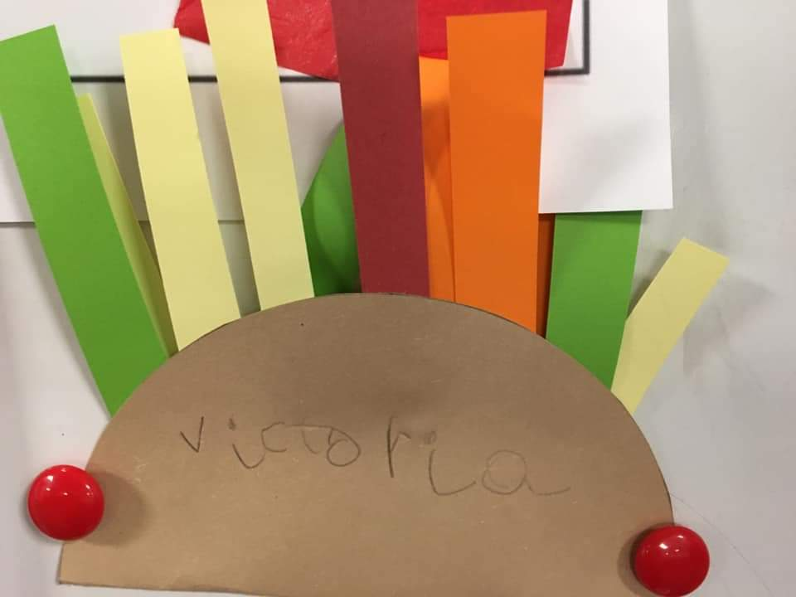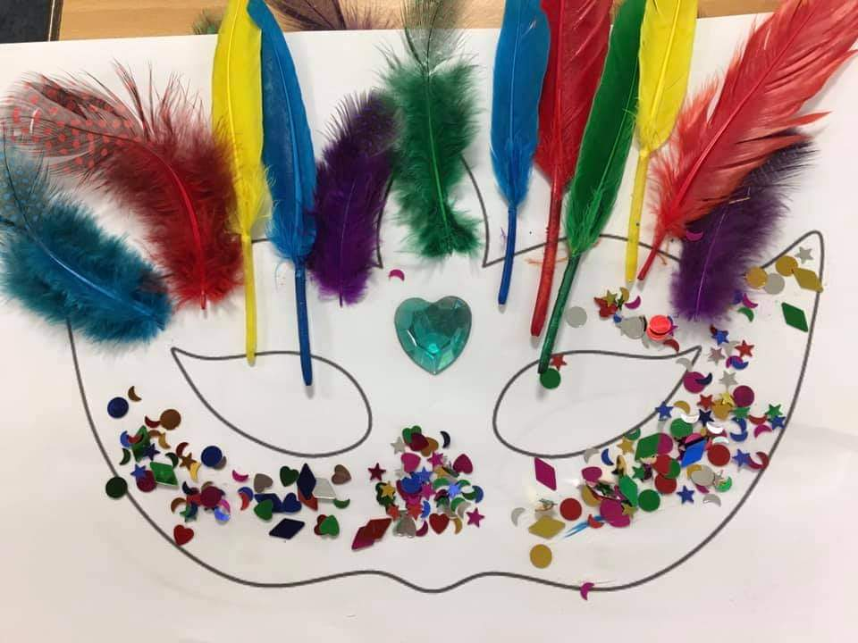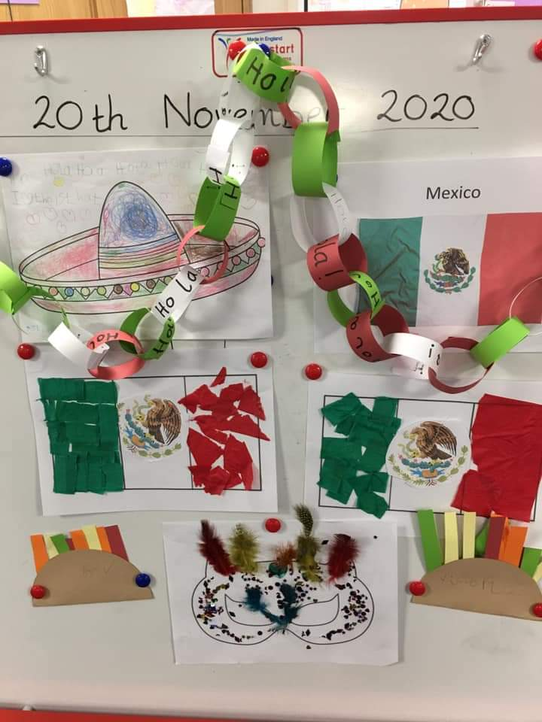
Year 2 – Vietnam
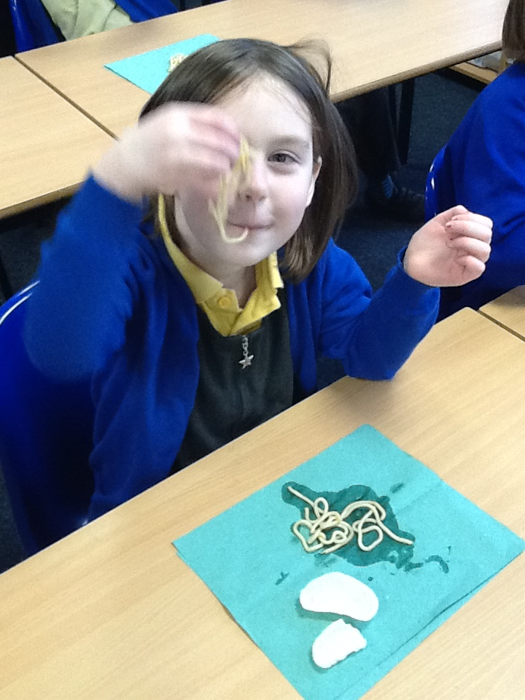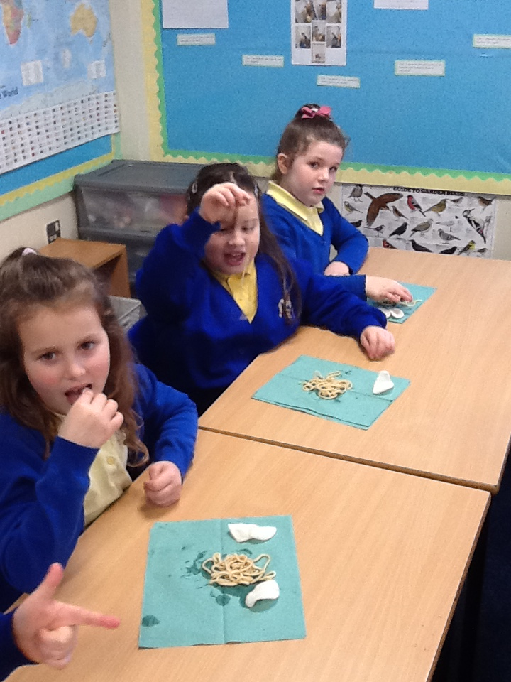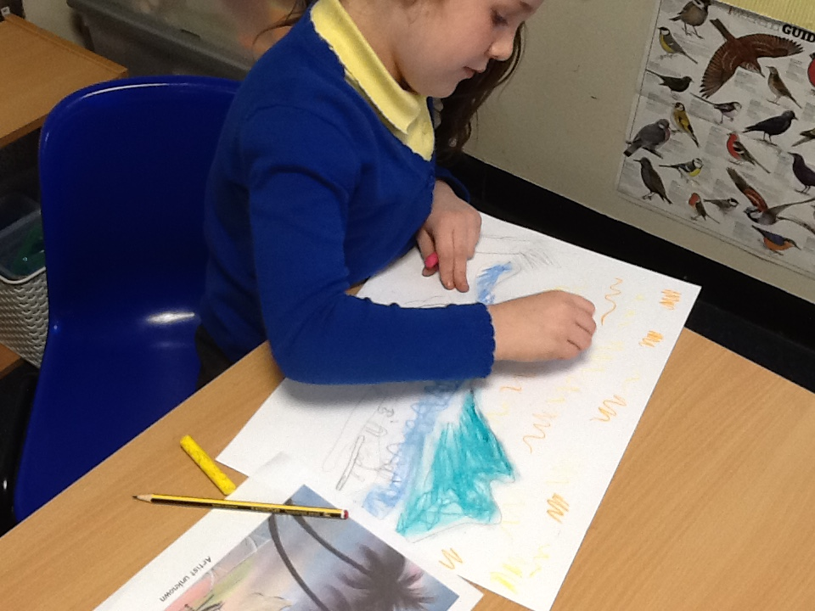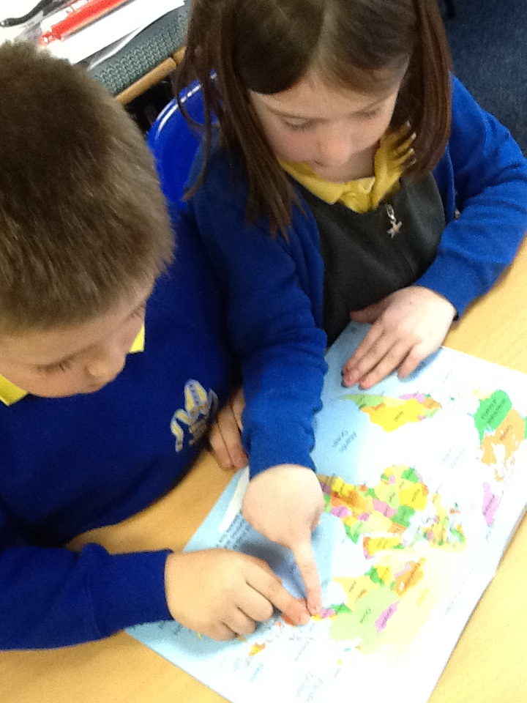
Year 2- Poland

Year 3- Holland – completed a film showing them saying hello and counting in Dutch, learning about popular food, tasting food, making tulips, creating flags and researching what Holland is famous for.
Year 3 – Italy – they completed a powerpoint showing the work they completed. This consisted on creating a fact file, learning Italian phrases, making flags and collage pizzas.
Year 4- France – they completed a film of them speaking French.
Year 4 – Spain
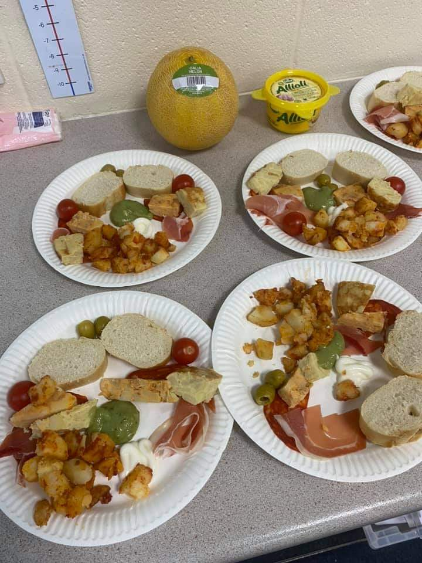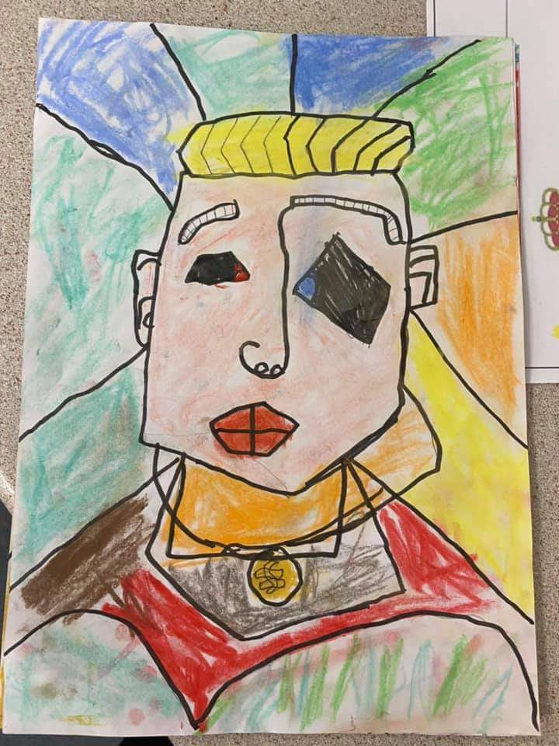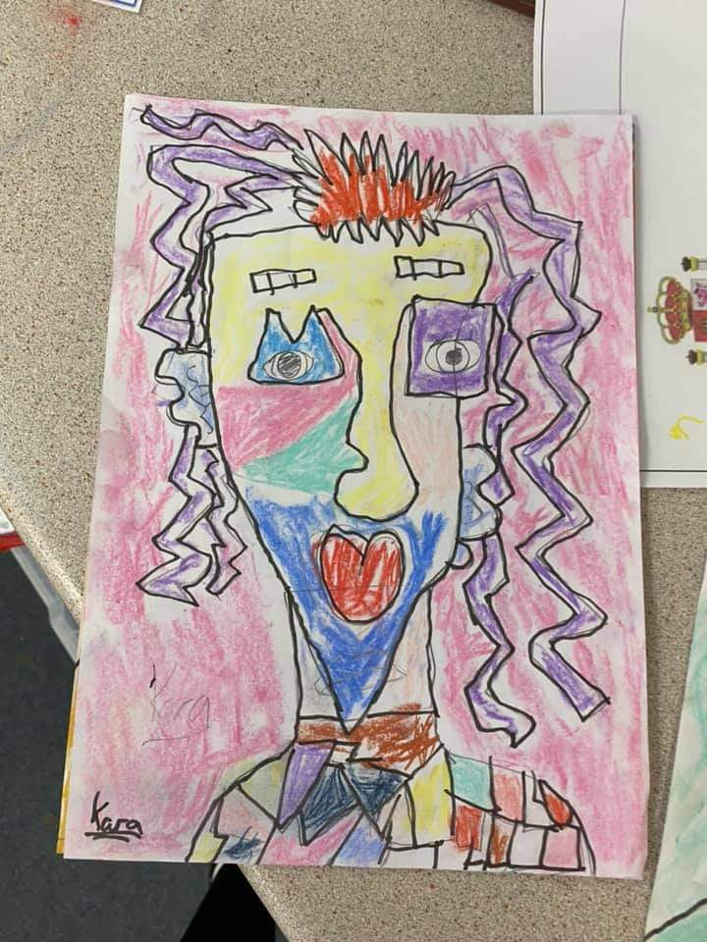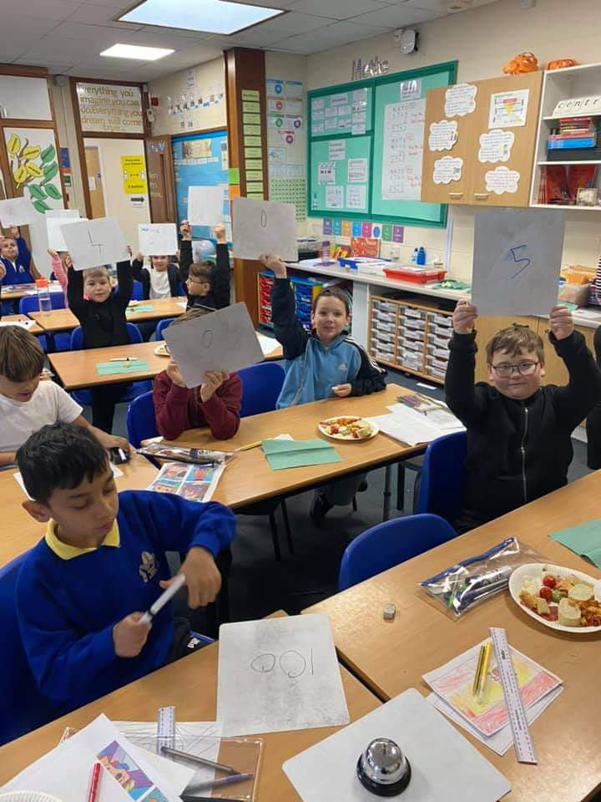
Year 5 – Japan – completed a film of the work they completed. This involved say ‘hello’, Japanese writing,
Year 5 – Mexico – they also filmed a Mexican hat dance.
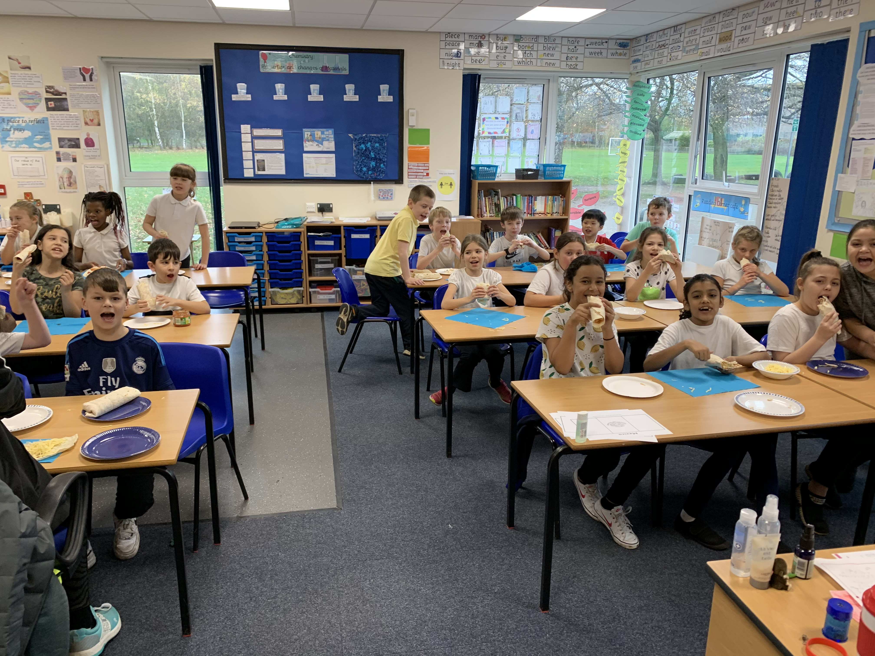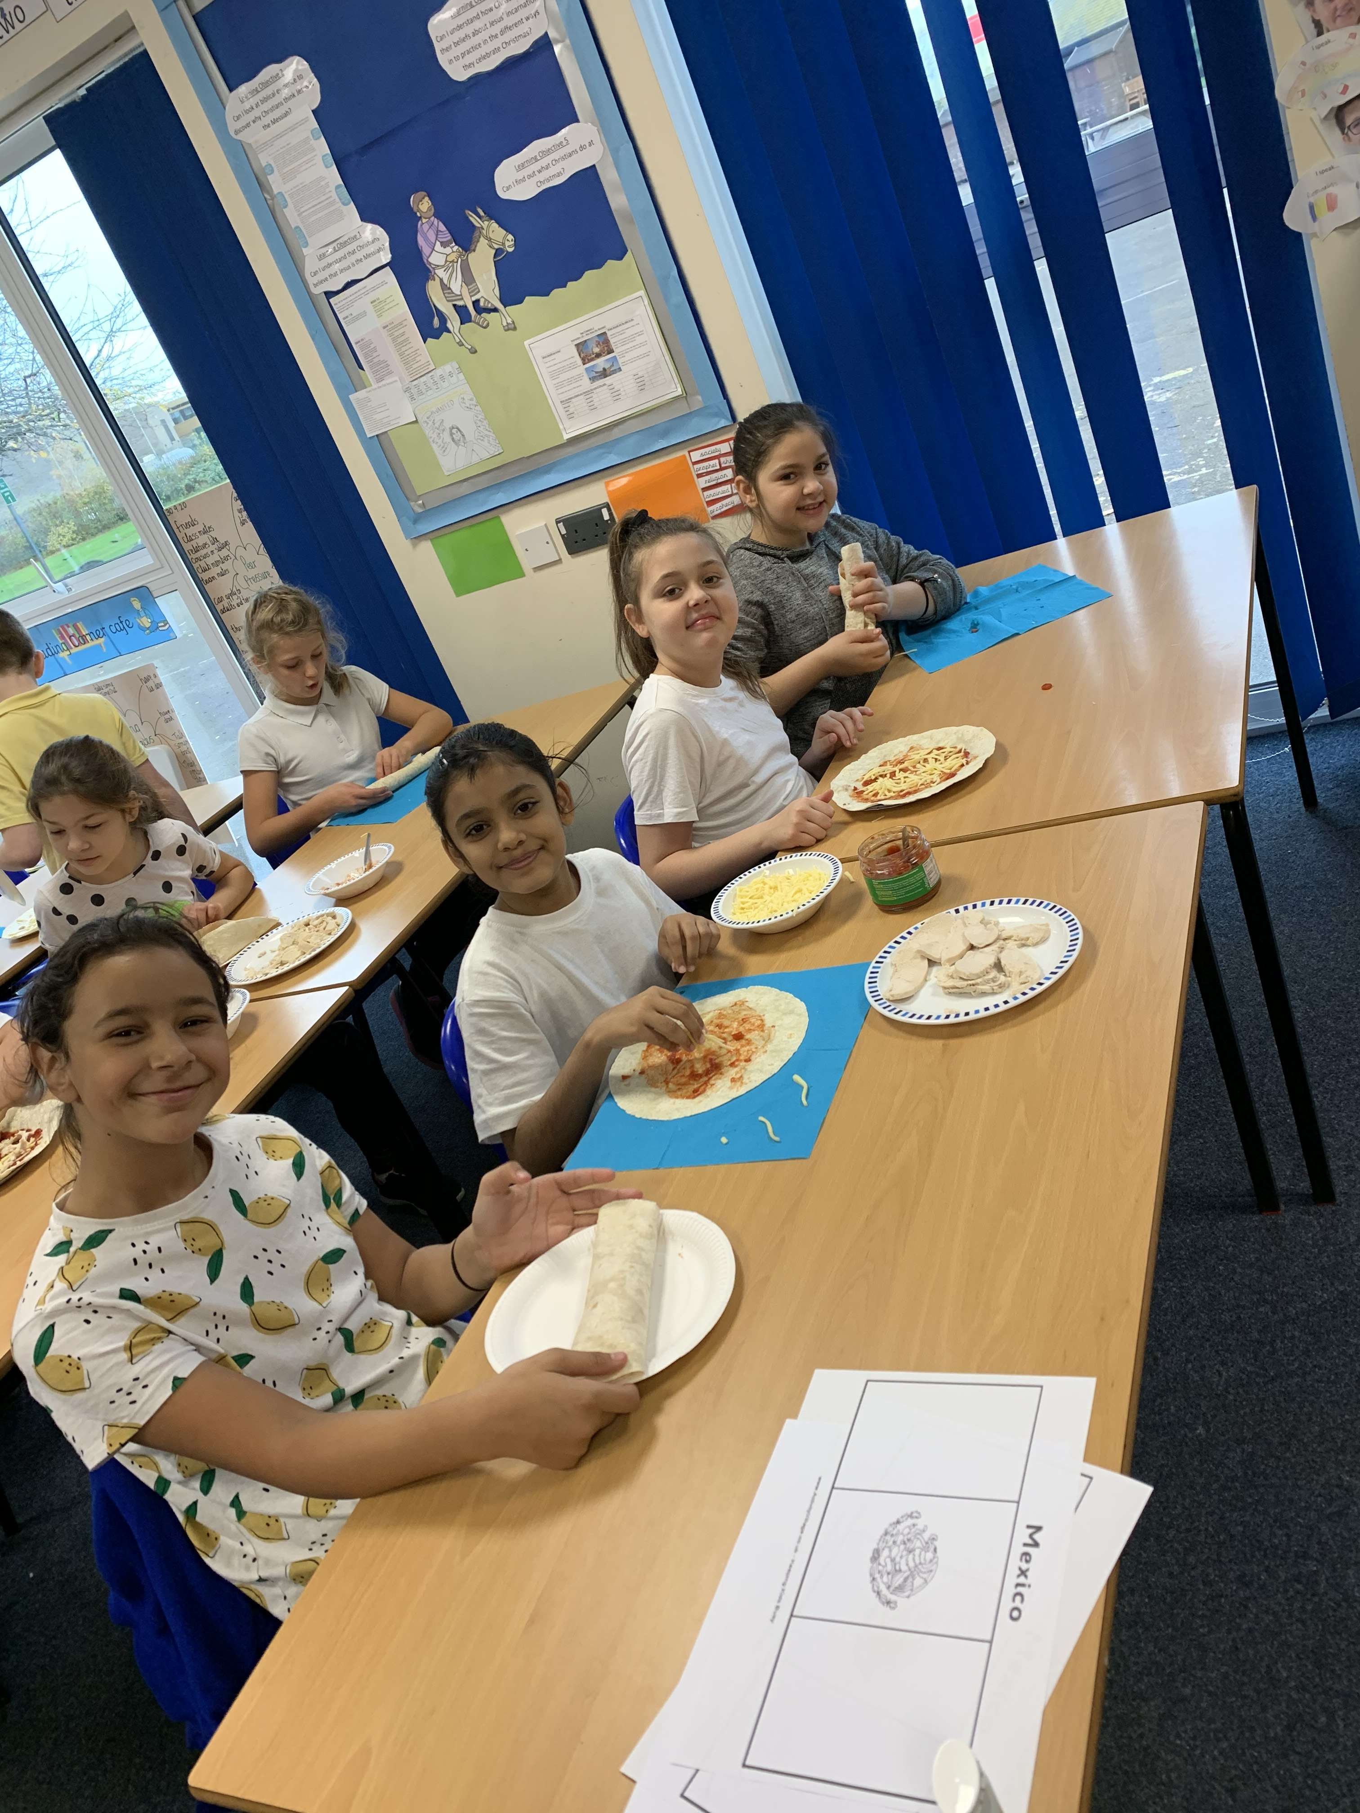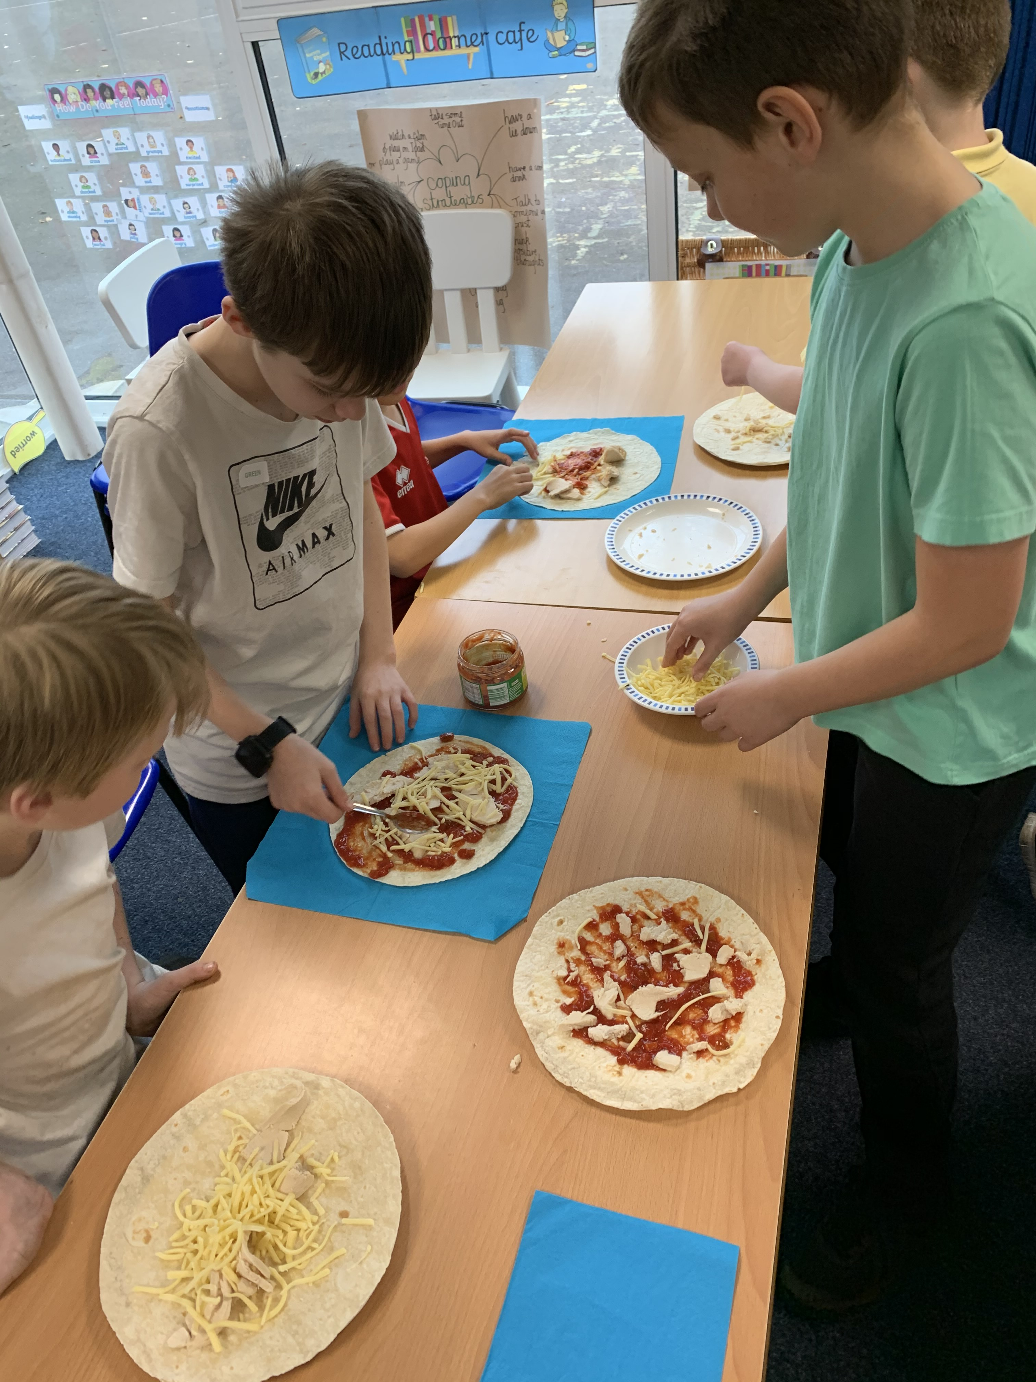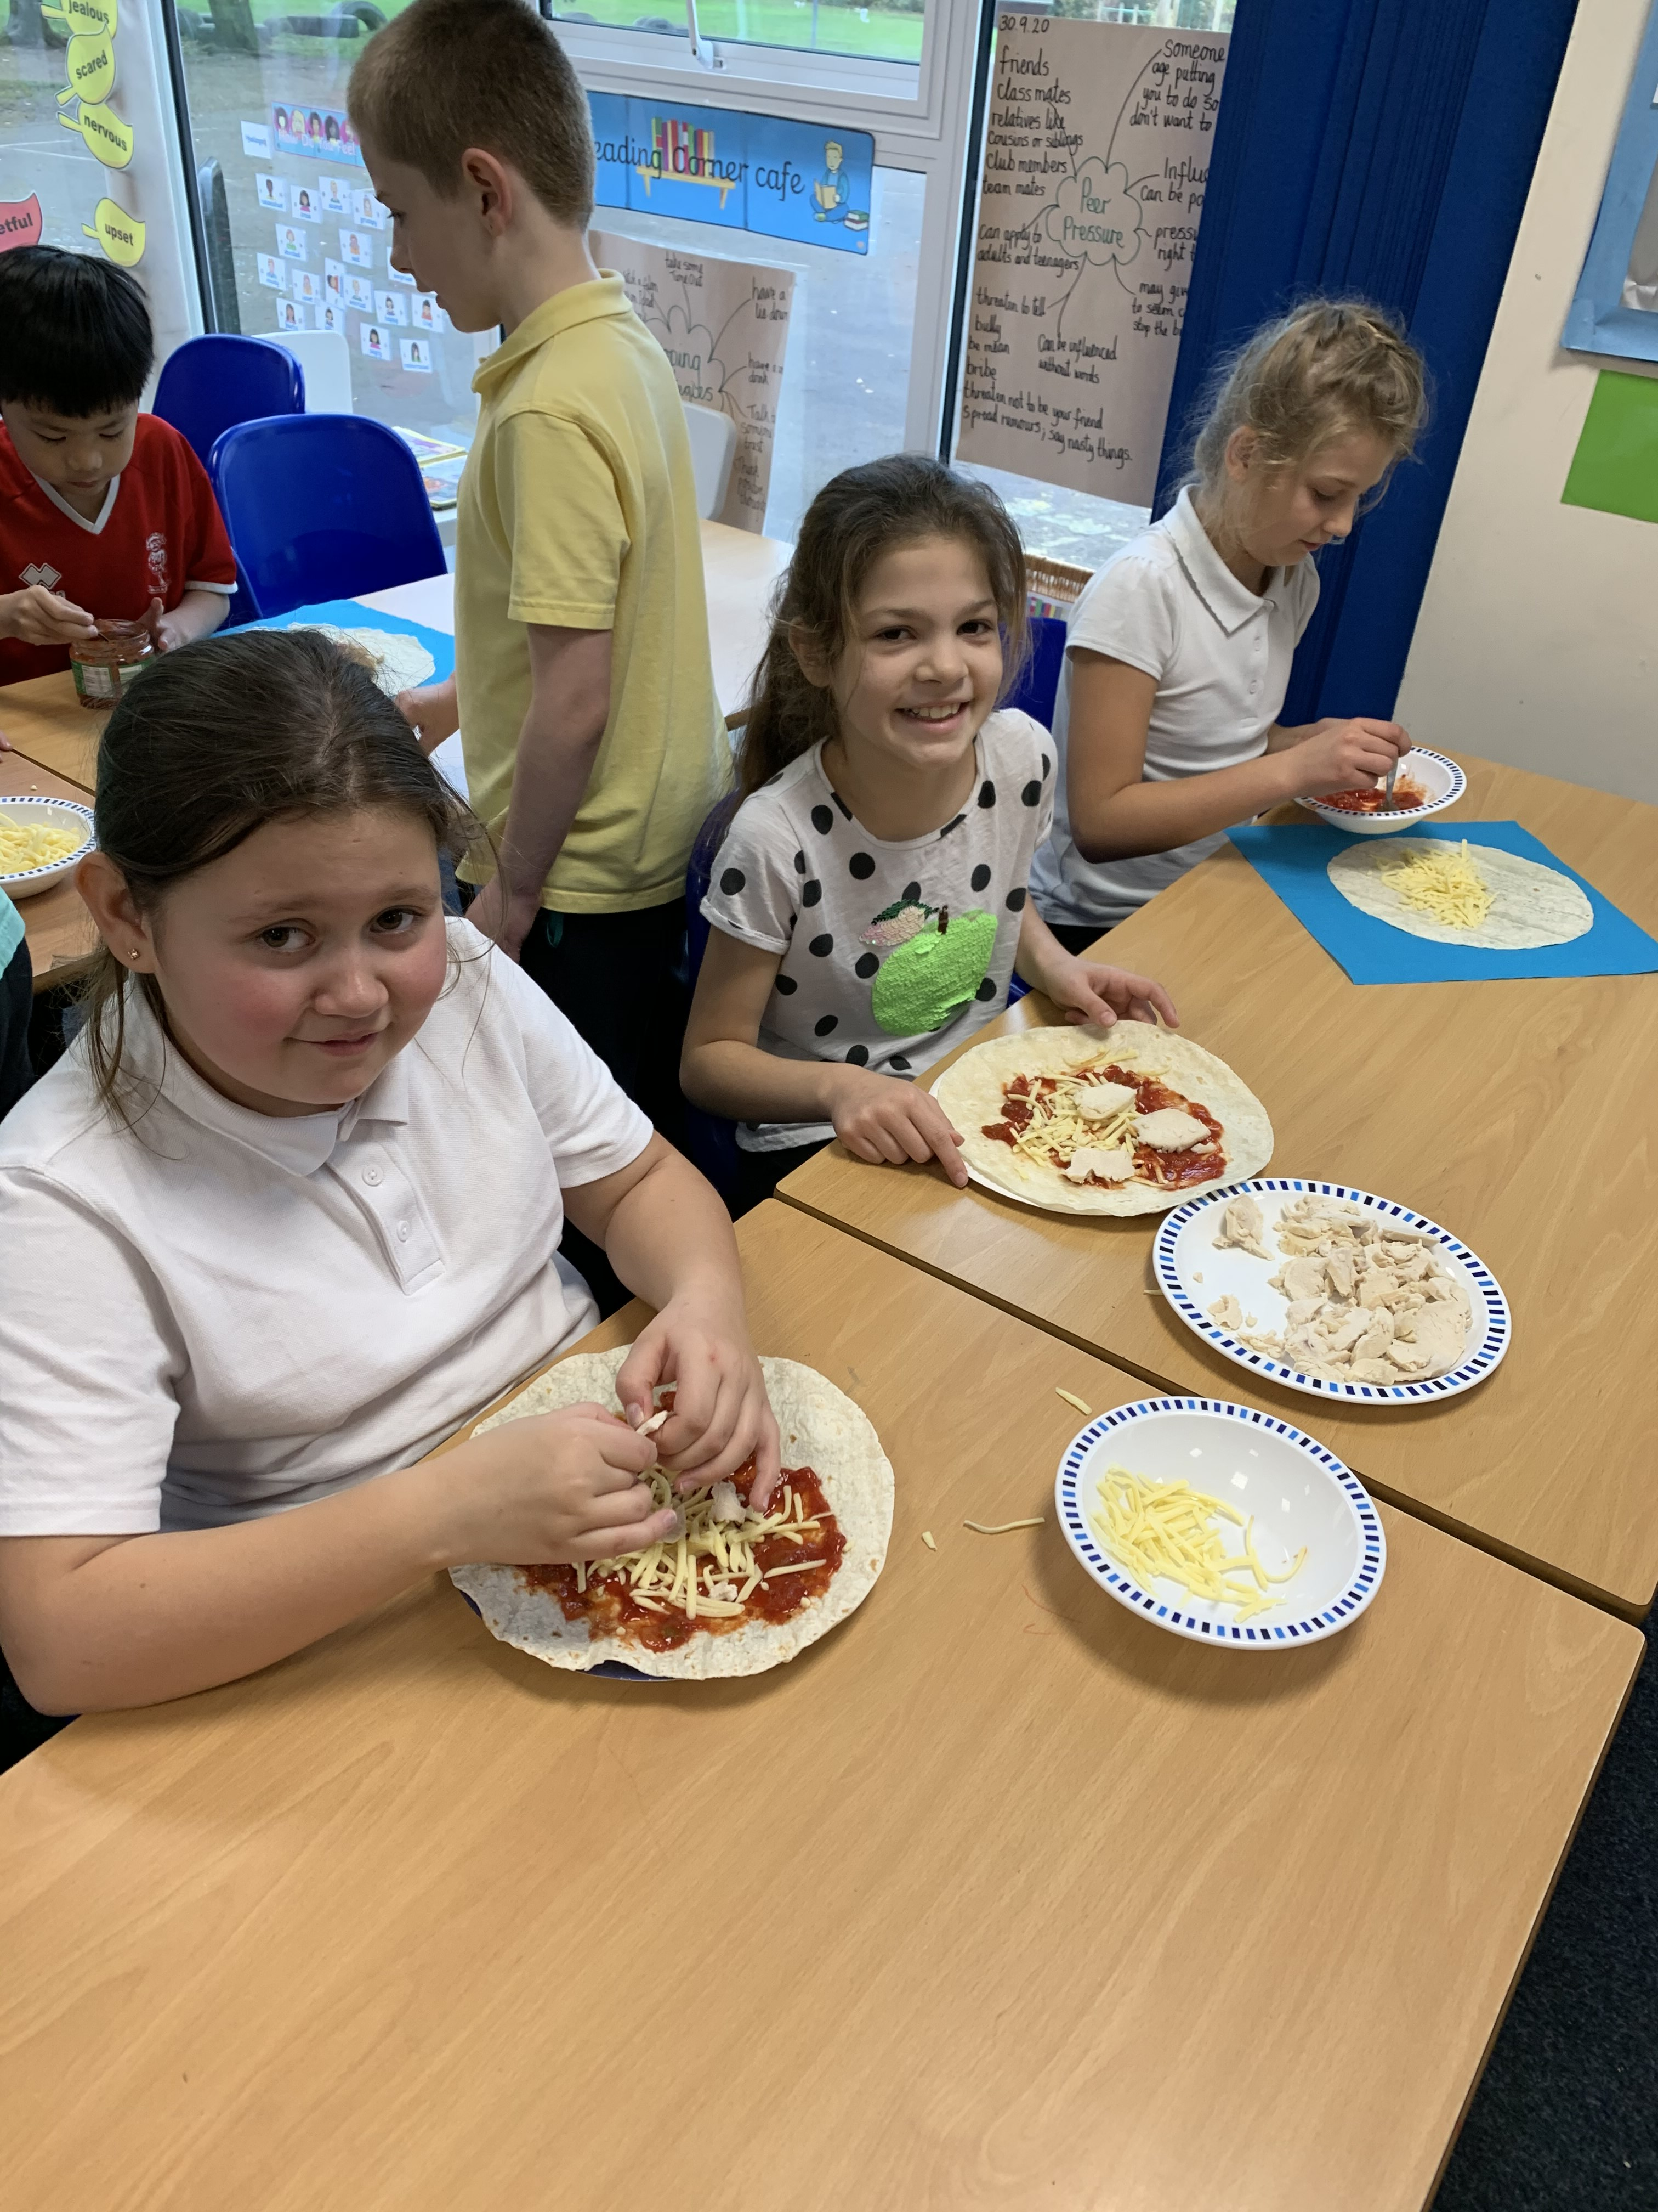
Year 6 – Ireland – completed a which showed them finding out about Ireland, making beautiful material shamrocks, tasting soda bread and drawing celtic knots.
Year 6- Bulgaria – completed a film which involved them playing music, making Bulgarian recipes, learning facts about Bulgaria including finding it on a map and making decorations.
Use of Multicultural books in KS2

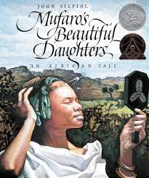
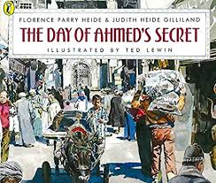
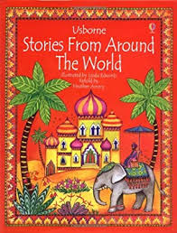

Year 3 have read a range of multicultural books this term.

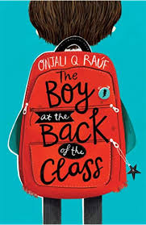
Year 4 have read The Boy at the Back of the Class.
This is about a refugee boy settling in to life in a multicultural school in London. It explores the issues around this.

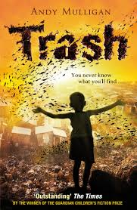

Year 5 are reading ‘Trash’ by Andy Mulligan as their whole class read.

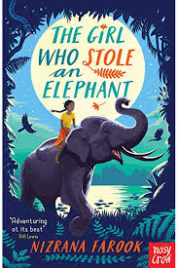
Year 6 have read the book ‘The Girl Who Stole an Elephant’. They completed lots of additional work about the story which they displayed outside the classroom.

Discussion about National events
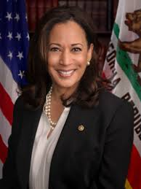
Year 3 discussed the theme challenging stereotypes and explored how Kamala Harris is the first female vice president of America. They discussed how this was 'fair that girls can be vice president. It doesn't matter if you're a boy or a girl. 'You can be a boy or a girl to do that job.'

Talking to the children about Covid/Coronavirus
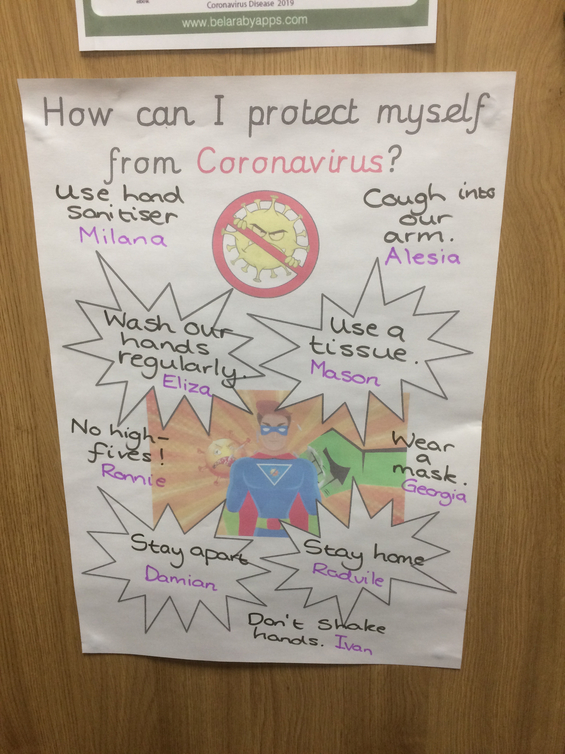
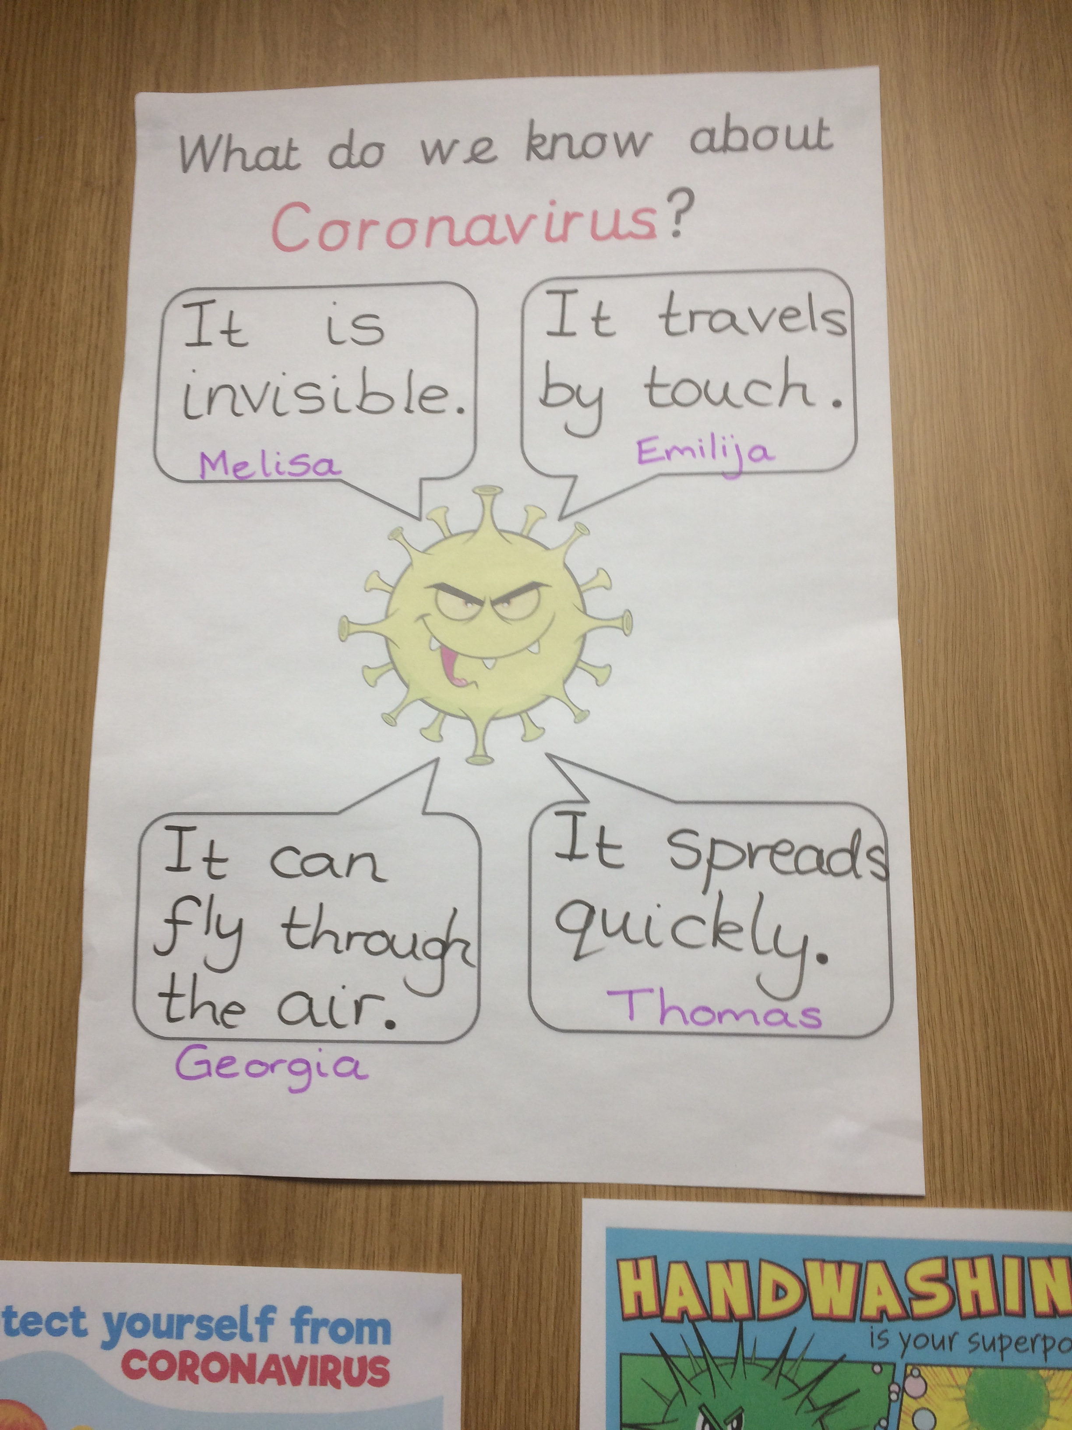

The children in Year 1 have been discussing what they know about coronavirus and what we can do to protect ourselves from it.

Work scrutiny in Early Years and Key Stage 1
Nursery – the world
The children in Nursery talked about the world. They looked at a globe and an atlas and talked about the sea and land. Then they made images, using different coloured ink to represent the land and sea.
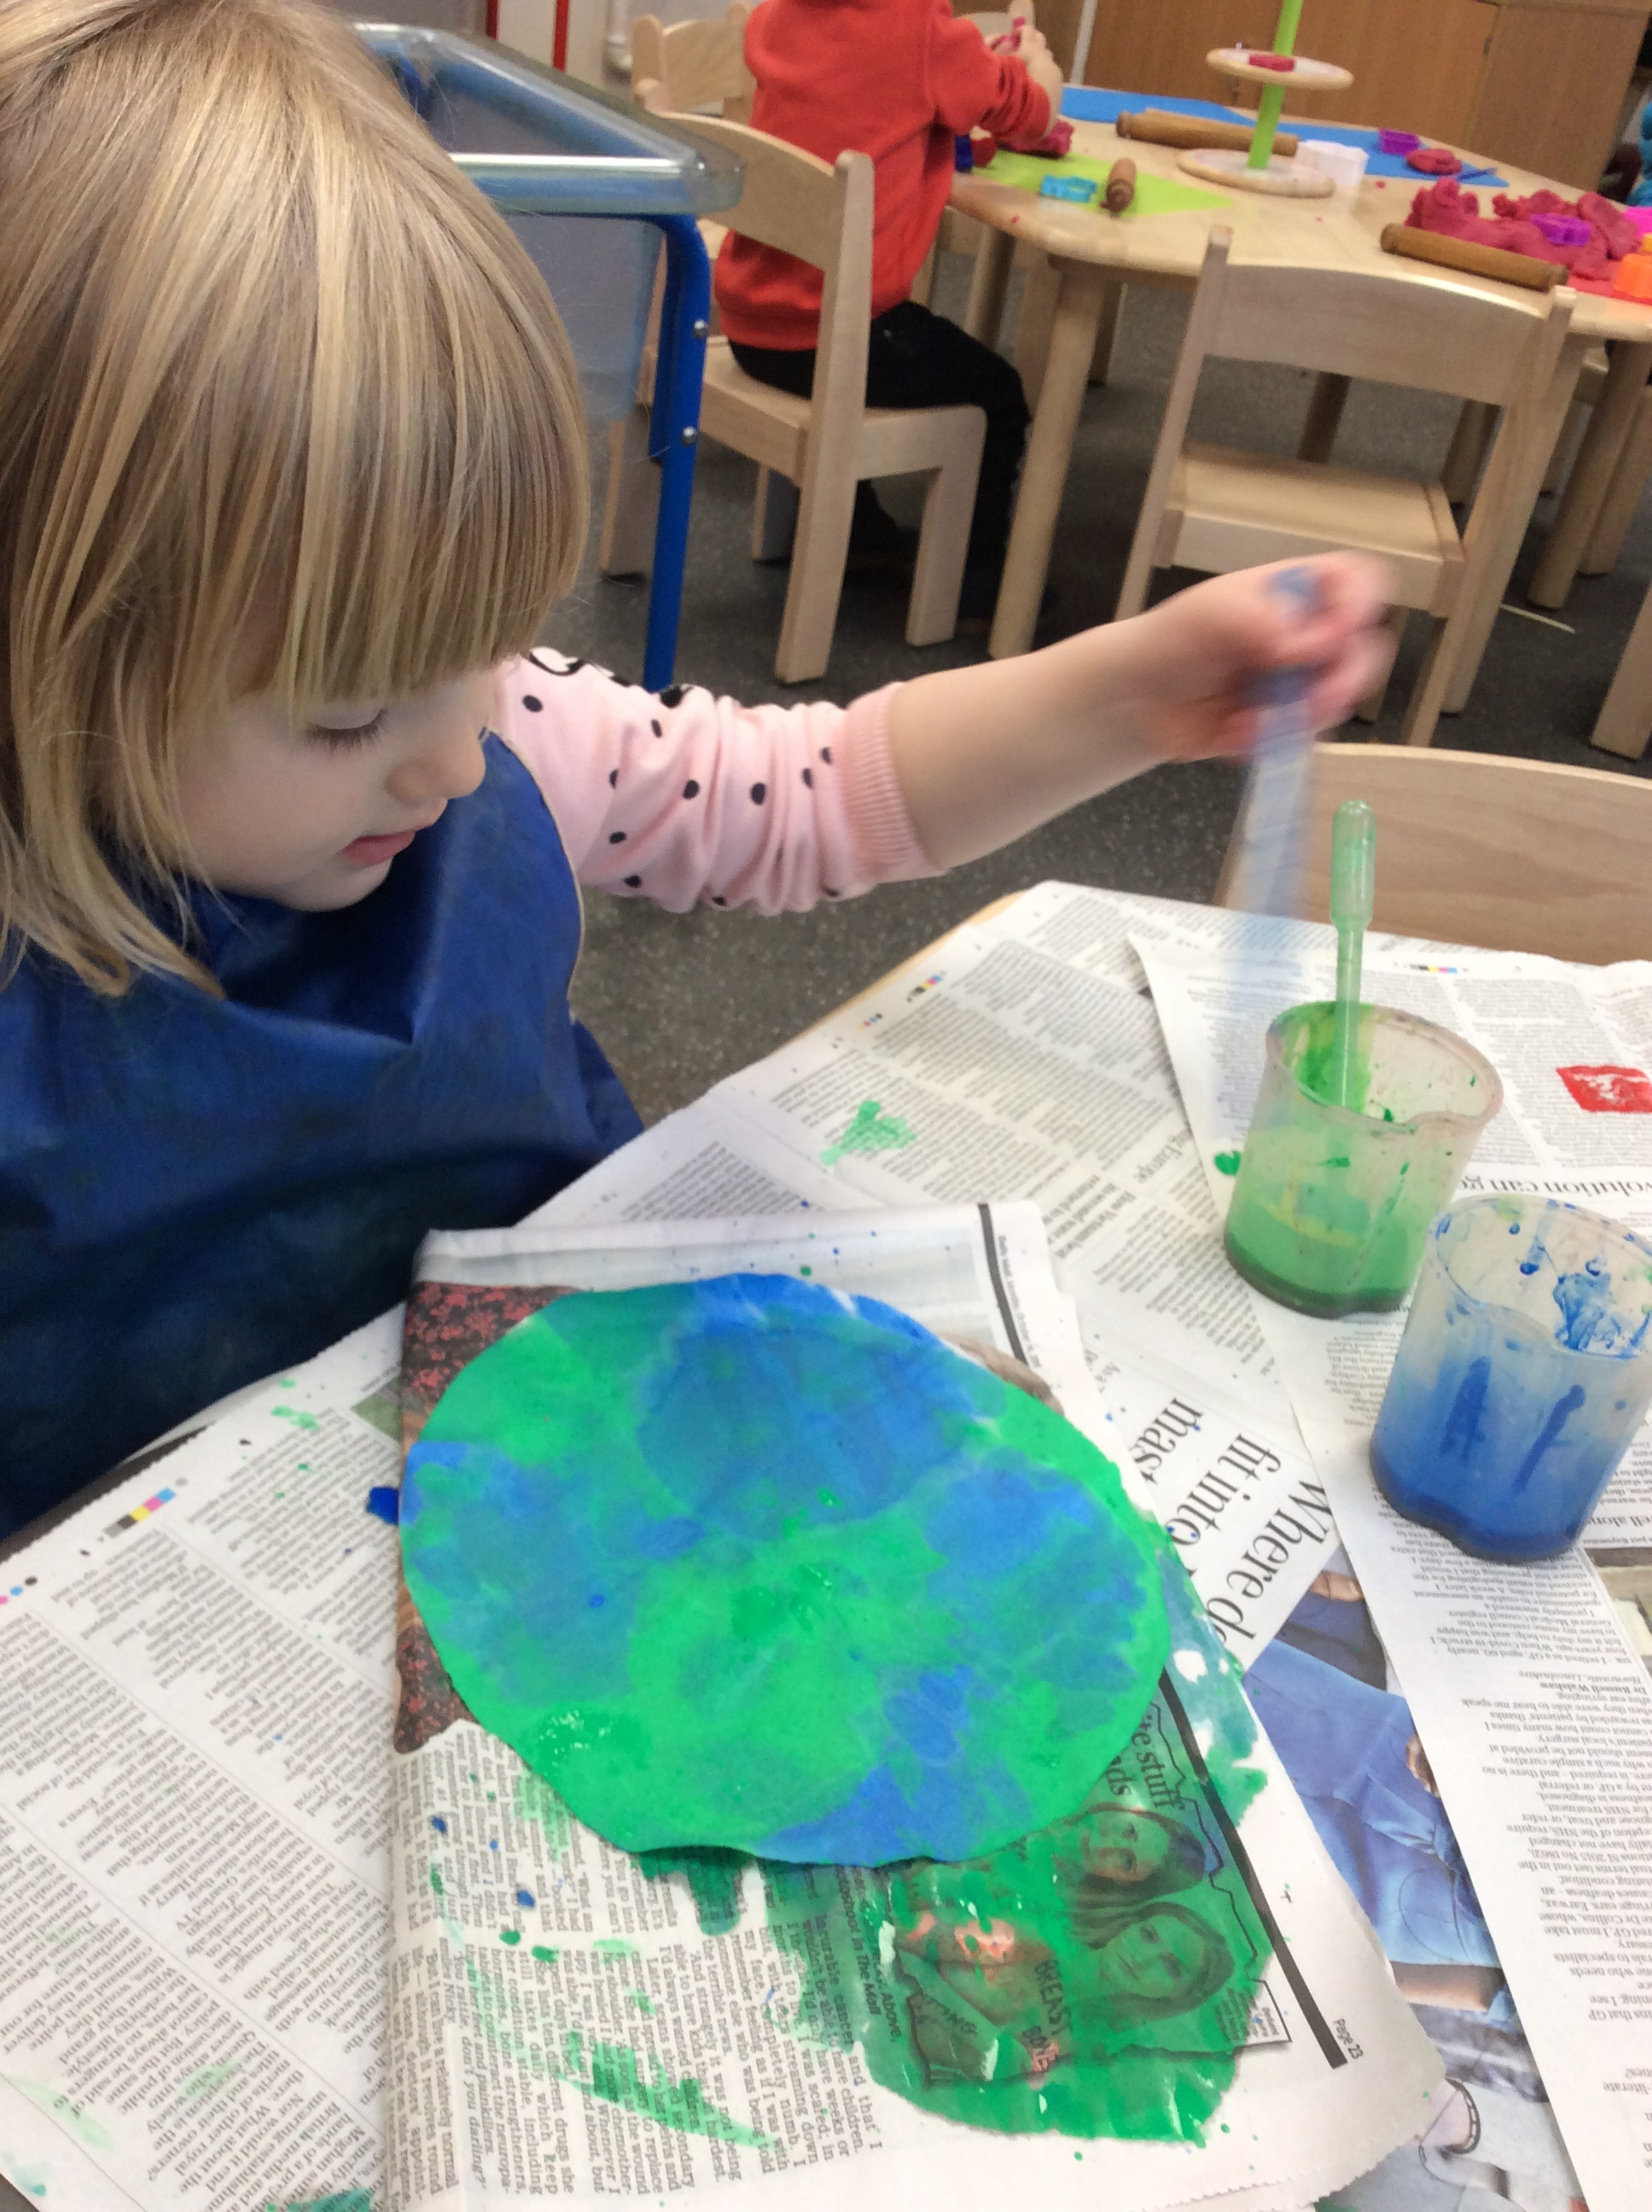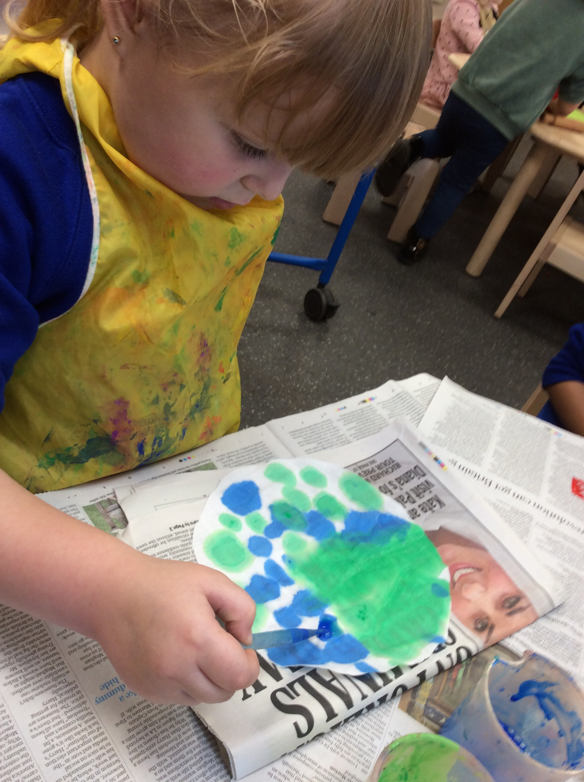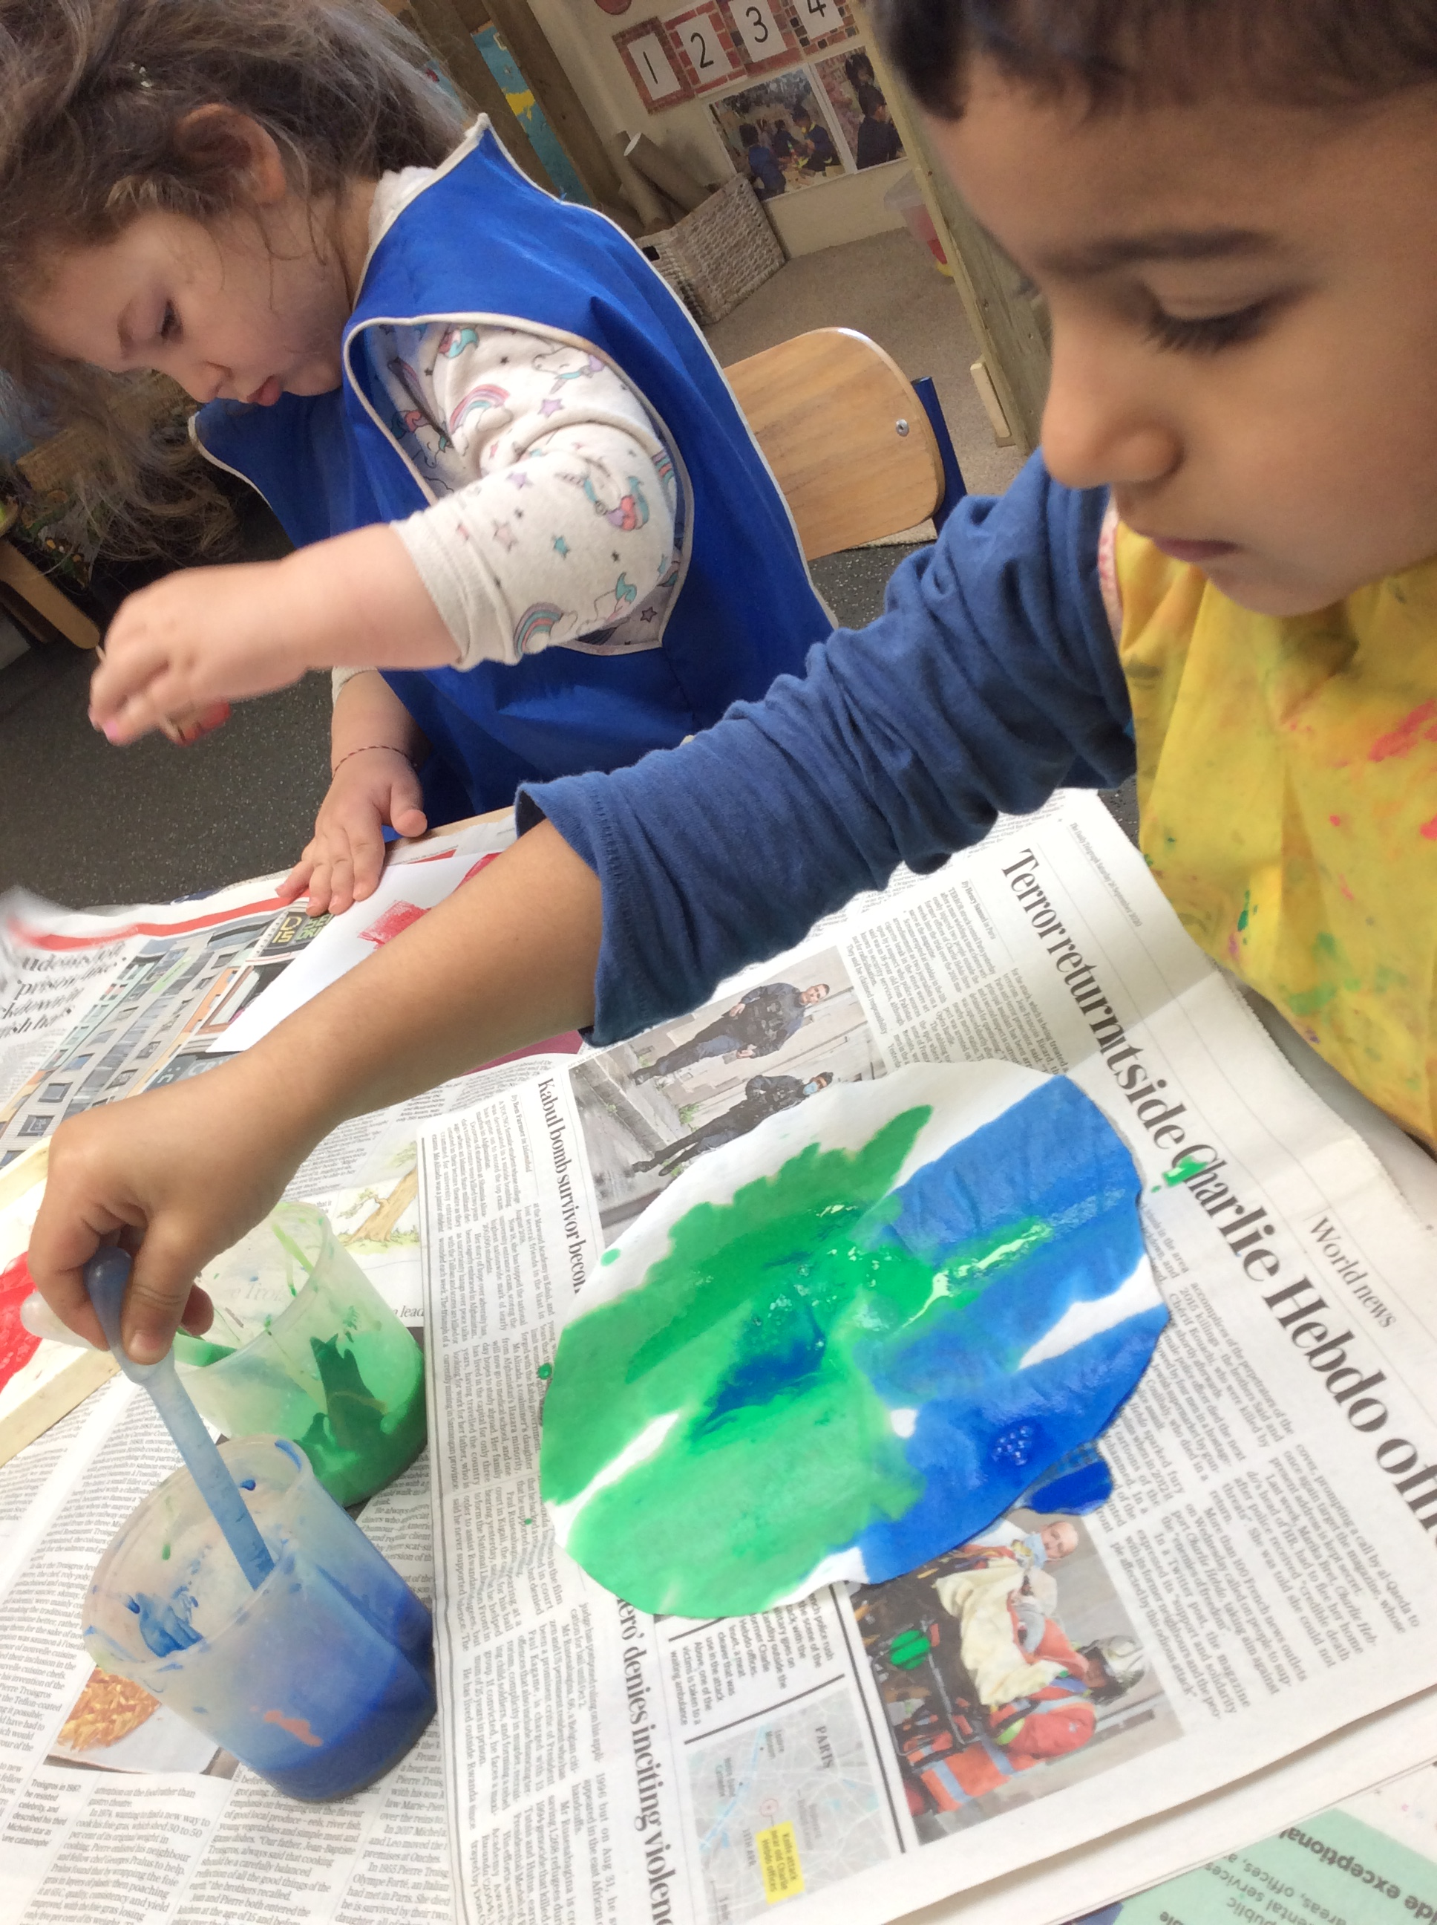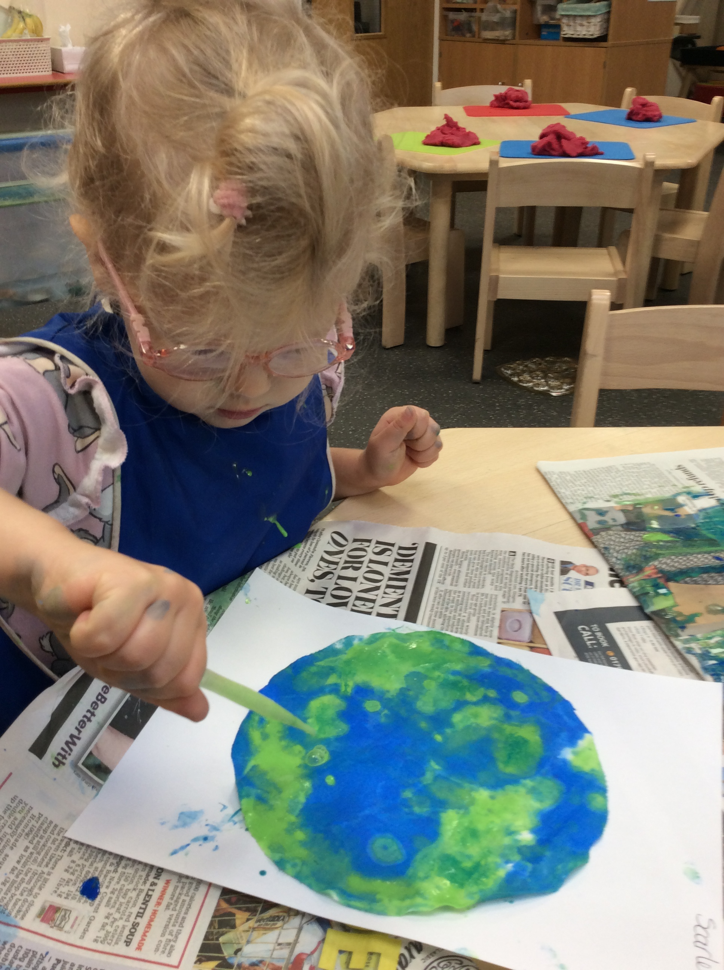

Diwali
In Early Years we learnt about the ‘Festival of Light’ -Diwali and how it is celebrated. We looked on the globe at countries that celebrate Diwali and watch film clip of children celebrating. Children made Rangoli patterns with chalk and divas.

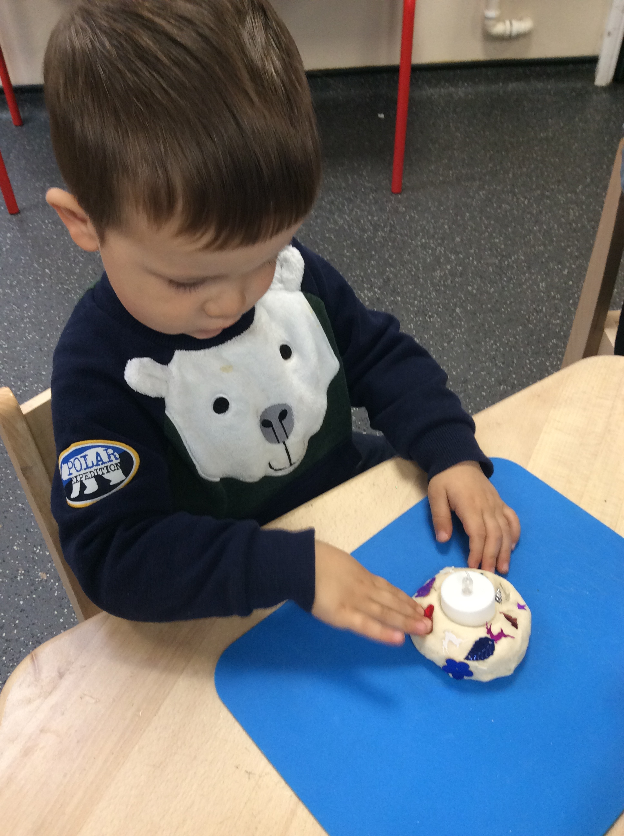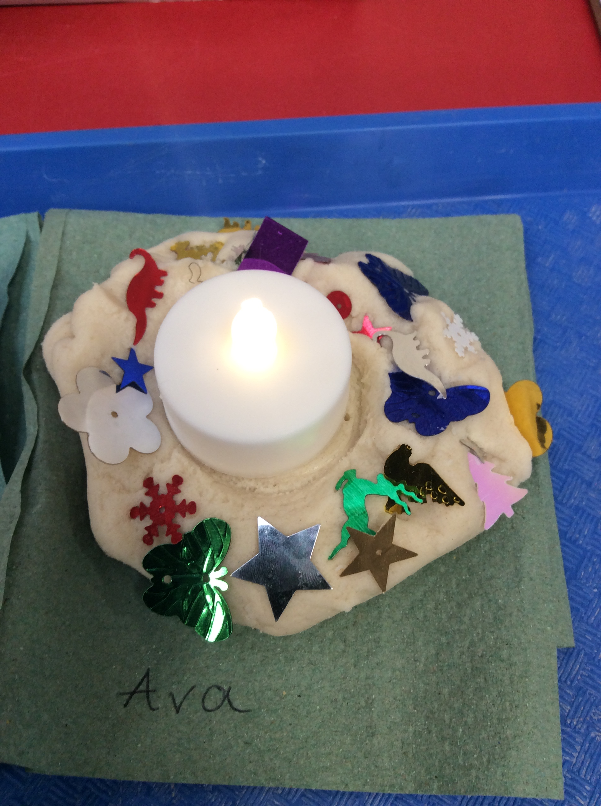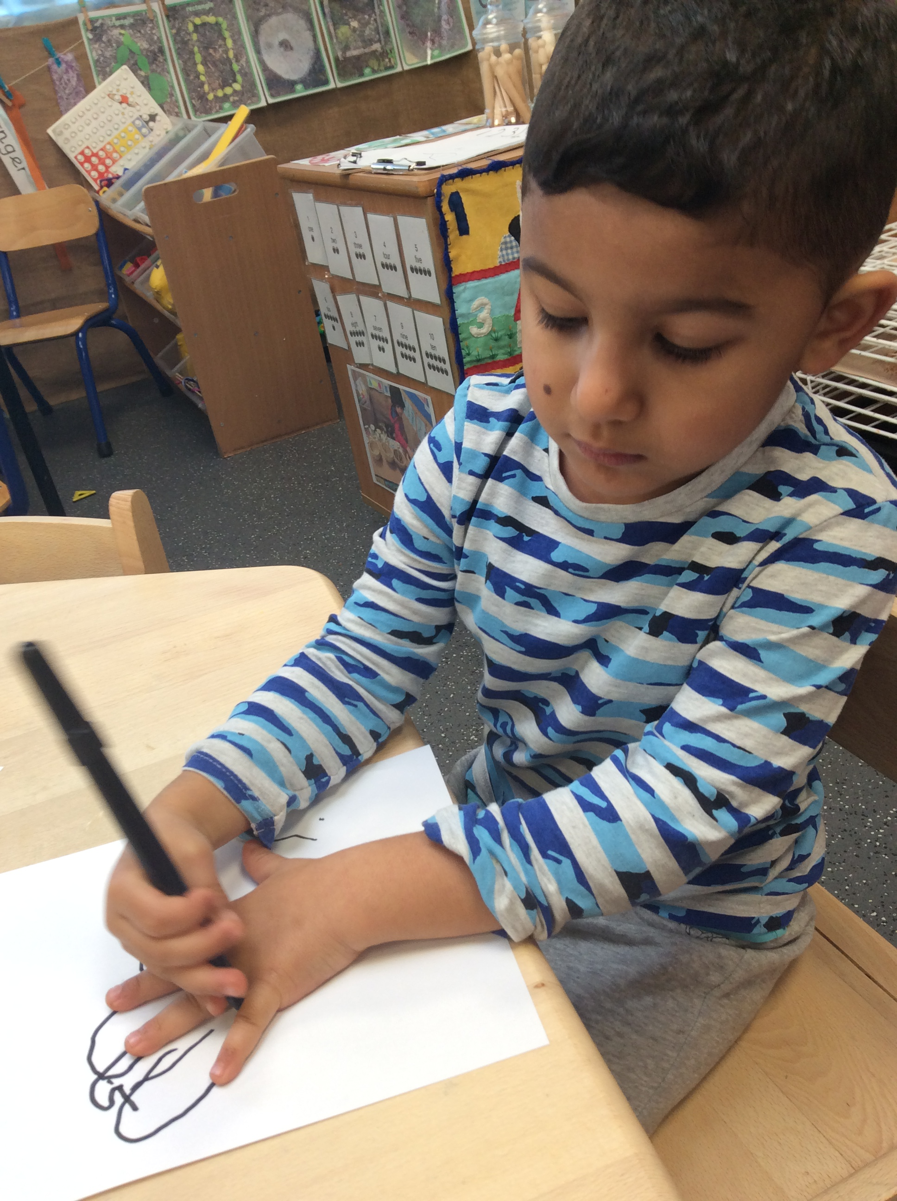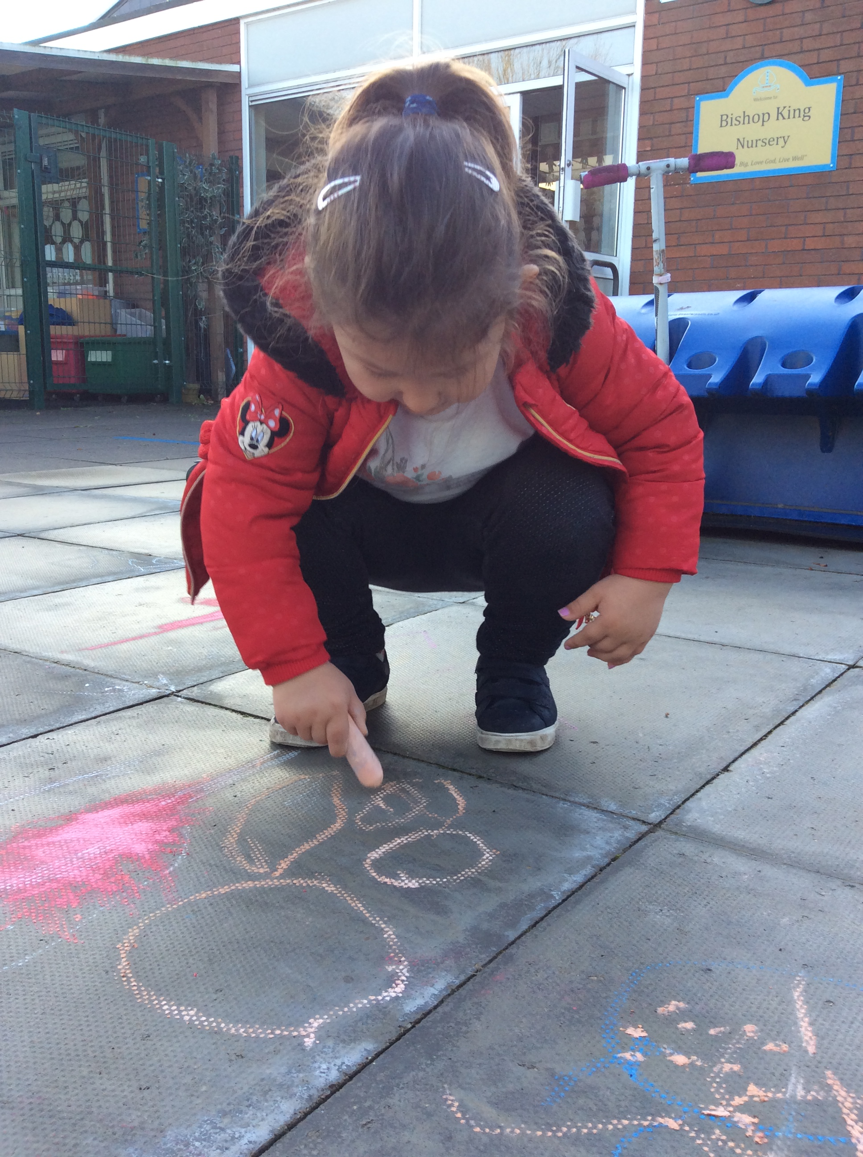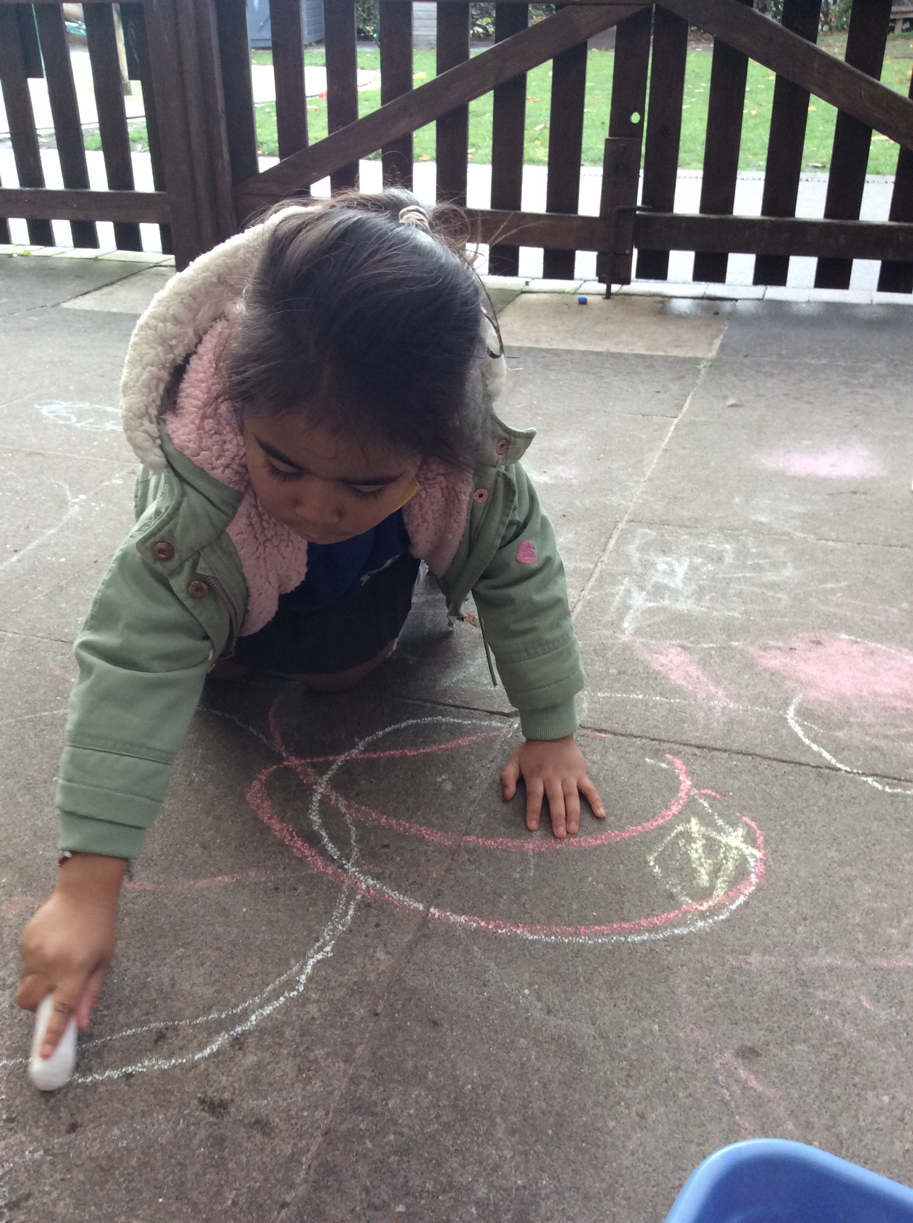

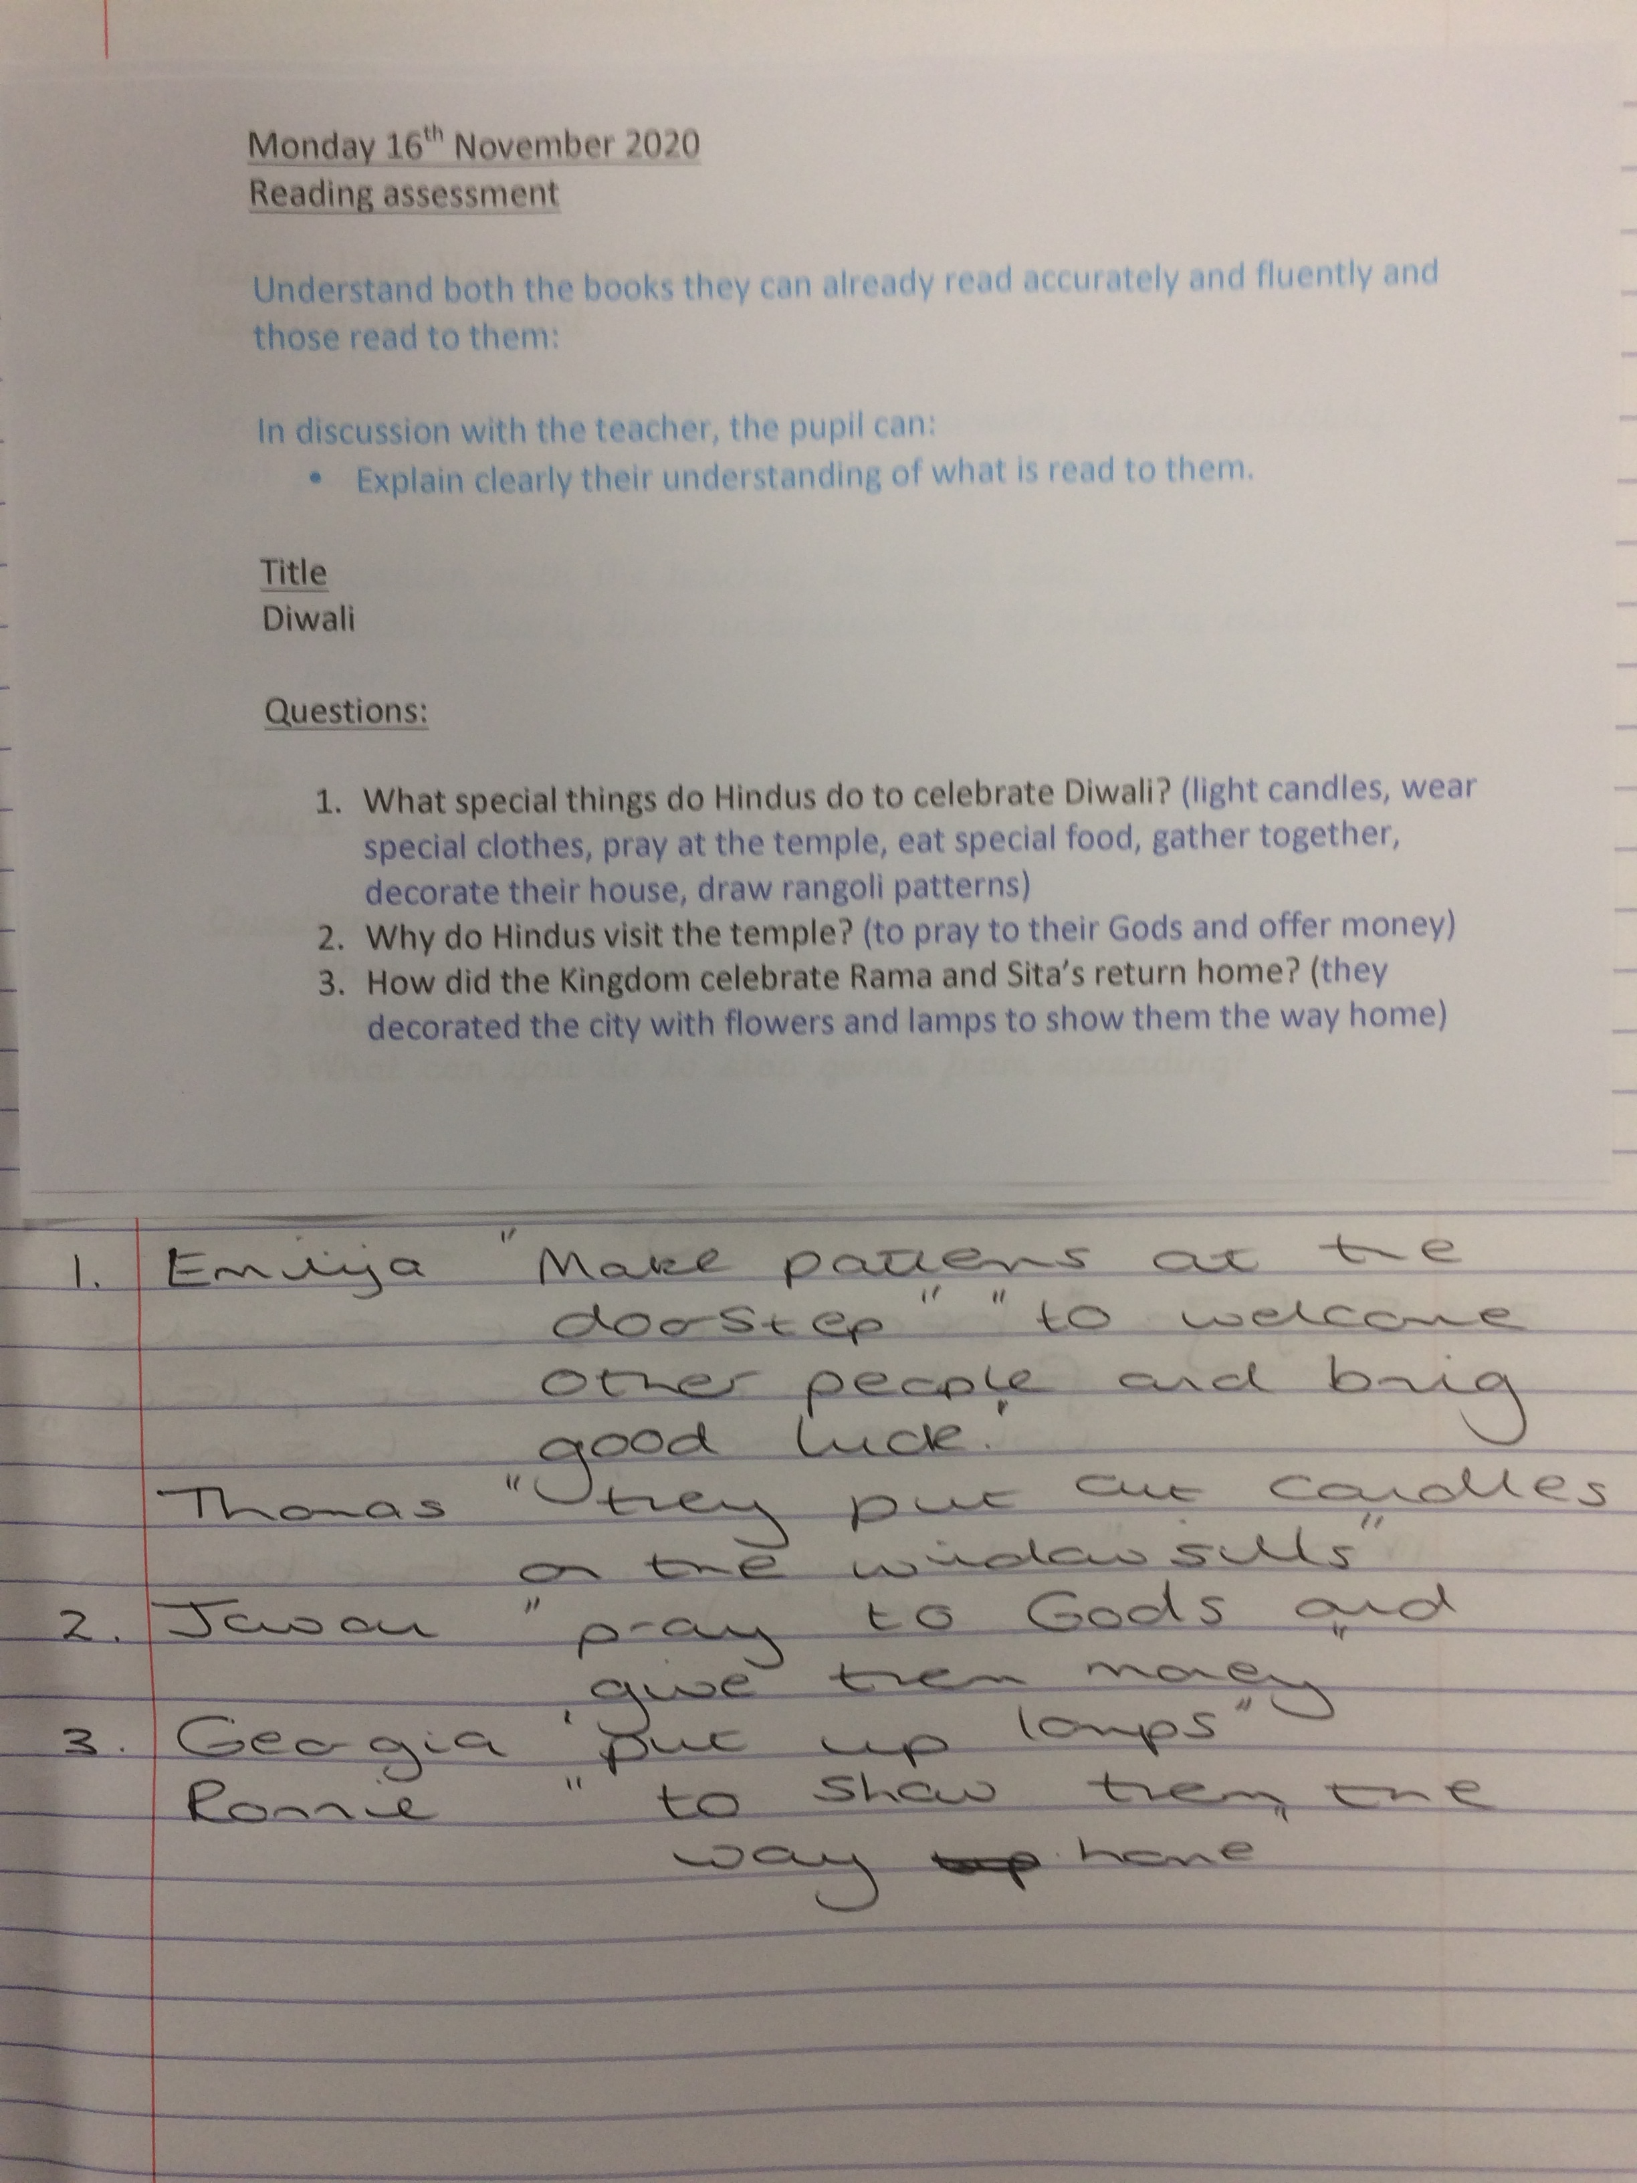
The children in Year 1 used a book about Diwali for their guided reading text. This is a good way of using celebrations from other cultures as context for learning.
Year 1 – the same and different
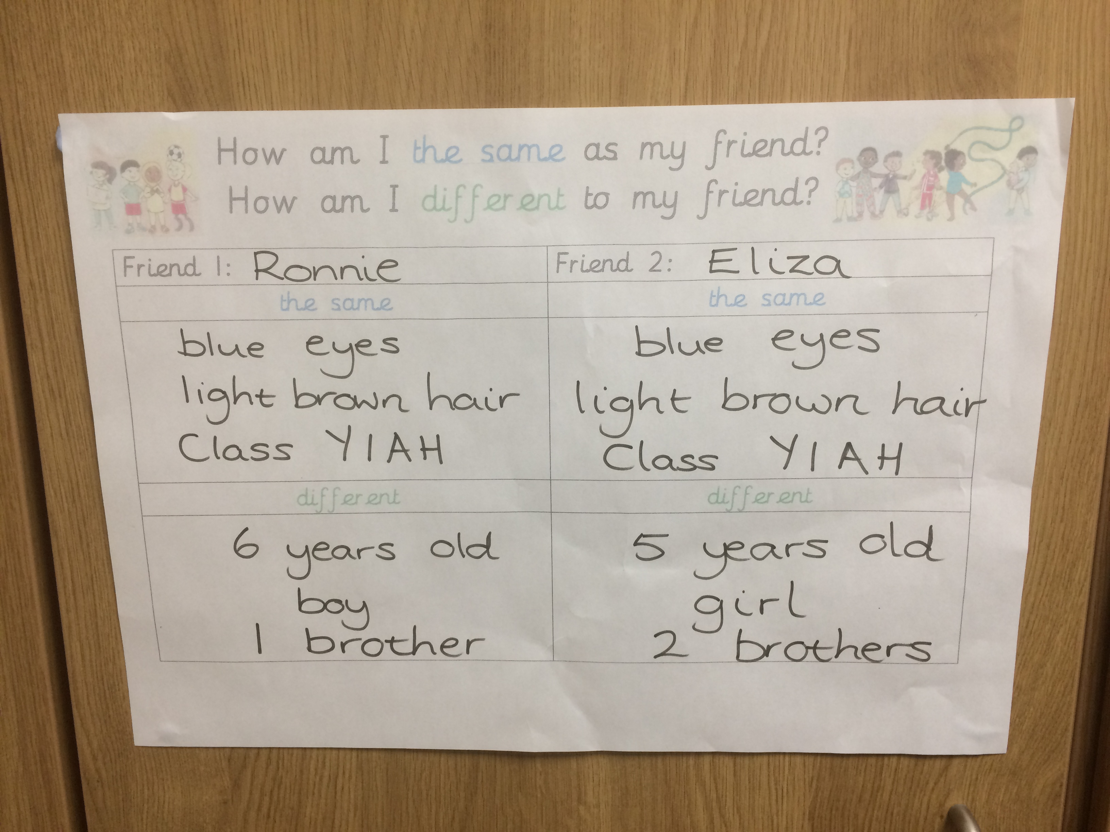
The children in Year 1 talked about how they were visibly the same or different to their friends. They then recorded what was the same and different about one friend.

Pupil voice
To identify the impact on Multicultural books on children’s knowledge and understanding of the wider world.

Key strengths
- Children talked incredibly enthusiastically about all the multicultural books.
- They all looked forwards to being read too were and talked in detail about how it made them feel.
- Children could tell me about both the differences and similarities between themselves and characters.
- They confidently talked about feelings of the characters in the books and related to when they felt a similar way.
- Children were really enthusiastic when the adult had made a personal link either with themselves, someone in the class or a family member

Pupil quotes
Reception – ‘Mrs Mihajlovic’s Dad is from here’.
Year One – ‘ Not England, the country is far away, you have to go on an aeroplane’.
Year Three – ‘Teachers make books more exciting’. ‘They use expression’.
‘There isn’t much technology in Egypt’. ‘Their stuff is older than ours, like computers.’
Year four – ‘Syria isn’t a nice place to live as there are lots of wars that happen there’. ‘People who live there want to leave to come to places like England’. ‘the child in the book has experienced tragedy and we haven’t, we are lucky’.
Year five – ‘When the teacher reads the book they explain all the words we might not have heard before’. ‘The way they read it makes it interesting and sometimes intriguing’.’ There are lots of differences between us and the boys in the story, they don’t have proper food, speak in a different language and they have different houses’.
Year six – ‘Teachers read with expression and more fluently’. ‘The child was very different as she didn’t follow rules, she had a very different view of what was right.’
Areas for development
- When asked what they found out about other countries they were unsure and sometimes said nothing. However, when talking about the stories and characters they said lots of things about where they lived eg. housing, climate, clothes and lifestyle illustrating that they had learnt about the countries.
- In Early Years and Key Stage One they could talk about the feeling of characters but found it tricky to link it to their own life experiences.

Actions towards action plan
- The above will impact on the children’s speaking and listening.
- Profile of Global learning through whole school projects eg. Erasmus KA1 and 2.
- The use of books which focus on diversity and a range of cultures is strong in EYFS and KS1.
- Connecting and collaborating with local partners through KA2 project and Connecting Classrooms.
- Plan ‘World Hello Day’.
- Monitored the use of multicultural books throughout school.

Next steps
To continue to lead the International projects.
To liase with MAPS and SPAG about project ideas.
To liase with partner school in Uganda to organise exchange of ideas and work.
To monitor how children are taught about current news through Picture News/ Newsround and First News.

