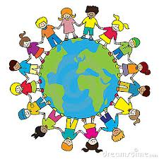
Global Learning Moderation
Autumn 1 2020/21

Ongoing International projects

KA2 Poland
- Project extended for another year as was due to finish in July 2020 but last two mobilities didn’t take place.
- Contacted MAPS about possible ideas for virtual mobilities or exchanging of children work and ideas.
- Year 6 to focus on this, particularly the children who were supposed to go the Poland earlier this year.
KA1 Bulgaria and Romania
- Start date postponed until January 1st 2021.
- Met with Natalie from SPAG to talk about participants and activities.
KA1 – France
- Final evaluation report submitted and sent. Waiting for approval and final funding!

Connecting classrooms
- Partner school – Gombe Standard Primary School, Butambala,Uganda.
- Contact made with partner school. Emails sent between HW and the Headteacher.
- Our aim for the project:
"We would like to help our children have a greater understanding of the wider world, other cultures and what life is like for children in different parts of the world. We hope that this will allow children/staff to increase their empathy for other cultures and understanding of global issues."
- There is a small amount of money which we would like to spend on a camcorder to record the children’s journey to school.

Global Learning and our multicultural ethos within the curriculum

Preparing for World Hello day
Due to the current climate we are unable to invite parents and visitors into school to celebrate World Hello Day this year. We are therefore celebrating in our classrooms using the various curricular subjects to find out about our chosen countries, making food, art work and crafts. This will be shared with the wider community through our website and social media pages and zoom meetings with other classes.

Global learning through booked which celebrate and focus on diversity and a range of cultures.

- Year 2 have focused on the following books this term.
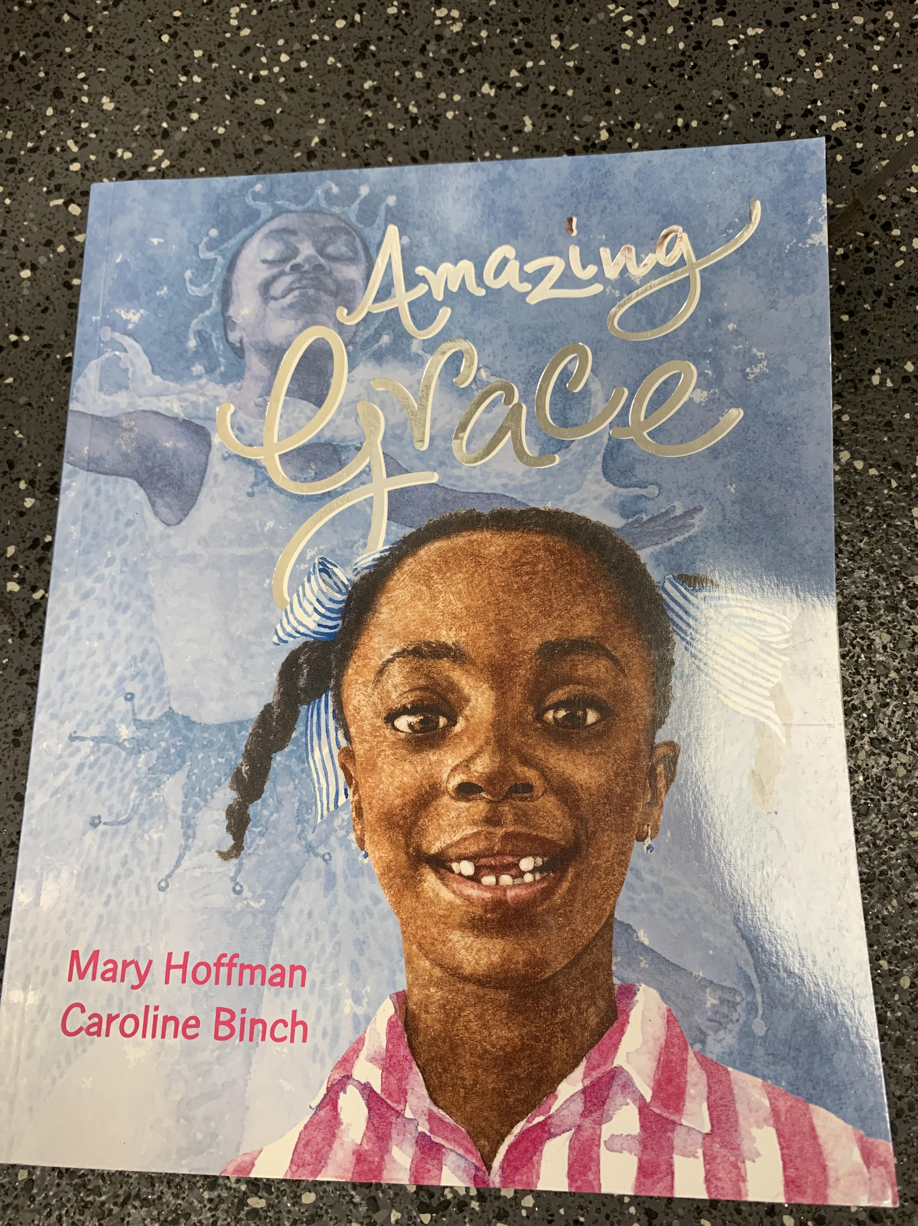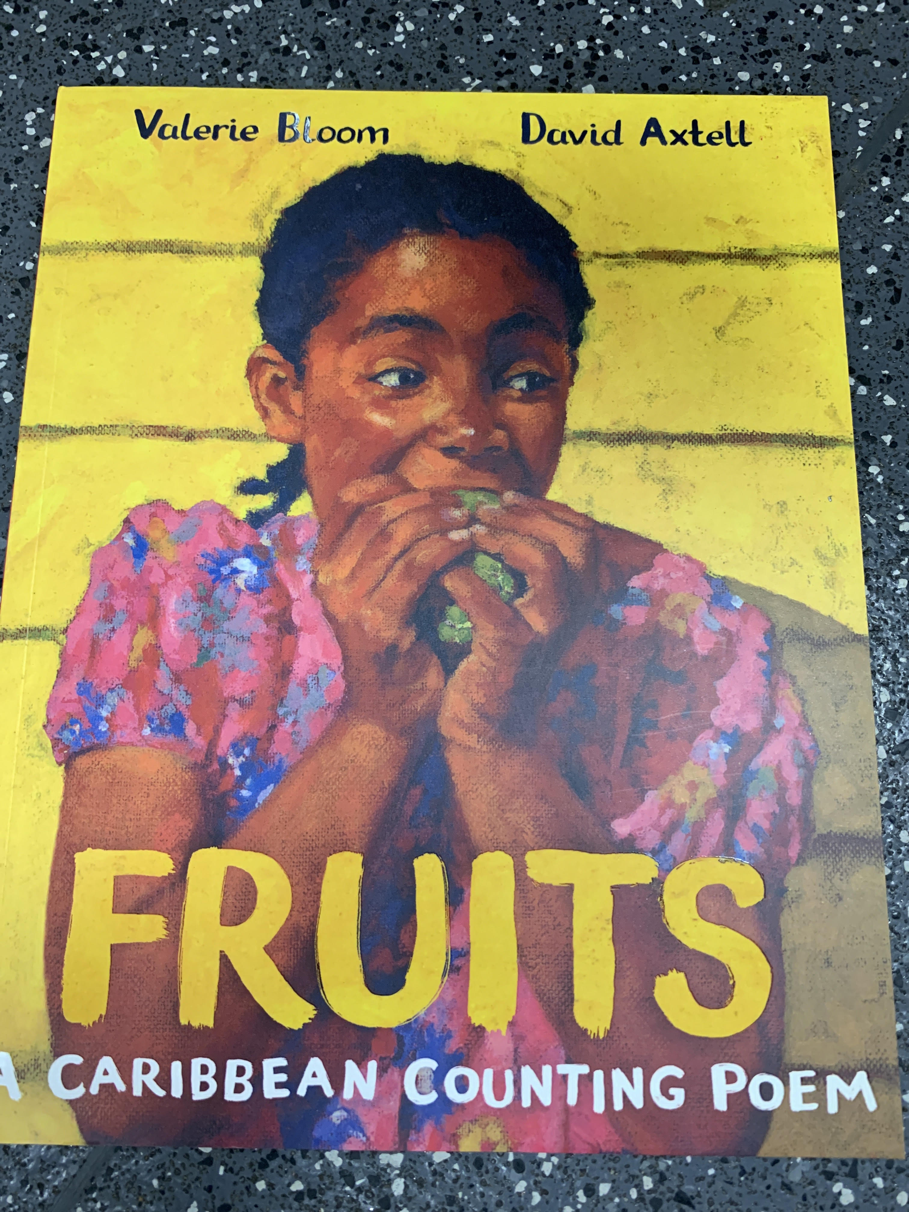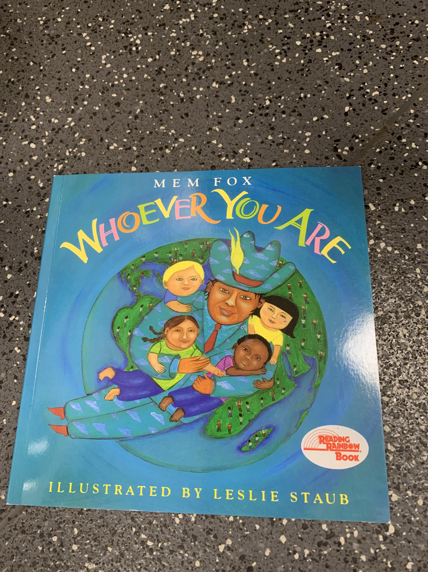
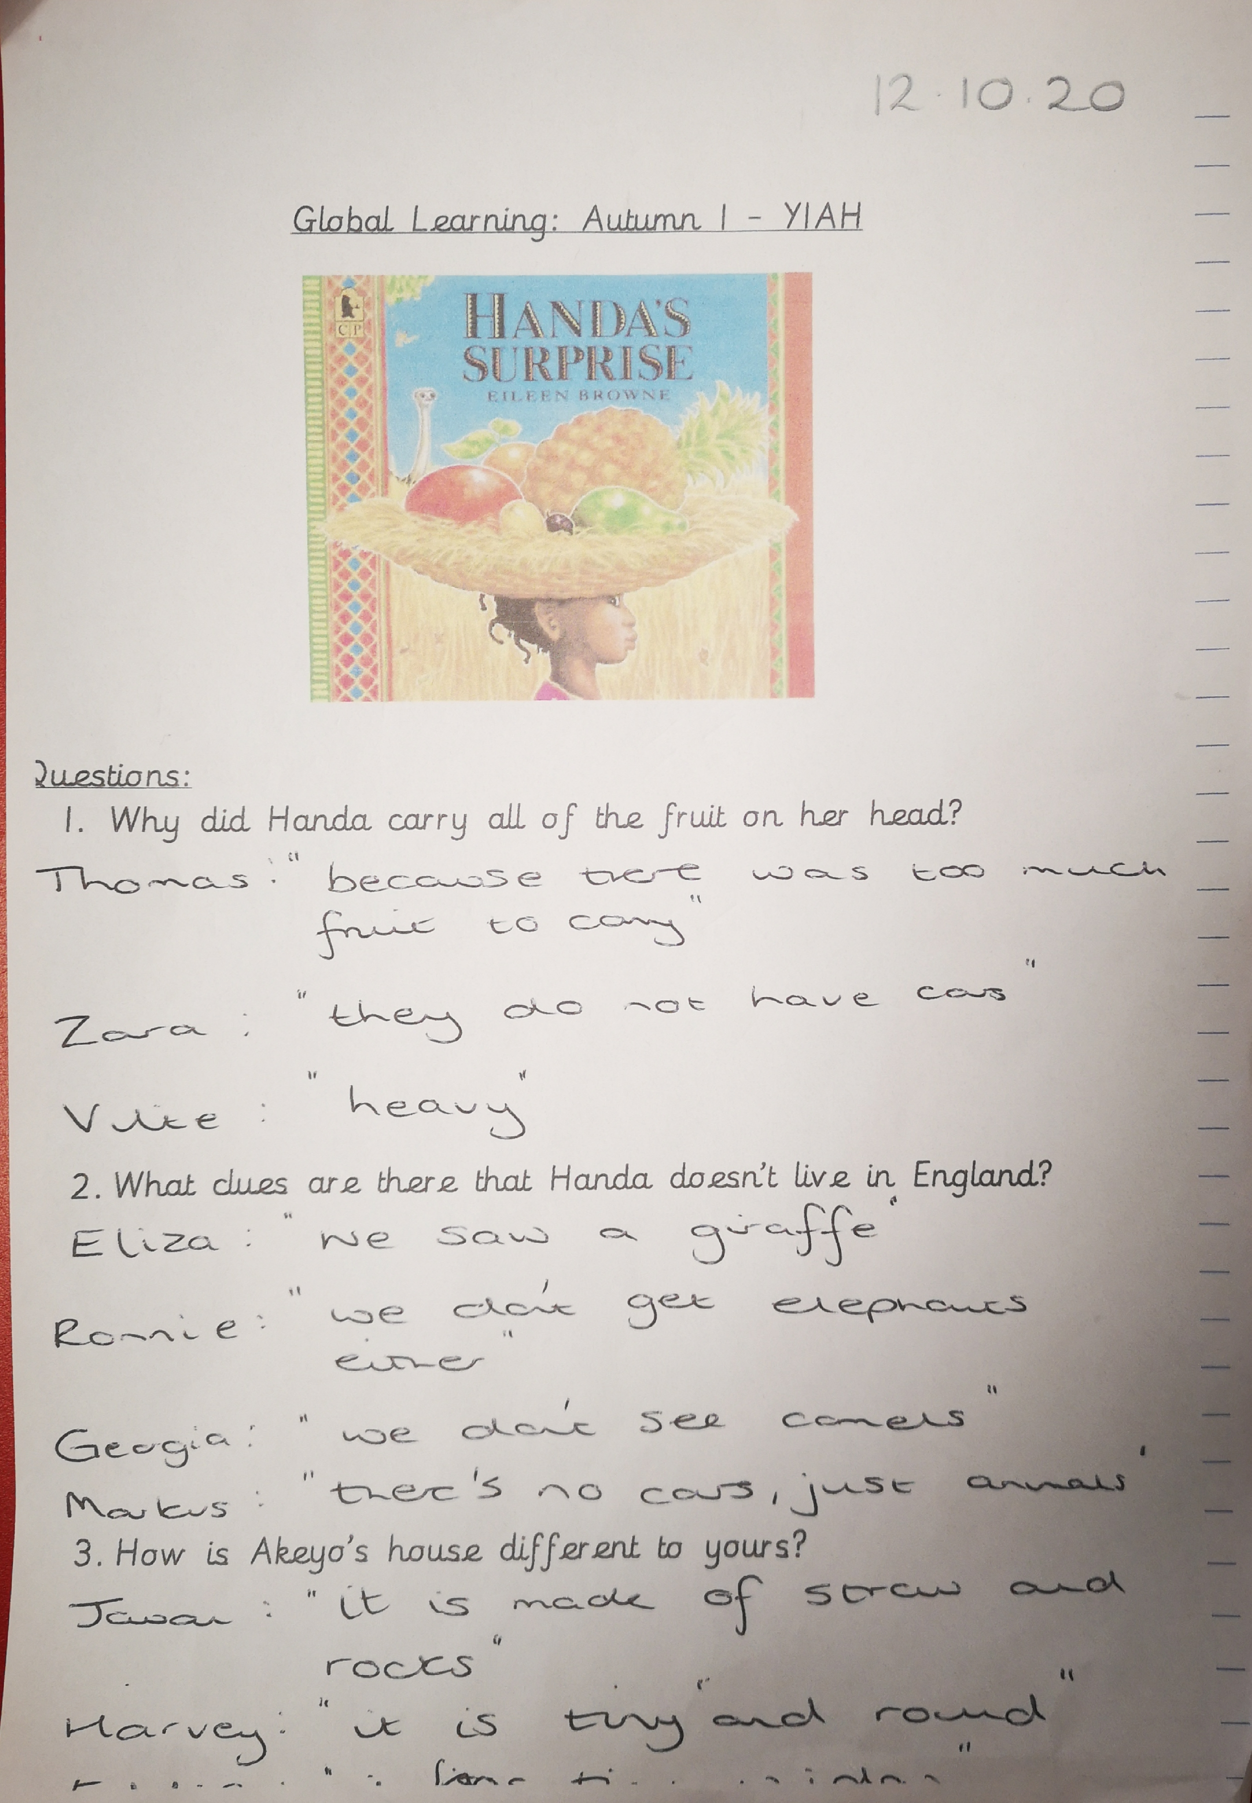
- Year 1 focused talked in detail
about their focus text
‘Handa’s Surprise’.

- Early Years have been focusing on families and have through this topic talked about different types of families through the use of pictures and books.
Nursery
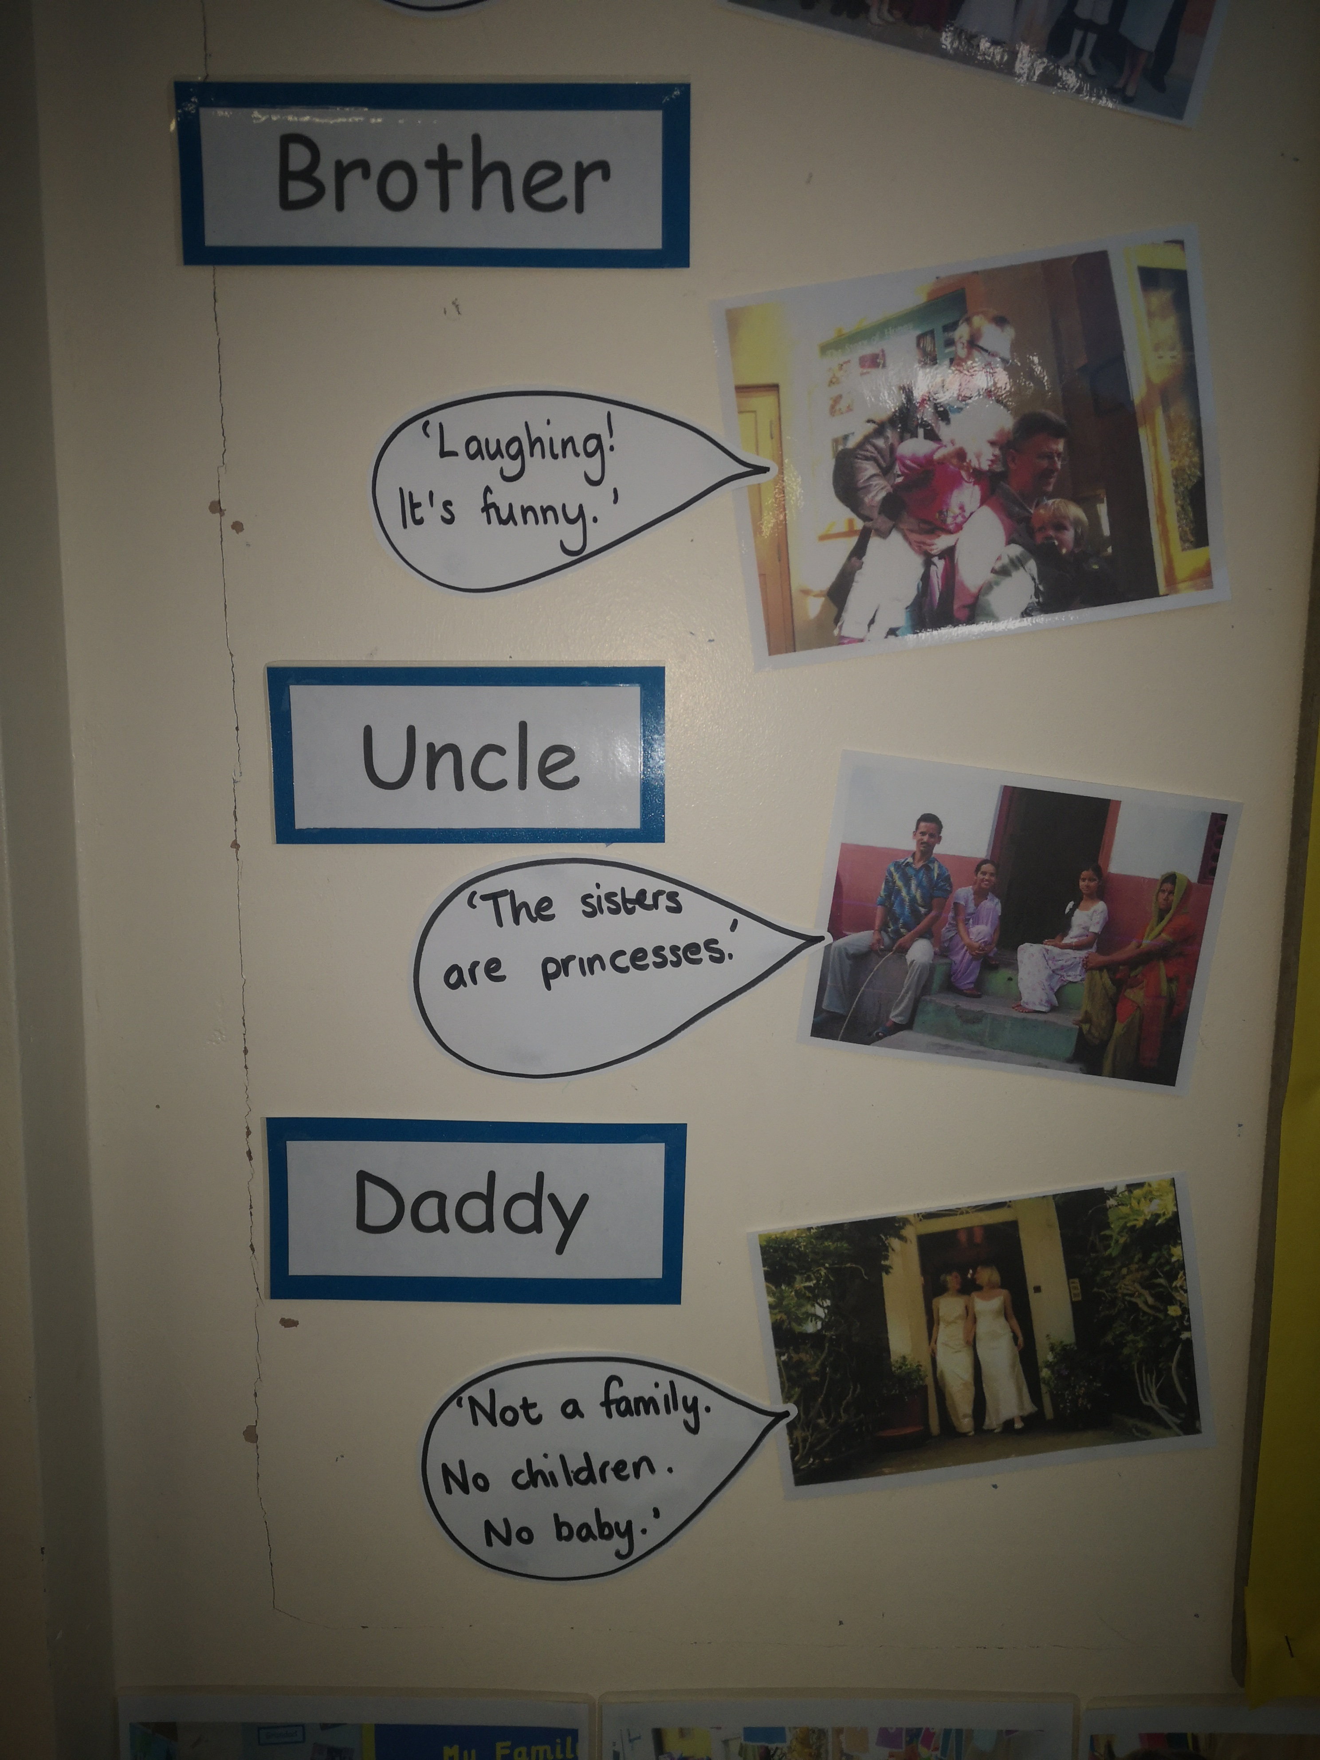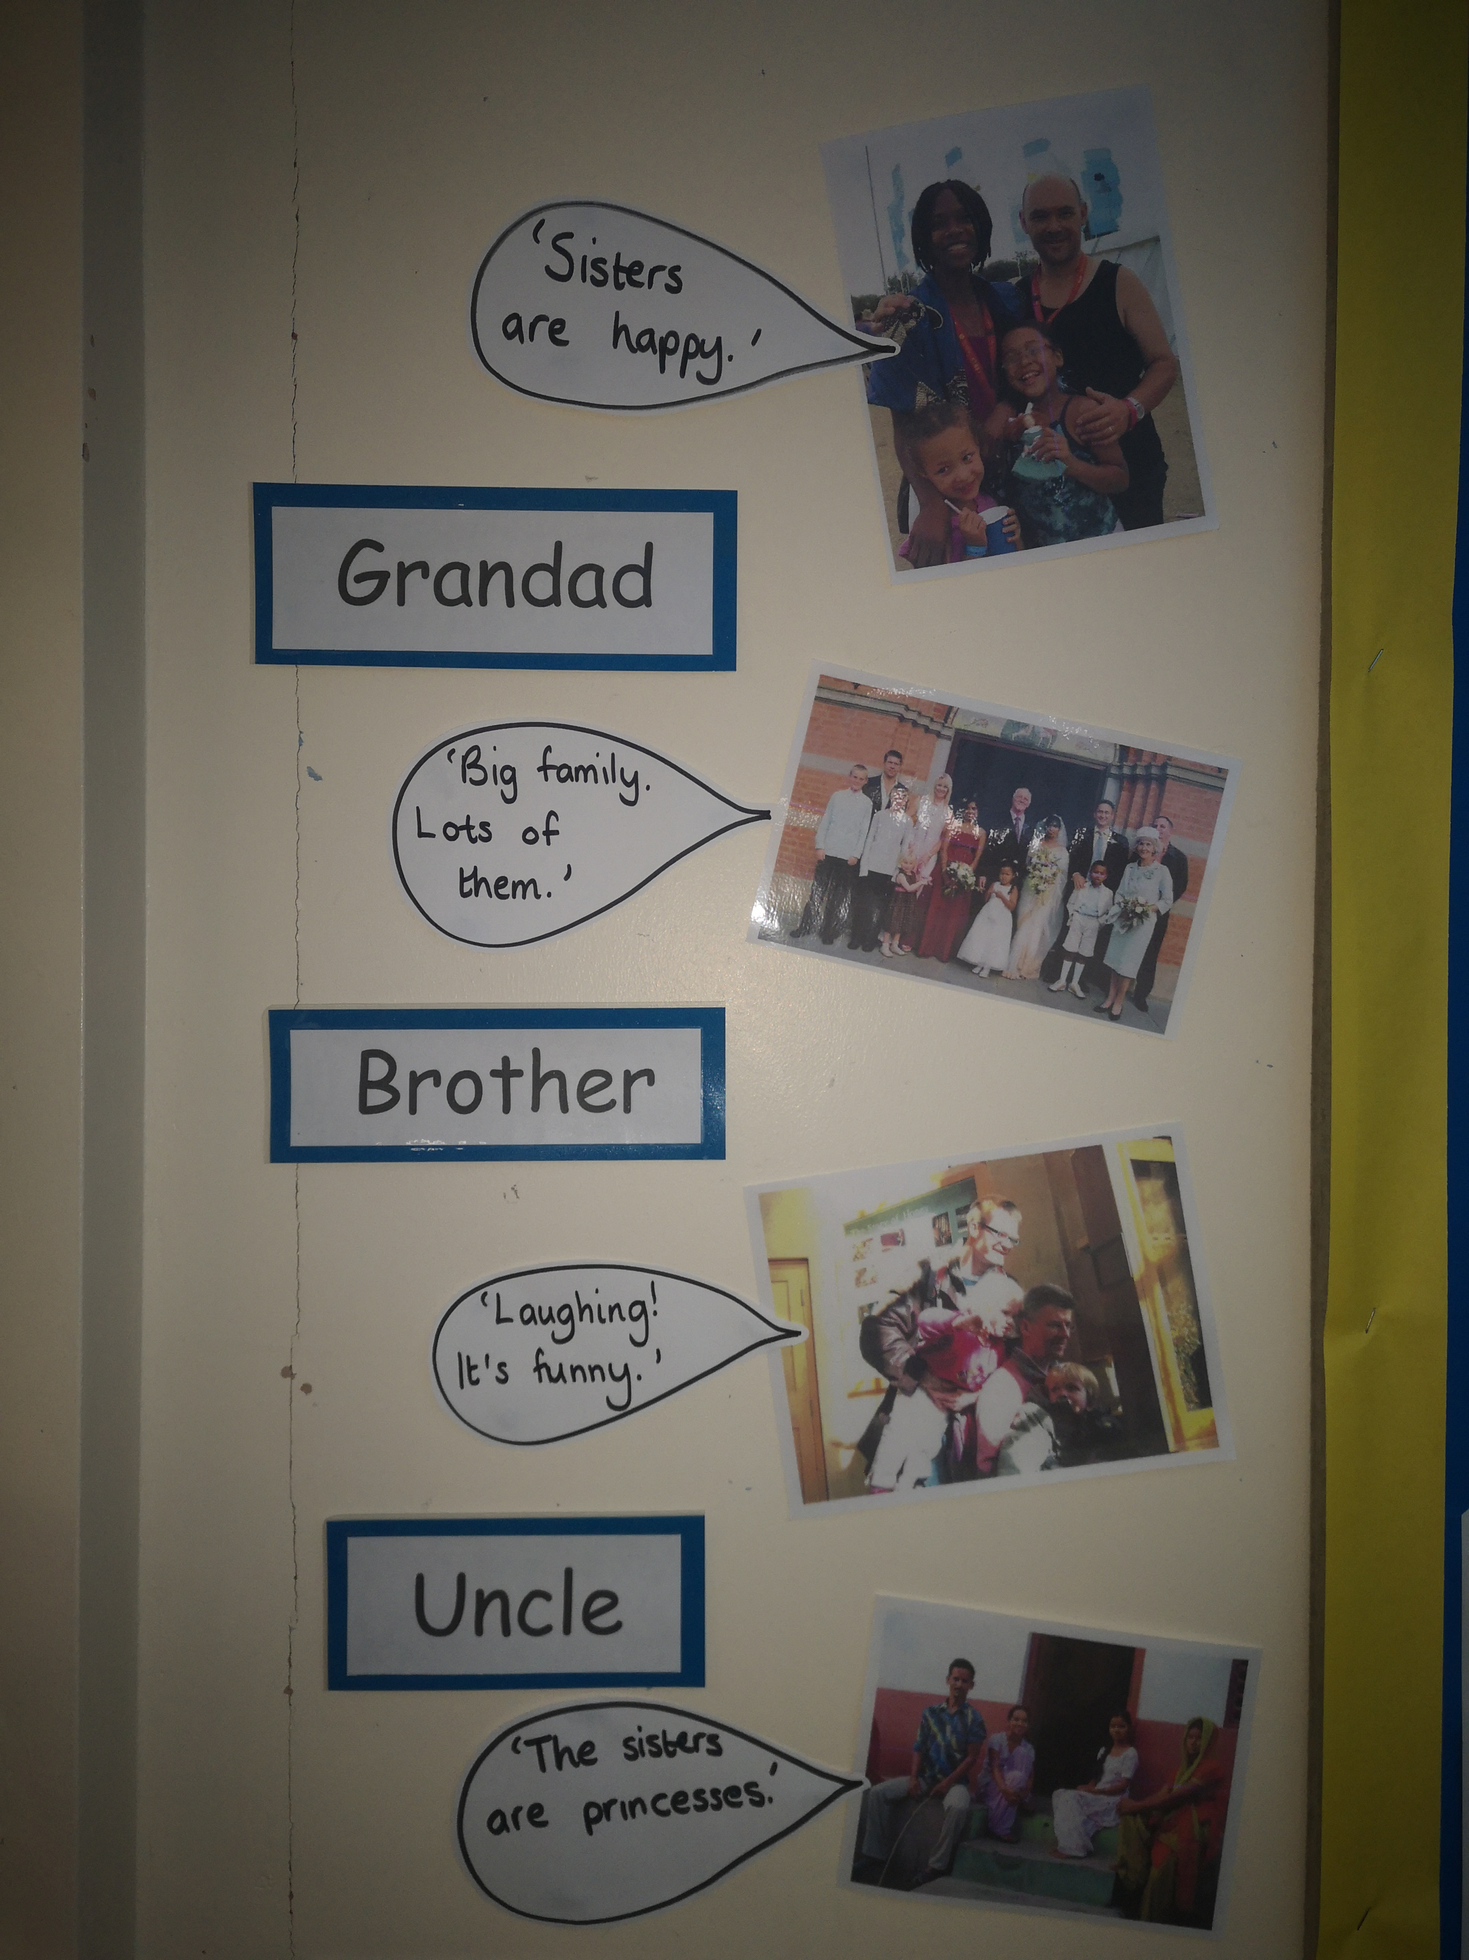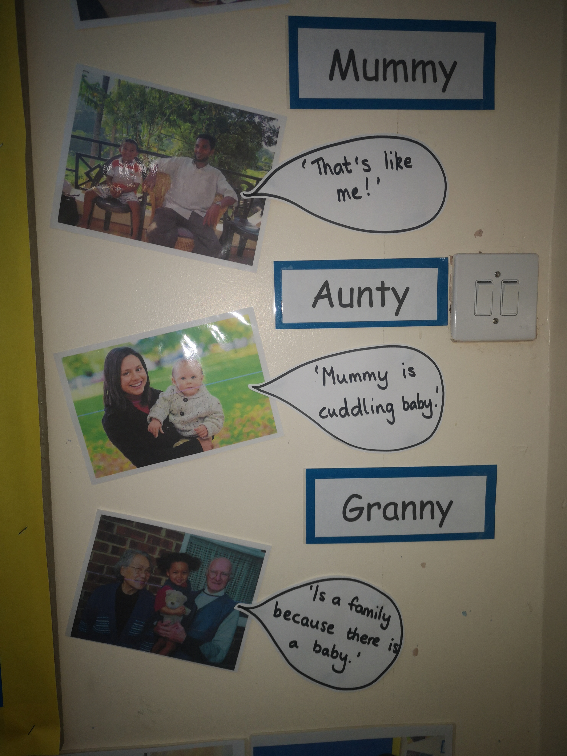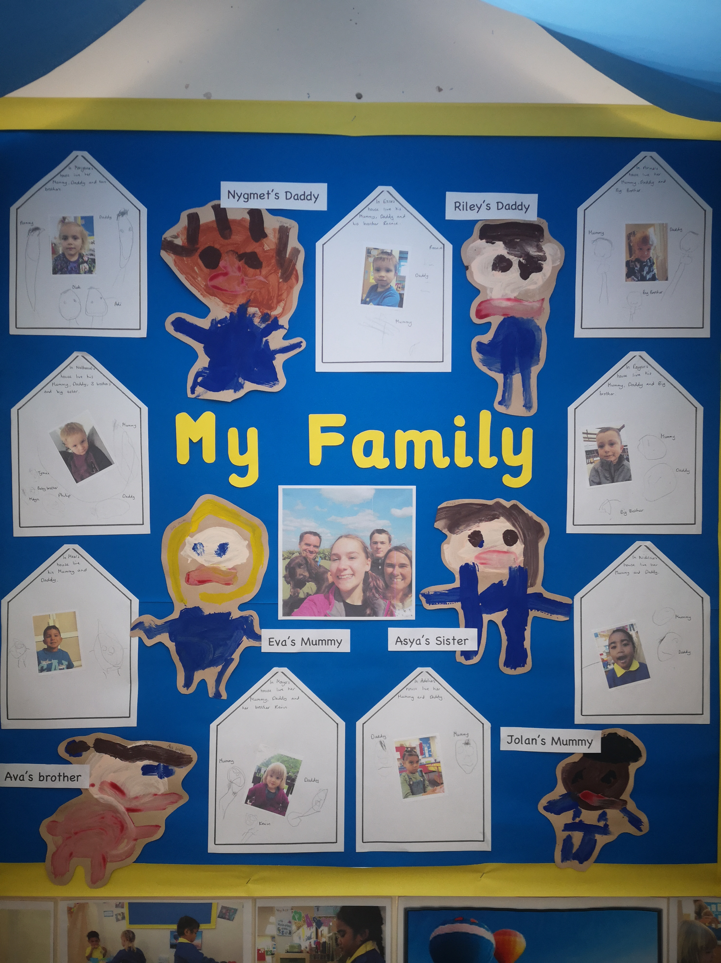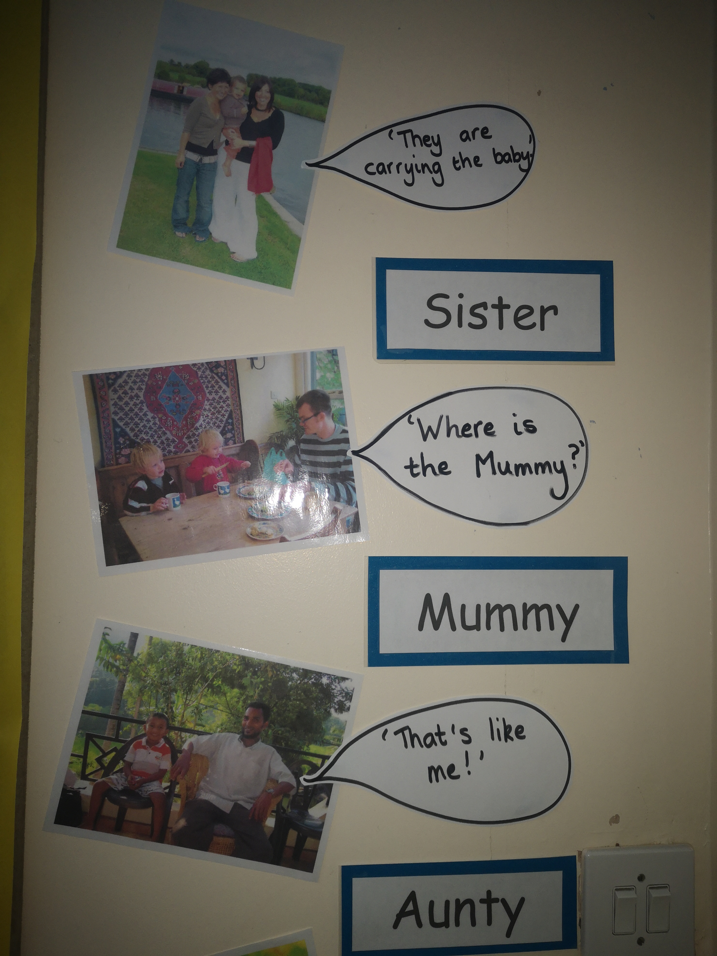

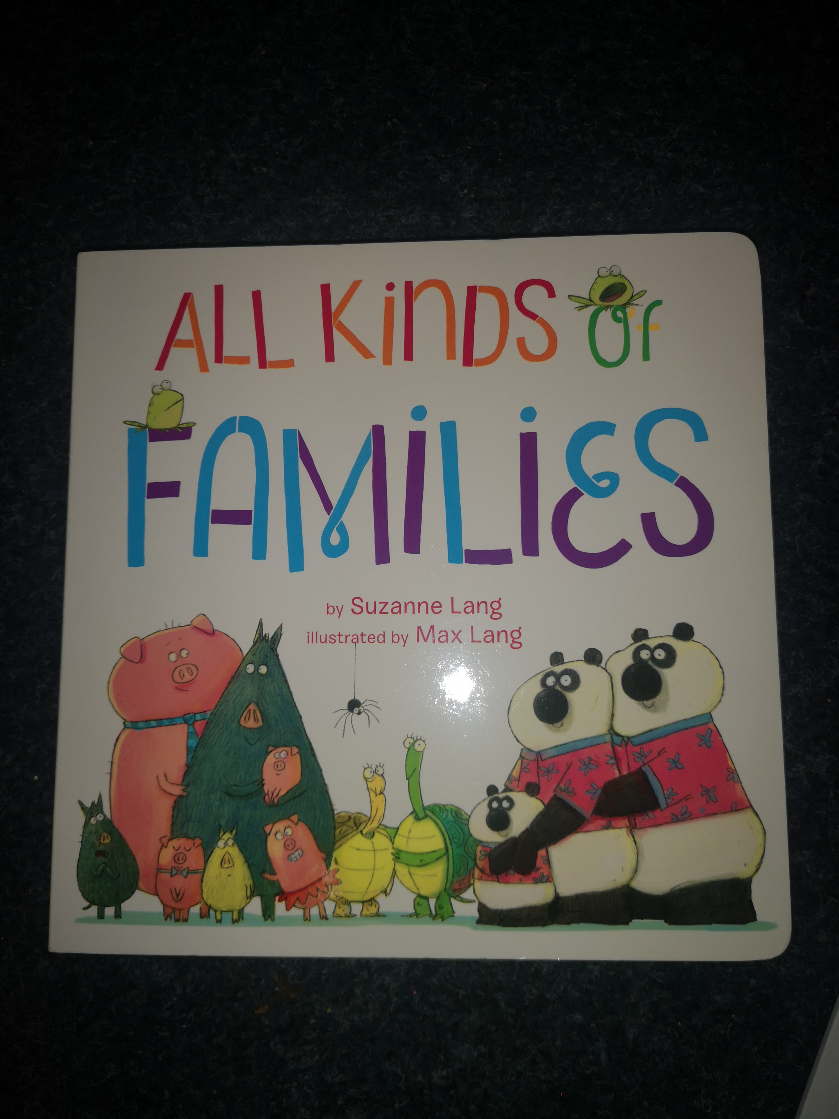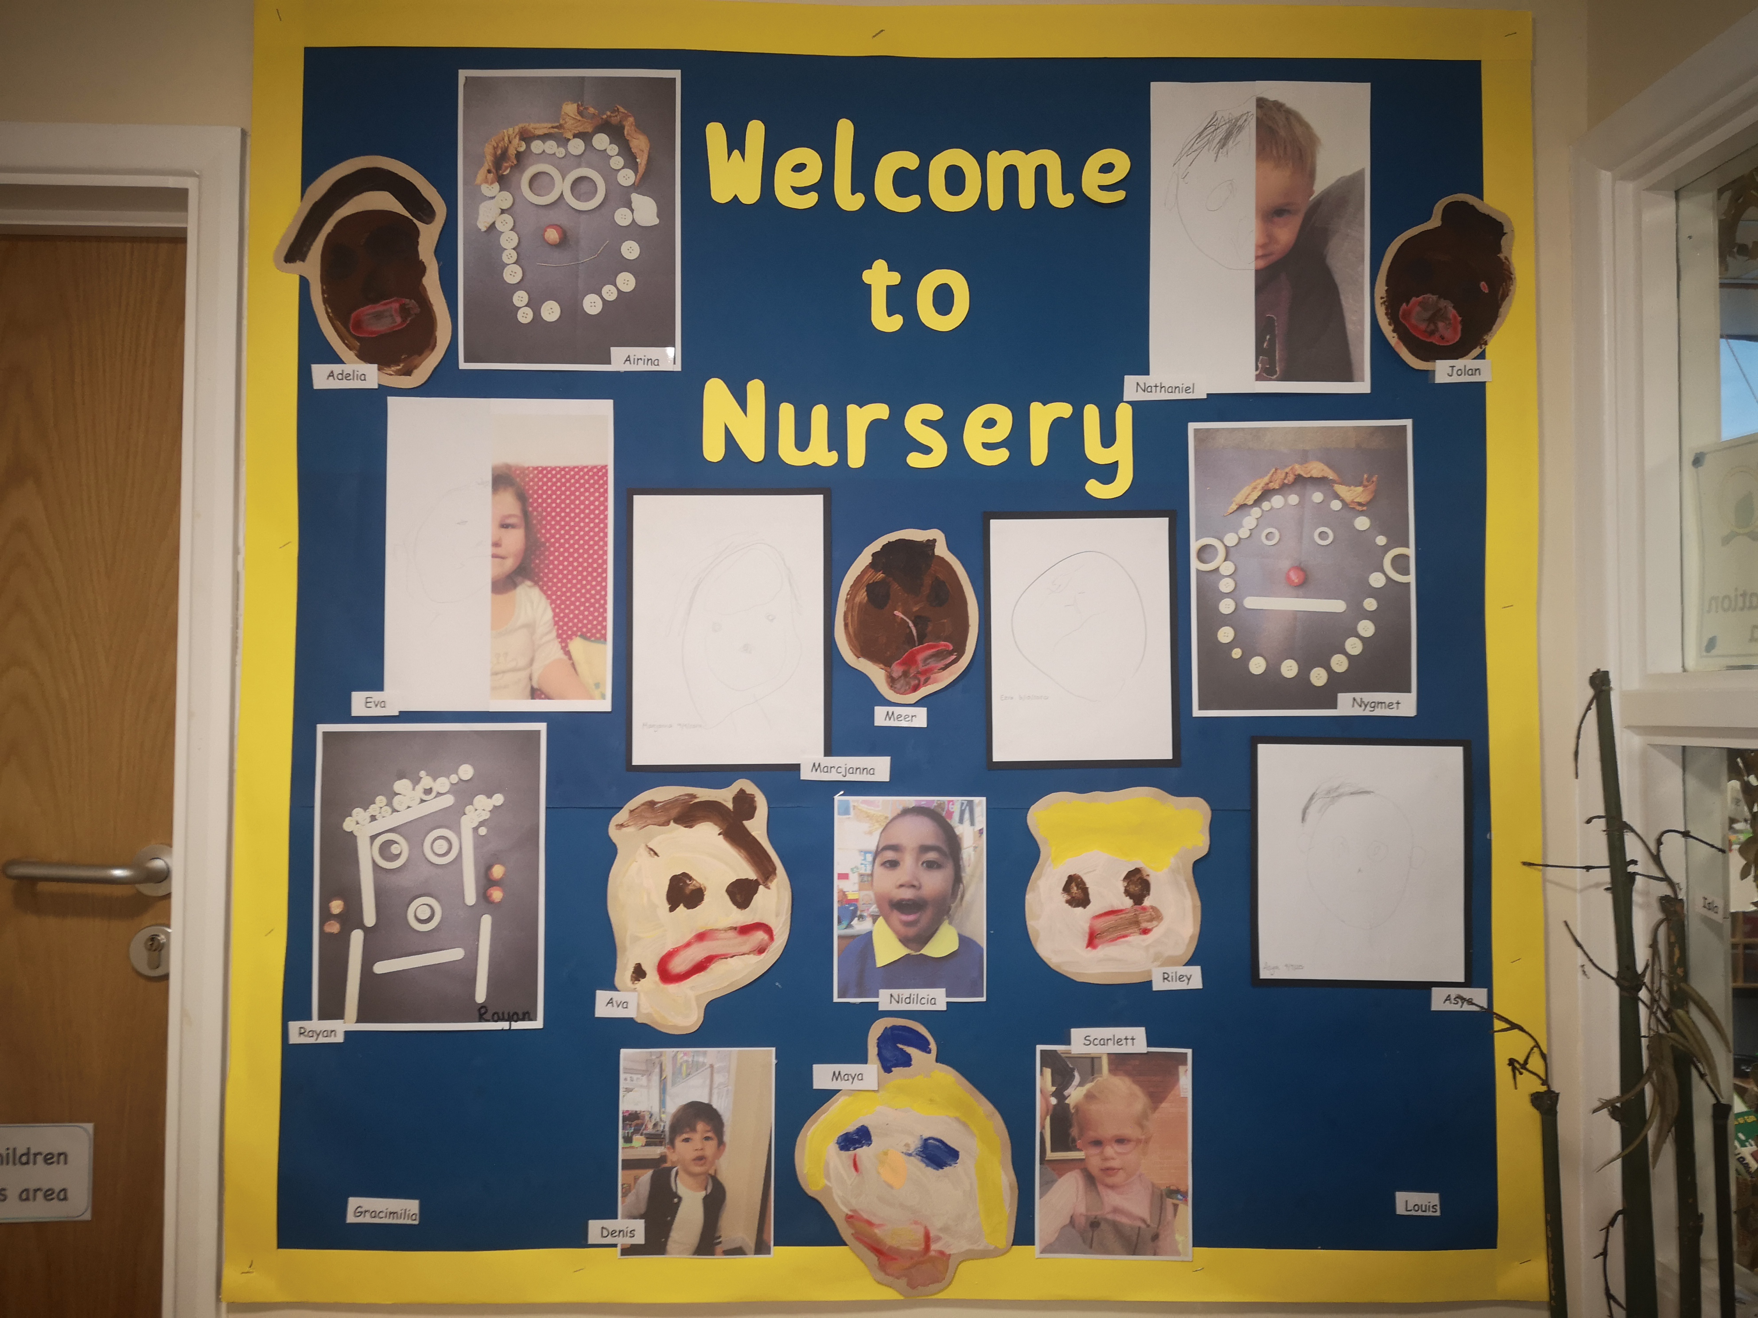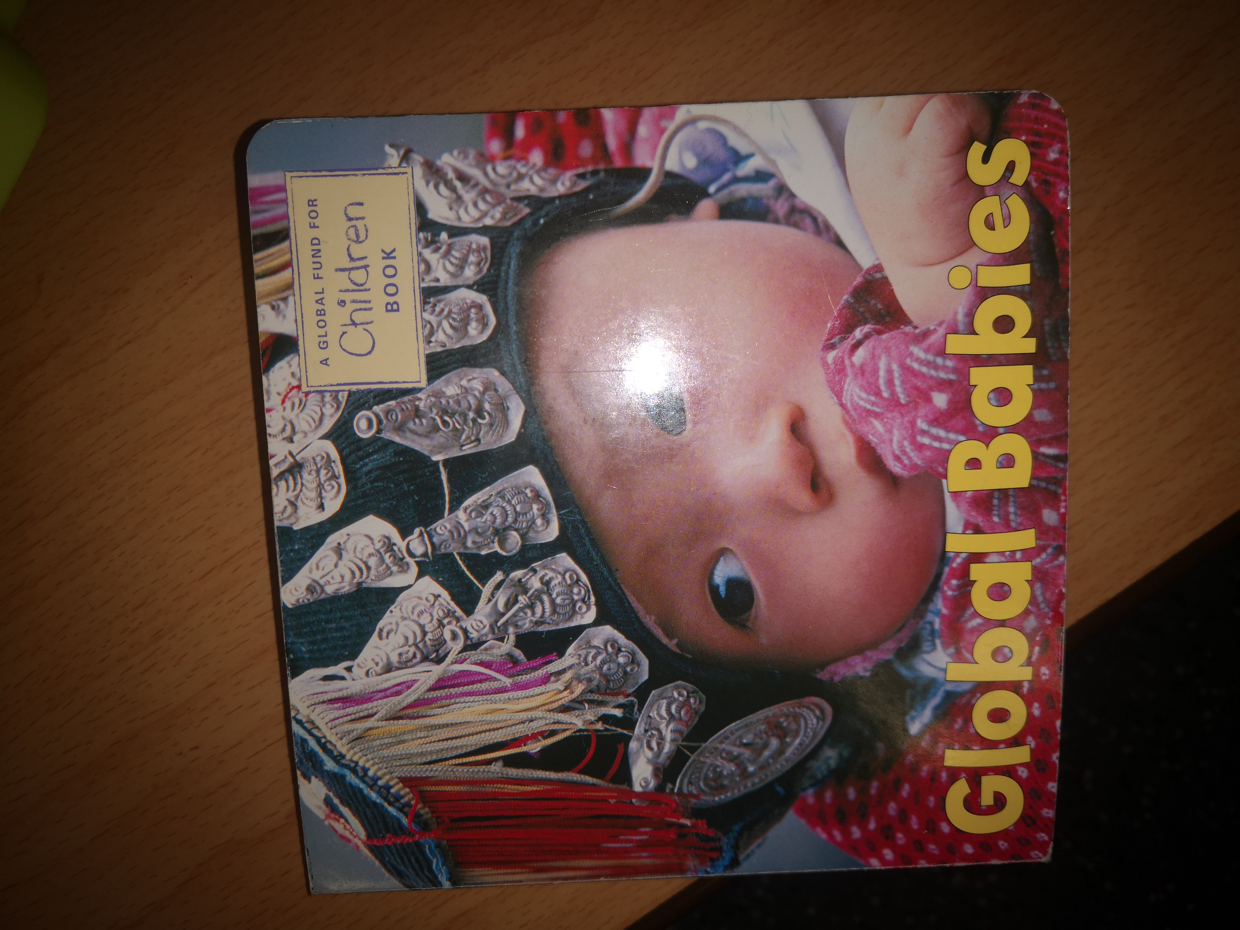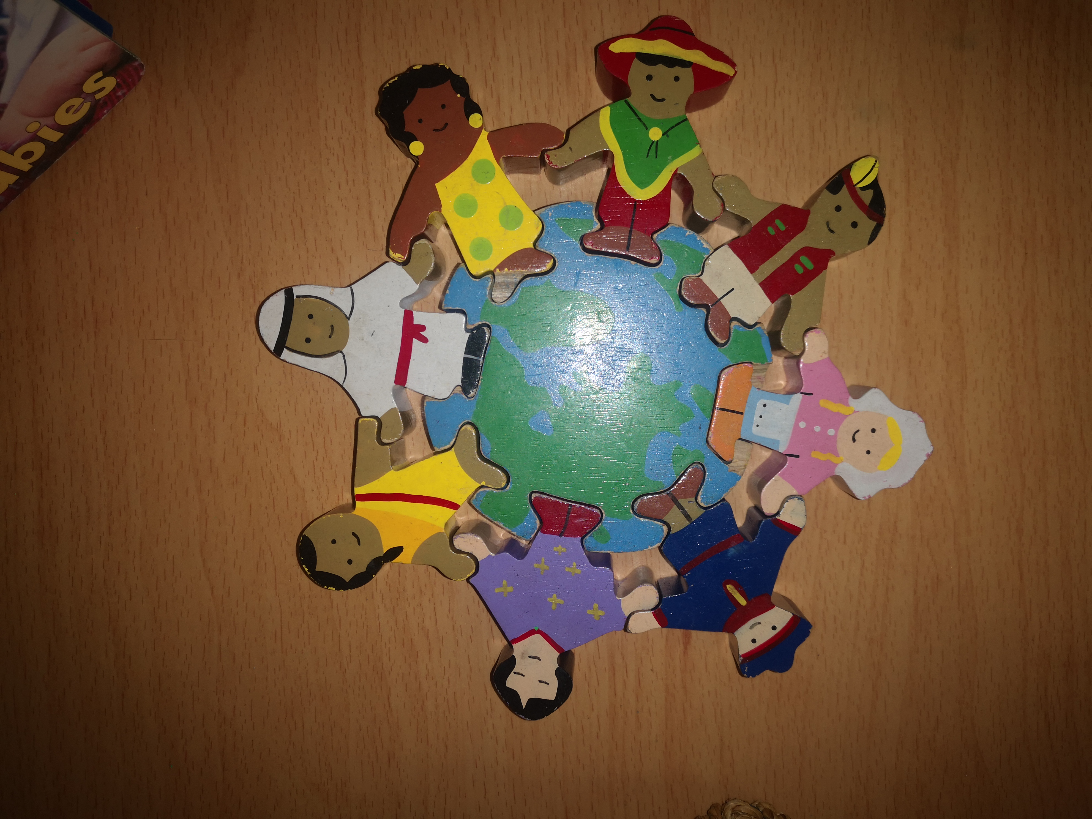
Reception
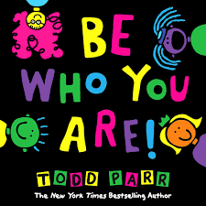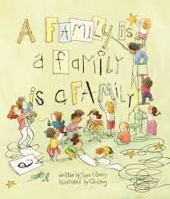

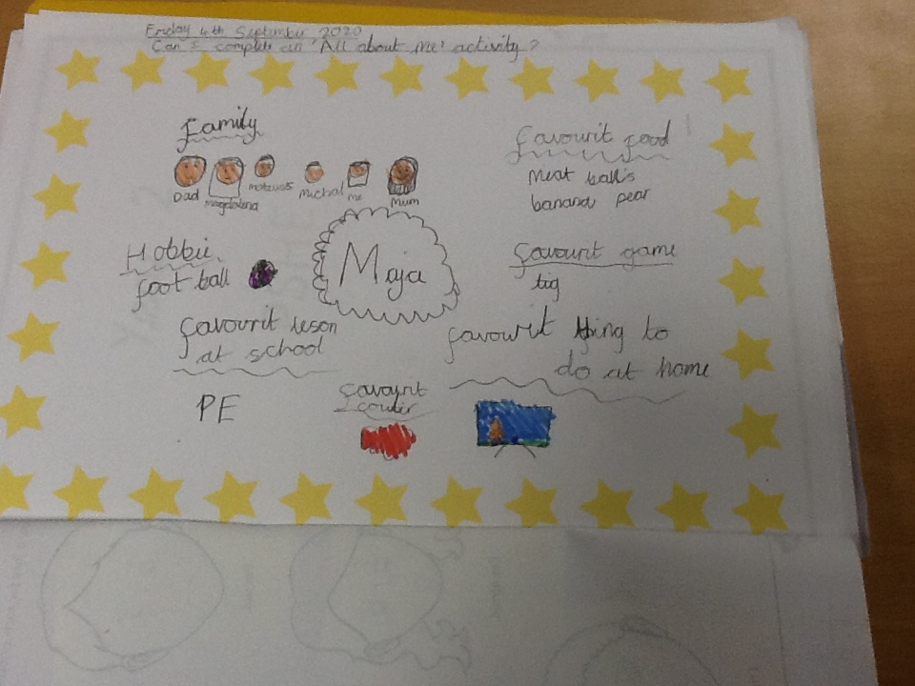
- The whole school have looked at democracy in Collective Worship and PSHE. They have mainly focused on feelings and emotions in PSHE/what is a class family/bubble

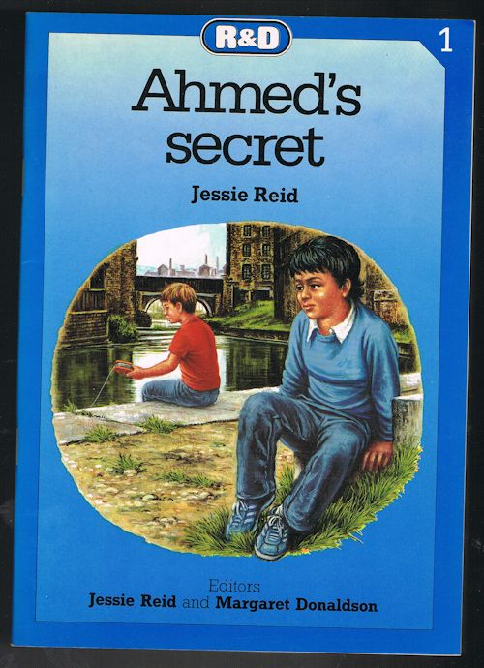
- Year 3 have read 'Ahmed's Secret' about a little boy from Egypt who learns to write his name. Our Class reader is 'The Wild Way Home' about a little boy whose baby brother is born with a hole in his heart so he runs away and slips through time to the Stone Age.

They have explored different habitats around the world and made our own habitat boxes.
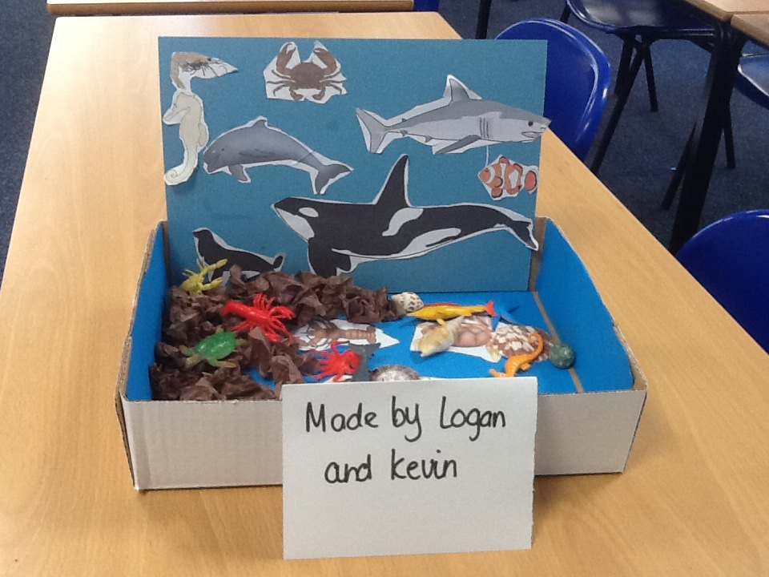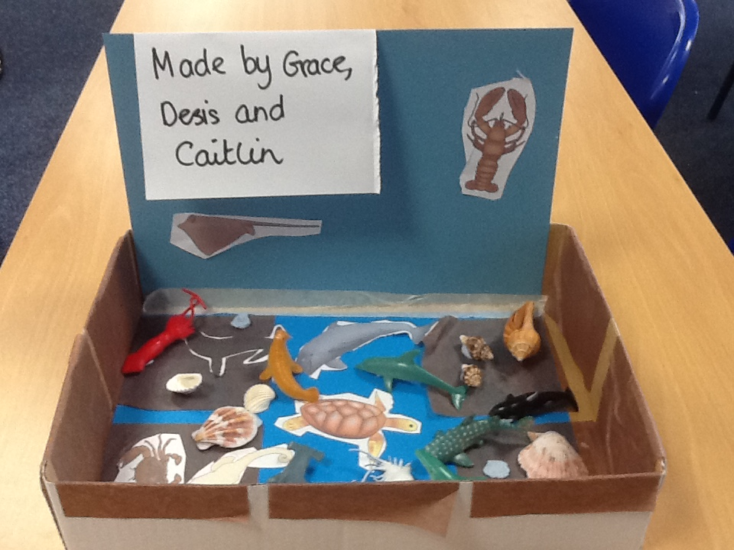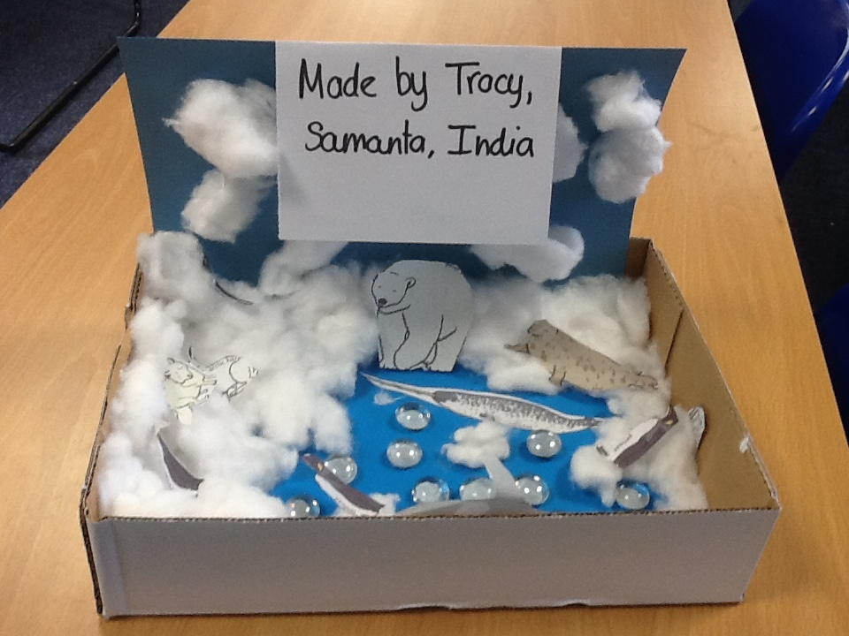
Year 3 are also doing whole class reading in Guided Reading and have looked at an article about a boy with a disability who climbed a mountain to raise money for charity.

Actions towards action plan
- The above will impact on the children’s speaking and listening.
- Profile of Global learning through whole school projects eg. Erasmus KA1 and 2.
- The use of books which focus on diversity and a range of cultures is strong in EYFS and KS1.
- Connecting and collaborating with local partners through ISA and KA2 projects.
- Plan ‘World Hello Day’.

Next steps
To complete a book and environment scrutiny in Autumn 2.
To lead World Hello Day and ensure that all films are shared through website.
To continue to lead the International projects.
To liase with MAPS and SPAG about project ideas.
To liase with partner school in Uganda to organise exchange of ideas and work.
To ensure all documentation is sent to support French evaluation.
To ensure that the ordered books are being used in KS2.

